May 21, 2025

Memorandum to: Alex Goodenough
Policy Analyst
Office of Information and Regulatory Affairs
Office of Management and Budget

CC: William E. Bestani
Policy Analyst
Office of Information and Regulatory Affairs
Office of Management and Budget

From: Robert Meiers
Attorney
Legislation Unit, Legal Division
Federal Deposit Insurance Corporation

RE: Non-material Revisions to FDIC National Survey of Unbanked and Underbanked Households (OMB Control No. 3064-0215)
The FDIC is submitting for OMB review and approval non-material revisions to the form associated with its information collection entitled FDIC National Survey of Unbanked and Underbanked Households (OMB Control No. 3064-0215). The FDIC is making non-material revisions to the survey questions to reduce time and cost burden of the collection of information. To do so, the FDIC is striking Question BATT10.B from the survey which reads as follows:
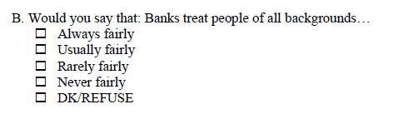
Removing this question will reduce the time burden of the survey by a total of 168 hours from all estimated respondents and will result in a decrease of $6,218 in dollar value of burden hours. The previously approved form and submission will otherwise remain unchanged.
If you have any questions, please let me know. Thank you for your consideration.

