MEMORANDUM

To: Laurel Havas
Office of Information and Regulatory Affairs (OIRA)
Office of Management and Budget (OMB)

From: Richard Lucas
Deputy Administrator for Evidence, Analysis and Regulatory Affairs
Food and Nutrition Service
U.S. Department of Agriculture

Date: June 24, 2025

Subject: Nonsubstantive Change Request – Supplemental Nutrition Assistance Program (SNAP) Forms: Applications, Periodic Reporting, and Notices (OMB Control Number: 0584-0064: Expiration Date: 6/30/2027)

This memo requests approval of nonsubstantive changes to a currently approved collection that is associated with the application and certification procedures of SNAP, as well as the issuance of SNAP benefits, required by the Food and Nutrition Act of 2008 (the Act), as amended. The Federal regulations for implementing these procedures are contained in Title 7 of the Code of Federal Regulations (CFR) in Parts 271, 272, 273 and 274.

On June 11, 2025, FNS submitted and published a nonsubstantive change request to add requirements to report to USDA several currently collected data elements related to SNAP certification and benefit issuance. These data elements will be covered under the newly established system of records entitled USDA/FNS-15, ‘‘National Supplemental Nutrition Assistance Program (SNAP) Information Database.’

The purpose of this subsequent nonsubstantive change request is to correct the OMB inventory for OMB control number: 0584-0064 by adding the original baseline burden estimates back into the inventory that was erroneously removed. During the prior non-substantive change request, 601,430, 663 total annual responses and 82,578,335 burden hours were approved. During the data entry process, approximately 456,895,305 responses and 60,222,299 burden hours were accidentally removed from the baseline of the existing collection under OMB control number: 0584-0064. This non-sub change request adds them back in, correcting this error.

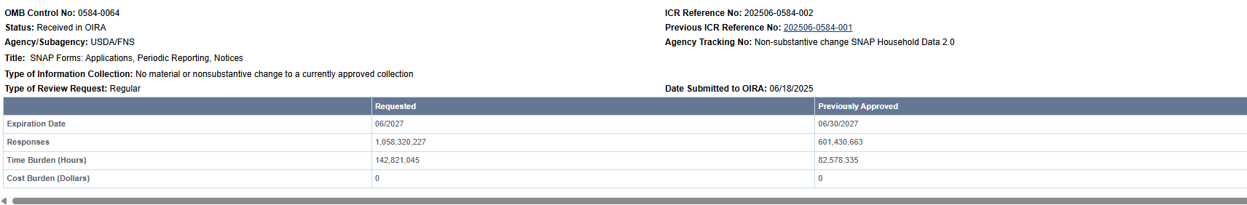

The original burden estimates came from the SNAP program’s application and recertification requirements for participants, recordkeeping and various notification processes from State agencies and participants. These burden hours are requested back into the OMB inventory, which is accurately reflected in the burden table, submitted with the original change request on June 11, 2025. With this new request and approval, all numbers will be correct for the original information collection inventory and the added burden numbers.

The summary of changes requested are listed below:

Respondent & Activity | Burden approved in baseline of collection prior to the 6/11 non-sub | Burden accidentally removed and now added back | Nonsubstantive Change Request 2.0 Revised Difference Due to Adjustments
Respondents (53 States + 2,724 Local Agencies + 2 Business/Private) | 2,227 | 2,227 | 2,227
Burden Hours | 142,800,634 | 82,578,335 | 60,222,299
Responses | 1,058,280,088 | 601,430,663 | 456,849,425

Please let us know if you have any questions.

