ROSTER
- CADD
Are you completing the National Health Interview Survey for:
[fill house number and street name]
[fill apartment number]
[fill city], [fill state] [fill five-digit ZIP code]?
- Yes
- No
If CADD=Yes, go to RLIVE. Else, go to LATER2.

- LATER2
The Census Bureau needs to collect information about:
[fill house number and street name]
[fill apartment number]
[fill city], [fill state] [fill five-digit ZIP code]
Because you indicated that you are not completing the National Health Interview Survey for that address, we do not need any further information at this time.
If you have received a paper questionnaire, you do not have to return it to the Census Bureau.
Thank you.
Survey ends.
- RLIVE
Do YOU live or stay at:
(Help)
[fill house number and street name]
[fill apartment number]
[fill city], [fill state] [fill five-digit ZIP code]
- Yes
- No

- AGECHECK
Are you at least 18 years old?
- Yes
- No
Go to end.

- YOURNAME
Please enter your name.
First Name Middle Initial Last Name

- LISTNAMES
Please list everyone, including people who are not related to you, who lives or stays at [FILL FROM VERADD].
First Name Middle Initial Last Name
Your name: [FILL FROM YOURNAME]
Person 2:
Person 3:

- MISCHILD
We do not want to miss anyone who lives or stays at this address.
The names listed so far are: [NAMES]
Are there any ADDITIONAL children who live or stay at this address, for example babies, grandchildren, or foster children? These children could be related or unrelated to you.
- Yes
- No

*If “Yes” to MISCHILD, display the following below.
7a) MISCHILD_ADD-Enter the name(s) and then click Next.
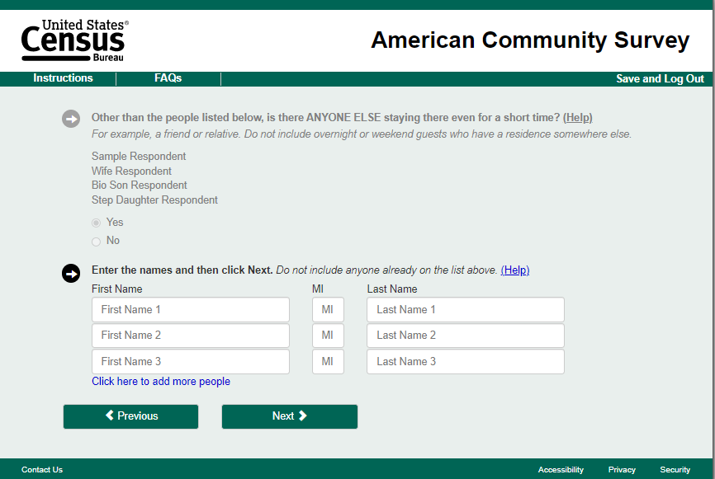
“Add person” button

- MISFIN
The names listed so far are: [NAMES]
Are there any ADDITIONAL people who live or stay at this [address], for example, roommates and other people or families? They could be related or unrelated to you.
- Yes
- No

*If “Yes” to MISFIN, display the following below.
8a) MISFIN_ADD-Enter the name(s) and then click Next.
“Add person” button

- ARMEDF
Select any people who live or stay at this address, but are now on full-time active duty with the Armed Forces. Select all that apply.
Active duty does not include training for the Reserves or National Guard, but DOES include activation, for example, for service in the U.S. or in a foreign country, in support of military or humanitarian operations.
[LIST ALL NAMES COLLECTED]

- FINCHECK
Select any people who live away now at school or college. Select all that apply.
[LIST OF NAMES COLLECTED]

- ONCAMPUS
Does [FILL FROM FINCHECK] live on campus?
On-campus housing includes residence halls and dorms where students live together. It also includes buildings that are owned, leased, or managed by the school. Fraternities and sororities are on-campus housing.
- Yes
- No

DEMOGRAPHICS
- SEX - Some of the questions in this survey are about topics like cervical and prostate cancer, so it is important to know which questions apply. [Are you/Is NAME] male or female?
- Male
- Female

- AGE – What is [your/NAME] age?
[UNIT] [PERIOD]
If blank or “Unit” or “Period” are missing and questions are not about the respondent, go to AGECHECK_DEMO. Otherwise, go to EDUC.
- AGECHECK_DEMO- Is NAME at least 18 years old?
- Yes
- No

This error message will be a hard edit so respondents must answer this question.

- EDUC
[if person is 18 or older in the household]
What is the highest level of school [you have/NAME has] completed or the highest degree [you have/NAME has] received?
  - Never attended/kindergarten only
  - Grade 1-11
  - 12th grade, no diploma
  - GED or equivalent
  - High school graduate
  - Some college, no degree
  - Associate degree: occupational, technical, or vocational program
  - Associate degree: academic program
  - Bachelor’s degree (Example: BA, AB, BS, BBA)
  - Master’s degree (Example: MA, MS, MEng, MEd, MBA)
  - Professional School degree (Example: MD, DDS, DVM, JD)
  - Doctoral degree (Example: PhD, EdD)

- WHOPAR
[if person less than 18 in the household]
Which people living in this household are [CHILD NAME] parents?
Please include biological, step, adoptive, or foster parents or other relatives who may act as parents.
Select all that apply.
- [NAME LIST]
- No biological, step, adoptive, or foster parents

SAMPLING
[At this point, the sample adult and if applicable, sample child, will randomly be chosen. If the respondent is the sample adult, ask ROSTEREMAIL. If they are not the sample adult or household is in the all adults treatment, ask ADULTEMAIL].
- ROSTEREMAIL
What is your email address?
[text field]
[If roster respondent is the sample adult and do not have a child, they can go to the Sample Adult survey. If roster respondent is sample adult and do have a child, ask KNOWLEDGECHILD. Otherwise, ask ADULTEMAIL.]
- ADULTEMAIL
What is [NAME’s] email address?
[text field]
[If Child is present in the household, ask KNOWLEDGECHILD. Otherwise go to end.]
- KNOWLEDGECHILD
Are you knowledgeable about and responsible for CHILDNAME’s health care?
1. Yes
2. No

If roster respondent is the sample adult, go to SAMPLE ADULT. If roster respondent said Yes to KNOWLEDGECHILD and is not the sample adult, they can go to the SAMPLE CHILD. Otherwise, invitation will be sent to the address and go to ROSTEREND.
- ROSTEREND
Thank you for your time. Your household will be receiving invitations to complete the rest of the survey at a later time.

SAMPLE ADULT
If Sample Adult is not the roster respondent OR they are not in the same session the roster was completed, go to ISTHISYOUADULT. Otherwise, go to ADULTHEALTH.
- ISTHISYOUADULT
We need to ask questions about [NAME]. Is this you?
- Yes [Go to ADULTHEALTH]
- No [GO TO ADULTSCRNOUT]

- ADULTSCRNOUT
Thank you for your time. This questionnaire will need to be answered by [NAME].
- ADULTHEALTH
Would you say your health in general is…
- Excellent
- Very good
- Good
- Fair
- Poor
Continue with the rest of the Sample Adult questionnaire

If Child questionnaire is completed, the adult is not eligible for the Child questionnaire, or there is no Child questionnaire, go to ADULTEND. If Child questionnaire still needs to be completed and they are eligible for the child, go to ADULTTOCHILD.
- ADULTEND
Thank you for completing this questionnaire. We appreciate your time!
- ADULTTOCHILD
You will now be answering questions about [NAME]’s health.

SAMPLE CHILD
If completed roster or Sample Adult in the same session, go to CHILDHEALTH.
If start Sample Child in a new session, go to CHILDHEALTH_INTRO.

- CHILDHEALTH_INTRO
We randomly selected one child from your household for a health interview. [NAME] was the child selected for this questionnaire.
- CHILDHEALTH
Would you say this [NAME]’s health in general is…
- Excellent
- Very good
- Good
- Fair
- Poor
Continue with the rest of the Sample Child questionnaire
When sample child questionnaire is completed, go to CHILDEND.

- CHILDEND
Thank you for completing the questionnaire. We appreciate your time!

