2026 Census Test Group Quarters Advance Contact
Instrument Screenshots
6/18/25

Note: On each screen, “GQ” will be changed to “group quarters” in the question wording, as applicable, and shown in the final screenshots.

Screenshot 1: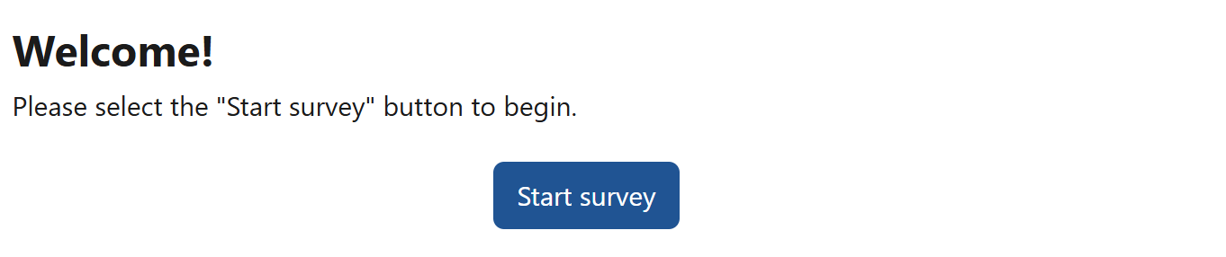

Screenshot 2:
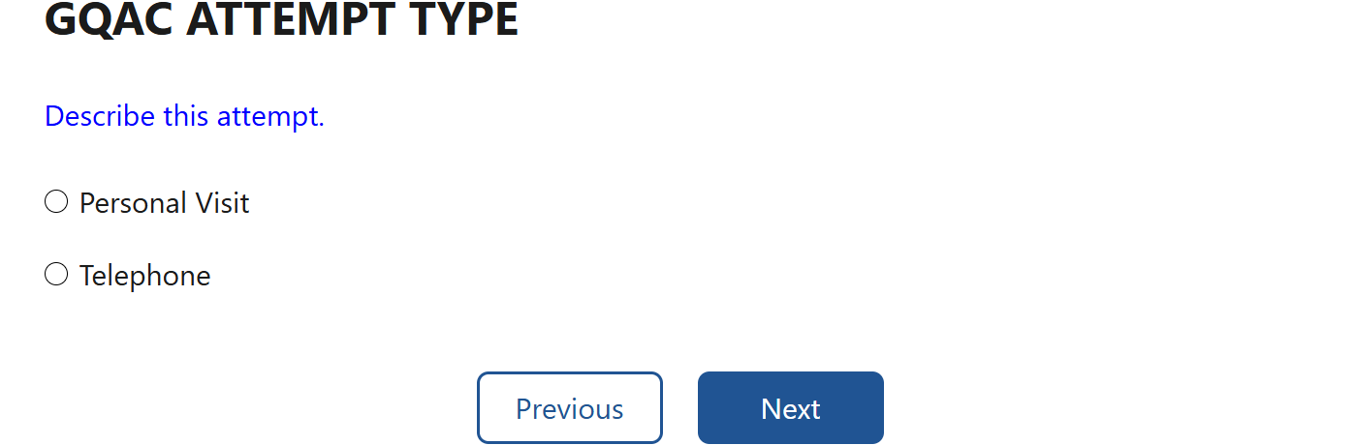

Screenshot 3:
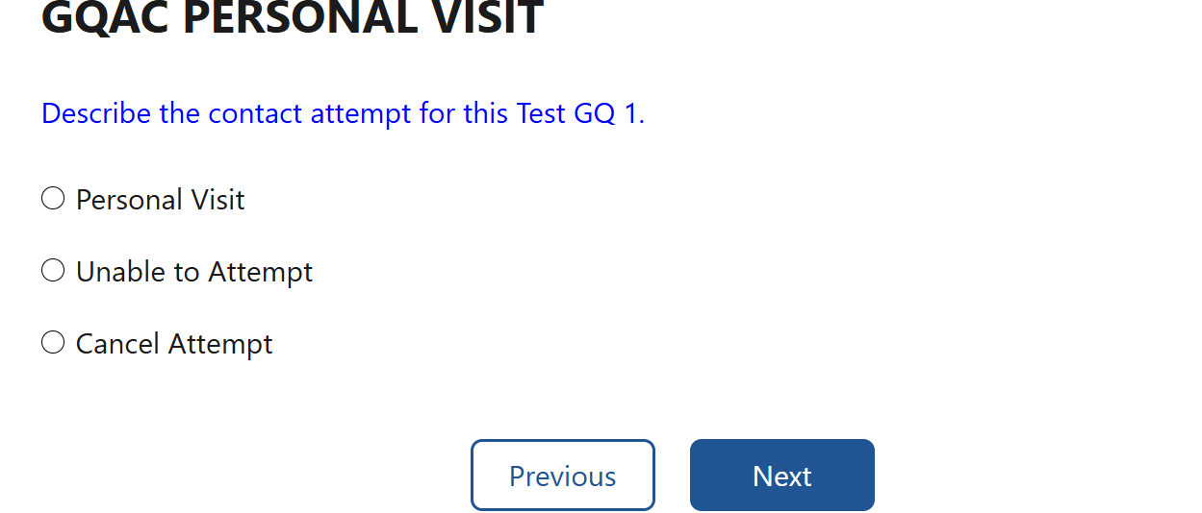

Screenshot 4:
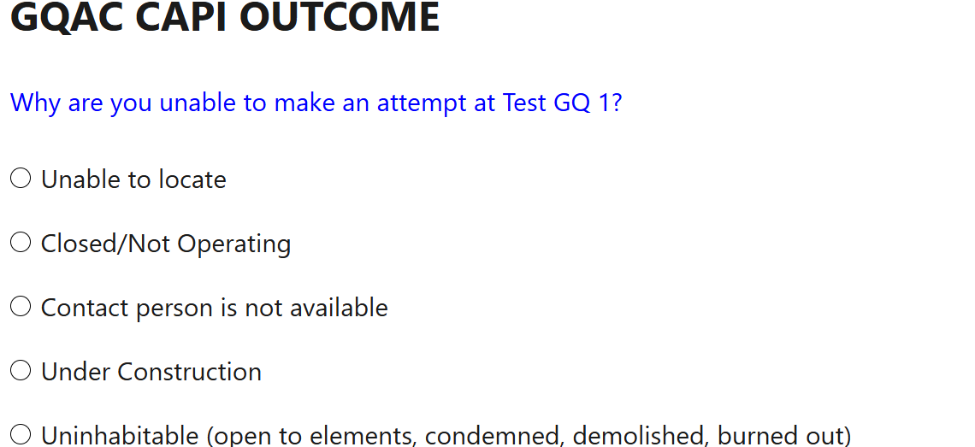
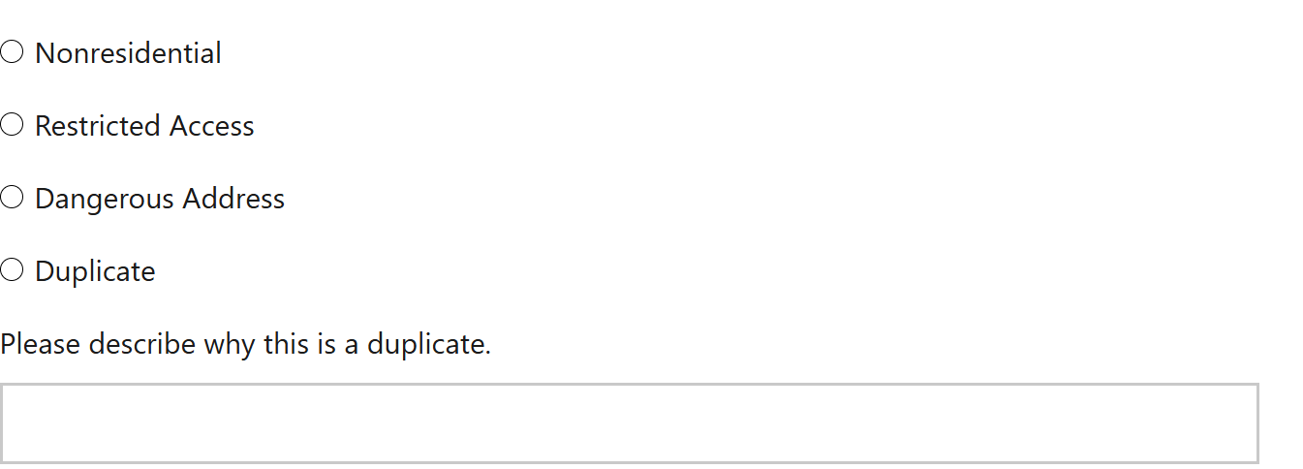
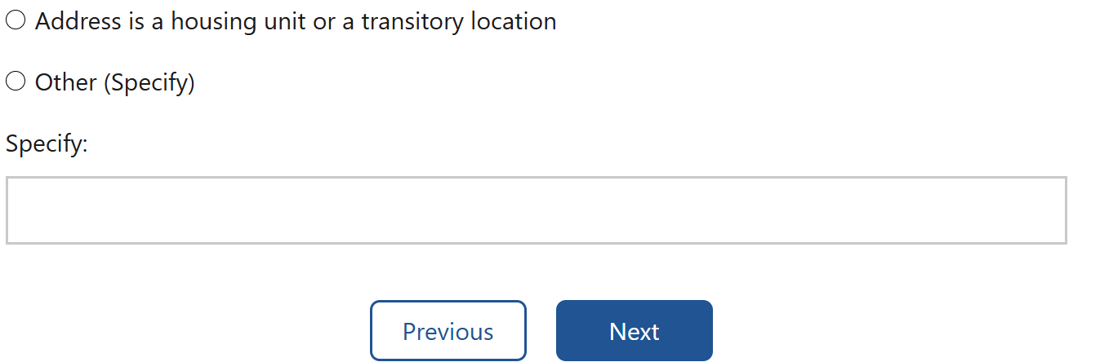
Screenshot 5:
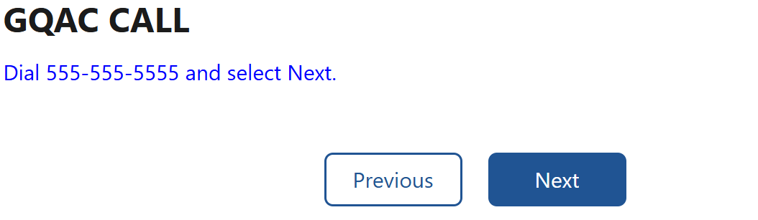

Screenshot 6:
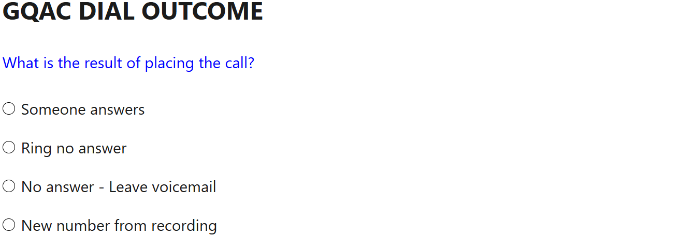
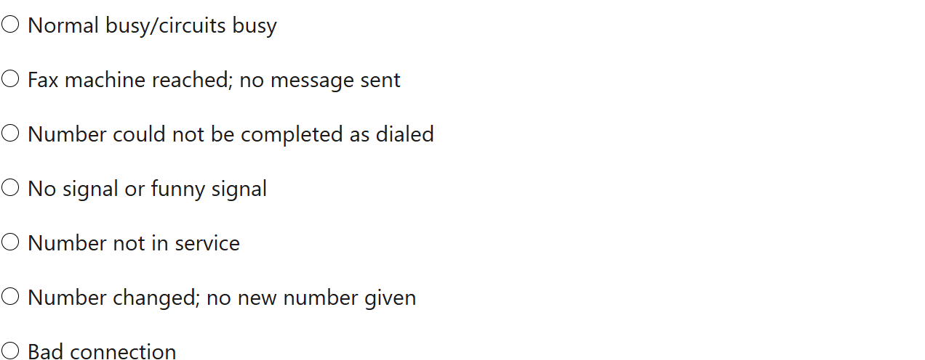
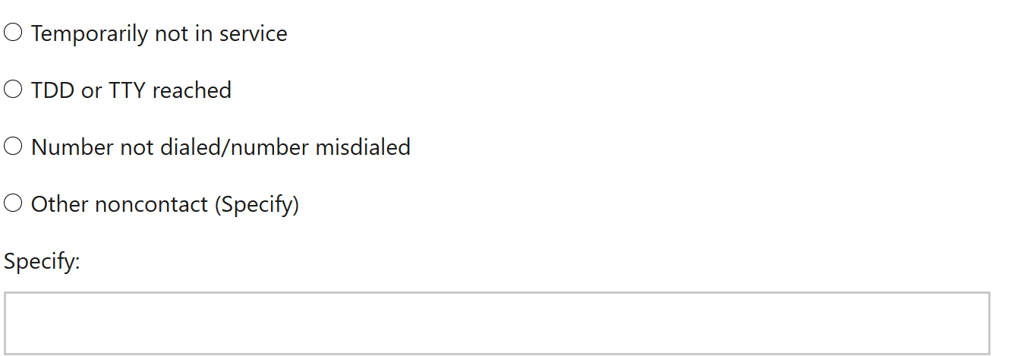

Screenshot 7:
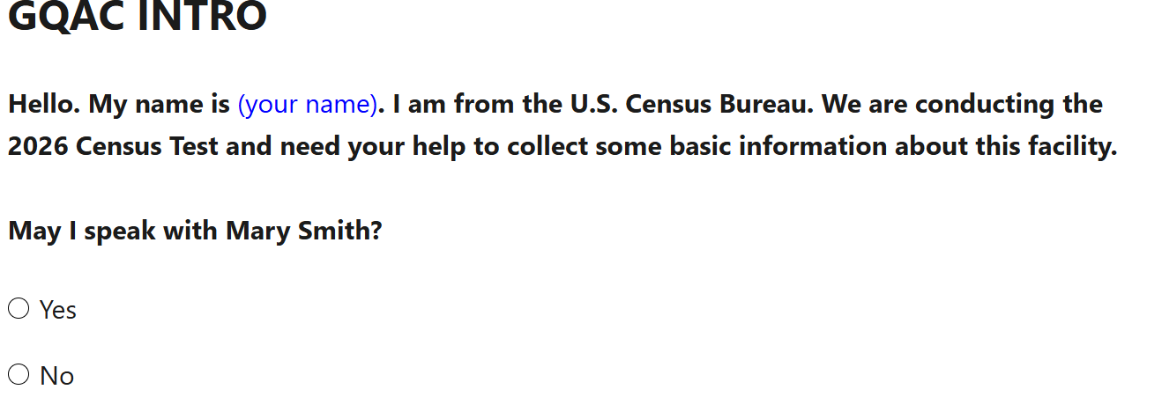


Screenshot 8 (1 of 3):
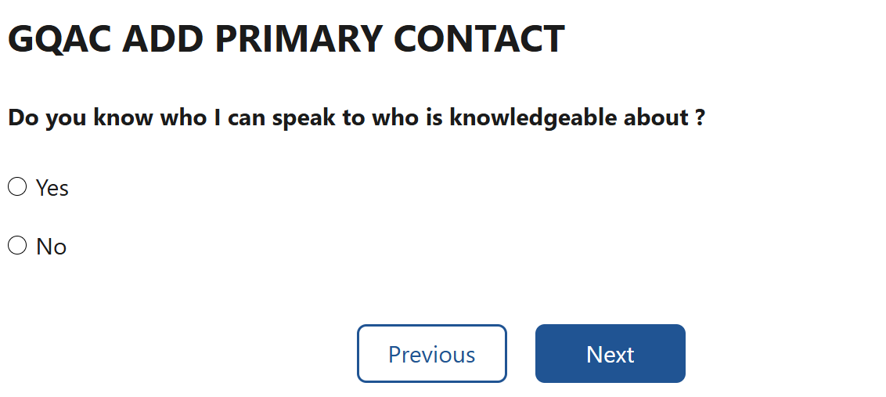

Note: The GQ name is not displaying on this screen, however, it will be shown in the final screenshot.

Screenshot 8 (2 of 3) – “Yes” selected:
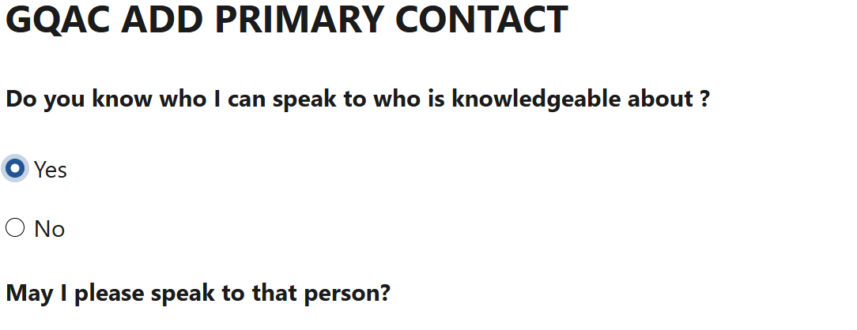
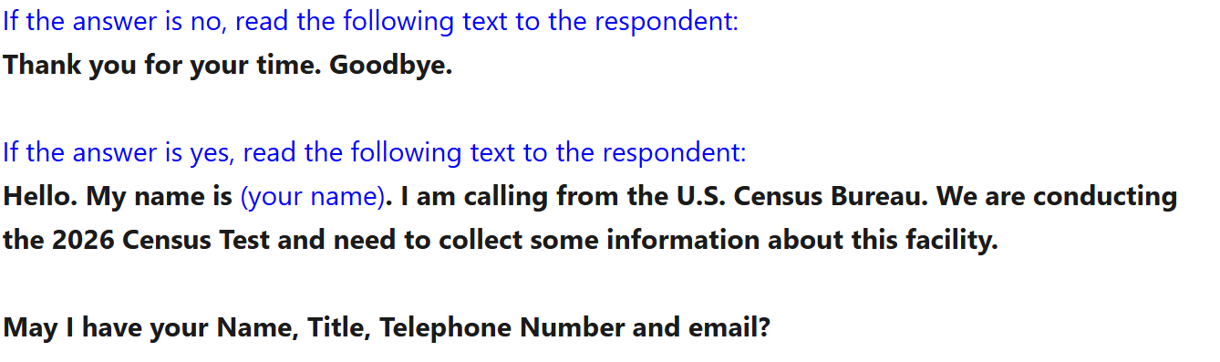

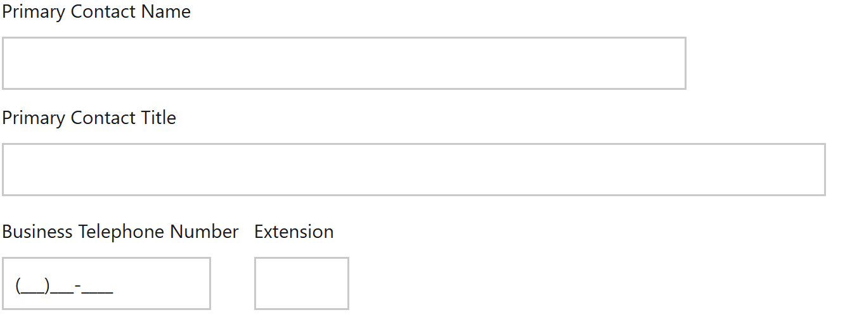
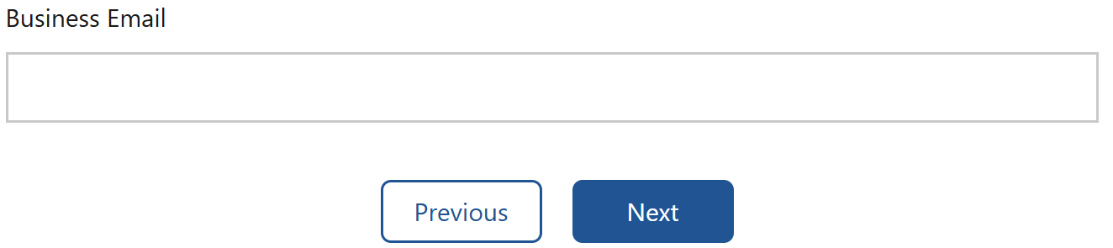

Screenshot 8 (3 of 3) – “No” selected:
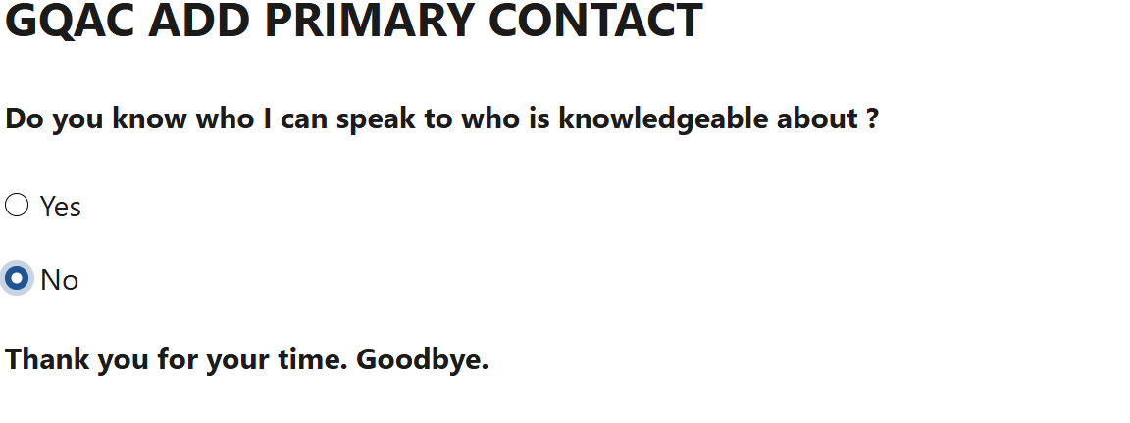


Screenshot 9:
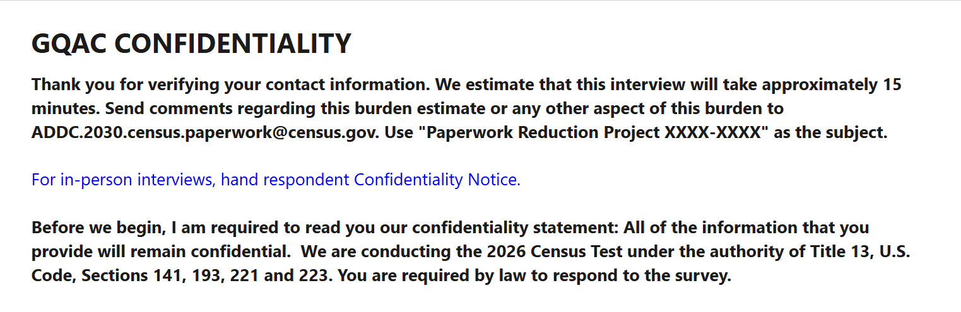
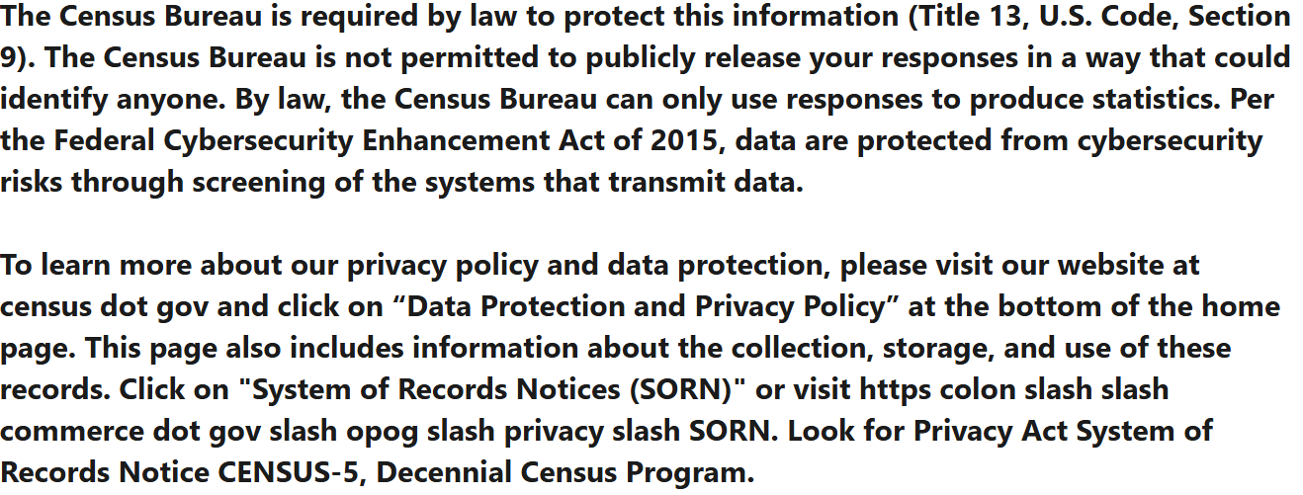

Screenshot 10:
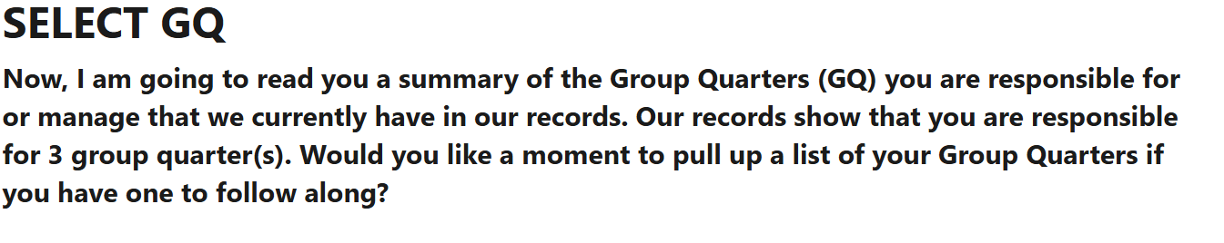
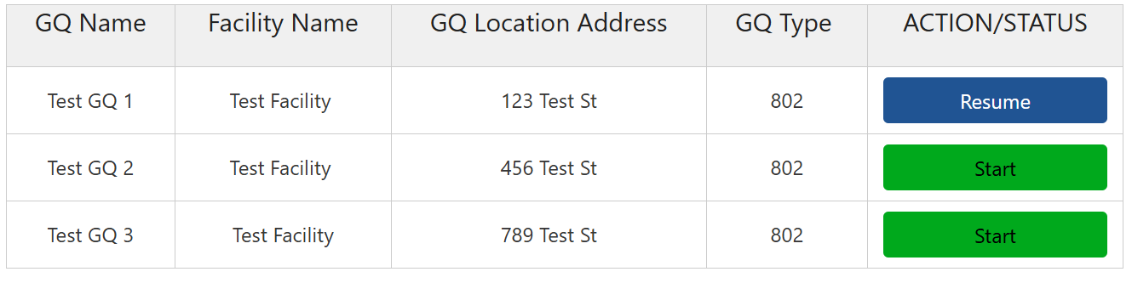

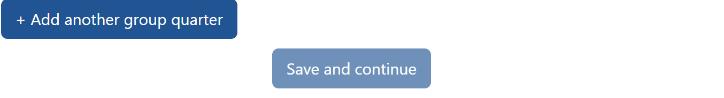

Screenshot 11:
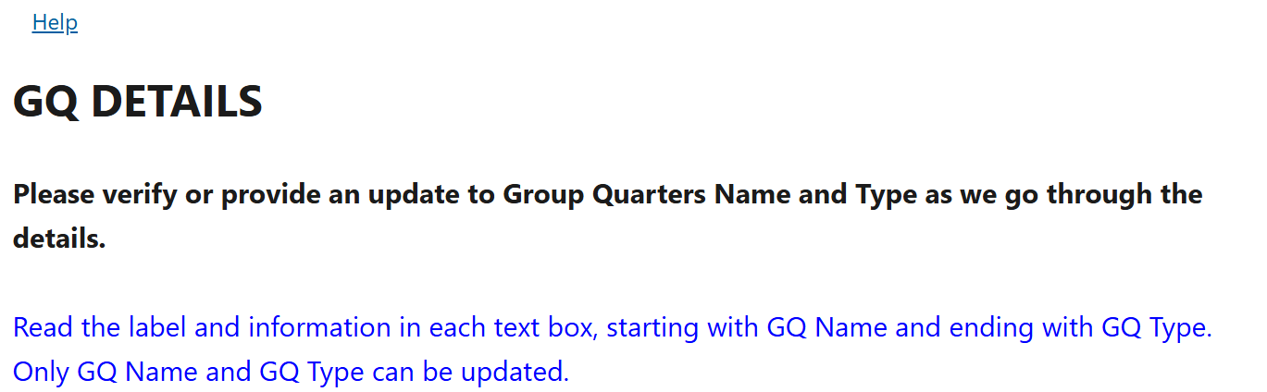
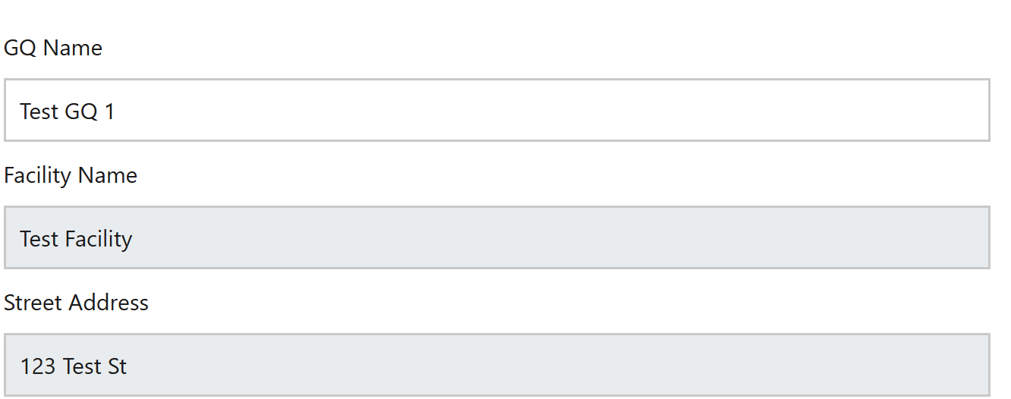
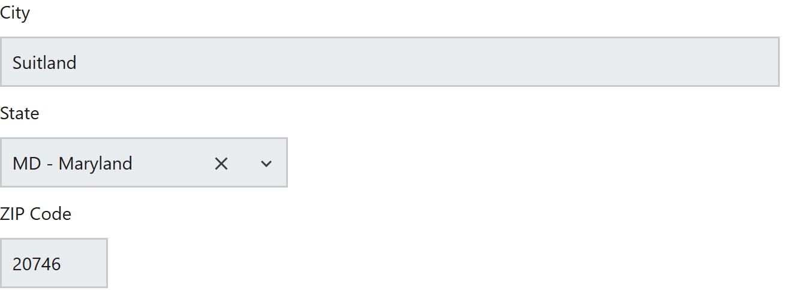
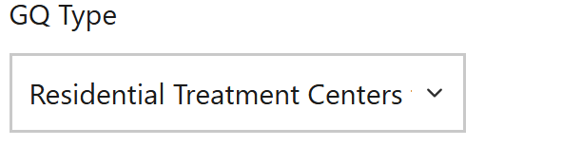
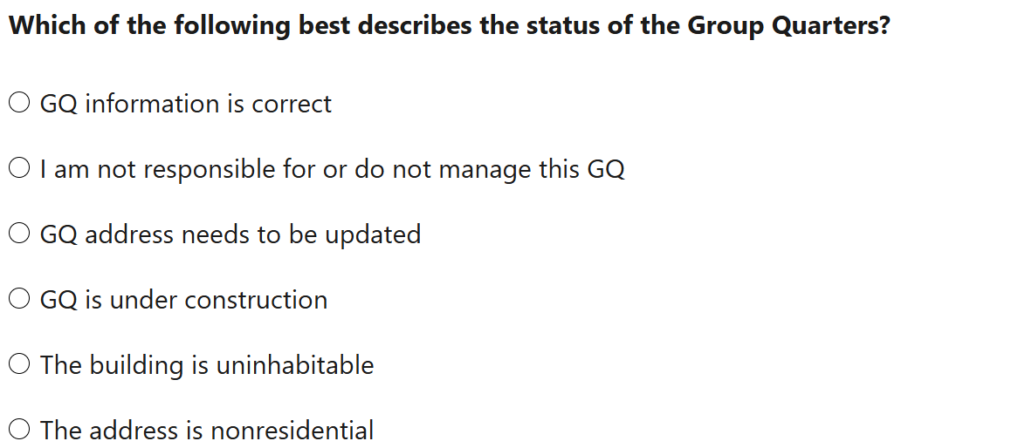
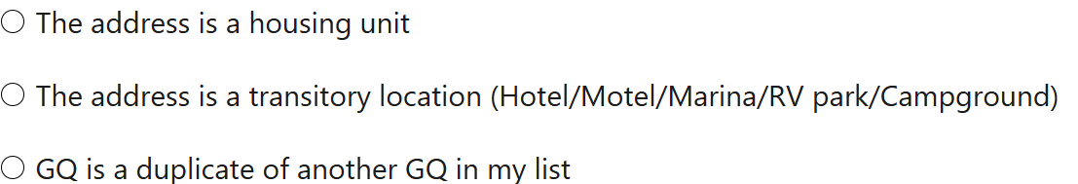


Screenshot 12:
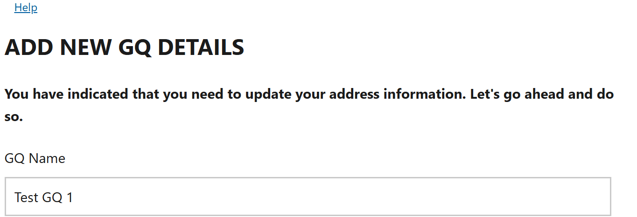
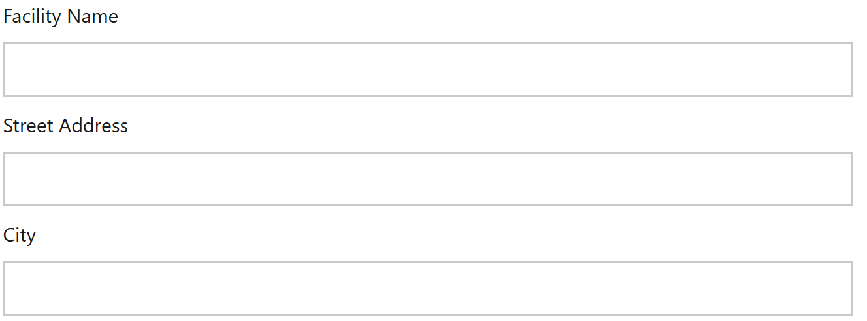
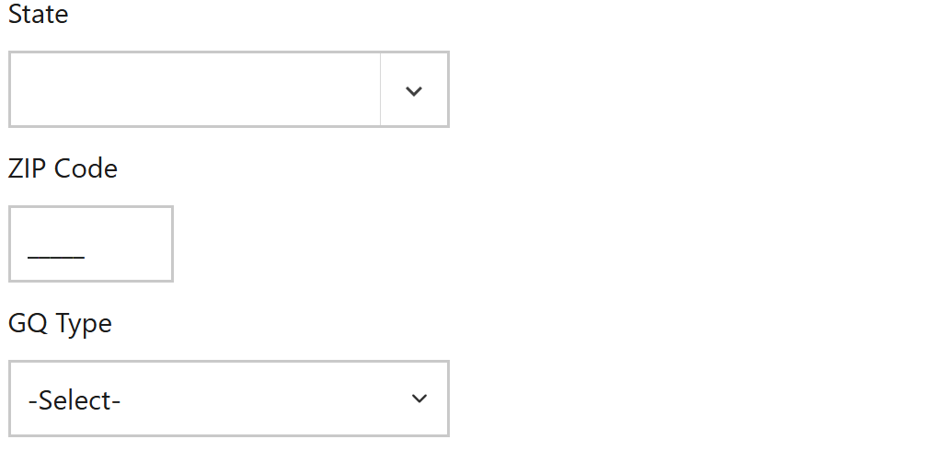
Screenshot 13 (1 of 2):
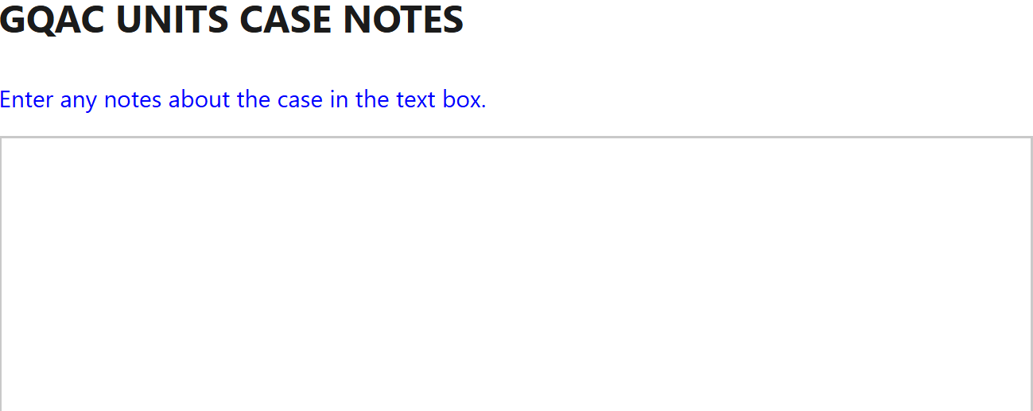
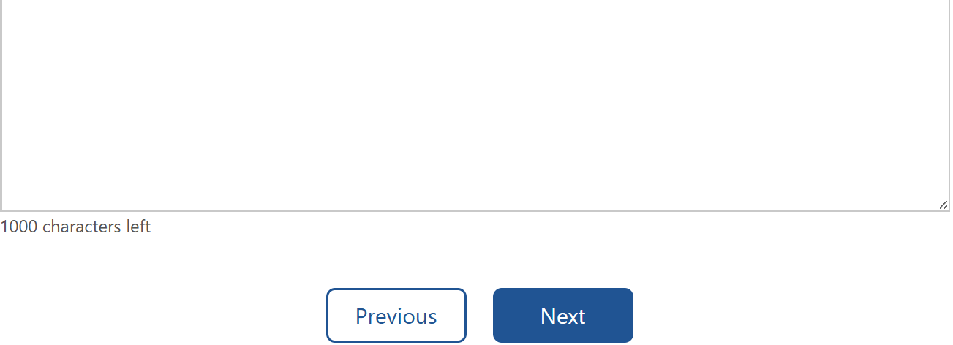

Note: The text box is split because these are two separate screenshots to capture the entire screen.
Screenshot 13 (2 of 2) – On GQ DETAILS, “I am not responsible for or do not manage this GQ” selected:
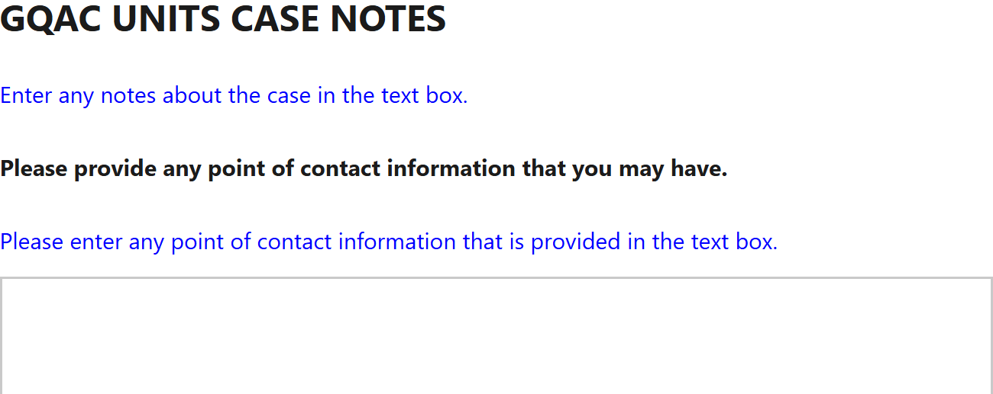
Screenshot 14:
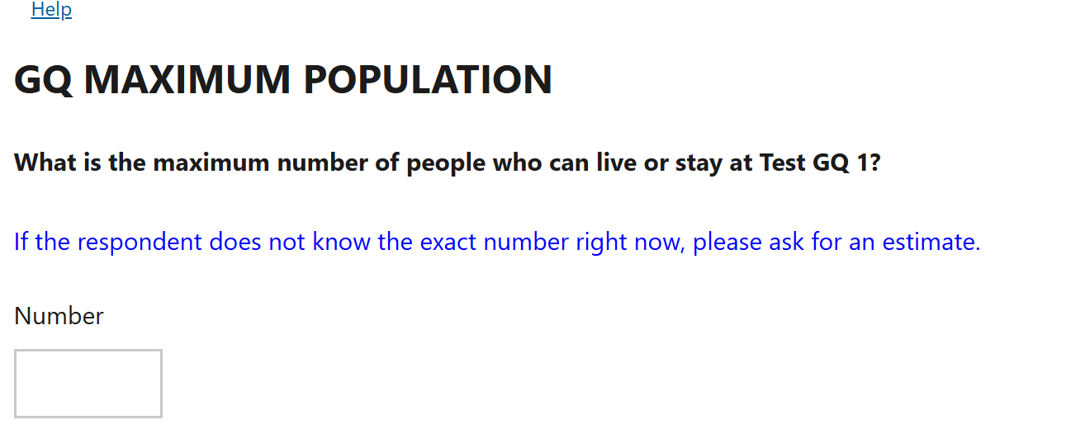


Screenshot 15:
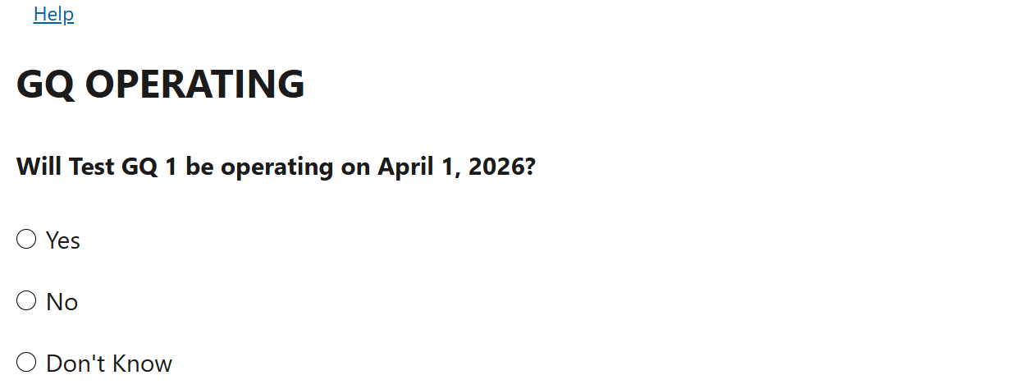

Screenshot 16 (1 of 3):
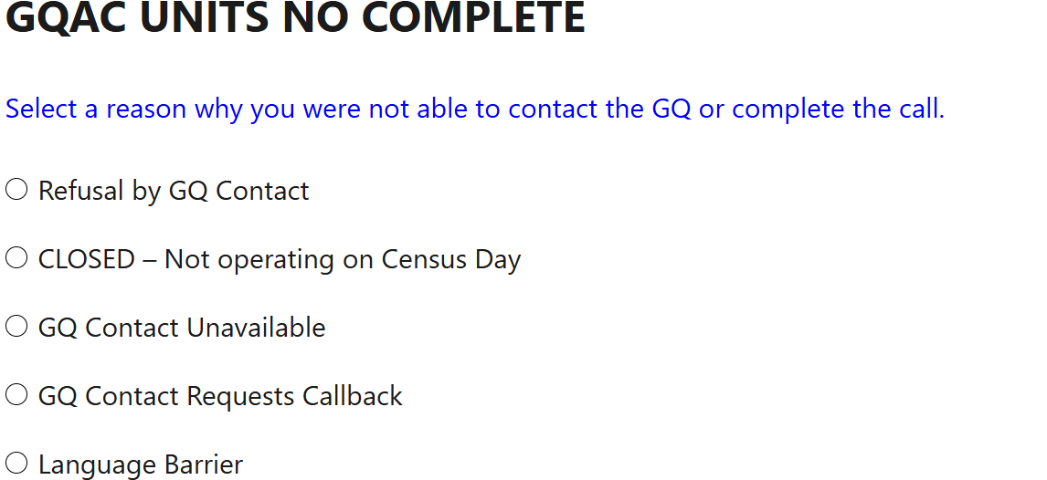
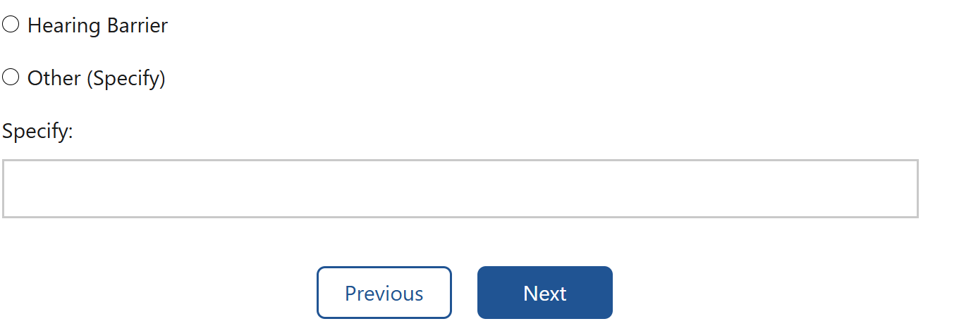
Screenshot 16 (2 of 3) – “Refusal by GQ Contact” selected:
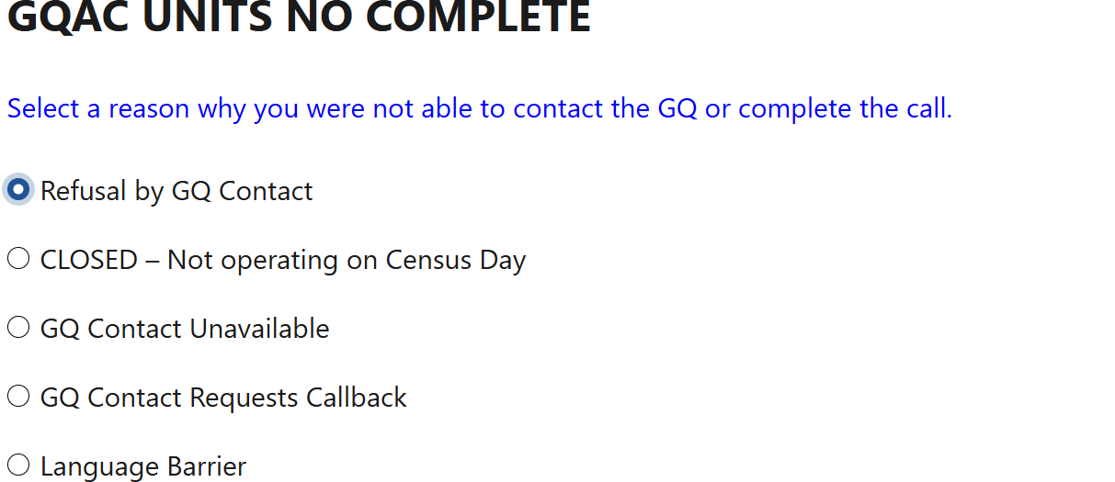
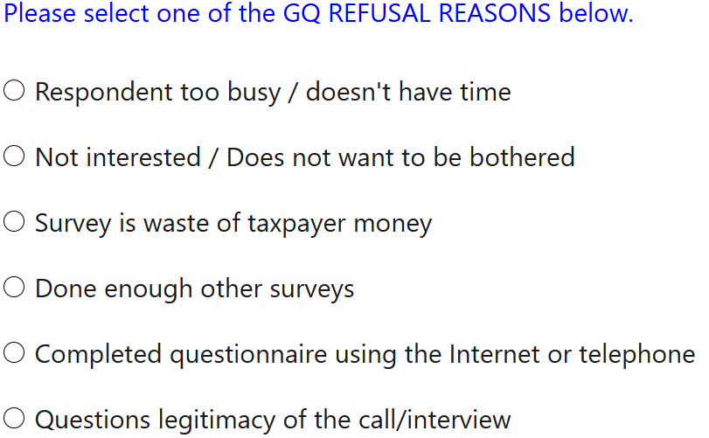
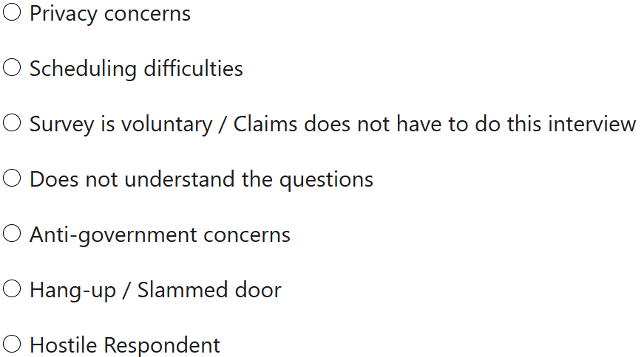
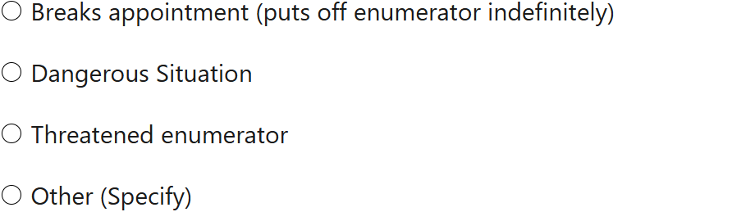
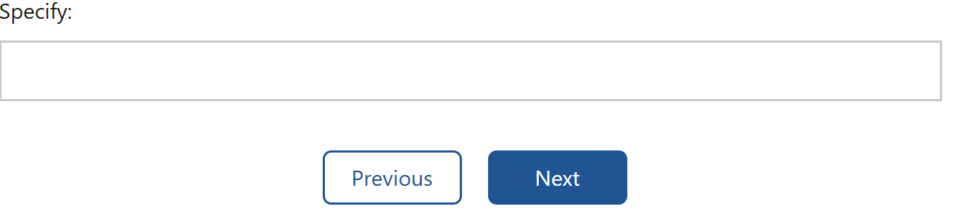

Screenshot 16 (3 of 3) – For the purpose of showing the wording below the text box regarding out-of-scope GQ Types in the 2026 Census Test, this group quarters was created as GQ Type Code 705 = Community Meal Kitchens under “Census Facility”; thus, this group quarters does not fall under “Test Facility” shown on Screenshot 10 – SELECT GQ, which includes GQ Type Code 802 = Residential Treatment Centers for Adults (Noncorrectional).:
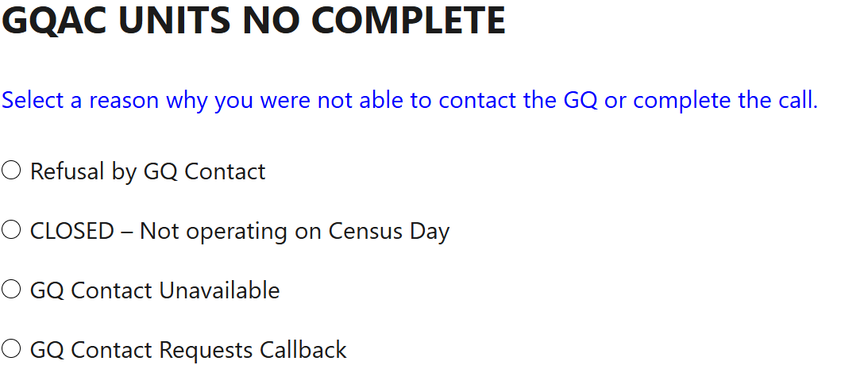
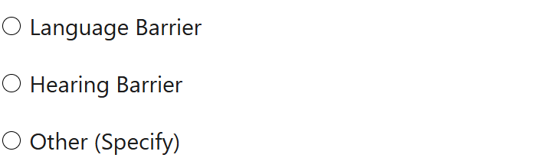
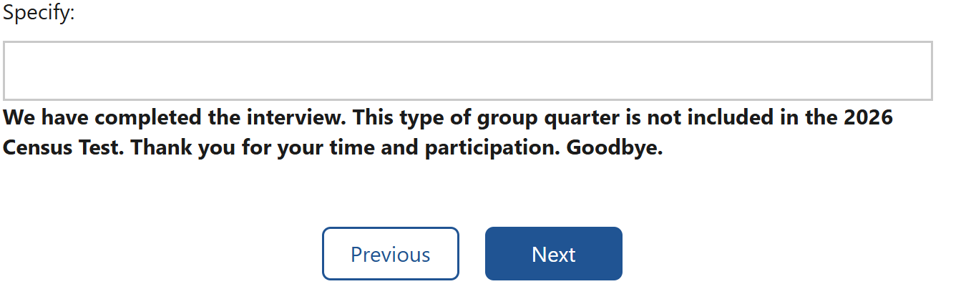

Screenshot 17:
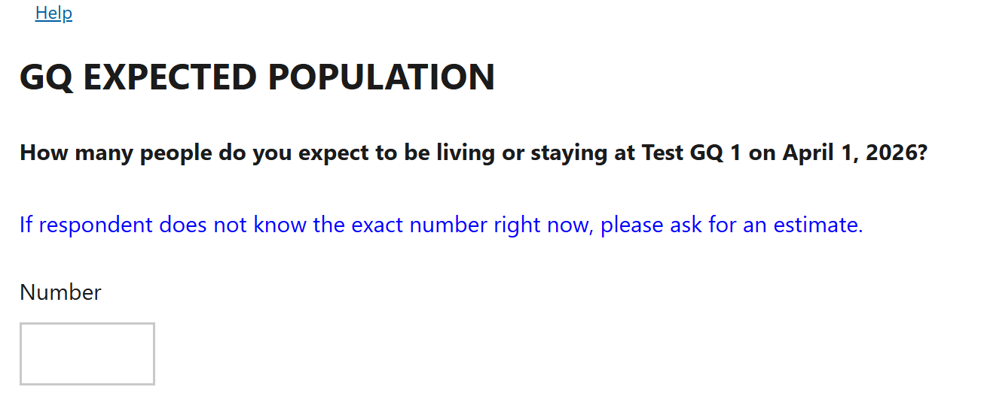

Screenshot 18:
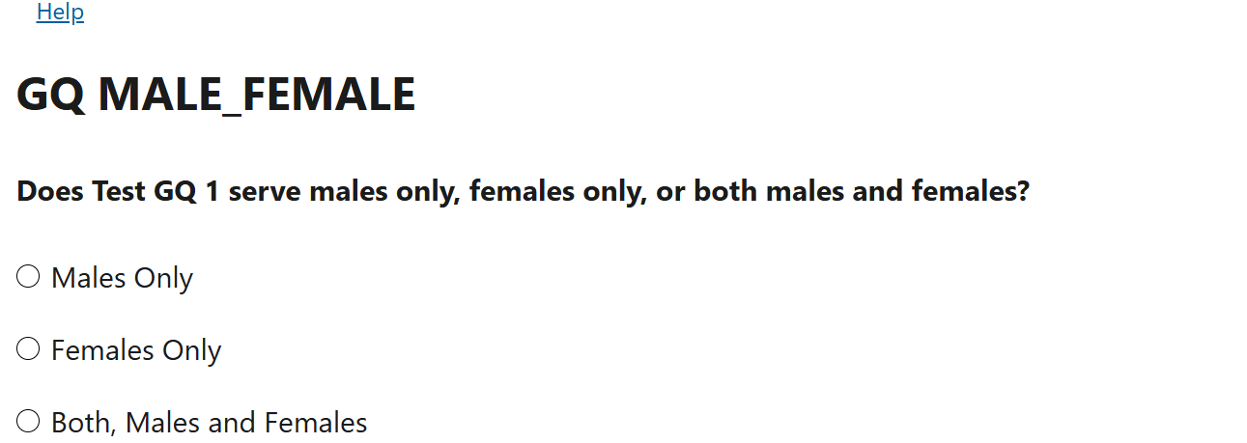

Screenshot 19 (1 of 3):
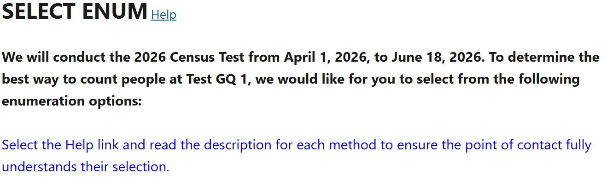
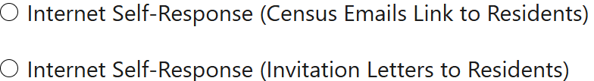


Note: The Help hyperlink is not positioned correctly. A defect has been logged to address this issue.
Screenshot 19 (2 of 3) – “Internet Self-Response (Census Emails Link to Residents)” selected:
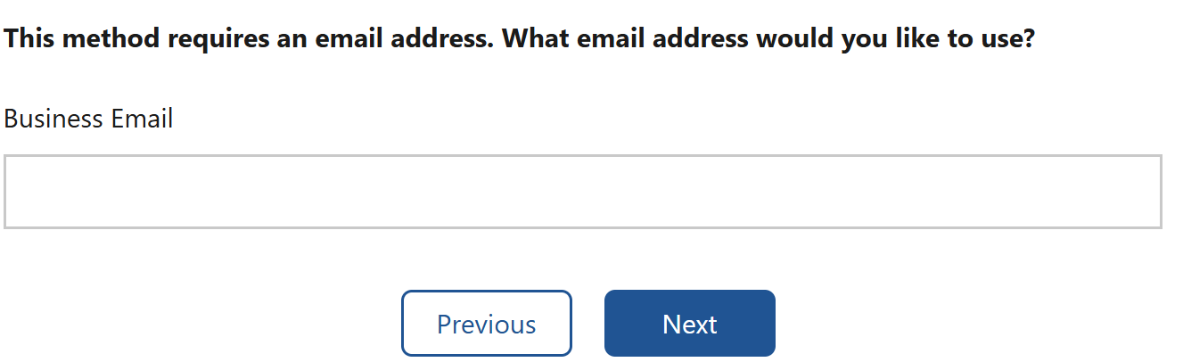
Screenshot 19 (3 of 3) – “Electronic Response Data Transfer (eResponse)” selected:
Screenshot 20:
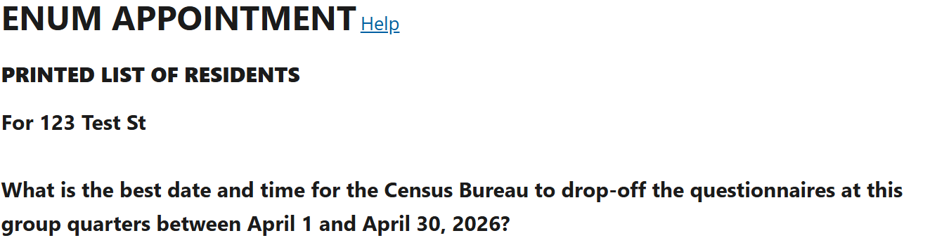
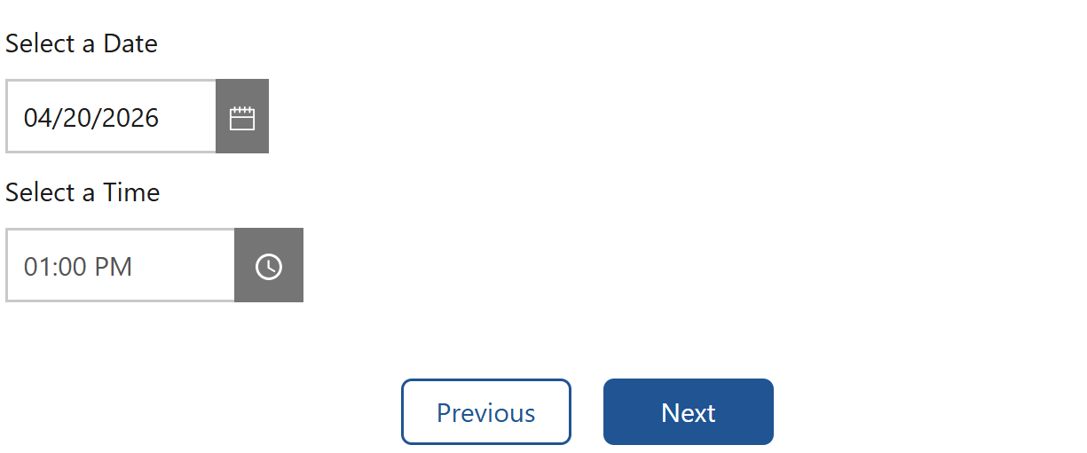

Note: The Help hyperlink is not positioned correctly. A defect has been logged to address this issue.
Screenshot 21 (1 of 2):
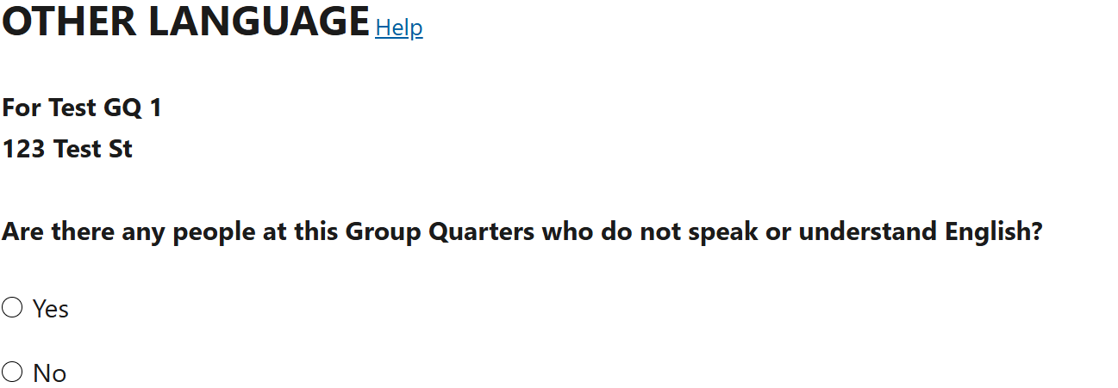
Note: The Help hyperlink is not positioned correctly. A defect has been logged to address this issue.

Screenshot 21 (2 of 2) – “Yes” selected:
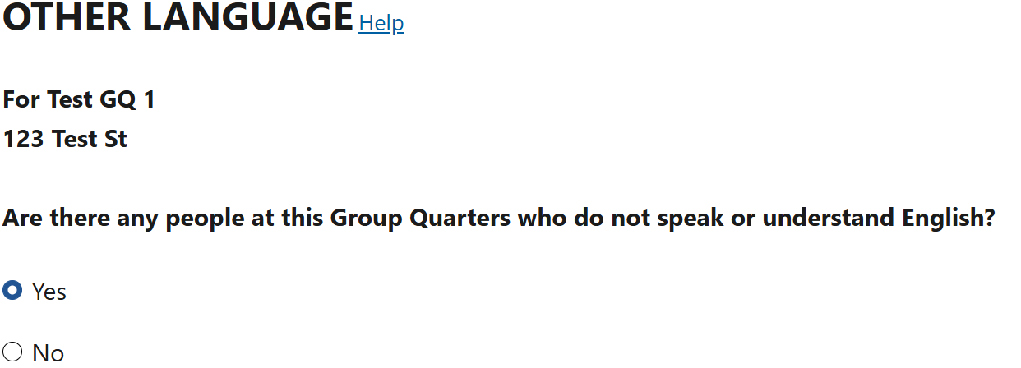

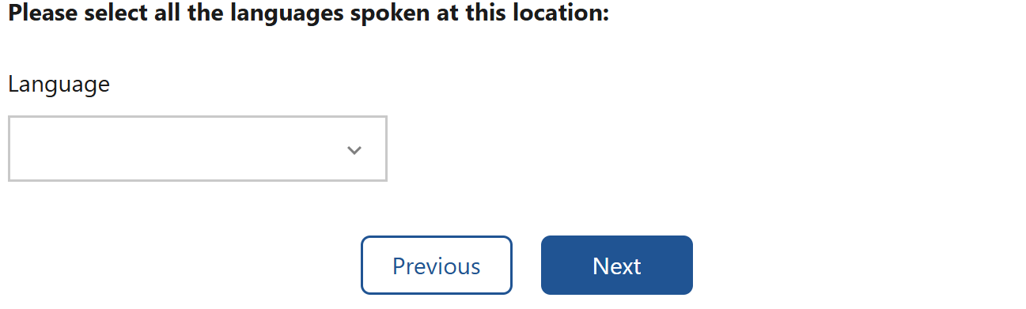 See next page for drop down list of languages
List of Languages
English | Igbo
Spanish | Ilocano
Mandarin | Indonesian
Cantonese | Italian
Vietnamese | Khmer
Korean | Lao
Russian | Lithuanian
Arabic | Malayalam
Tagalog | Marathi
Polish | Navajo
French | Nepali
Haitian Creole | Punjabi
Portuguese | Romanian
Japanese | Serbian
Albanian | Sinhala
American Sign Language | Slovak
Amharic | Somali
Armenian | Swahili
Bengali | Tamil
Bosnian | Telugu
Bulgarian | Thai
Burmese | Tigrinya
Croatian | Turkish
Czech | Twi/Akan
Dutch | Ukrainian
Farsi | Urdu
German | Yiddish
Greek | Yoruba
Gujarati | Other
Hebrew
Hindi
Hmong
Hungarian

Screenshot 22:
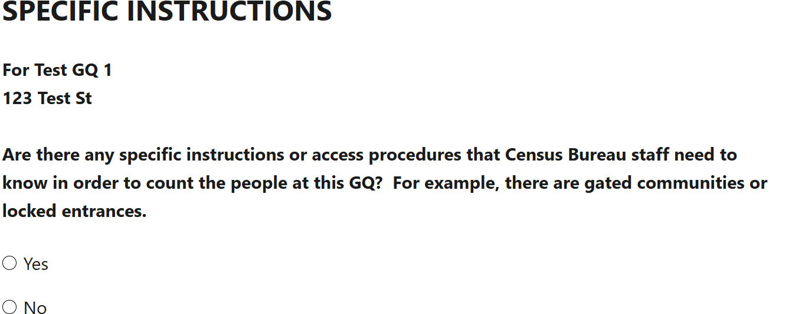

Screenshot 23:
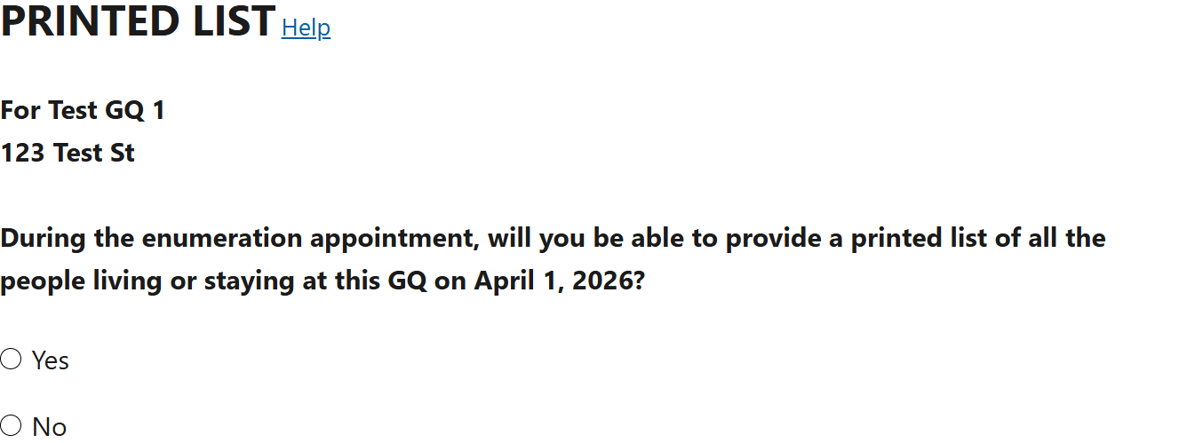
Note: The Help hyperlink is not positioned correctly. A defect has been logged to address this issue.

Screenshot 24:
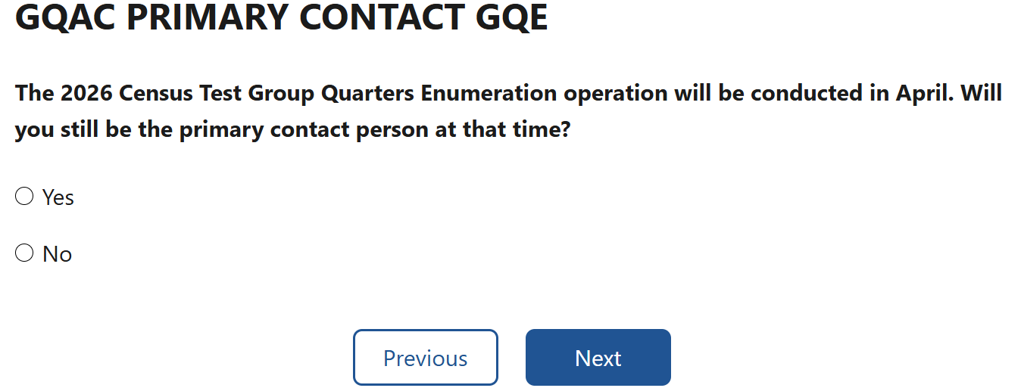

Screenshot 25:
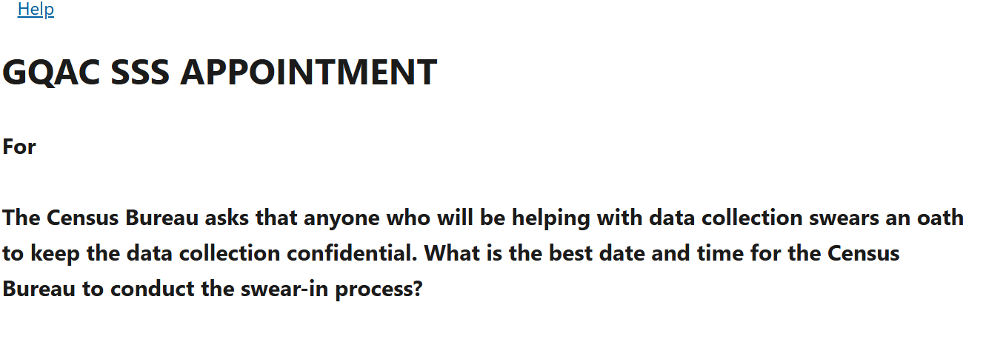
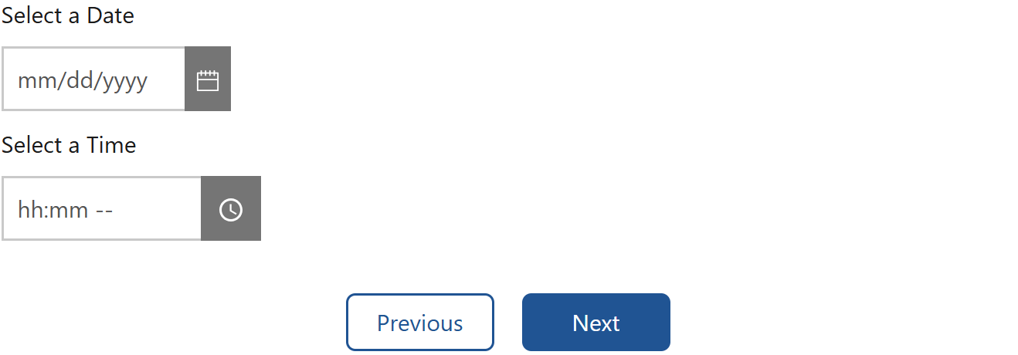

Note: The GQ address is not displaying on this screen, however, it will be shown in the final screenshot.
Screenshot 26:
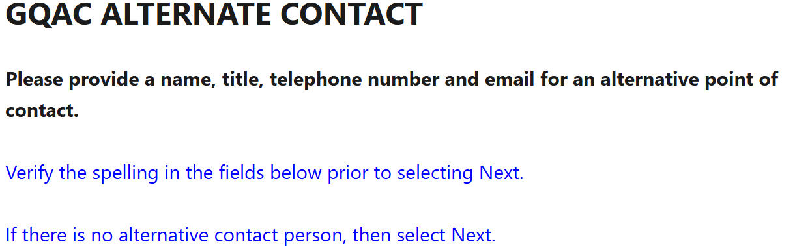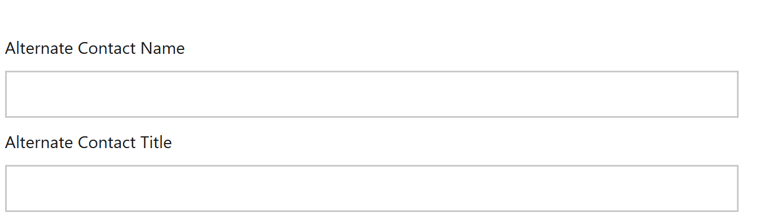

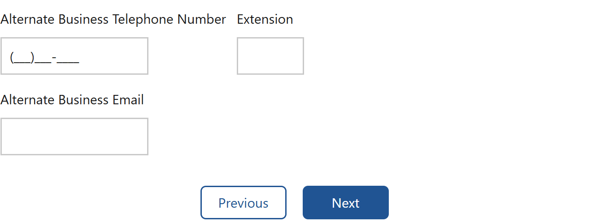
Screenshot 27:
Note: This screen is under development and will be shown in the final screenshot.

Screenshot 28:
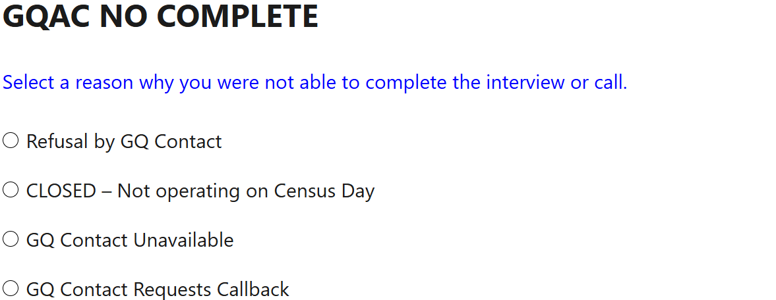
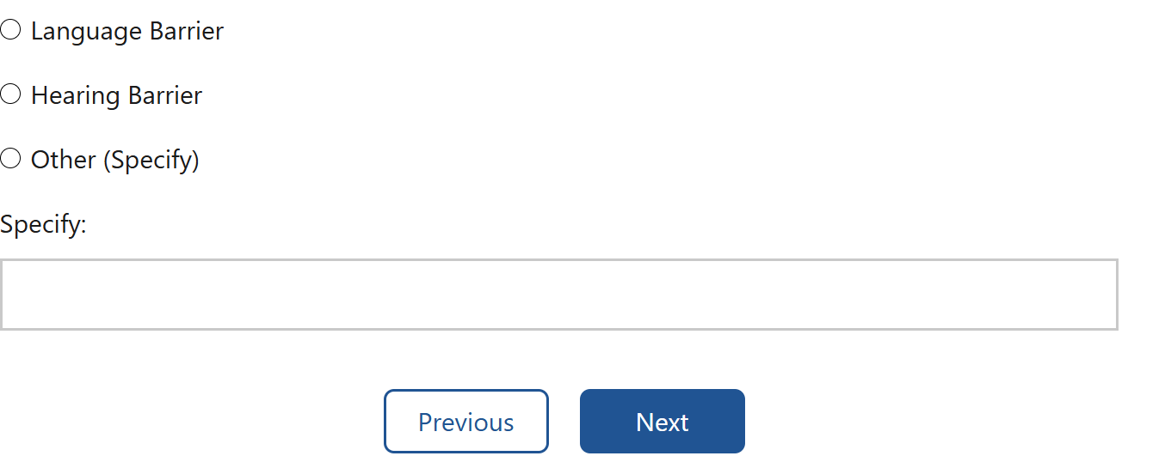
Screenshot 29:
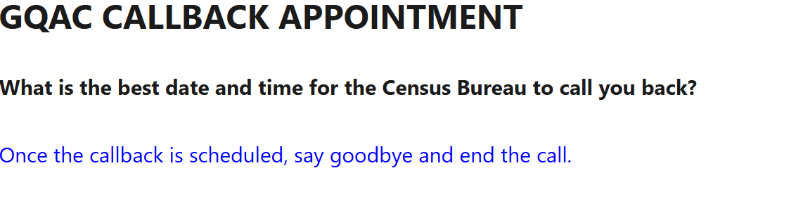
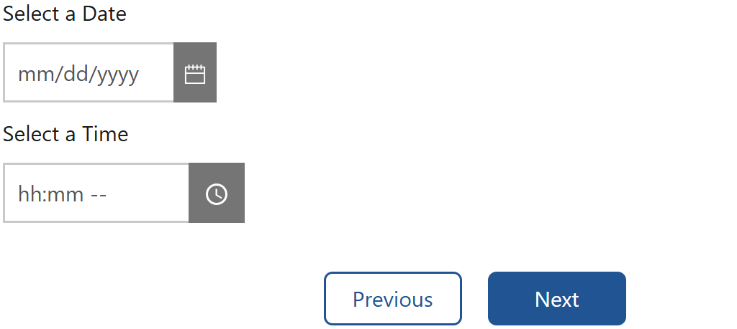

Screenshot 30:
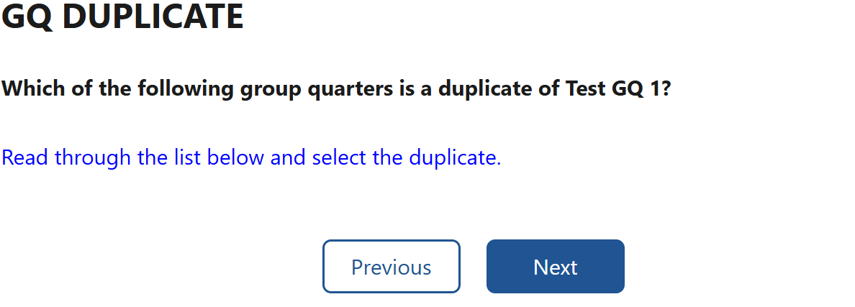
Note: This screen is under development, as a dropdown list of group quarters needs to be added, so it will be shown the final screenshot.

Screenshot 30:
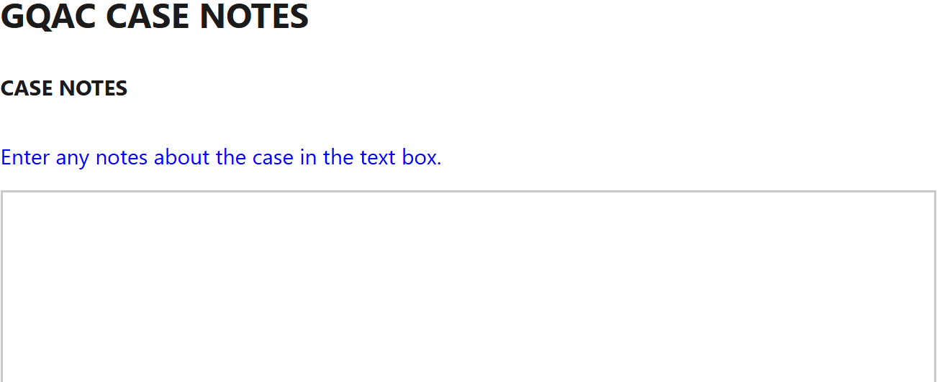
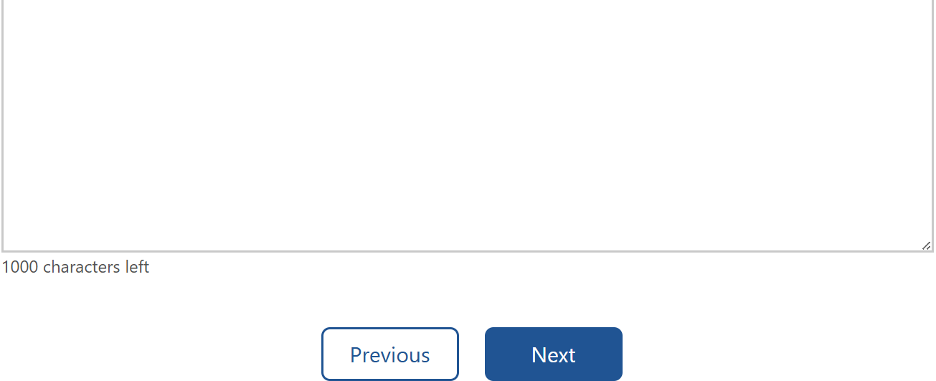

Note: The text box is split because these are two separate screenshots to capture the entire screen.
Screenshot 31:

