**Citizen Science Prototype for Baseline Video Annotation**

**Instructions:**

1. OER will solicit volunteers to test the Citizen Science prototype website
   1. This will be accomplished by having a link for volunteers found, http://oceanexplorer.noaa.gov/ , with a brief description of the project.
   2. Teachers often contact OER to engage their classrooms in Ocean Exploration. These classrooms may participate in testing the prototype site.
2. After a user clicks on the link for the prototype website then they will be asked to voluntarily create a username and password.
   1. This username will be to keep track of virtual points that users will earn for participation.
   2. Virtual points will have no monetary value.
3. Once an account is created, users will view videos ranging in length from 30 sec to 5 minute of ocean exploration.
4. While watching these videos users may press buttons next to the screen creating ‘digital bookmarks’ for what is being viewed. Conceptual design below.

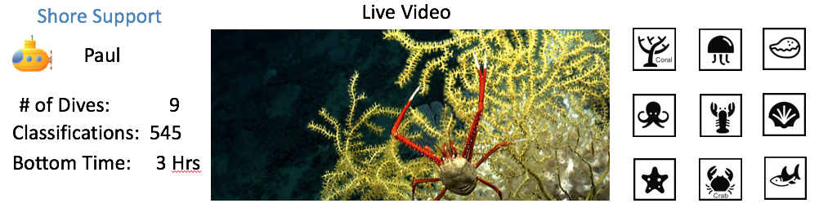

These time stamped annotations or ‘digital bookmarks’ will be easily accessible to Scientists. Where, for example, a coral specialist will be able to view when Citizen Scientists annotated the video containing corals.

1. After a short video (30 secs to 5 min) users will be given the opportunity to watch another short video or log off.

Public reporting burden for this collection of information is estimated to average 10 minutes per response, including the time for reviewing instructions, searching existing data sources, gathering and maintaining the data needed, and completing and reviewing the collection of information. Send comments regarding this burden estimate or any other suggestions for reducing this burden to NOAA’s Ocean Exploration and Research, 1315 East West Highway, Silver Spring, MD, 20910.

Notwithstanding any other provisions of the law, no person is required to respond to, nor shall any person be subjected to a penalty for failure to comply with, a collection of information subject to the requirements of the Paperwork Reduction Act, unless that collection of information displays a currently valid OMB Control Number.