**Snapshots of the Cyber Supply Chain Survey Tool**

**Below is the Cyber supply chain survey tool front page where general information is provided.**

**Note that we are still in phase one where the site is only available to federal employees only.**

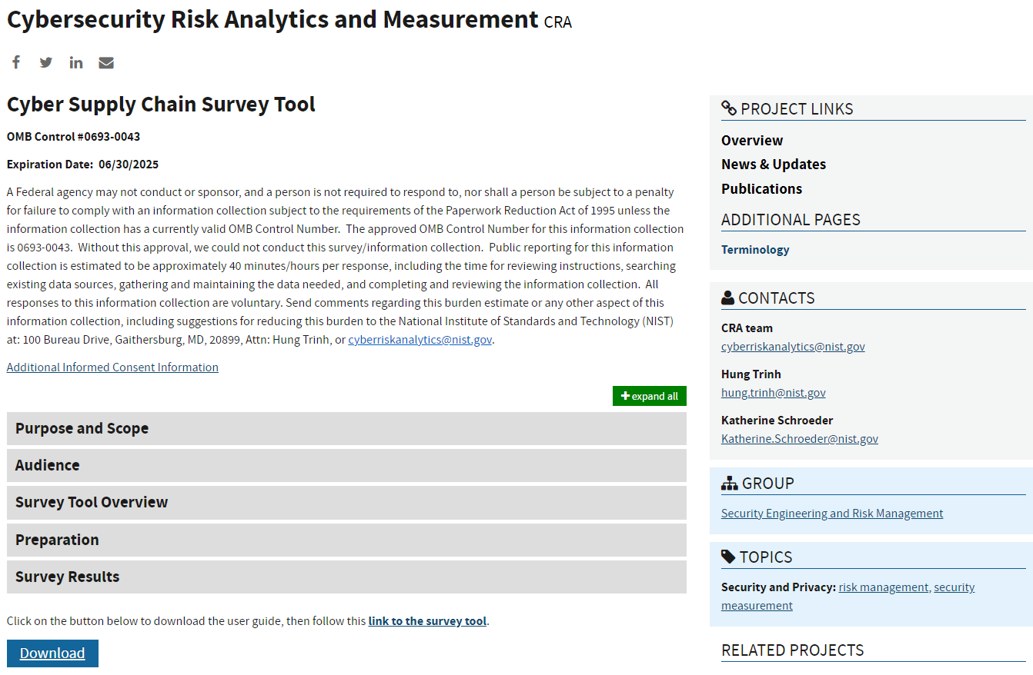

The expandable sections can be viewed through this link

<https://cms.csrc.nist.gov/preview/projects/cybersecurity-risk-analytics/cscs-tool>

**The link from the front page has a link to the** [**Cyber supply chain survey page**](https://csrc.test-e1a.nist.gov/Projects/cybersecurity-risk-analytics/cyber-supply-chain-survey?_gl=1*vdh91f*_ga*NjQwMzc1MTU4LjE3MTIzMjEyODE.*_ga_TSQ0PLGJZP*MTcxMjMyMTI4MC4xLjEuMTcxMjMyMTMzMi4wLjAuMA..) **where the survey questionnaire is located. They are divided into six expandable sections.**

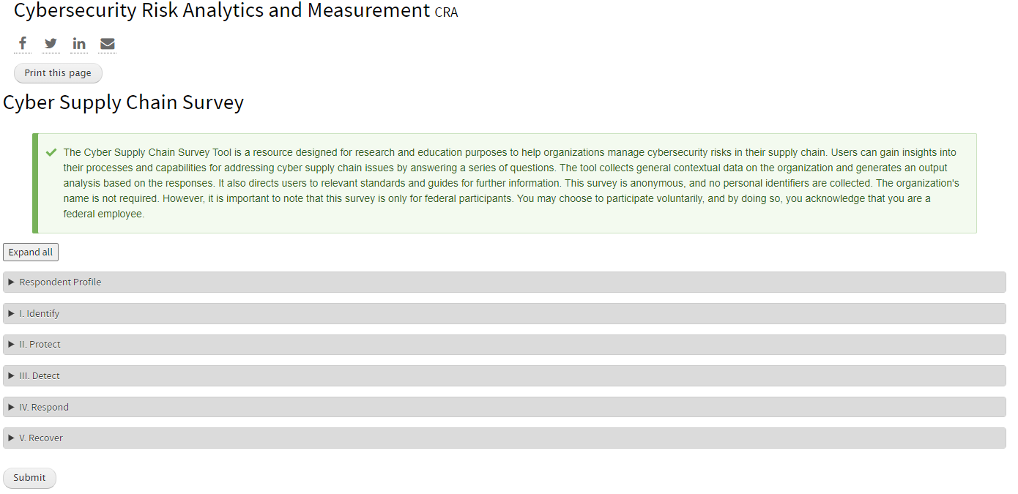

**Expanded Respondent profile section**

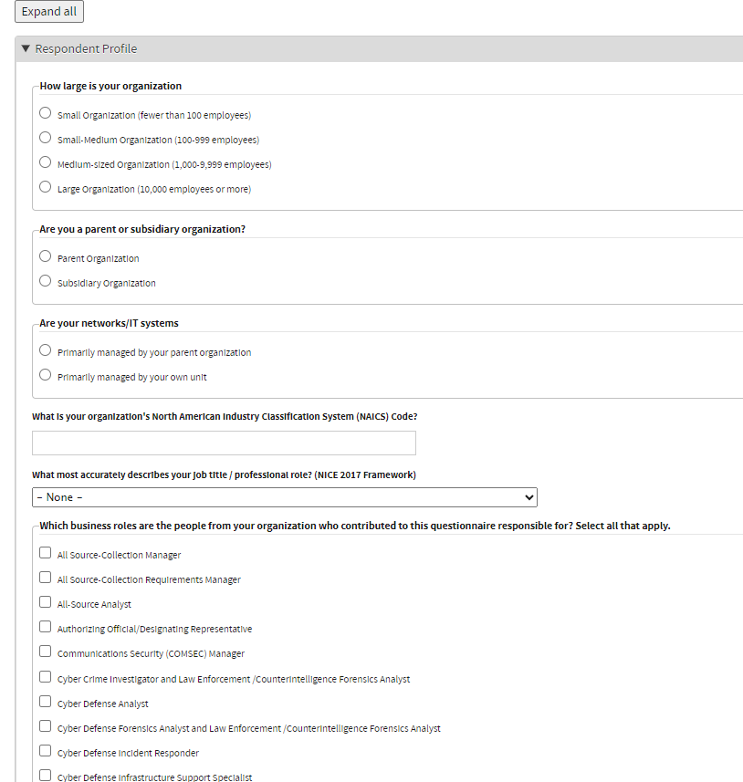

**Expanded Identity section**

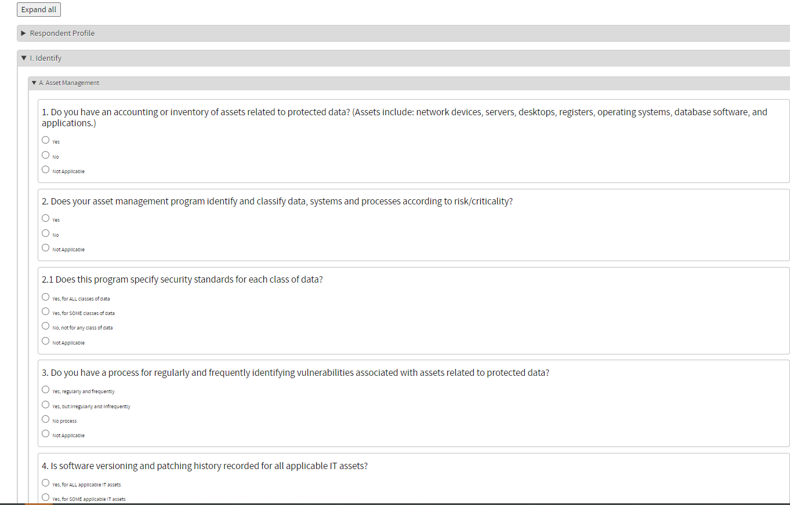

**Sample analysis after the respondent submit the data.**

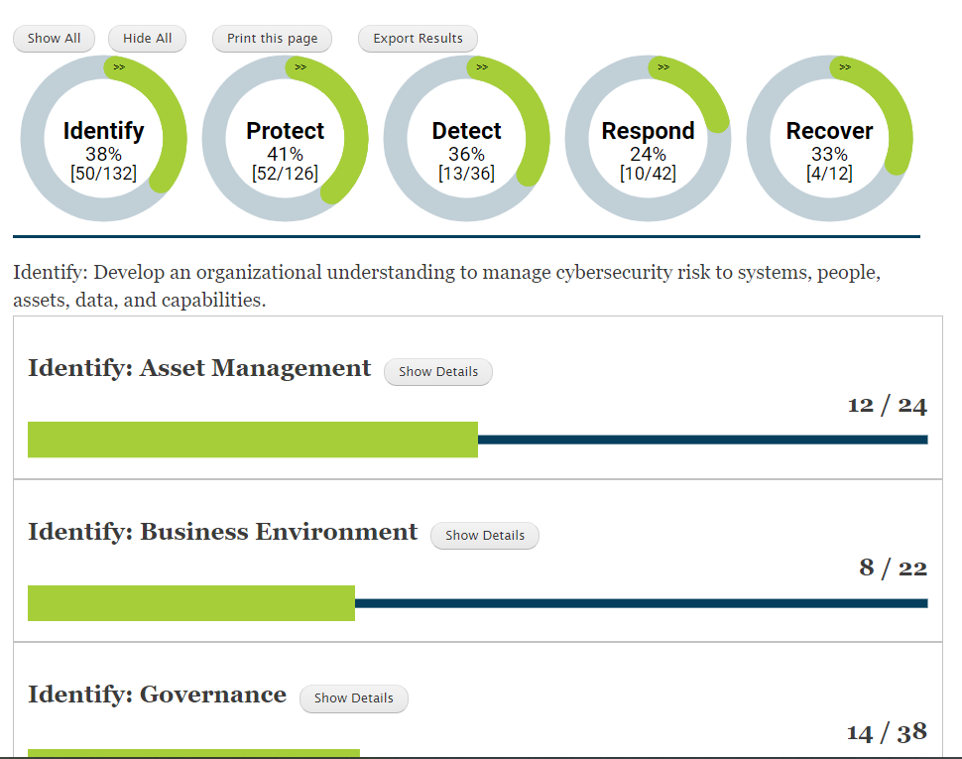

Sample expanded sub-section under the Identity where links are provided to additional resources and references.

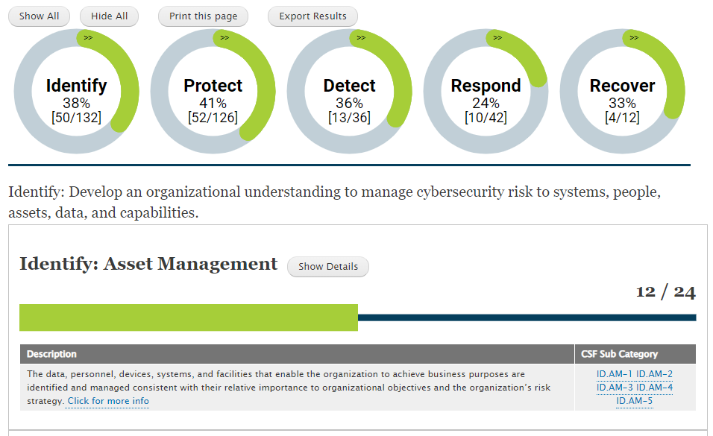

**The links from the assessment output directs the users to another tool maintained by ITL where resource mapping is continuously updated to all relevant guidance and standards.**

