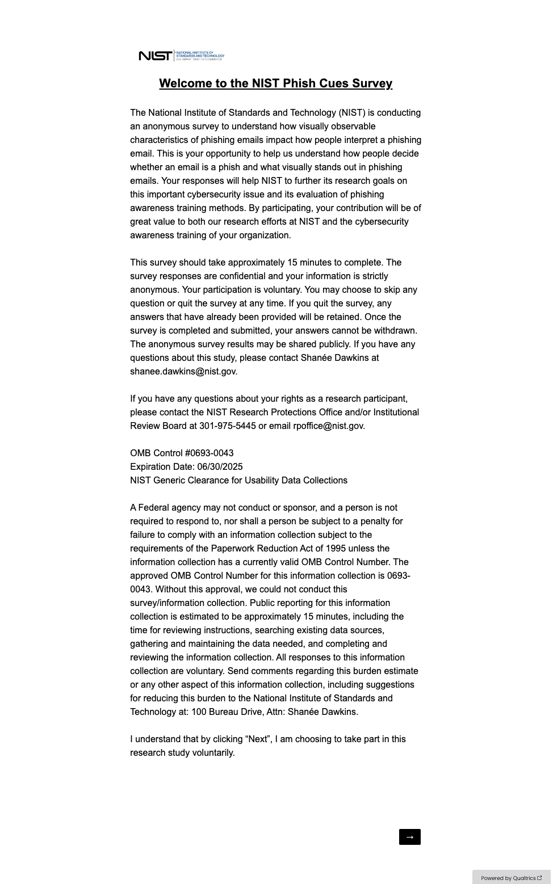
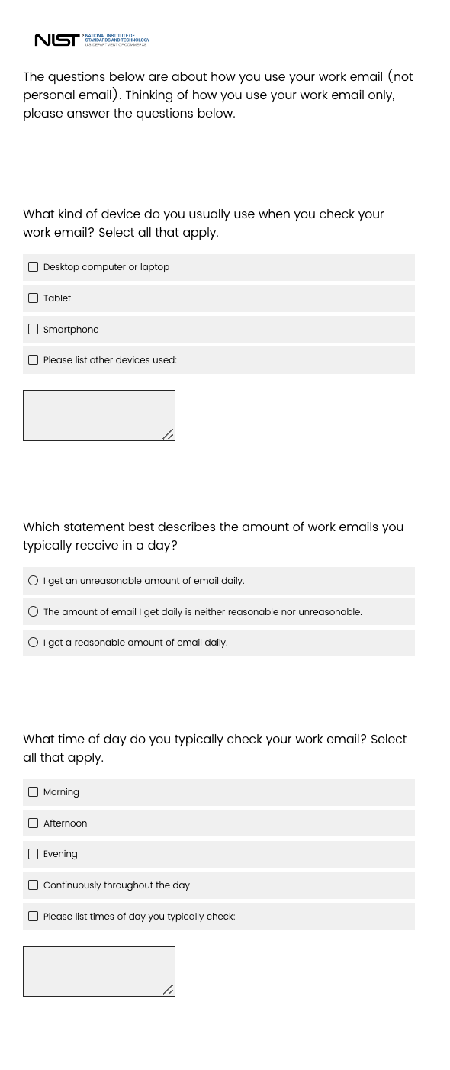
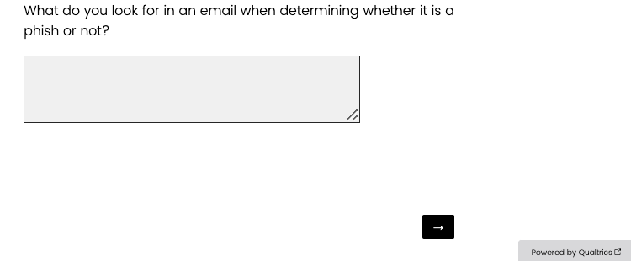
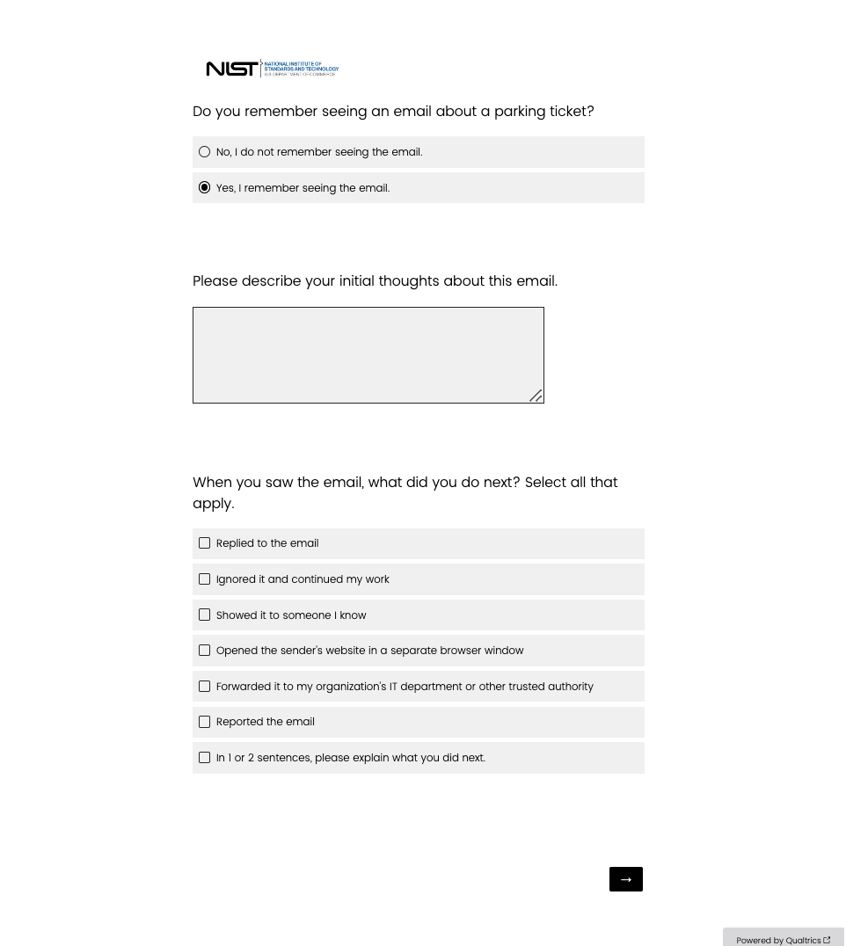
These questions are conditional – whether participants are asked or not depends on the participant’s responses to earlier questions.
If participants select “Yes, I remember seeing the email” then they are shown these questions. If they do not select this option, they do not see these questions.
The wording of this question (“parking ticket”) is conditional. The subject of the email depends on the email template the participant receives.

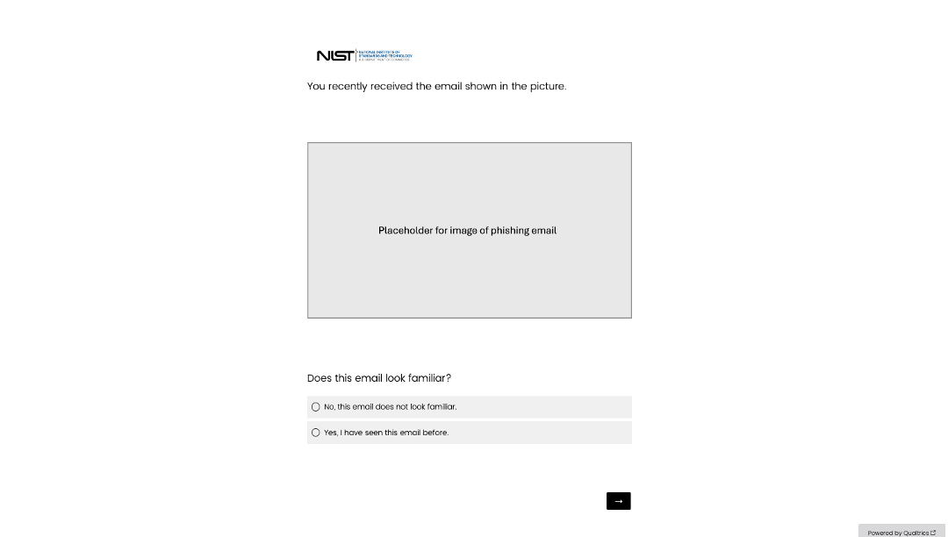
This page is conditional – whether participants are asked this question or not depends on the participant’s responses to earlier questions. If participants select “No, I do not remember seeing the email” then they are shown this page. If they do not select this option, they do not see this page.
Placeholder images throughout this file are dependent on the email template the participant receives.

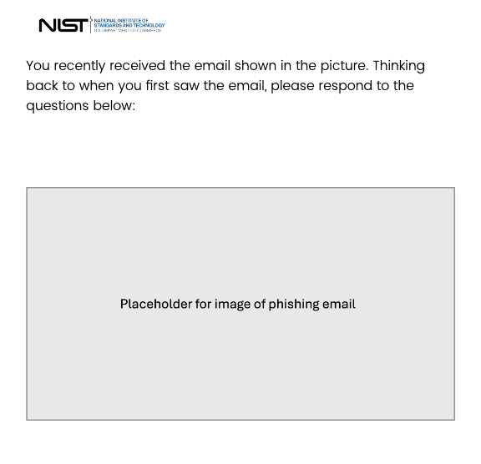
Based on responses, participants can see the following questions
This page has conditional questions. The bracket shows the possible questions that are shown based on responses to questions on this page.
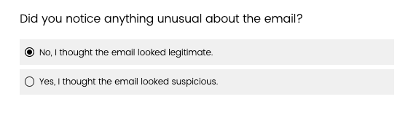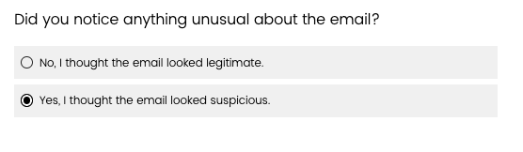

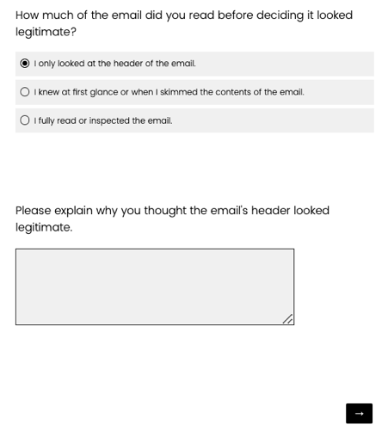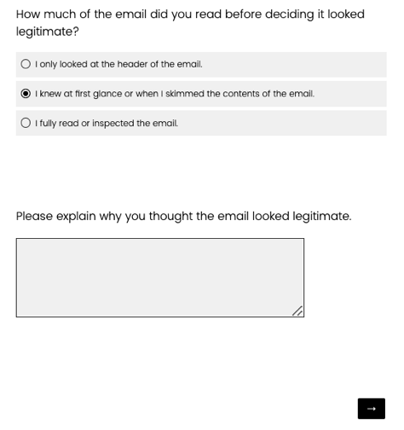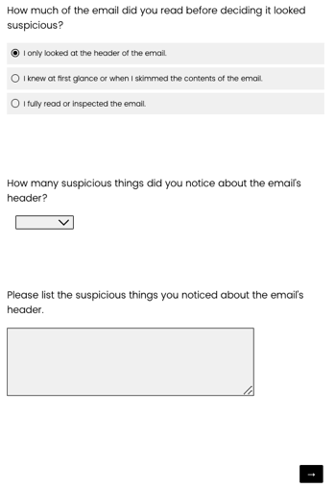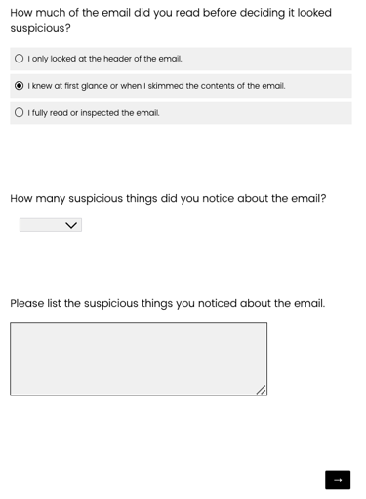
These two questions are also shown if they select “I fully read or inspected the email”
This question is also shown if they select “I fully read or inspected the email”

Page 5 OR Page 6 is asked to the participant, depending on their previous survey responses. All questions on pages 5 and 6 are conditional unless otherwise noted.

For pages 5 and 6, the grid questions below the placeholder image are conditional – whether they are asked or not depends on the email template the participant receives. Only one grid question will be asked per survey.
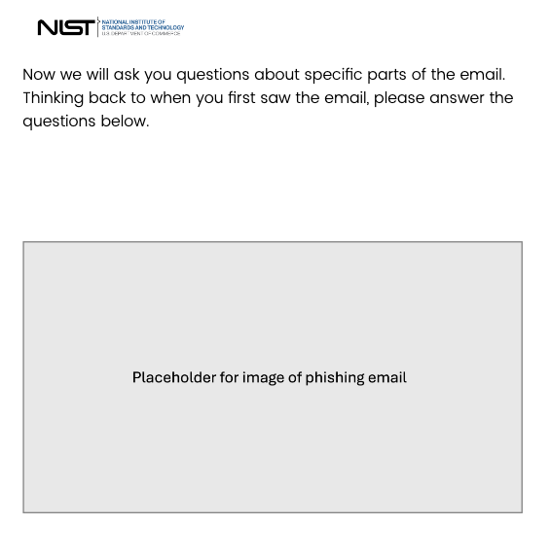

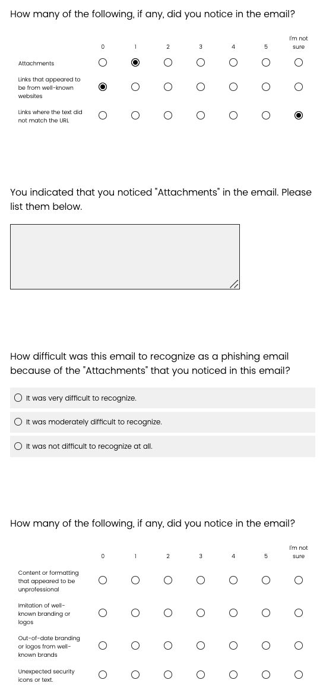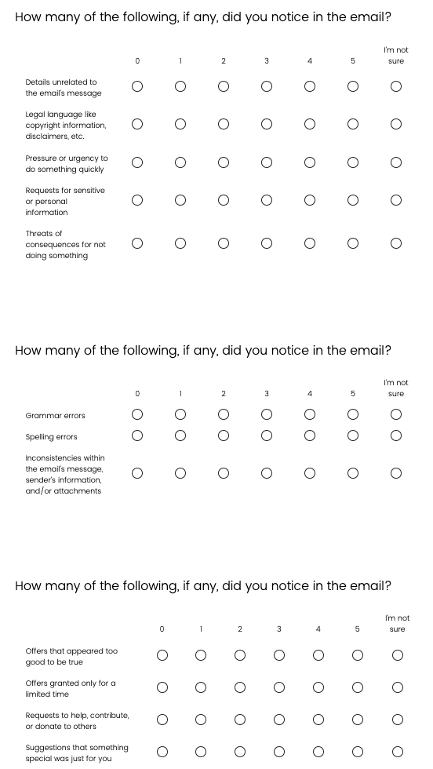
Based on responses to the grid questions, participants can see the following questions.

These two questions appear for each grid row when participants select “1”, “2”, “3”, “4”, or “5”.

For pages 5 and 6, the grid questions are also conditional – whether they are asked or not depends on the email template the participant receives.
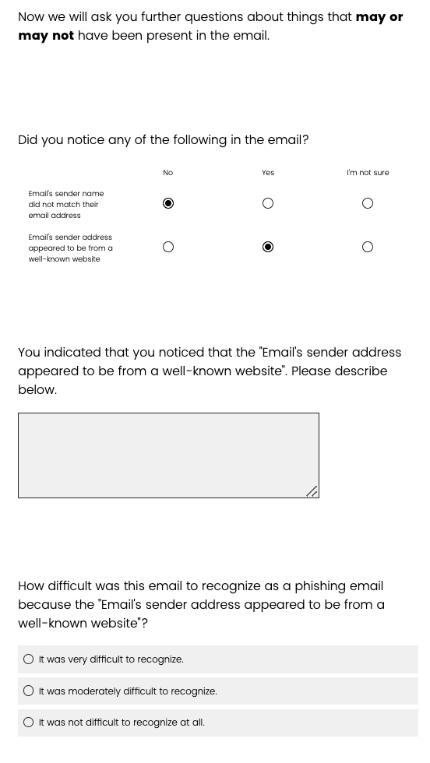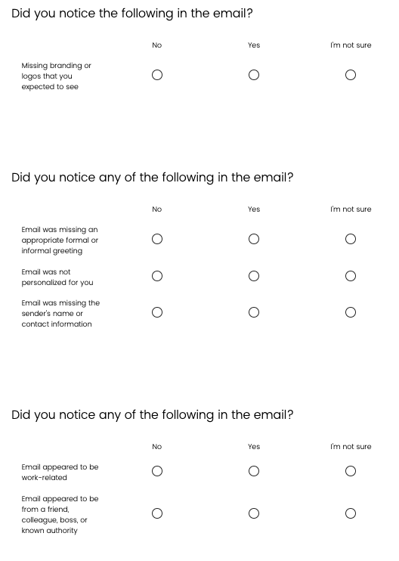
Based on responses to the grid questions, participants can see the following questions.

These two questions appear for each grid row when participants select “Yes”.
For pages 5, these questions are asked to all participants and are not conditional.

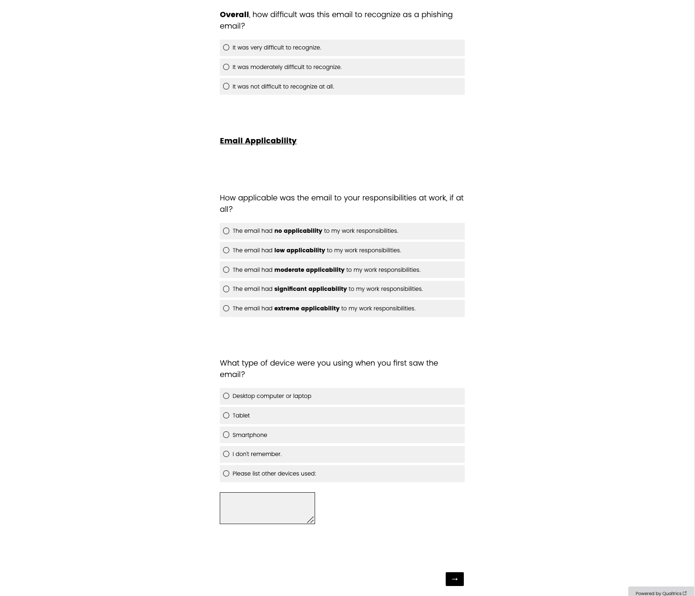

Page 5 OR Page 6 is asked to the participant, depending on their previous survey responses.

The skip logic and branching are identical to page 5. The only difference between page 5 and page 6 is the wording of certain questions.
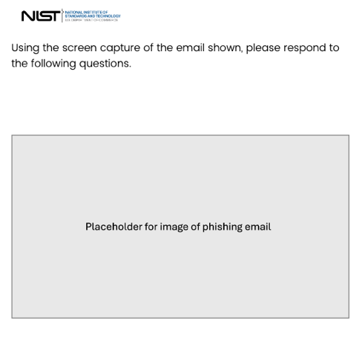
Based on responses to the grid questions, participants can see the following questions.

These three questions appear for each grid row when participants select
“1”, “2”, “3”, “4”, or “5”.

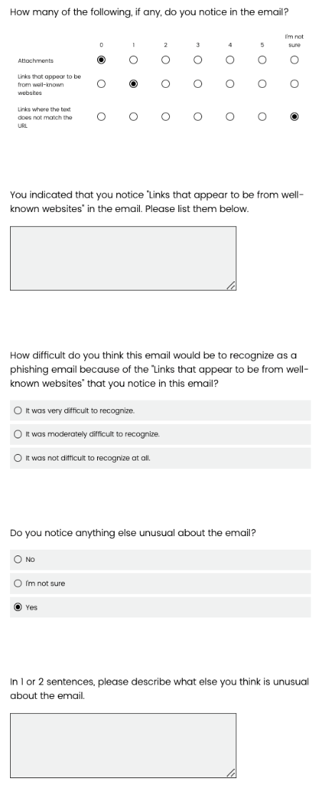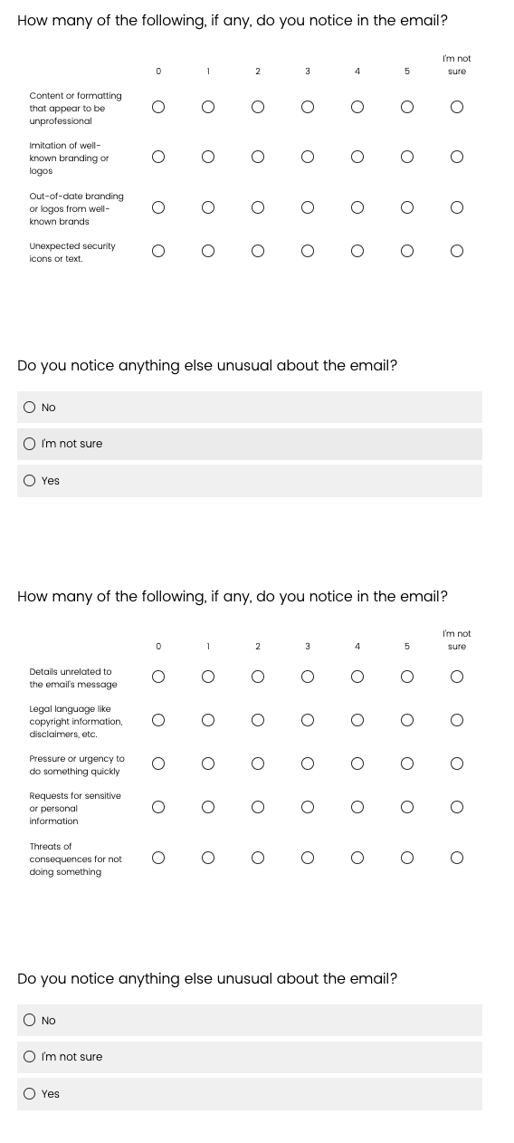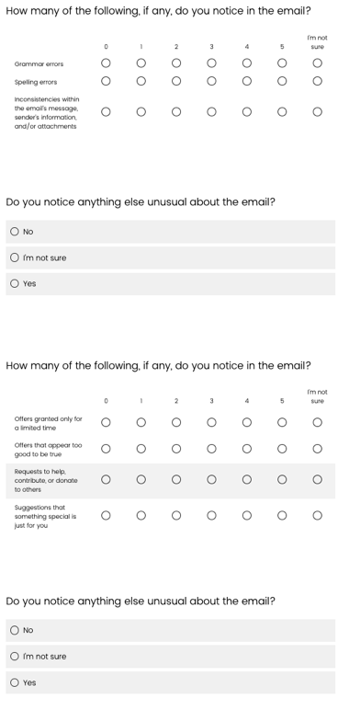
Based on the response to the previous question, participants can see the following question.

This question appears when participants select “Yes”.

For pages 5 and 6, the grid questions are also conditional – whether they are asked or not depends on the email template the participant receives.

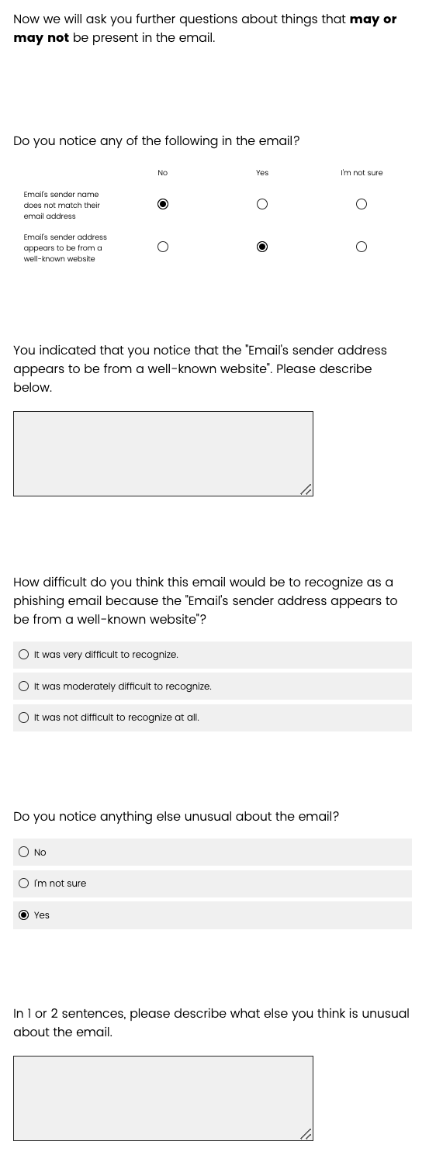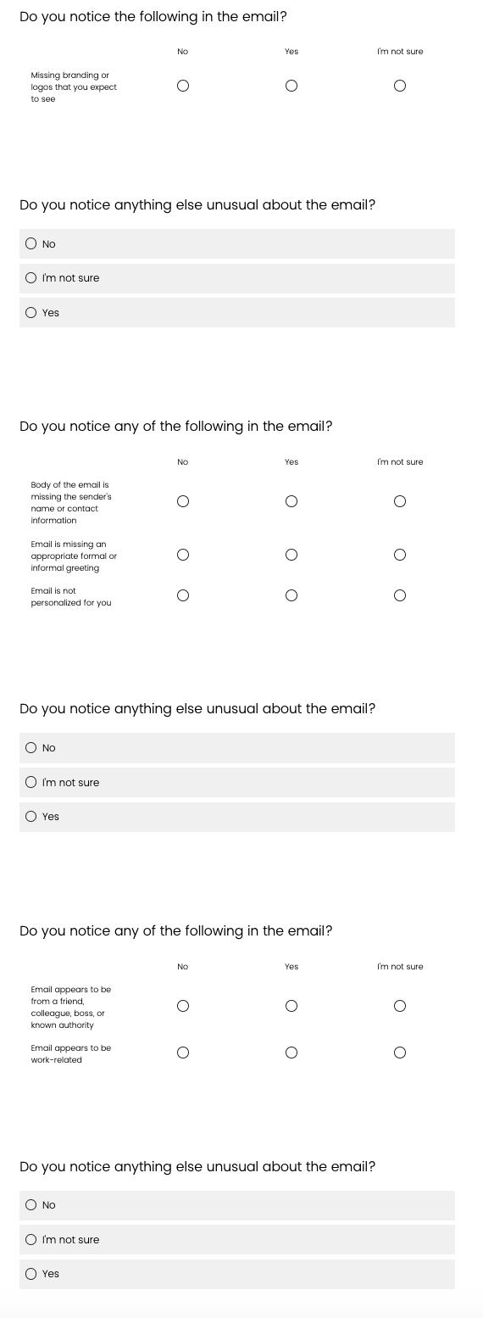
Based on the response to the previous question, participants can see the following question.

This question appears when participants select “Yes”.
Based on responses to the grid questions, participants can see the following questions.

These three questions appear for each grid row when participants select “Yes”.

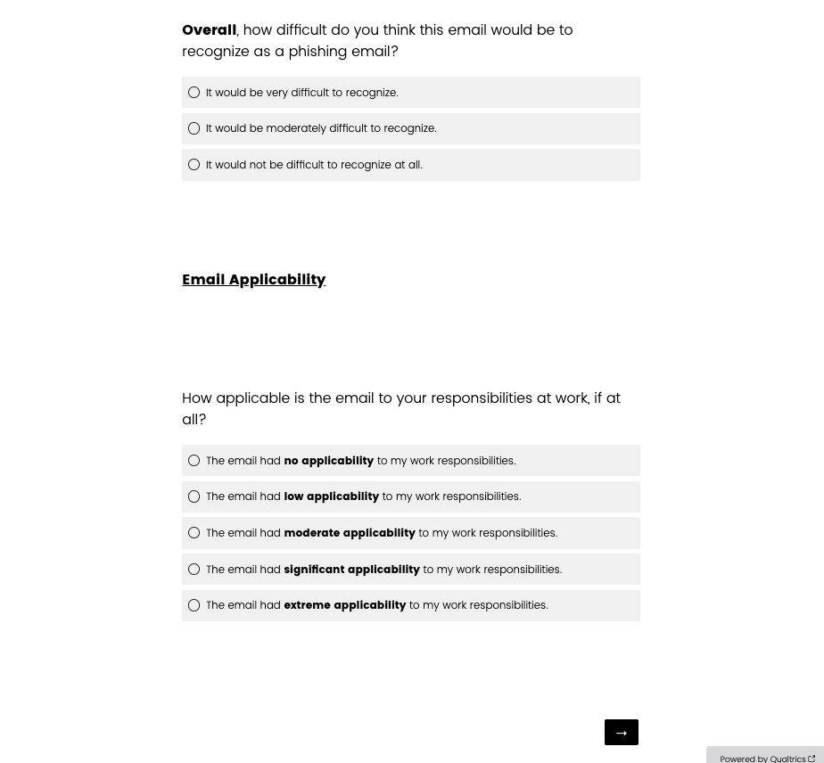
For pages 6, these questions are asked to all participants and are not conditional.

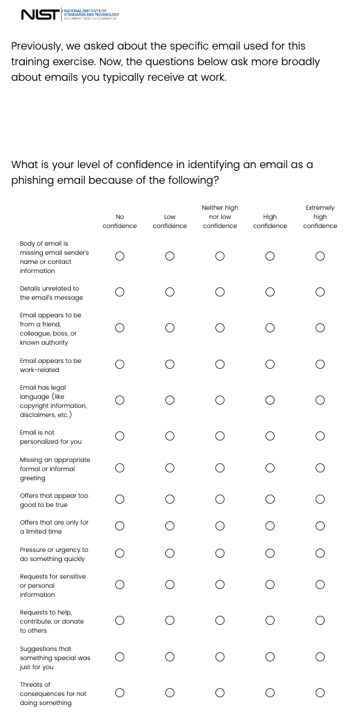
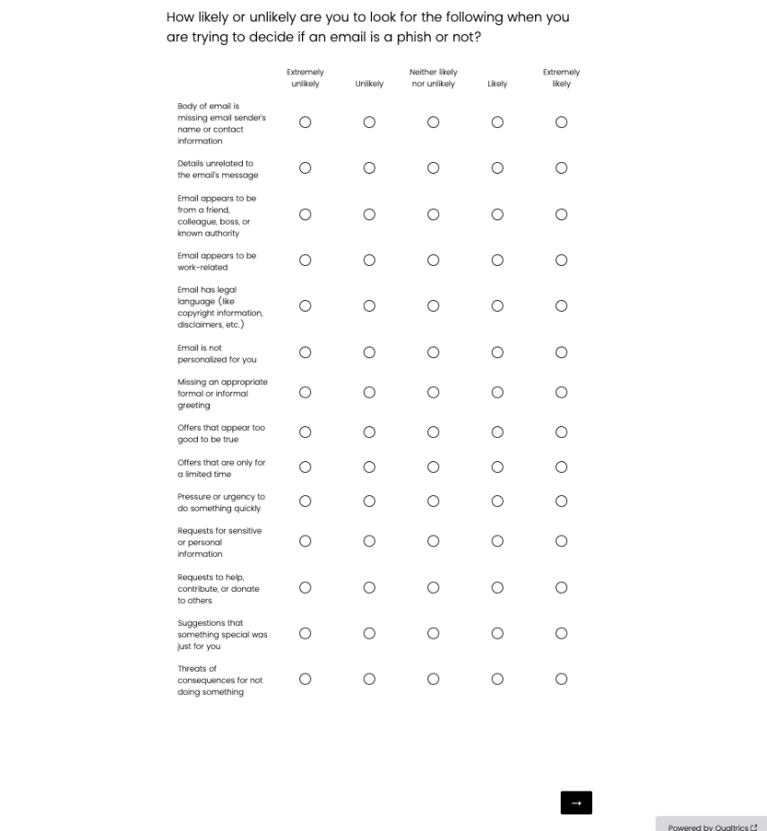

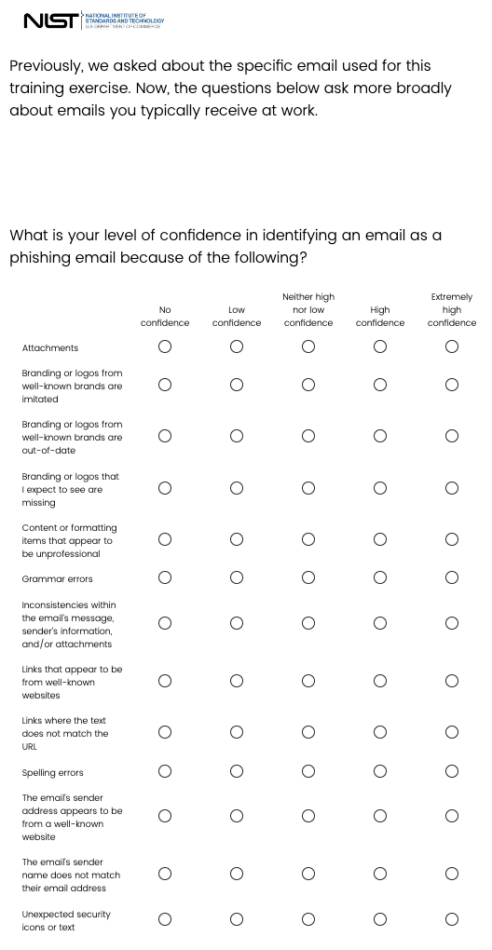
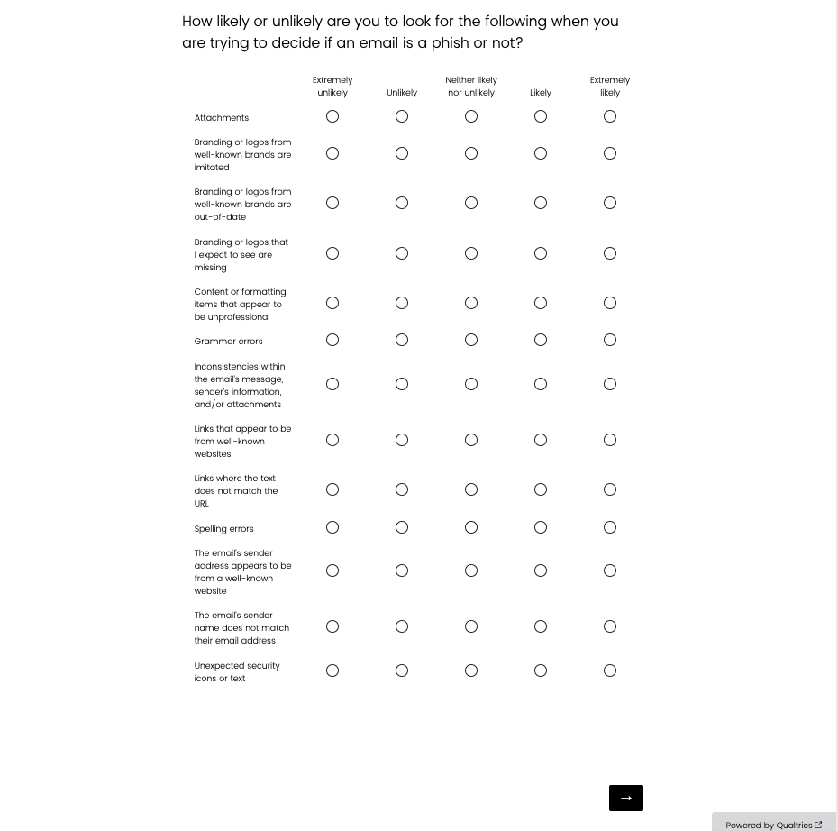
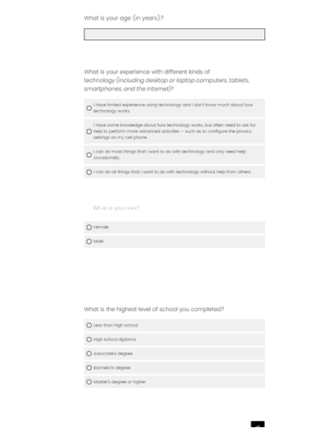
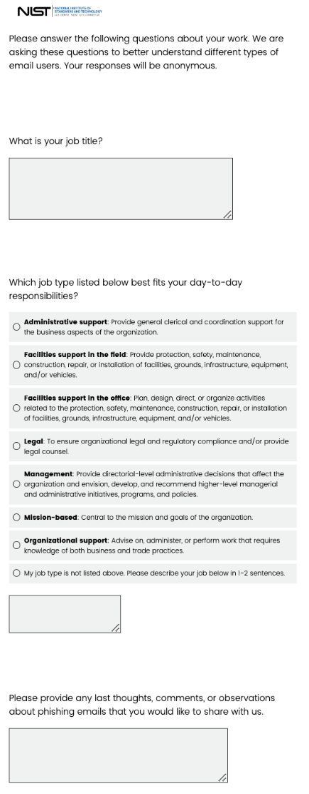
When a participant hovers over a response option, examples of the job type will be displayed:
- Administrative support-For example, timecard tracking, travel and expense report preparation, or meeting planning.
- Facilities support in the field-For example, security guard, janitorial staff or groundskeeper.
- Facilities support in the office-For example, a facilities manager or security captain.
- Legal-For example, general counsel.
- Management-For example, Chief Executive Officer, Director, or Department Chair.
- Mission-based-For example, an instructor, scientist, researcher, or salesperson.
- Organizational support-For example, grants and contracts, employee relations, finance, public affairs, auditing, or information technology.
