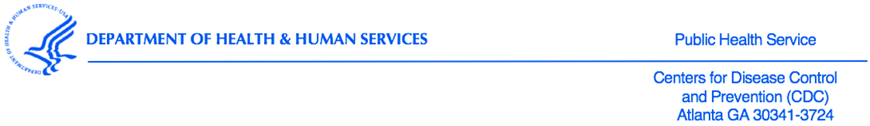

Dear Superintendent <<Last Name>>:
School(s) in your district have been randomly sampled to participate in the 2024 National Youth Tobacco Survey (NYTS). Efforts such as the NYTS have increased our ability to measure changes in tobacco use behaviors and their influences, thereby enabling states, school districts, schools, and community organizations to adapt their tobacco prevention and control programs to combat the most prevailing issues at hand. Your partnership and support play a large role in your school and students’ participation, and the ability of the NYTS to continue providing data critical to advancing the quality of tobacco prevention education in the U.S.
Conducted since 1999, the NYTS is an ongoing survey of students in grades 6 through 12 that gathers information on: (1) prevalence of use (electronic cigarettes, cigarettes, cigars, smokeless tobacco, hookahs, pipe tobacco, and bidis), (2) knowledge and attitudes, (3) media and advertising, (4) minors' access and enforcement, (5) school curriculum, (6) secondhand smoke exposure, and (7) cessation. Each cycle has produced valuable data regarding students’ knowledge of and attitudes toward tobacco, their exposure to secondhand smoke, and their exposure to influences that promote or discourage tobacco use.
The following schools in your district have been sampled for participation in the 2023-2024 school year: <<SCHOOLS>>.
The online survey can be completed from any internet-connected device, typically takes about 20 minutes to complete, and can be administered on any day chosen by the school (between [DATES]). Click here to view the NYTS study flyer and FAQ.
As a symbol of appreciation for contributing their time and support, the CDC will provide each participating school with a monetary award. One option is to use these funds for prevention curriculum and educational materials. However, no restrictions will be placed on how schools can use these funds. Participating schools will also receive an invitation to a webinar discussing the results of the 2024 NYTS.
In the next few weeks, our team will email survey information to schools that have been selected to participate in the 2024 NYTS. Following that email, a study representative will contact schools to discuss their participation. We are grateful for your partnership and support. Please contact the survey team with any questions at: 866-354-0987 or email NYTS@rti.org. We look forward to working with your school(s) in the 2023-2024 school year.
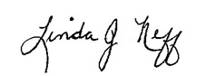
Sincerely,

Linda J. Neff, PhD, MSPH
Chief, Epidemiology Branch, Office on Smoking and Health
National Center for Chronic Disease Prevention and Health Promotion
Centers for Disease Control and Prevention

