# Core SIPP Rubric Reporting Platform

Core State Injury Prevention Program – CE21-2101

### Task Details

Recipient navigates through this page to get to rubric entries. OMB information is listed in the bottom left of this screenshot.

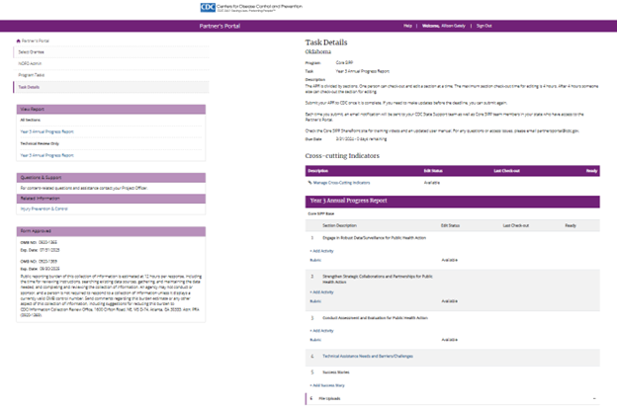

### Implementation Capacity Rubric

Each base strategy has a rubric to complete, with 9-11 prompts to complete (checklist or radio button selection).

#### Checklist:

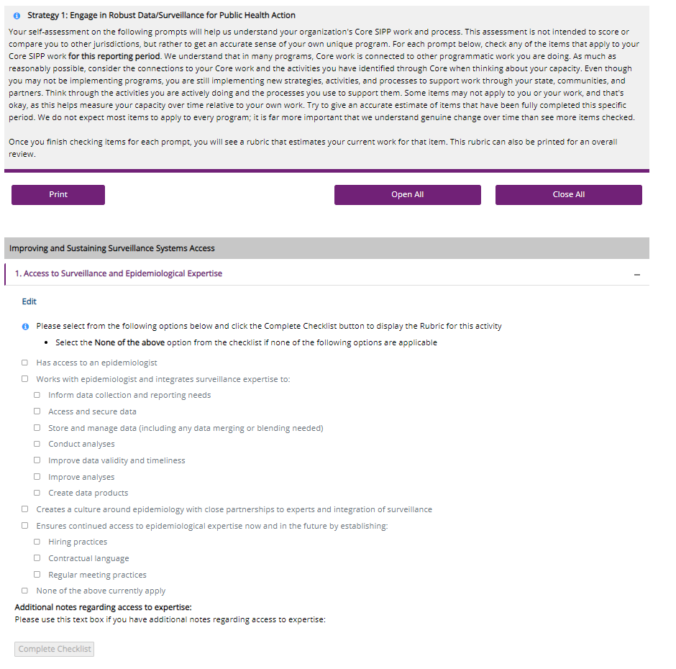

#### Radio Button:

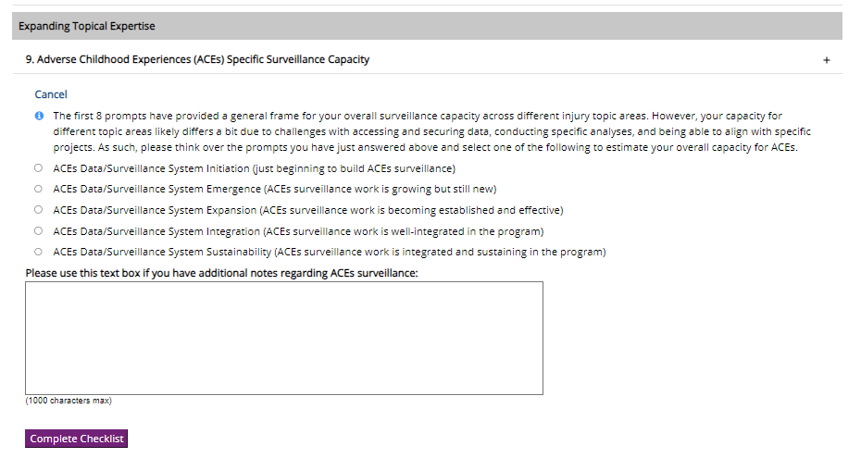

### Economic Indicator Submission Screen

