Attachment 9 - Materials to test

Shellfish HAB toxin materials to test
Type of material | Graphic/ Screenshot | Message | Testing presentation
Social media post | 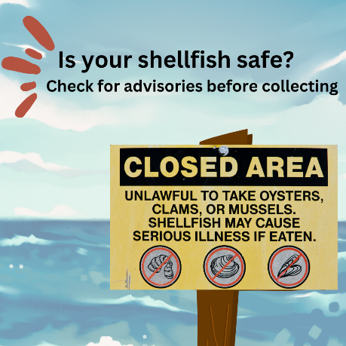 | You can’t see, taste, or smell toxins from algae in shellfish. Check for and follow local shellfish advisories before eating any shellfish you collect yourself. More ways to avoid getting sick: cdc.gov/habs | Show social media post on slide, read copy aloud
Social media post | 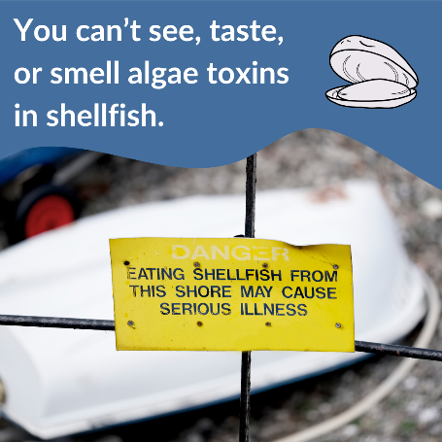 | Eating shellfish from waters with harmful algae can make you sick. Check for local advisories from your state government before collecting shellfish. Where to find advisories: cdc.gov/habs | Show social media post on slide, read copy aloud
Social media post | 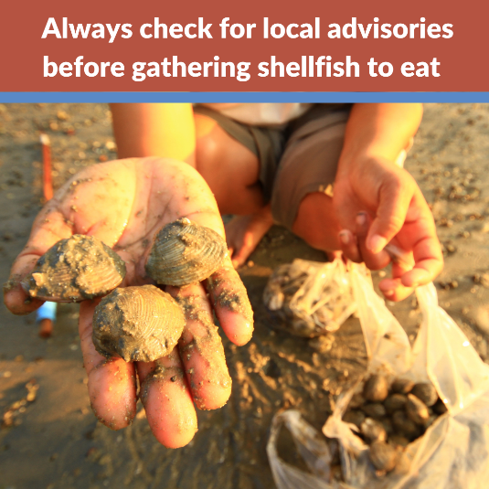 | You can’t see, taste, or smell algae toxins in shellfish. Cooking won’t remove them either. Avoid food poisoning by following shellfish guidelines posted on your state’s website or near the water. More about algae toxins: cdc.gov/habs | Show social media post on slide, read copy aloud
Social media post | 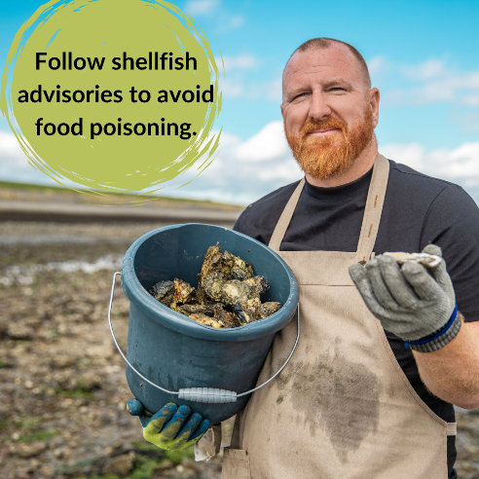 | Before you collect and eat shellfish, check shellfish advisories from your local government. Tasteless and odorless toxins can contaminate shellfish and give you food poisoning. More ways to avoid getting sick: cdc.gov/habs | Show social media post on slide, read copy aloud
Social media post | 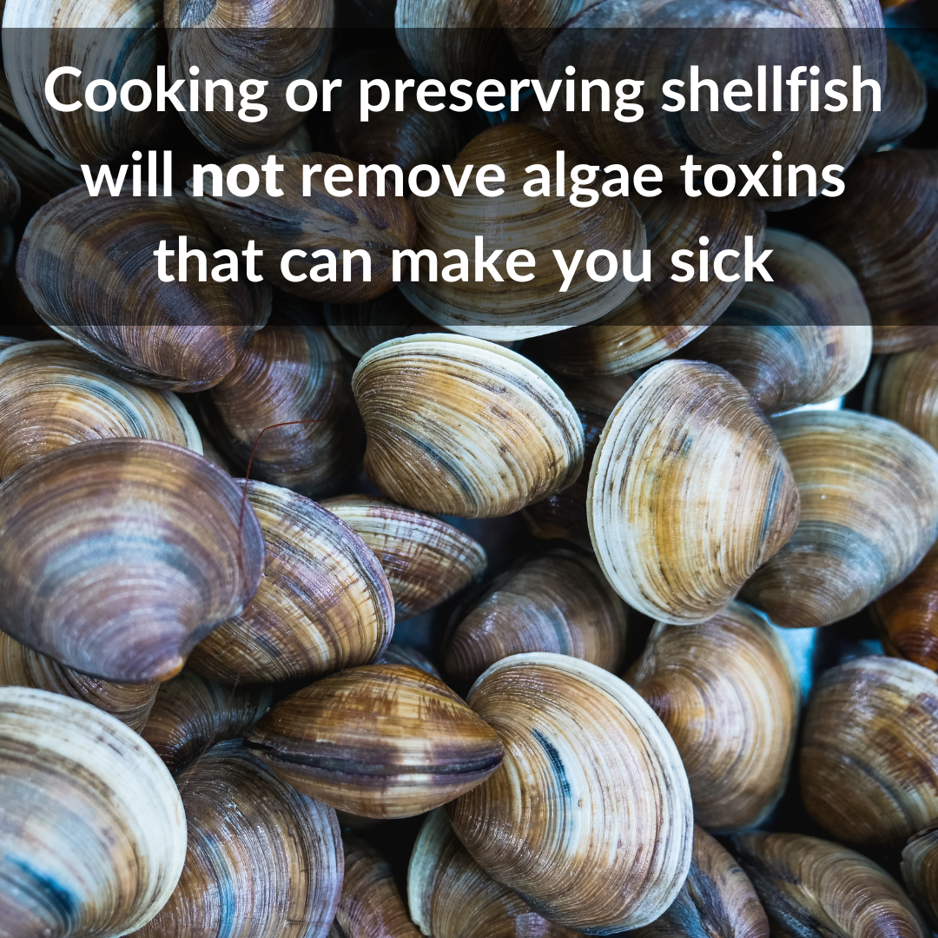 | Coastal states test shellfish for algae toxins (poisons). If levels in shellfish are unsafe, they’ll close harvesting areas to protect you. Always follow local advisories to avoid getting food poisoning from shellfish you harvest. Where to find advisories: cdc.gov/habs | Show social media post on slide, read copy aloud
Social media post | 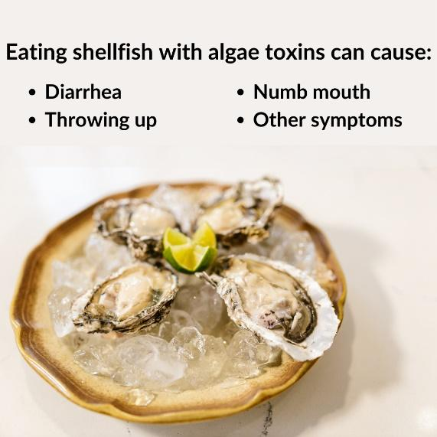 | Eating contaminated shellfish you’ve collected yourself can cause mild to life-threatening symptoms. Avoid getting sick by checking your state’s website for advisories before collecting shellfish.  More possible symptoms: cdc.gov/habs | Show social media post on slide, read copy aloud
Social media post | 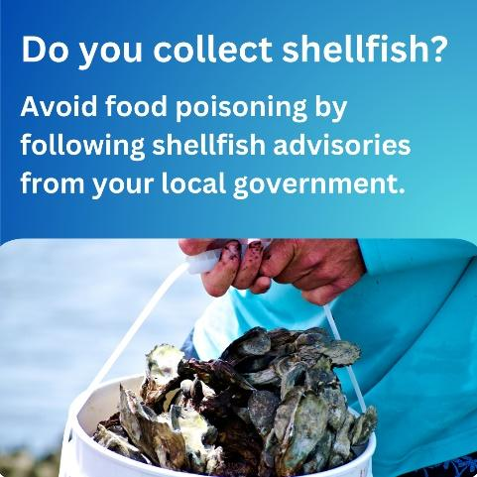 | Seafood sold in U.S. stores or restaurants must meet safety standards. However, these standards don’t apply to seafood you collect yourself. Always check for advisories from your local government before eating seafood you collect yourself. Find out why: cdc.gov/habs | Show social media post on slide, read copy aloud
Social media post | 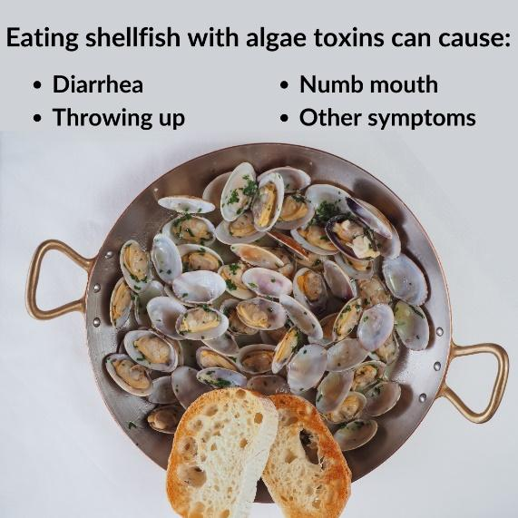 | Feel sick after eating shellfish you collected yourself? Contact a healthcare provider or Poison Control at 1-800-222-1222. They can help you feel better. Get more info about symptoms: cdc.gov/habs | Show social media post on slide, read copy aloud
Website information | 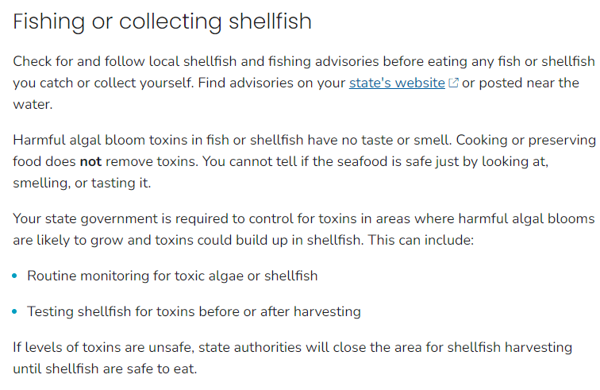 | Information on Preventing Illnesses Caused by Harmful Algal Blooms | Harmful Algal Bloom (HAB)-Associated Illness | CDC | Show webpage content using web link
Website information | 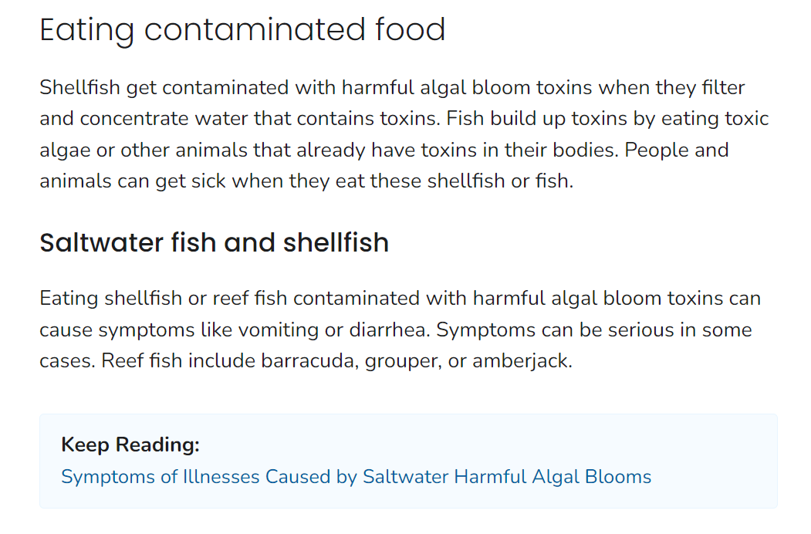 | Information on How People and Animals Get Sick From Harmful Algal Blooms | Harmful Algal Bloom (HAB)-Associated Illness | CDC | Show webpage content using web link
PDF | 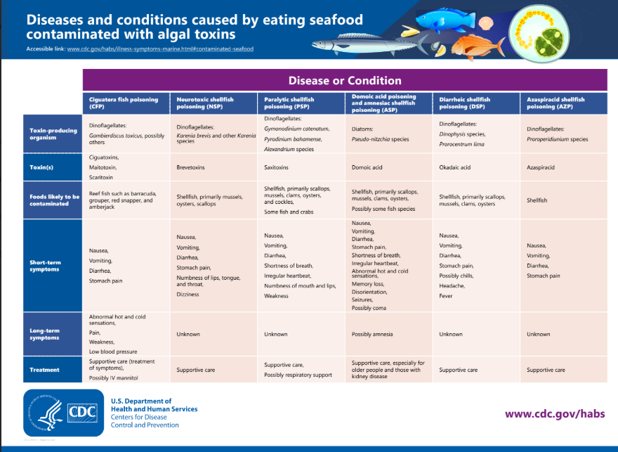 | Diseases and conditions caused by eating seafood contaminated with algal toxins | Show PDF

