Recruitment Materials

Draft Recruitment Email for Women Mine Workers
Hello,
My name is [NIOSH personnel’s name] and I am a [job title] in the NIOSH Mining Program.
We are conducting a study to learn about the experiences of women working in the U.S. mining industry. We are currently recruiting women mine workers to participate in either in-person or virtual focus groups for about 90 minutes. We will ask questions about the various job tasks you perform or would like to perform, your experiences with work-related hazards and risks and how they affect or impact your work, ways you think your job could be improved or made safer, and other thoughts and experiences you want to share about being a woman in mining.
Attached is the informed consent form for more details. If you’d like to participate, please let me know so we can find a date and time that would work best for you. If you know of someone in your professional network that you feel would be a good fit for our study, please feel free to forward this email or have them reach out for more information. If you are unsure if you would like to participate but have questions about this study, please do not hesitate to contact me.
I look forward to hearing from you.
Thank you,
[insert NIOSH personnel’s name]
Draft Recruitment Email for Mine Managers/H&S Professionals
Hello,
My name is [NIOSH personnel’s name] and I am a [job title] in the NIOSH Mining Program.
We are conducting a study to learn about the experiences of women working in the U.S. mining industry. We are currently recruiting mine managers and mine health and safety professionals to participate in either in-person or virtual focus groups for about 90 minutes. We will ask questions about your mine site and your job and work history; different job tasks performed at your site and their related hazards that may be posing additional risk(s) or burden on women mine workers who are performing those jobs; and potential mitigation strategies.
Attached is the informed consent form for more details. If you’d like to participate, please let me know so we can find a date and time that would work best for you. If you know of someone in your professional network that you feel would be a good fit for our study, please feel free to forward this email or have them reach out for more information. If you are unsure if you would like to participate but have questions about this study, please do not hesitate to contact me.
I look forward to hearing from you.
Thank you,
[insert NIOSH personnel’s name]

Recruitment Flyer for Women Mine Workers
All recruitment materials will go through proper clearance channels and receive the required approvals before use.
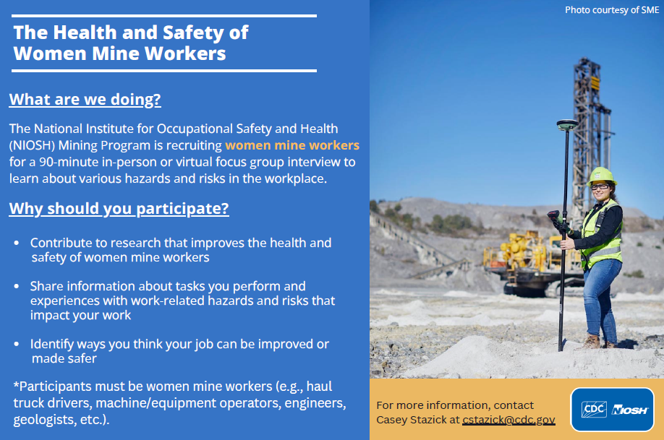

Recruitment Flyer for Mine Managers/Health and Safety Professionals
All recruitment materials will go through proper clearance channels and receive the required approvals before use.
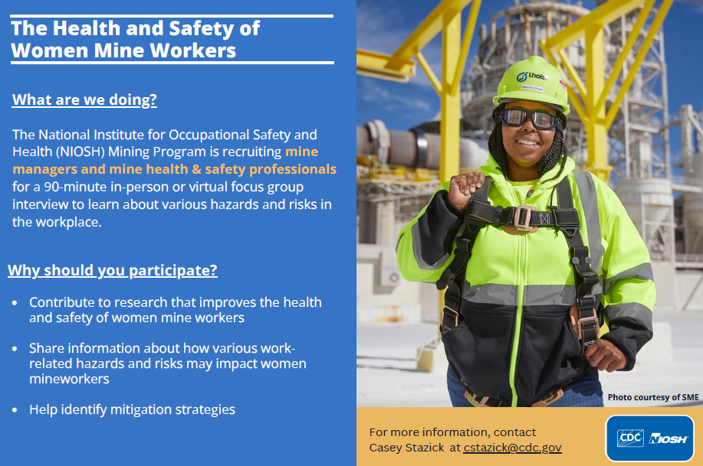
Recruitment PowerPoint Slide
A PowerPoint slide to include in presentations will be developed from the recruitment flyer graphics
Examples of Recruitment Social Media Posts
All social media posts will go through proper clearance channels and receive the required approvals before use.

NIOSH is recruiting women mine workers for a focus group study to learn about various hazards and risks in the workplace. To participate or get more information, contact us here. #WomenInMining

NIOSH is recruiting mine managers and mine health and safety professionals for a focus group study to learn about different hazards and risks in the workplace that may be uniquely impacting women miners. To participate or get more information, contact us here. #MiningIndustry #HealthAndSafety

