Screen 1

Screen 2

Screen 3

Screen 4

Screen 5

Screen 6

Screen 6 continued

Screen 7

Screen 8

Screen 9

Screen 9 continued

Screen 10

Screen 11

Screen 12

Screen 13

Screen 14

Screen 15 (*Note: the numerical of value of ‘8,’ shown below, is a piped-text entry based on the value input into Q5b)*

Screen 16

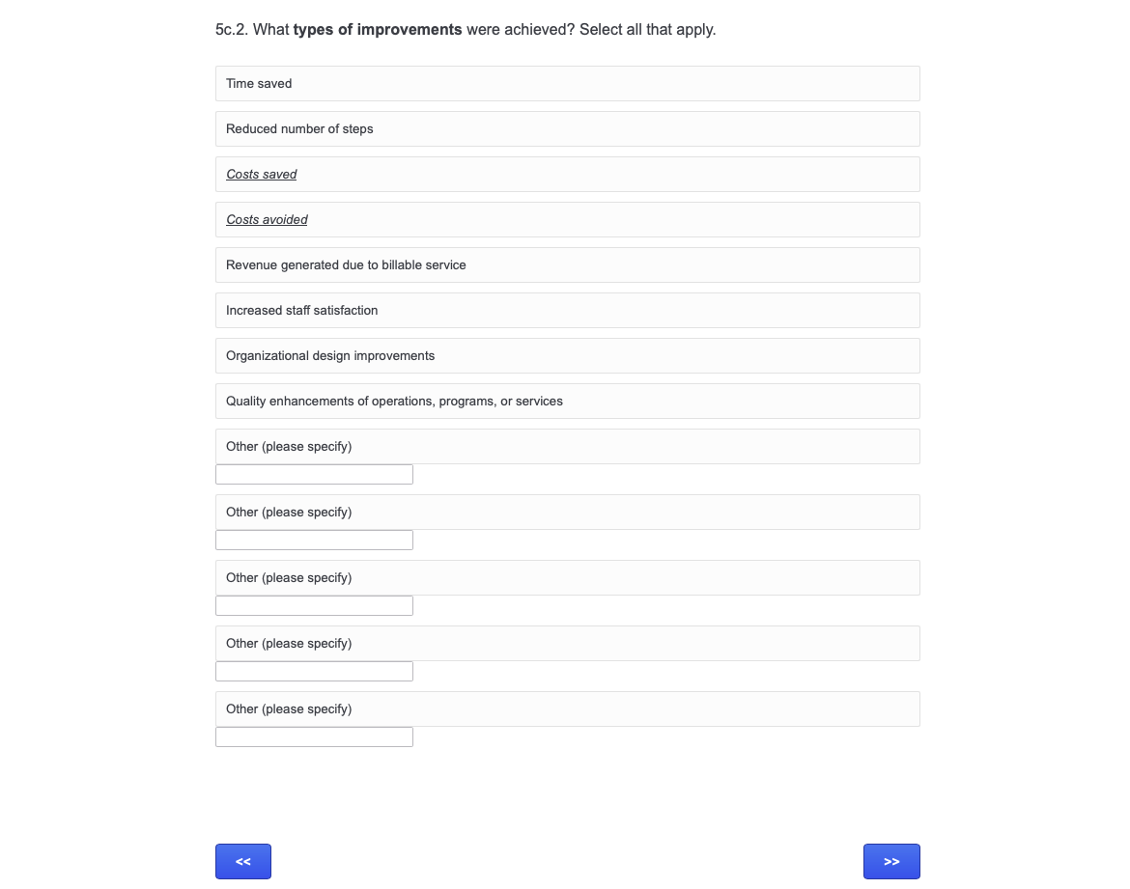

Screen 17

Screen 18: (*Note: the numerical of value of ‘8,’ shown below, is a piped-text entry based on the value input into Q5c.1)*

Screen 19

Screen 19 continued

Screen 20

Screen 21: (*Note: the numerical of value of ‘8,’ shown below, is a piped-text entry based on the value input into Q5d.1)*

Screen 22

Screen 23

Screen 24: (*Note: the numerical of value of ‘8,’ shown below, is a piped-text entry based on the value input into Q5e.1)*

Screen 25

Screen 25 continued (*if ‘yes’ is selected for 5f*)

Screen 26

Screen 27

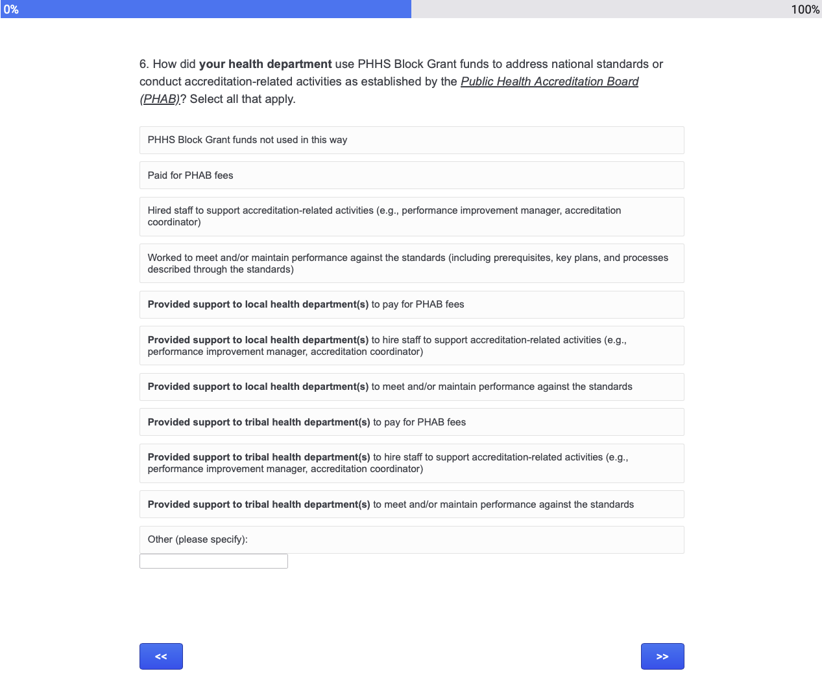

Screen 28

Screen 29

Screen 30

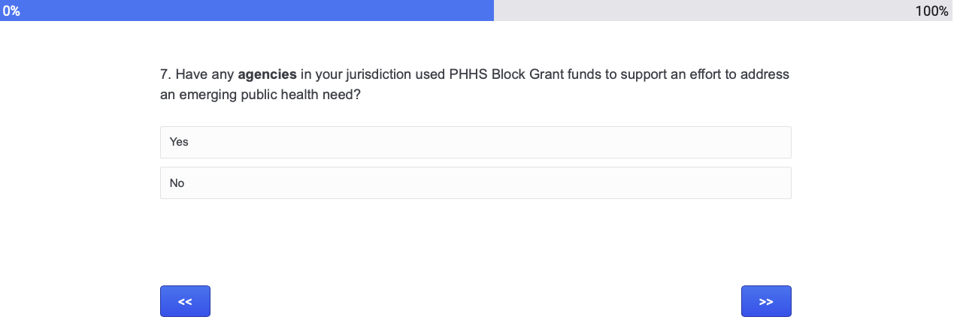

Screen 31

Screen 32

Screen 33

Screen 34

Screen 34 continued

Screen 35

Screen 36

Screen 36 continued:

Screen 37

Screen 38

Screen 39

Screen 40

Screen 41

Screen 41 continued

Screen 41 continued:

Screen 42: *Note: the numerical of value of ‘8,’ shown below, is a piped-text entry based on the value input into Q8b.1. The rows displayed are equal to the items selected in 8b.2*

Screen 43

Screen 43 continued

Screen 43 continued:

Screen 44: *Note: the numerical of value of ‘8,’ shown below, is a piped-text entry based on the value input into Q8c.1. The rows displayed are equal to the items selected in 8c.2*

Screen 45

Screen 46

Screen 46 continued

Screen 46 continued:

Screen 47: *Note: the numerical of value of ‘8,’ shown below, is a piped-text entry based on the value input into Q8d.1. The rows displayed are equal to the items selected in 8d.2*

Screen 48

Screen 49

Screen 49 continued

Screen 49 continued:

Screen 50: *Note: the numerical of value of ‘8,’ shown below, is a piped-text entry based on the value input into Q8e.1. The rows displayed are equal to the items selected in 8e.2*

Screen 51

Screen 52

Screen 53

Screen 54

Screen 55

Screen 56

