Form Approve

OMB No:0920-1369

Exp. Date: xx-xx-xxxx

Public Reporting burden of this collection of information is estimated at 11 hours, including the time for reviewing instructions, searching existing data sources, gathering and maintaining the data needed, and completing and reviewing the collection of information.  An agency may not conduct or sponsor, and a person is not required to respond to a collection of information unless it displays a currently valid OMB control number.  Send comments regarding this burden estimate or any other aspect of this collection of information, including suggestions for reducing this burden to CDC/ATSDR Reports Clearance Officer, 1600 Clifton Road NW, MS D-74, Atlanta, GA 30333; Attn:  PRA (0920-xxxx).

# Partner’s Portal Screenshots

## Core State Injury Prevention Program – CE21-2101

### Task Details

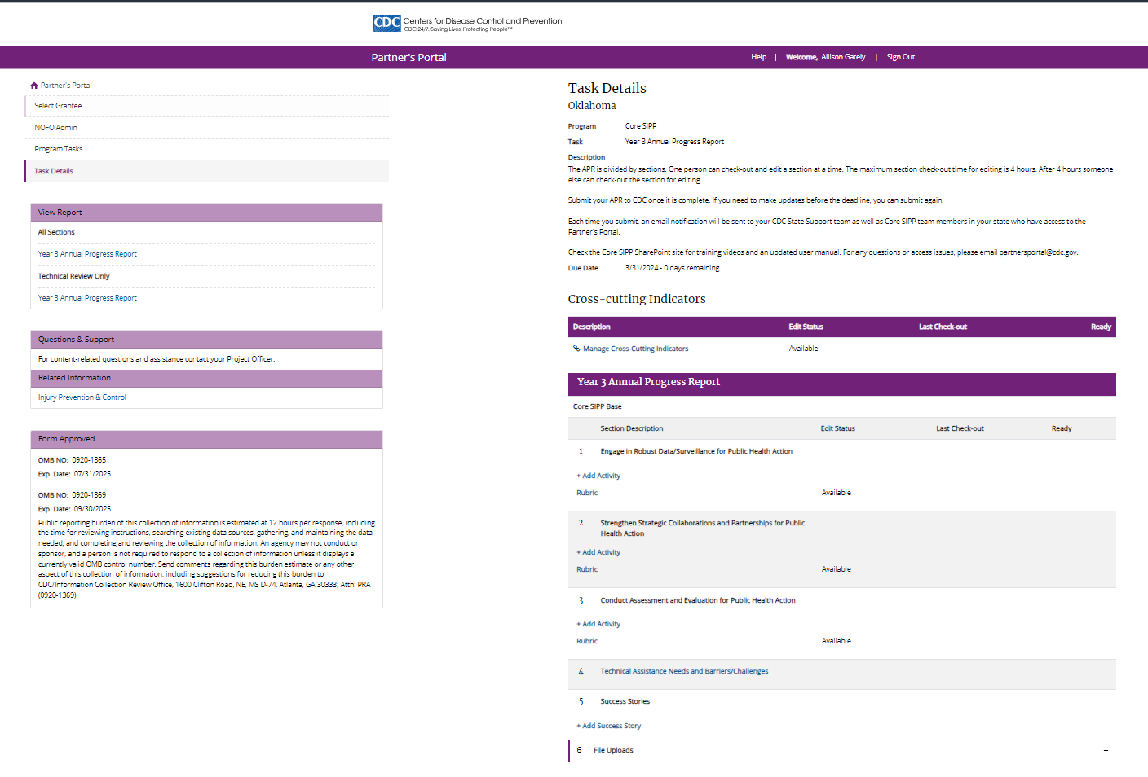

Fields on page 2-7 will be completed for all 3 primary strategies and the Enhanced component strategy (Activity Overview, Indicators, Sub-Activities):

* Engage in Robust Data/Surveillance
* Strengthen Strategic Collaboration
* Conduct Assessment and Evaluation
* Implementation and Enhanced Evaluation (Enhanced component only)

### Activity Overview (Base and Enhanced component)

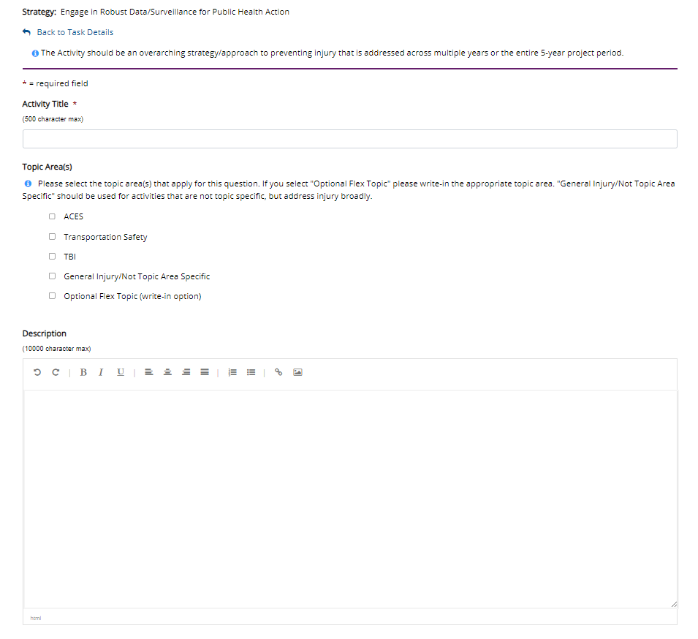

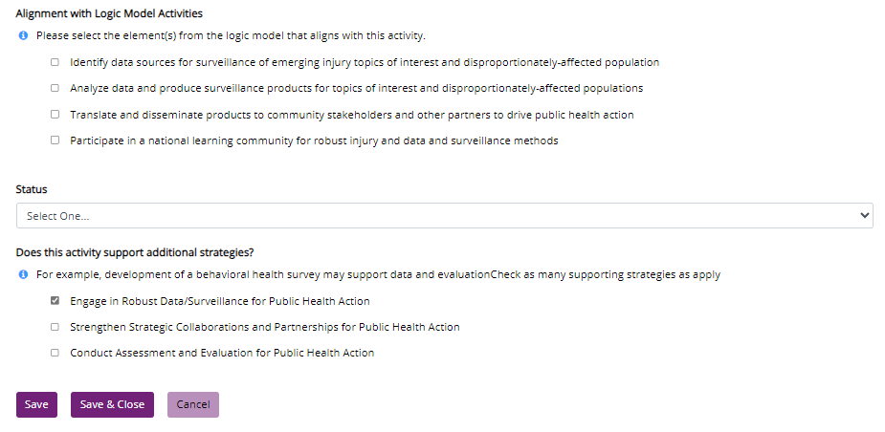

### Indicators (Base and Enhanced component)

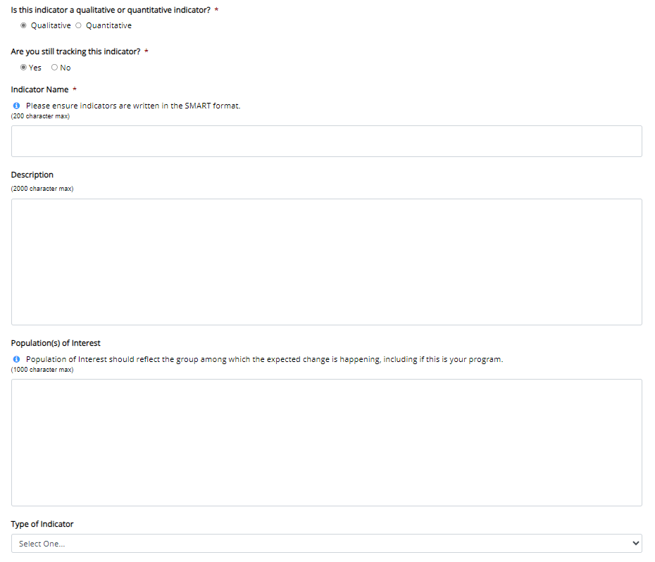

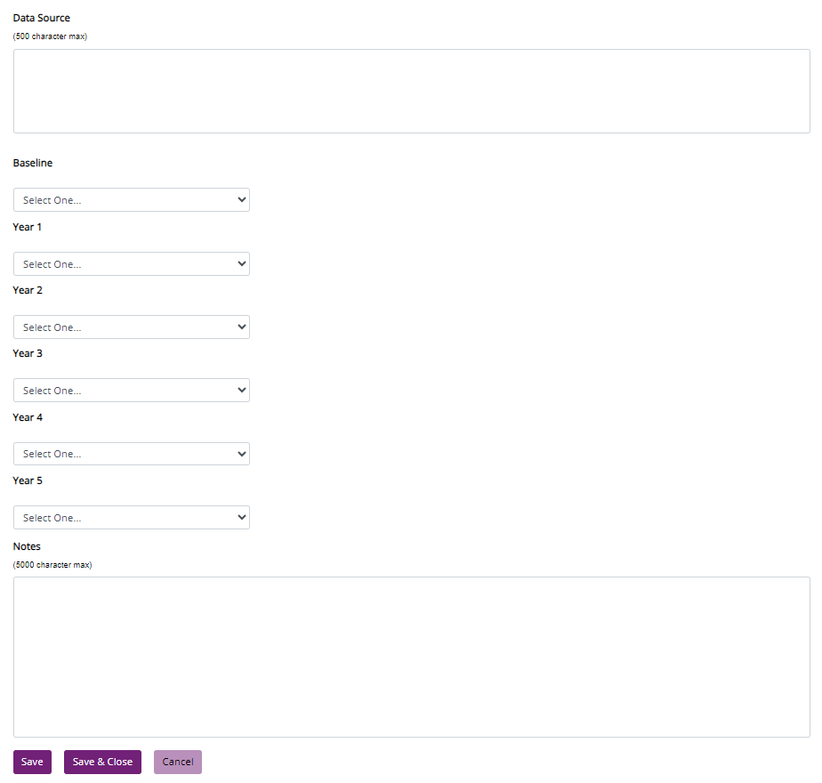

### Sub-Activities (Base and Enhanced component)

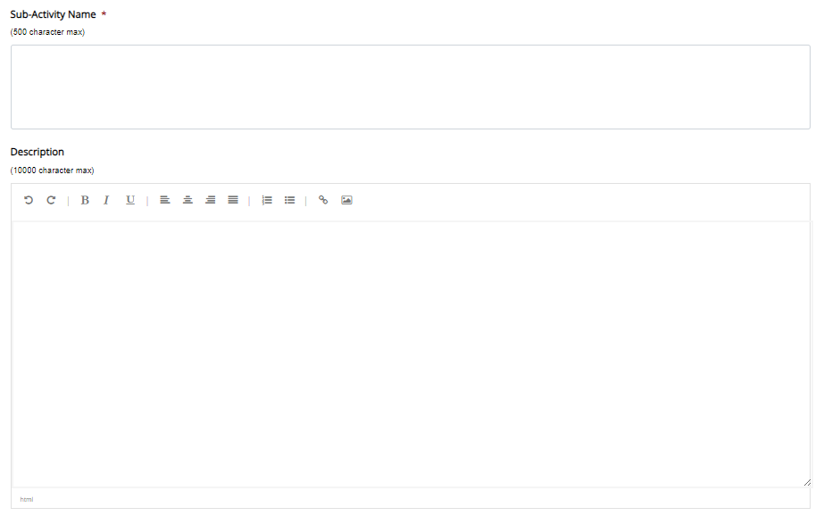

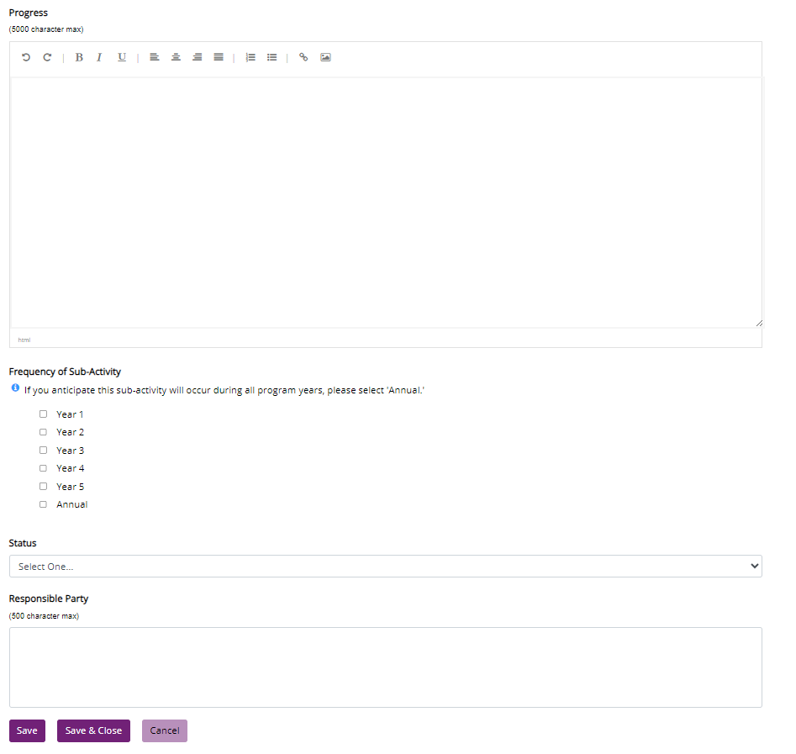

### Success Stories (Base and Enhanced component)

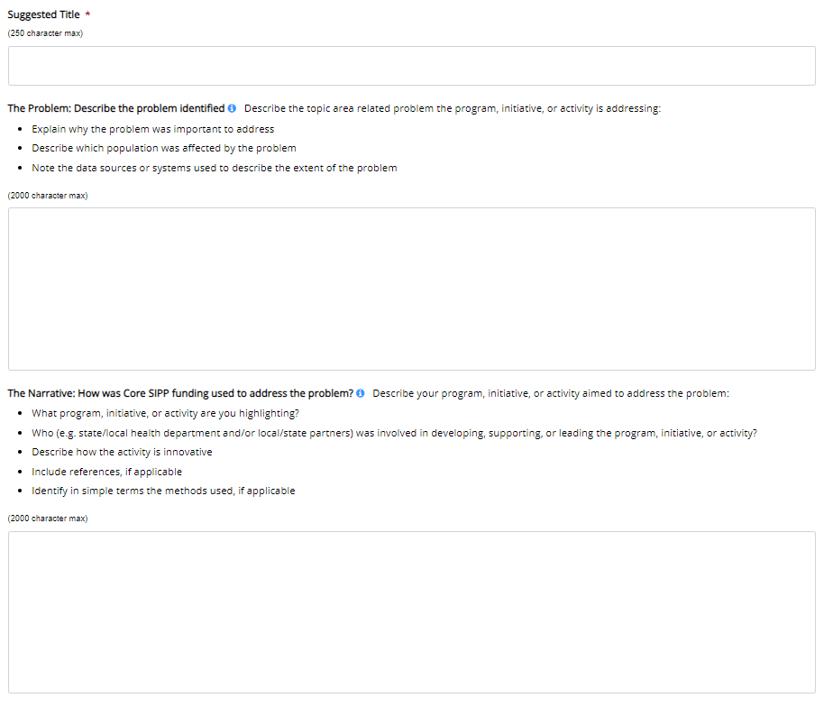

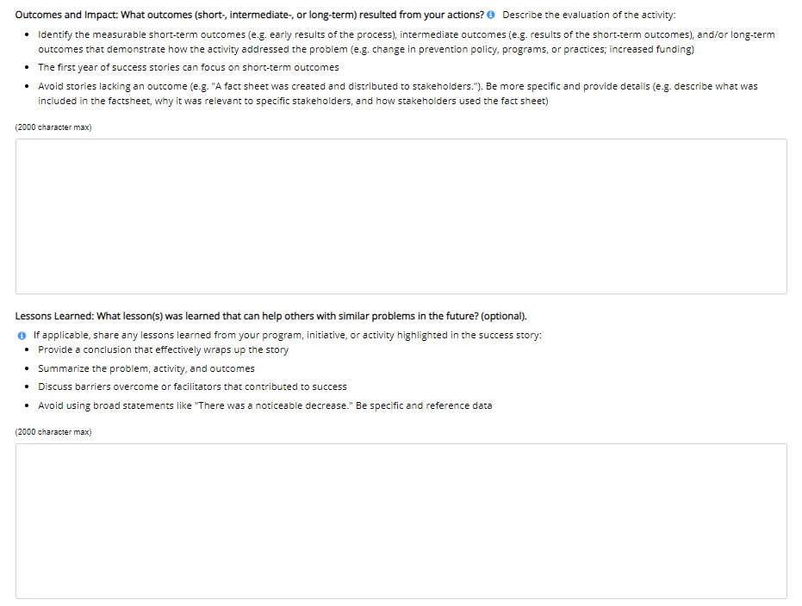

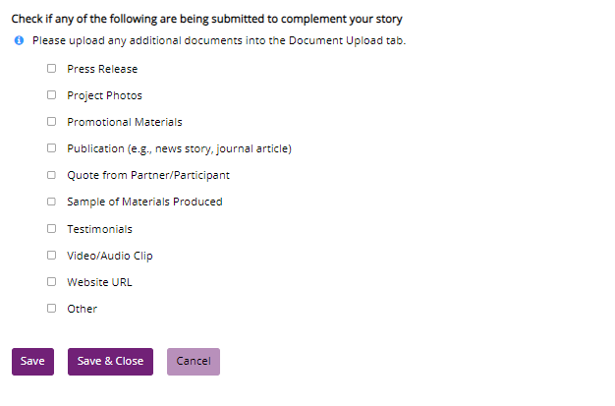

### Technical Assistance Needs and Challenges/Barriers (Base and Enhanced component)

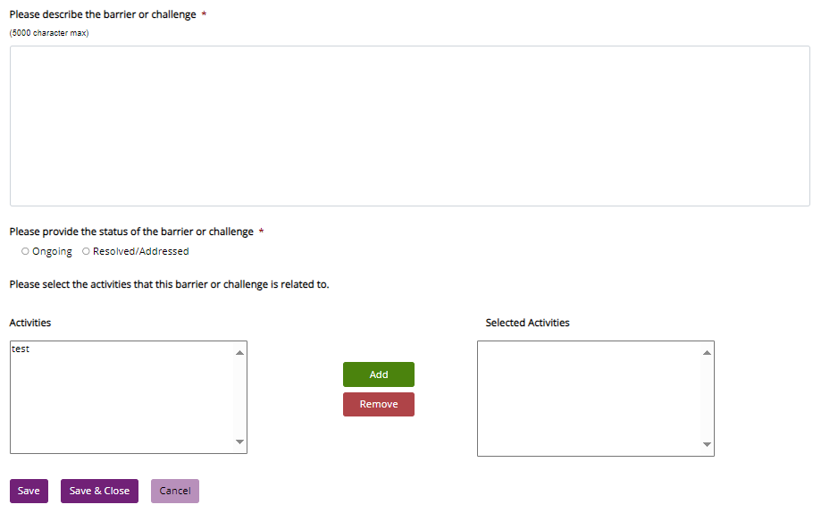

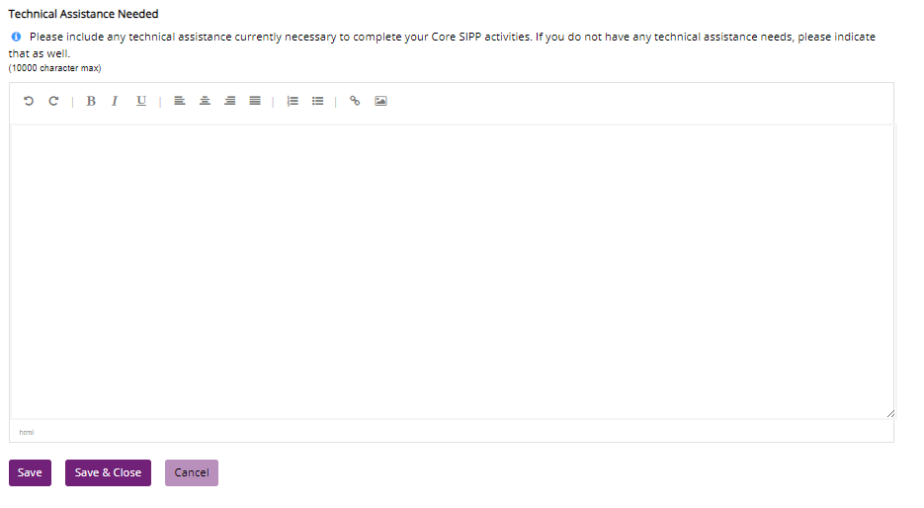

### Enhanced Component

