# Draft Schedule of Evaluation Activities

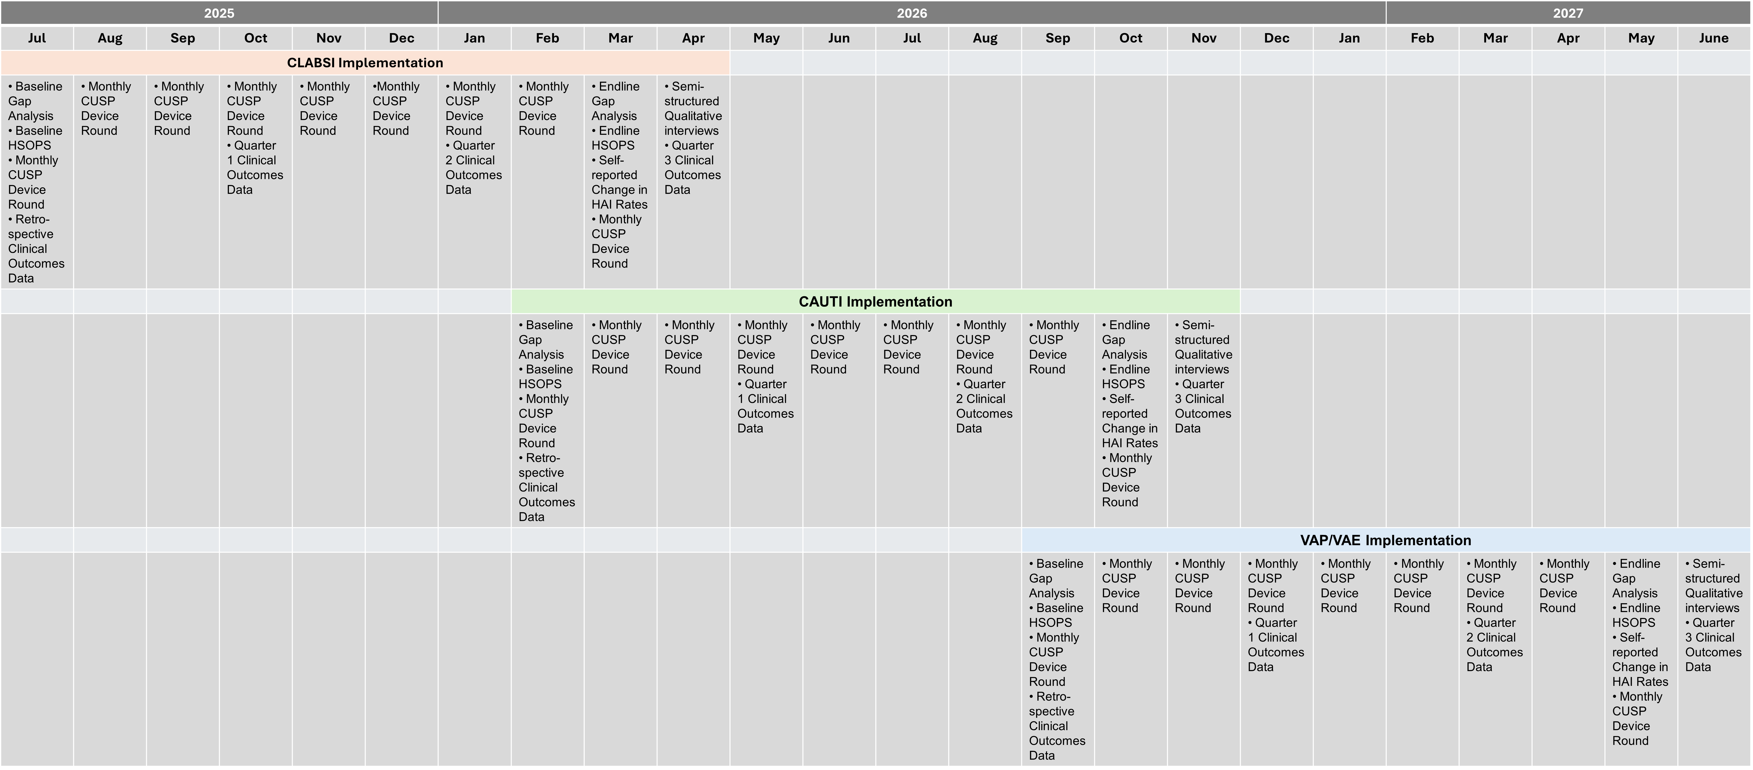This illustrates the project timeline by cohort.