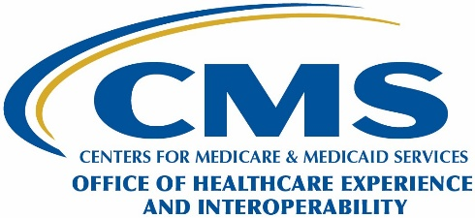Department of Health & Human Services

Centers for Medicare & Medicaid Services

7500 Security Boulevard, Mail Stop N1-19-21

Baltimore, Maryland 21244-1850

**Corrective Action Follow-up Letter**

Date of Notice: FULLDATE

CONTACTNAME

JOBTITLE

CENAME

ADDRESS1

ADDRESS2

CITY, ST ZIP

Re: Compliance Review Number **XXXXX**

Dear FIRSTNAME LASTNAME:

In a notice dated (month day, year), we informed you that the Department of Health and Human Services (HHS), National Standards Group (NSG) within the Centers for Medicare & Medicaid Services (CMS), opened a corrective action record based on violations discovered during the **<Covered Entity Name>** 20XX Health Insurance Portability and Accountability Act of 1996 (HIPAA) and Affordable Care Act (ACA) compliance review. In that notice, we requested that **<Covered Entity Name>** provide a Corrective Action Plan (CAP) to address all violations that warrant corrective action by (month, day, year) and included a CAP template for your use. To date, we have not received a completed or acceptable CAP for **<Covered Entity Name>**.

**<Covered Entity Name>** must upload a completed or acceptable CAP to the ASETT Covered Entity Portal by (month day, year). Please refer to the *CMS Identity Management (IDM) System and Compliance Review Covered Entity Portal Access Quick Start User Guide* to review instructions for accessing the ASETT Covered Entity Portal.

Failure to provide this information as requested may warrant further action as described in 45 CFR Part 160.314.

If you have questions regarding this letter, please send an email to [HIPAACompliance@cms.hhs.gov](mailto:HIPAACompliance@cms.hhs.gov). Please include the compliance review number located at the top of this letter.

Sincerely,

**Michael Cimmino**

Director, National Standards Group

Office of Healthcare Experience and Interoperability

Centers for Medicare & Medicaid Services