CCE Medicare Only Beta – 2021 Screenshots (if different) | CCE Medicare Only Beta Re-Release – 2025 Screenshots (if different) | Change
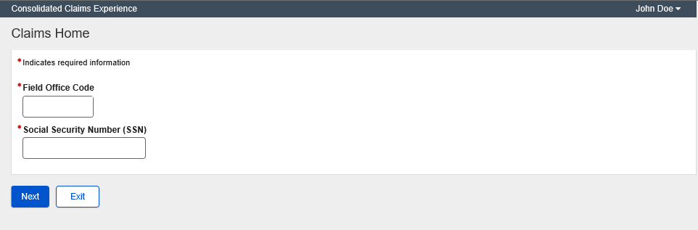 | 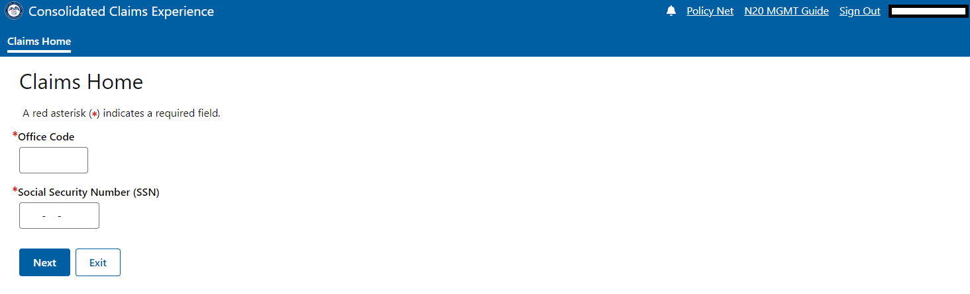 | Changed label to Office Code
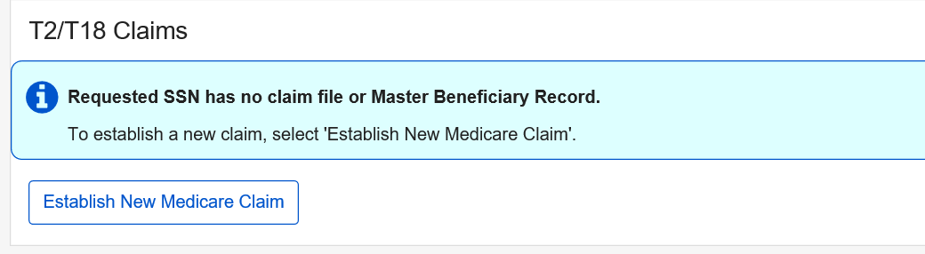 | 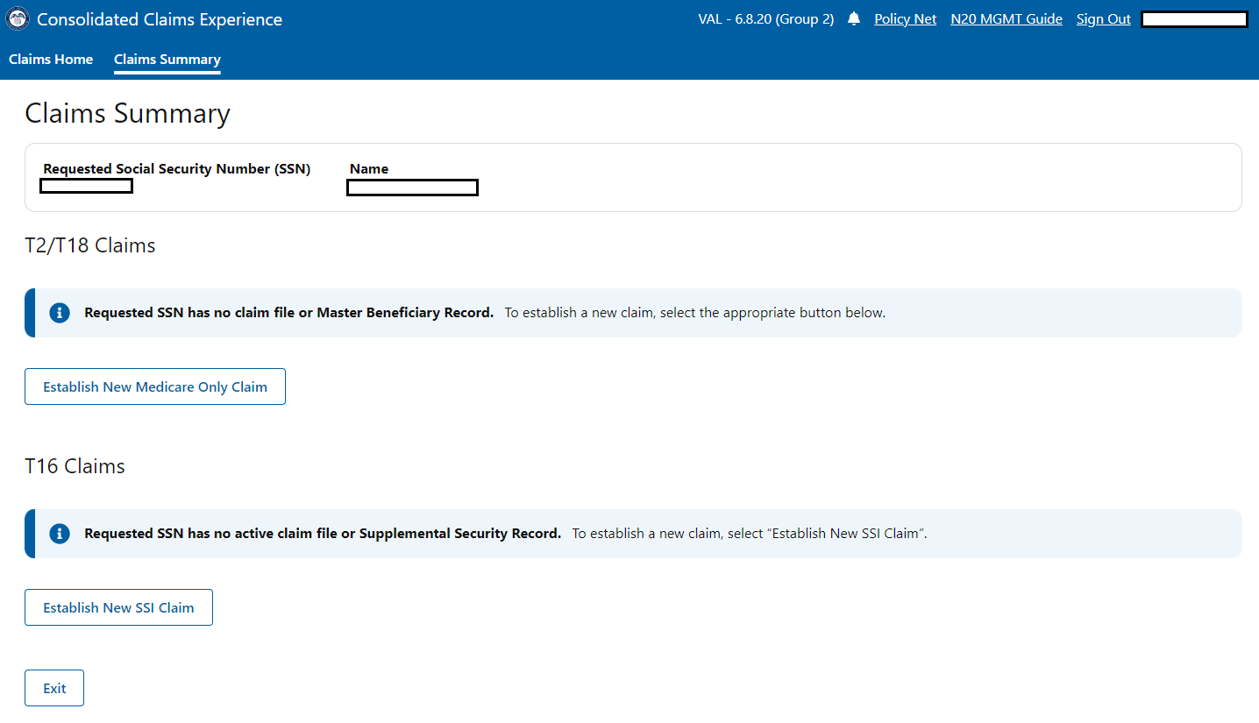 | Changed button to Establish New Medicare Only Claim
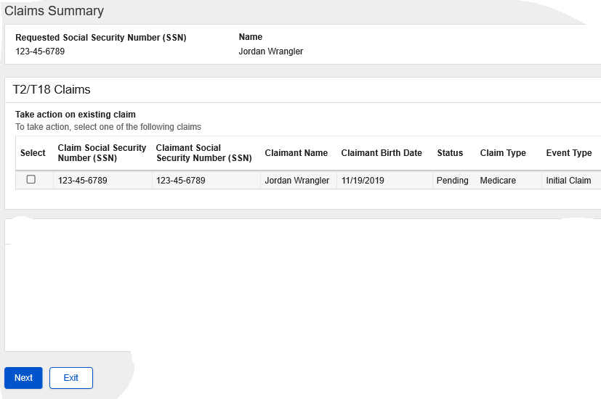 | 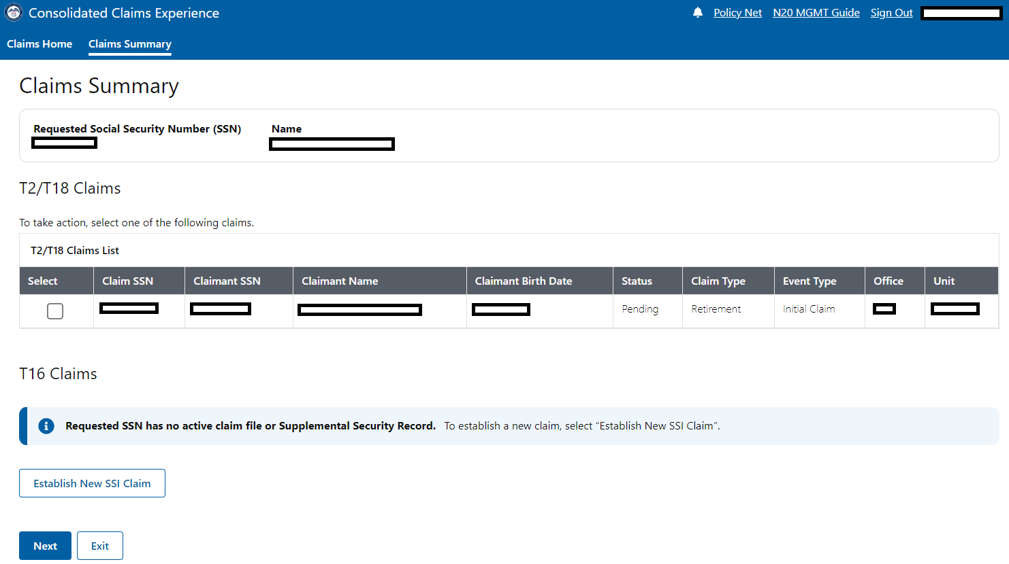 | Abbreviated Social Security Number to SSN and added Office and Unit
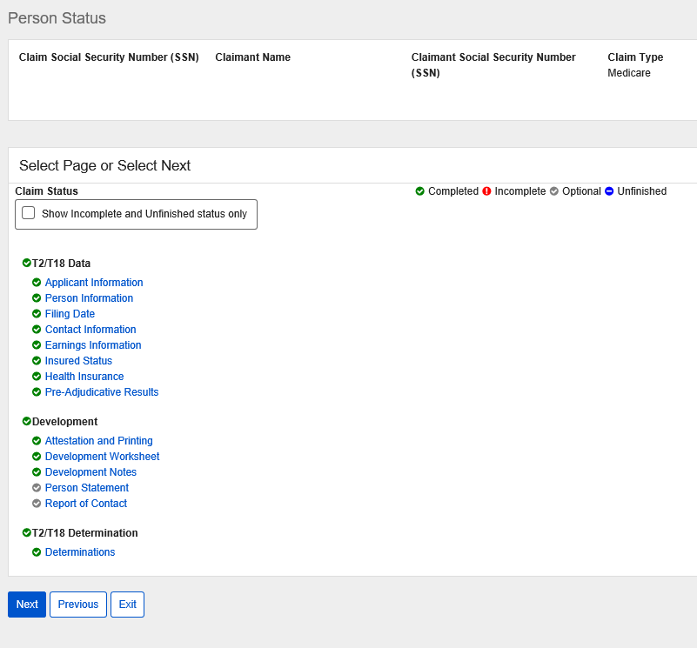 | 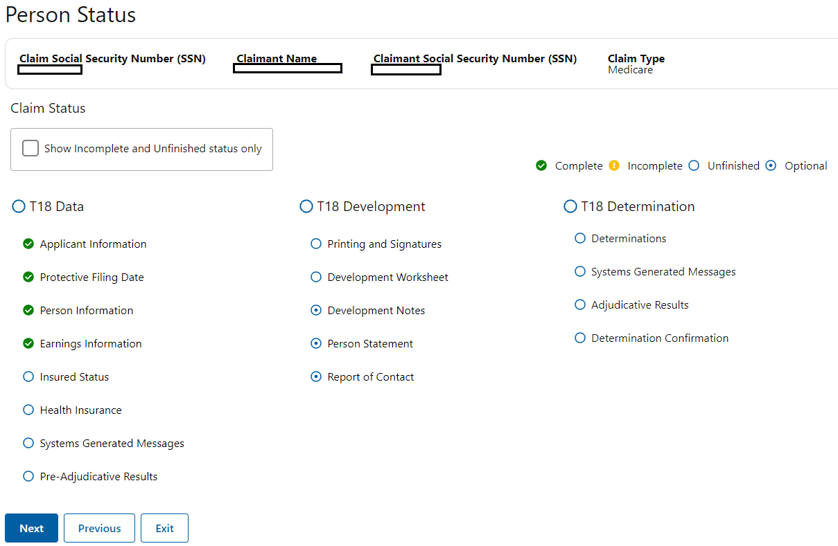 | Retitled to mark as T18 for Medicare Only displayed Systems Generated Messages and all determination pages
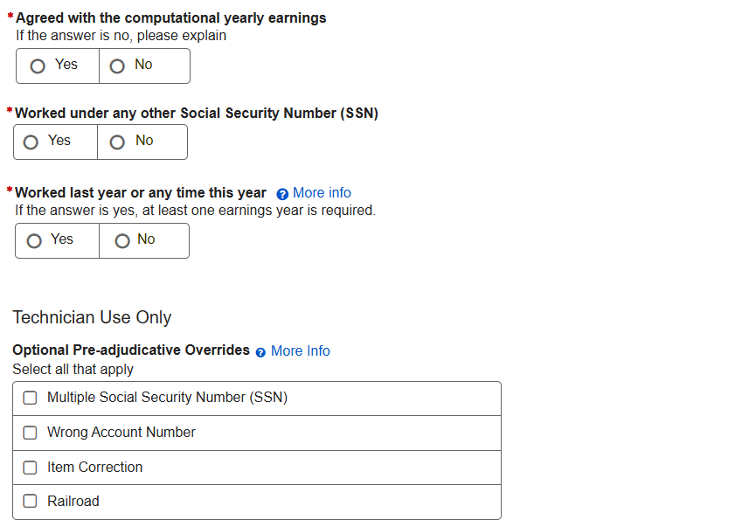 | 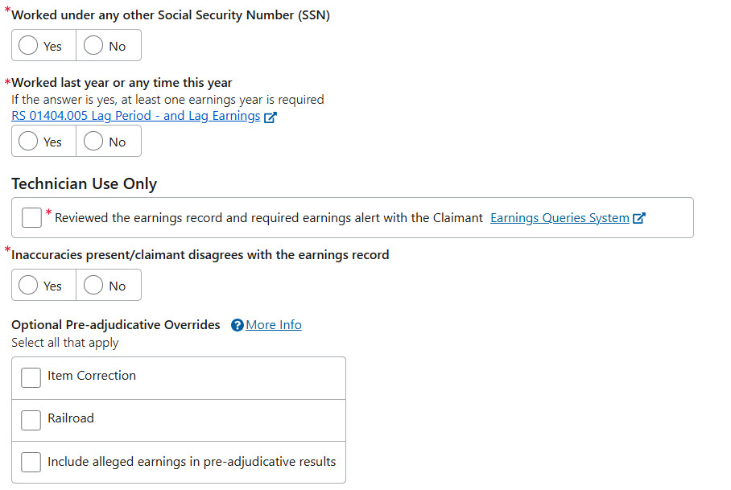 | Moved earnings questions to technician use only (like for RIB), removed multiple SSN override (like for RIB)
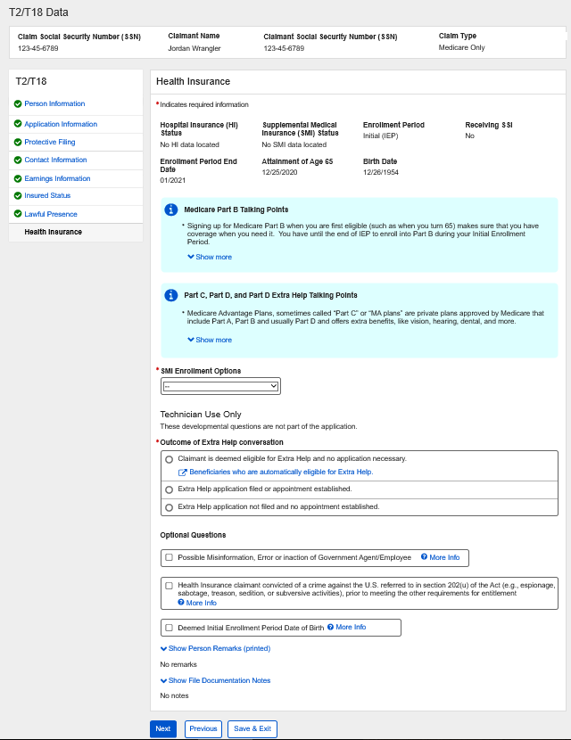 | 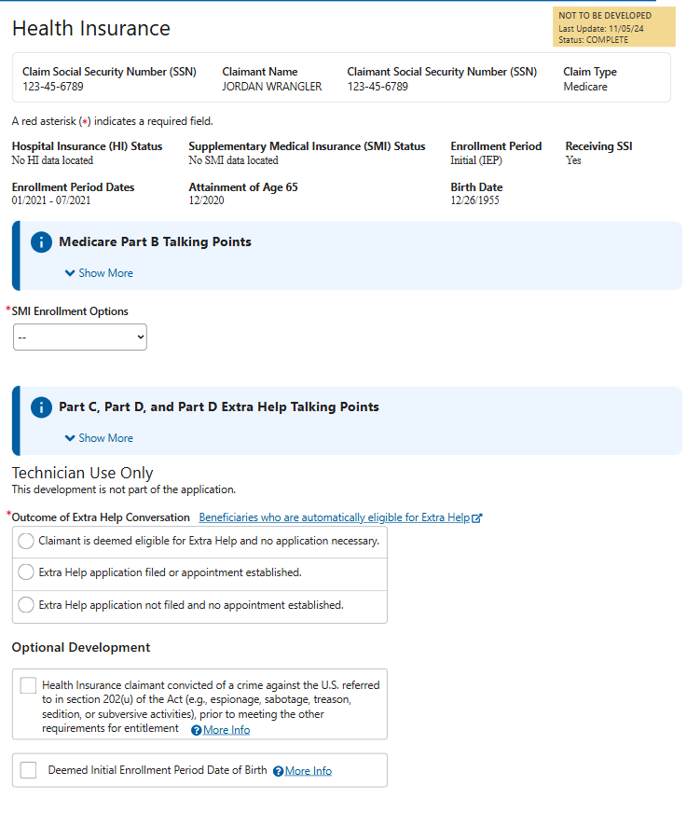 | Removed Possible Misinformation, Error or inaction optional question
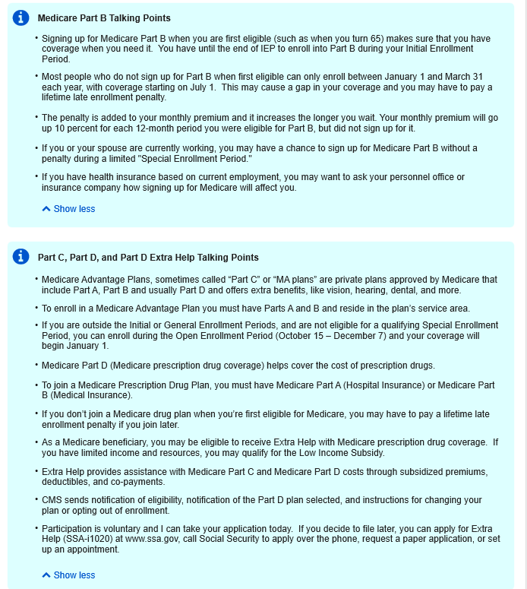 | 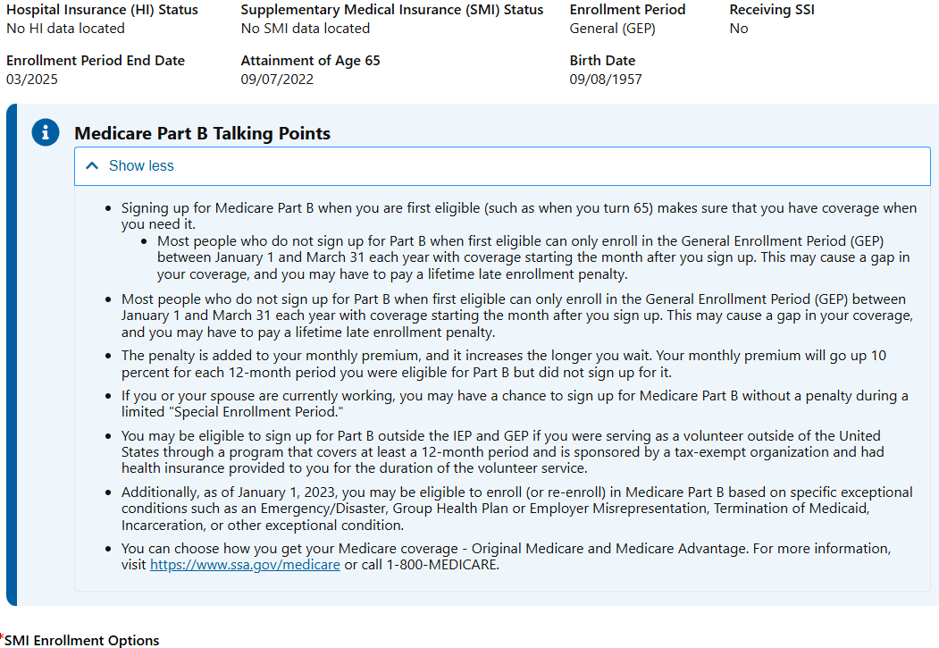 | Adjusted talking points per stakeholder changes
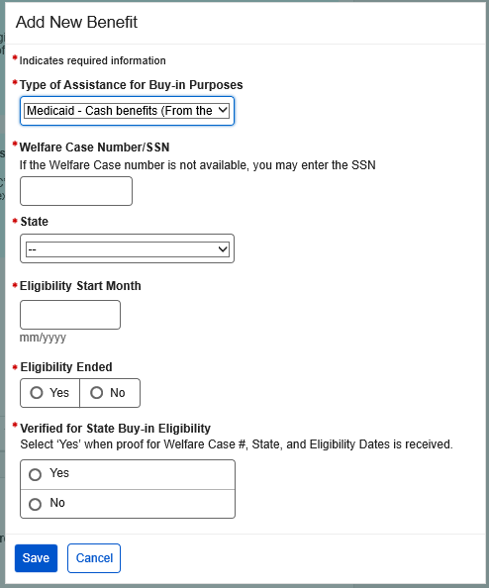 | 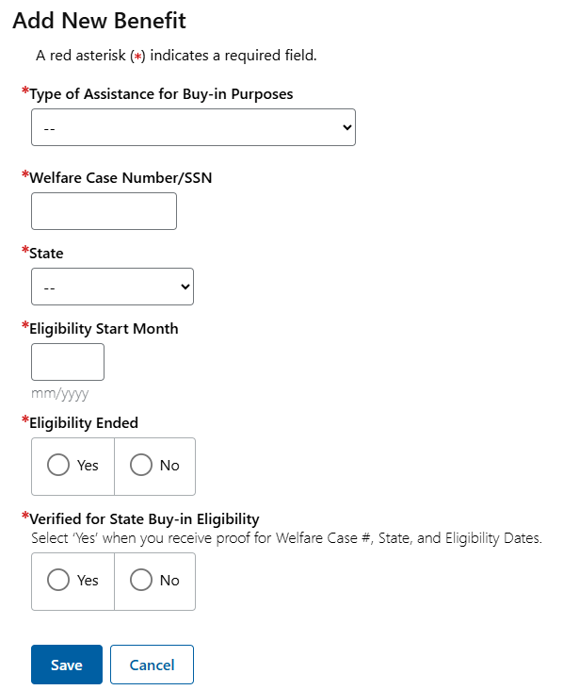 | Adjusted sub-text for Verified for State Buy-in Eligibility
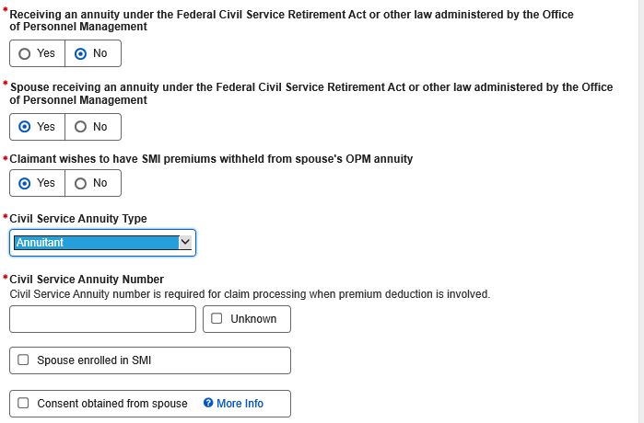 | 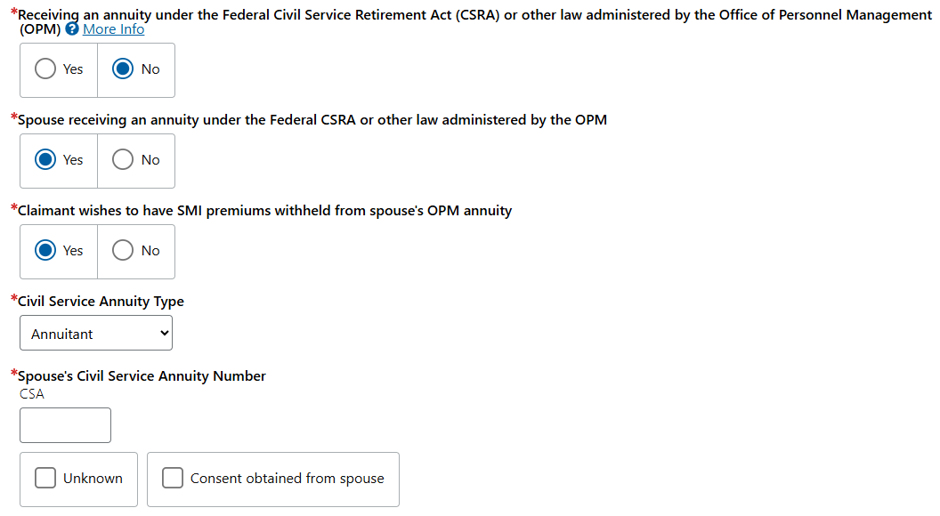 | Removed Spouse enrolled in SMI field
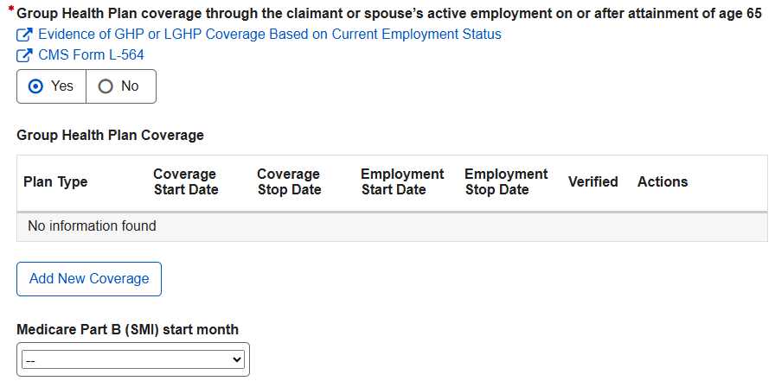 | 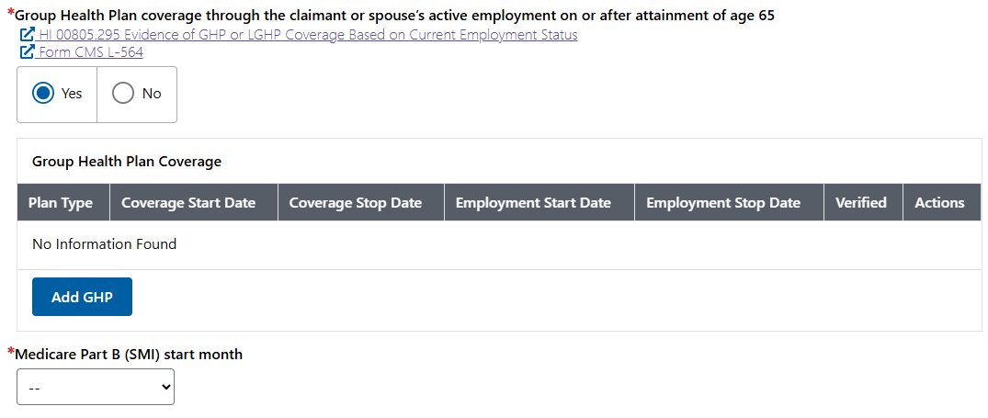 | Changed button to Add GHP
 | 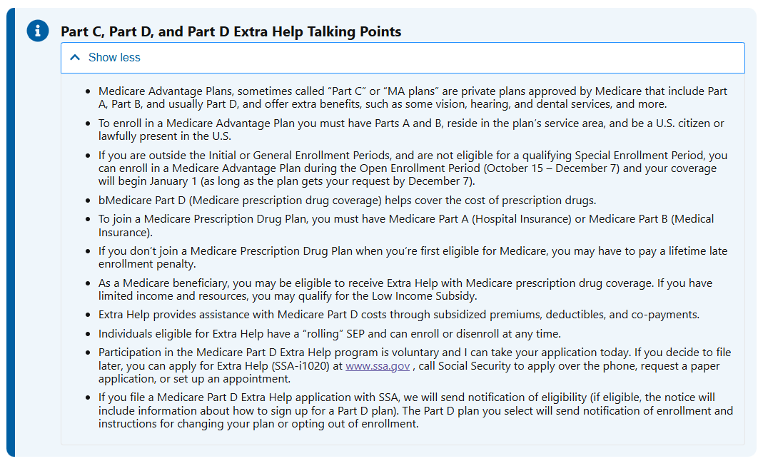 | Adjusted talking points per stakeholder changes
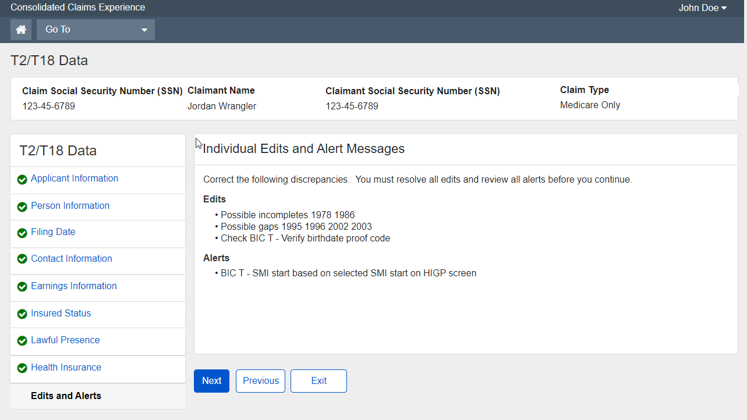 |  | Reformatted Edits/Alerts to show Systems Generated Messages (like for RIB)
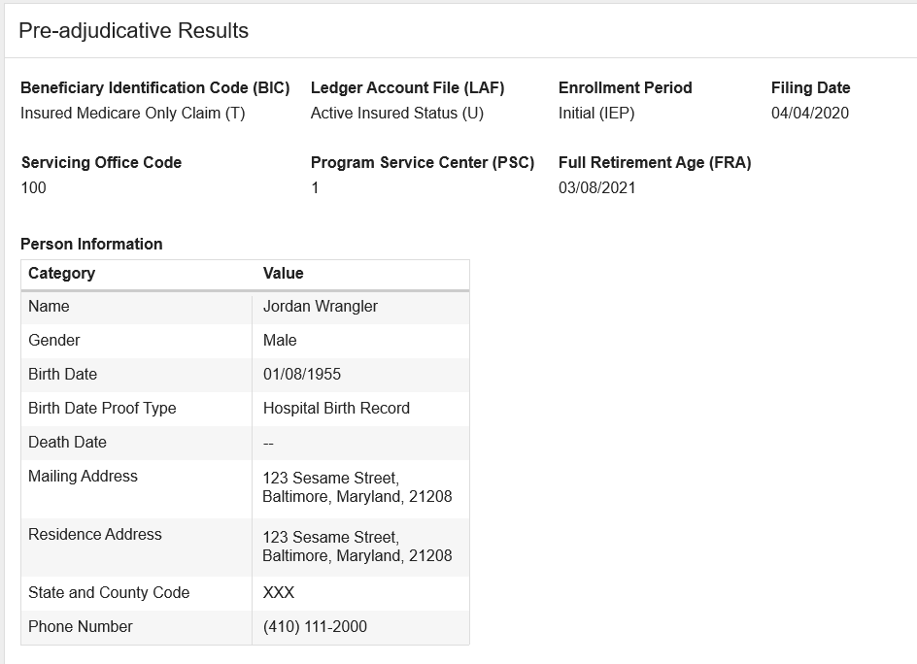 | 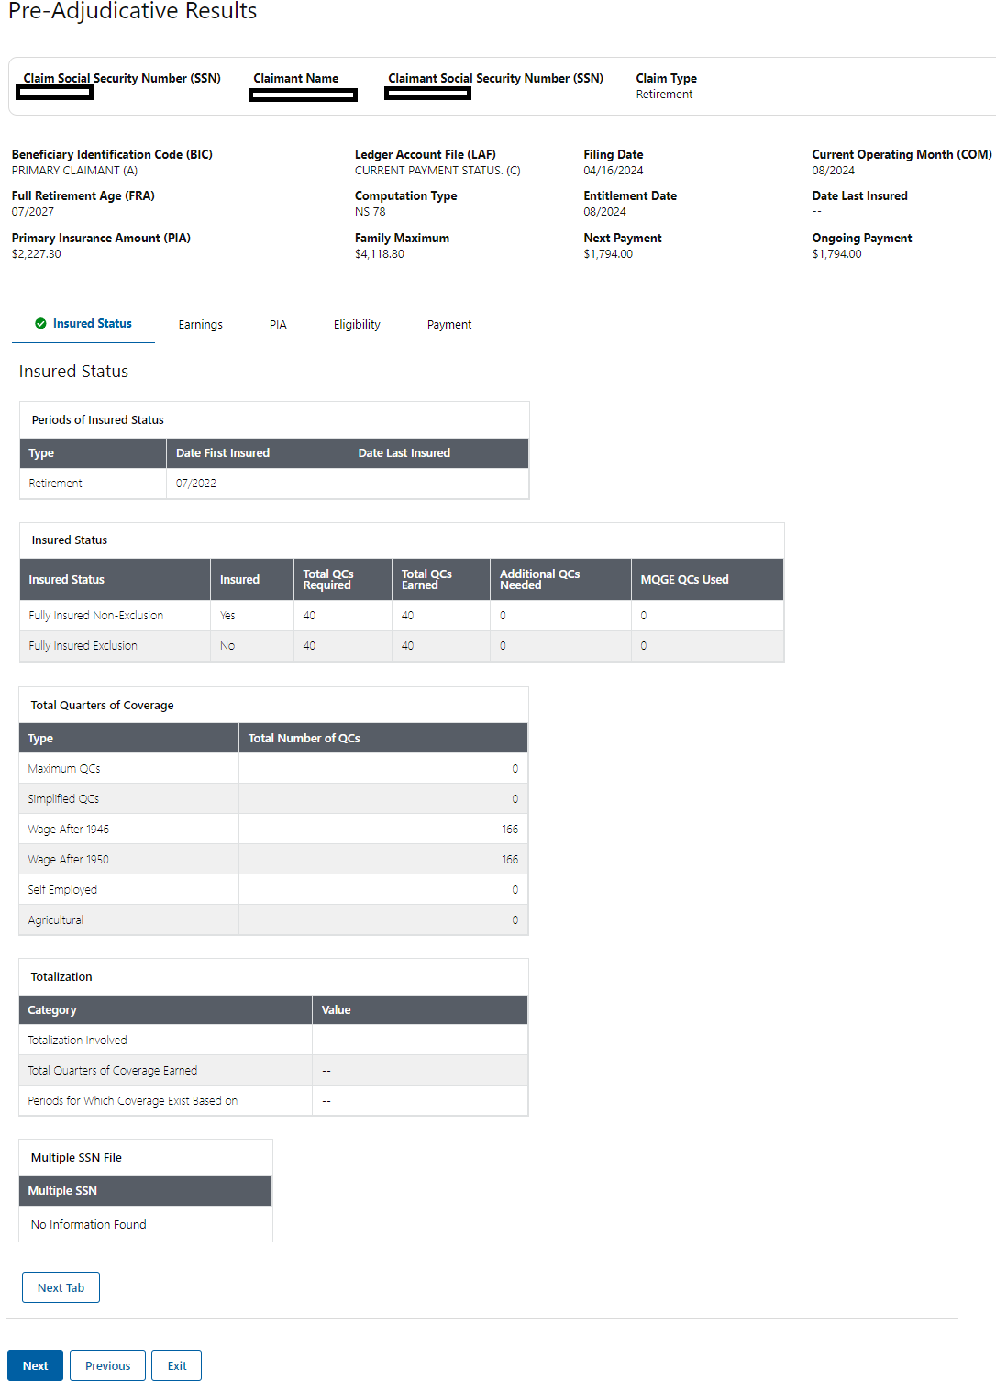 | Reformatted Pre-Adjudicative Results and Adjudicative Results
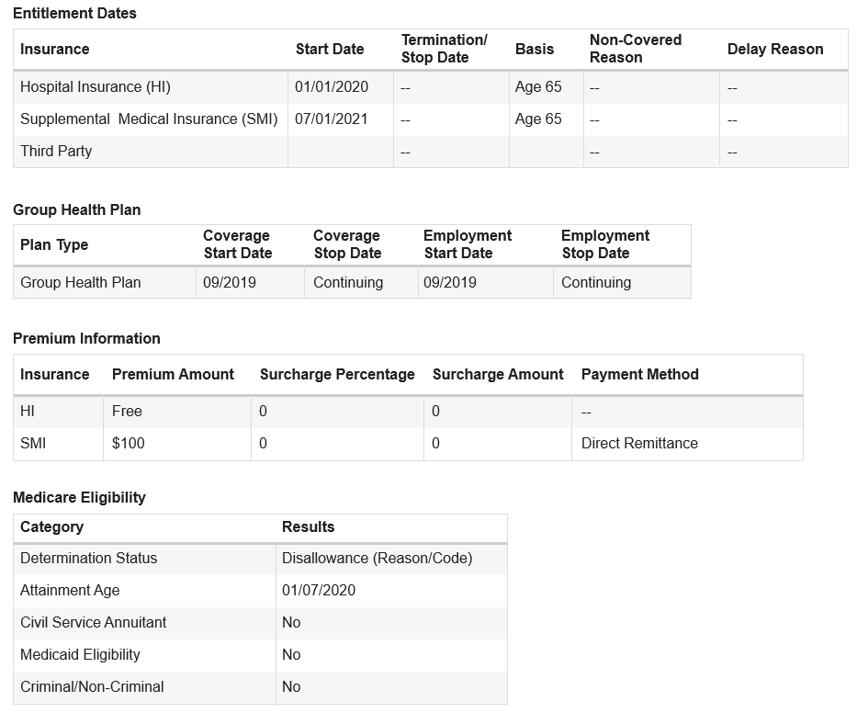 | 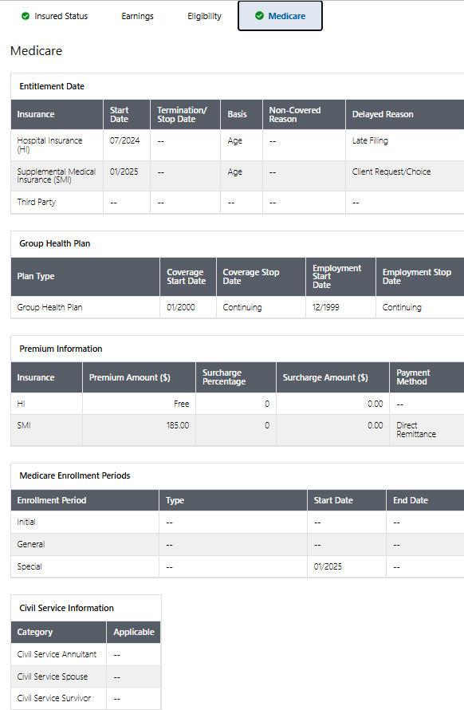 | Displaying Enrollment Periods and Civil Service Information
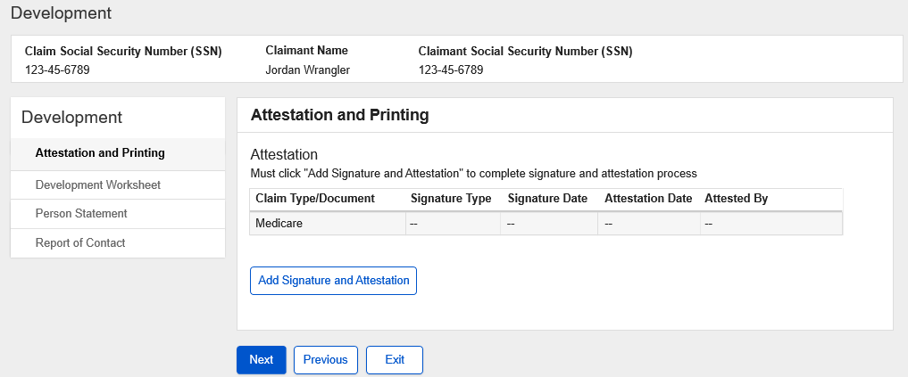 |  | Retitled the page and fields to reflect Signature and Certification rather than Attestation
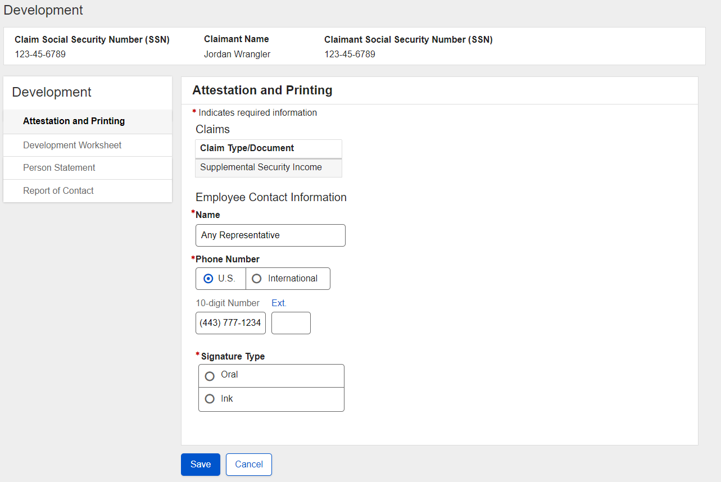 | 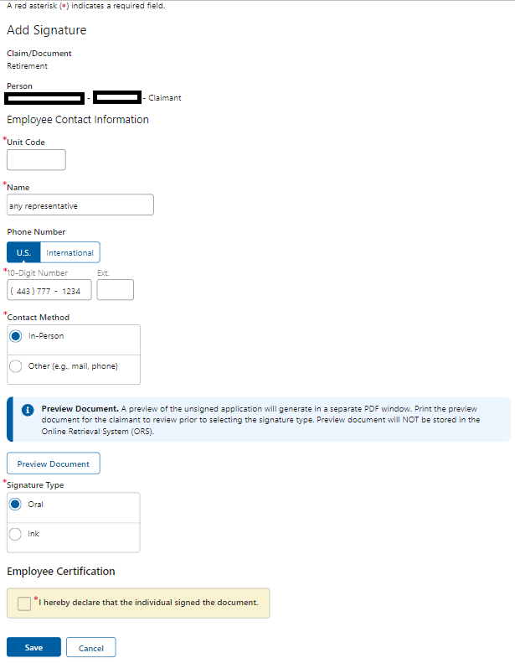 | Added unit code, contact method, preview document instructions (like for RIB)

