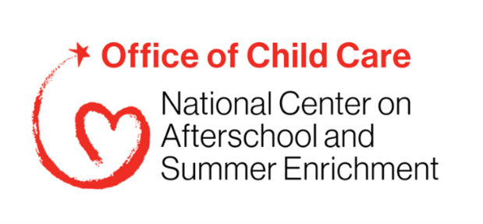
National Center on Afterschool and Summer Enrichment (NCASE)
Question Bank for Technical Assistance (TA) Polls & Discussion Prompts
PAPERWORK REDUCTION ACT OF 1995 (Public Law 104-13) STATEMENT OF PUBLIC BURDEN: The purpose of this information collection is to obtain feedback regarding technical assistance received. Public reporting burden for this collection of information is estimated to average 5minutes per respondent, including the time for reviewing instructions, gathering and maintaining the data needed, and reviewing the collection of information. This is a voluntary collection of information. An agency may not conduct or sponsor, and a person is not required to respond to, a collection of information subject to the requirements of the Paperwork Reduction Act of 1995, unless it displays a currently valid OMB control number. The OMB # is 0970-0401 and the expiration date is 5/31/2027. If you have any comments on this collection of information, please contact Carrie Liston, cliston@edc.org.

This document includes a bank of data collection questions to gather participant feedback of NCASE TA. Relevant items will be selected for each session. In any one session, participants would spend no more than 5 minutes responding to relevant questions.
Polls (During a webinar or PLG session)
What are you hoping to get out of this session? Select all that apply.
- Increase collaboration within my state around this topic
- Learn specific strategies and practices to apply to my state
- Learn about national trends and resources
- Learn from other states
- Share strategies and resources with other states
- Draft goals or an action plan for my state
- Have dedicated work time with others in my state on this topic
Before this session, how would you rate the level of collaboration around [this topic]?
- None
- Low
- Medium
- High
Prior to this session, what was your level of awareness related to this topic?
- Not at all aware
- Minimally aware
- Moderately aware
- Very aware
What are you most interested in learning about (this specific topic)? (open response question in chat box)
What were one or two things you learned during today’s session? (open response question in chat box)
What feedback, suggestions, or questions do you have related to today's session? (open response question in chat box)
What activities, if any, have you been able to do since the last session? Select all that apply.
- Communicated with my PLG state team members
- Reviewed PLG resources
- Communicated with others in my state outside my PLG team about this topic
- Worked on our state’s action plan
- Met with my state team
- Participated in individual check-in calls with NCASE staff
- Communicated with PLG participants from other states
- Other

Would you like to continue to meet with your PLG lead on a periodic basis to continue strengthening your partnership work?
- Yes
- No

Would you like to meet with other states on a periodic basis to continue fostering these partnerships?
- Yes
- No

Discussion Prompts (During a webinar or PLG session)

Partnerships are important because...

What is one thing you wish other organizations knew about you?

What is something you would like to learn more about from this organization?

Who are your regular partners?

How does your organization benefit from those partnerships?

How has your organization been successful in using multiple funding sources?

