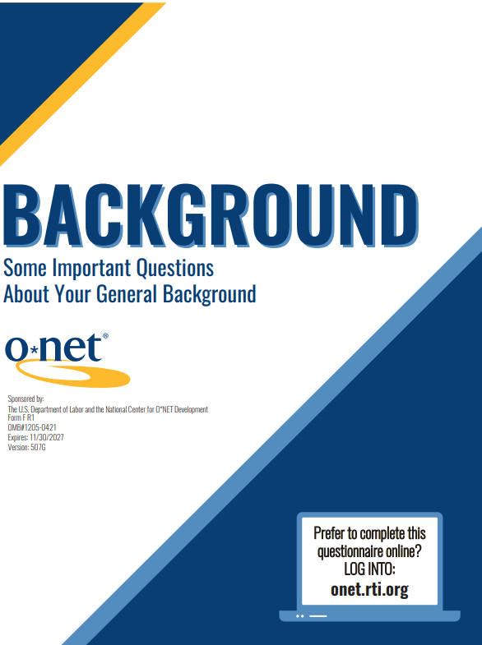

Instructions for Making Knowledge Ratings

Persons are not required to respond to this collection of information unless it displays a currently valid OMB control number. Respondents' obligation to reply to these reporting requirements is voluntary. Public reporting burden for this collection of information is estimated to average 5 minutes per response, including the time for reviewing instructions, and completing and reviewing the collection of information.
Send comments regarding this burden estimate or any other aspect of this collection of information, including suggestions for reducing this burden to the U.S. Department of Labor, Office of Workforce Investment, Attn: O*NET Project, Frances Perkins Building, Mail Stop C4526, 200 Constitution Ave., NW, Washington, DC 20210 (OMB Control Number 1205-0421).

Return to: Research Triangle Institute
Research Operations Center
ATTN: O*NET Data Receipt
5265 Capital Boulevard
Raleigh, NC 27616-2925

TURN THE PAGE TO START THE SURVEY

Getting Started
Mark your response by placing a check mark, an “X,” or completely filling in the circle:

X
 | or |  | or
The goal of this project is to get accurate, up-to-date information on the occupation from a representative set of experts in the field. Please answer the following questions to help us achieve this goal.
Nannies
Care for children in private households and provide support and expertise to parents in satisfying children’s physical, emotional, intellectual, and social needs. Duties may include meal planning and preparation, laundry and clothing care, organization of play activities and outings, discipline, intellectual stimulation, language activities, and transportation.
- When were you last active in this occupation? Please consider the last time you performed work, supervised workers, conducted training, or taught educational courses in the occupation.
Currently active in this occupation
Within the last 6 months
At least 6 months ago, but less than 1 year
One year or more ago
Never active in this occupation Go to 7
2. What is the title of your most recent job in this occupation?

3. In your most recent job in this occupation, were you employed part-time or full-time?
Part-time
Full-time
4. Which of the following best describes your employer in your most recent job in this occupation?
Family business
Self-employed
Government
Private for-profit company
Non-profit organization, including tax-exempt and charitable organizations
Academic institution
Other (Specify)
5. How many years have you performed the work described in the occupation listed on the previous page?
Ten years or more
At least 5 years, but less than 10 years
At least 3 years, but less than 5 years
At least 1 year, but less than 3 years
Less than 1 year
Never performed work in the occupation
6. How much total experience do you have related to this occupation? Please include experience performing work, supervising workers, conducting training, and teaching educational courses in this occupation.
Ten years or more
At least 5 years, but less than 10 years
At least 3 years, but less than 5 years
At least 1 year, but less than 3 years
Less than 1 year
7. What sex were you assigned at birth, on your original birth certificate?
Female
Male
8. What is your age?
Less than 21 years old
21-40 years old
41-60 years old
61 years old or older

9. What is your race and/or ethnicity? Select all that apply.
American Indian or Alaska Native
For example, Navajo Nation, Blackfeet Tribe of the Blackfeet Indian Reservation of Montana, Native Village of Barrow Inupiat Traditional Government, Nome Eskimo Community, Aztec, Maya, etc.
Asian
For example, Chinese, Asian Indian, Filipino, Vietnamese, Korean, Japanese, etc.
Black or African American
For example, African American, Jamaican, Haitian, Nigerian, Ethiopian, Somali, etc.
Hispanic or Latino
For example, Mexican, Puerto Rican, Salvadoran, Cuban, Dominican, Guatemalan, etc.
Middle Eastern or North African
For example, Lebanese, Iranian, Egyptian, Syrian, Iraqi, Israeli, etc.
Native Hawaiian or Other Pacific Islander
For example, Native Hawaiian, Samoan, Chamorro, Tongan, Fijian, Marshallese, etc.
White
For example, English, German, Irish, Italian, Polish, Scottish, etc.
10. What is the highest level of education that you have completed?
Less than a High School Diploma
High School Diploma or the equivalent (such as a GED)
Post-Secondary Certificate
Some College Courses
Associate's Degree or other 2-year degree
Bachelor's Degree
Post-Baccalaureate Certificate
Master's Degree
Post-Master's Certificate
Doctor’s Degree – Professional Practice (such as a J.D. for Law or an M.D. for Medicine)
Doctor's Degree – Research/Scholarship (such as a Ph.D.)
Post-Doctoral Training
11. Are you deaf or do you have serious difficulty hearing?
Yes
No
12. Are you blind or do you have serious difficulty seeing even when wearing glasses?
Yes
No



Please return your completed questionnaire in the enclosed envelope to:
onet.rti.org
RTI Research Operations Center 5265 Capital Blvd
Raleigh, NC 27616-2925

