BLS 2025 FedCASIC Feedback Survey

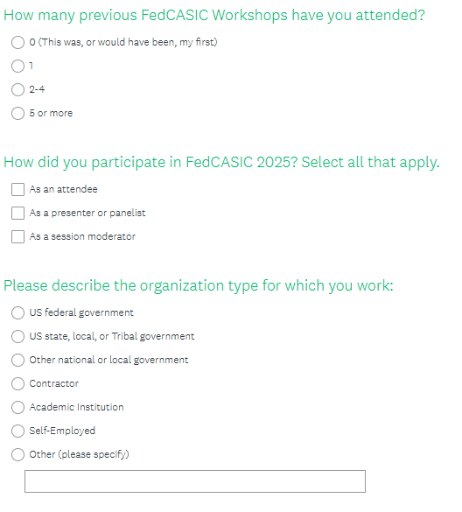

BLS FedCASIC-2025