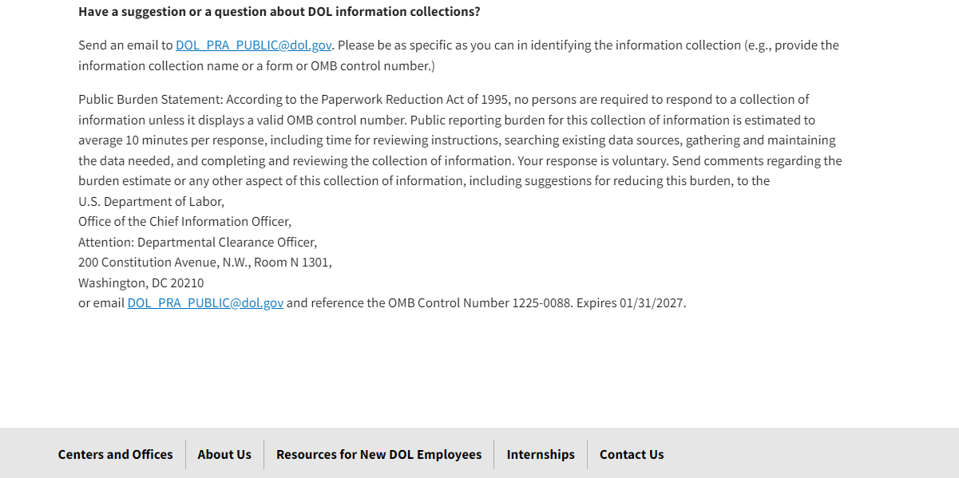

Paperwork Reduction Act | U.S. Department of Labor (dol.gov)

