**1660-0002 Disaster Registration Intake “Call Center” Updates**

**Personal Information Screen**

**Old Version with “Preferred Name (Optional)” and “non-Citizen” language. *Co-applicant page updated* *No original screenshot provided\***

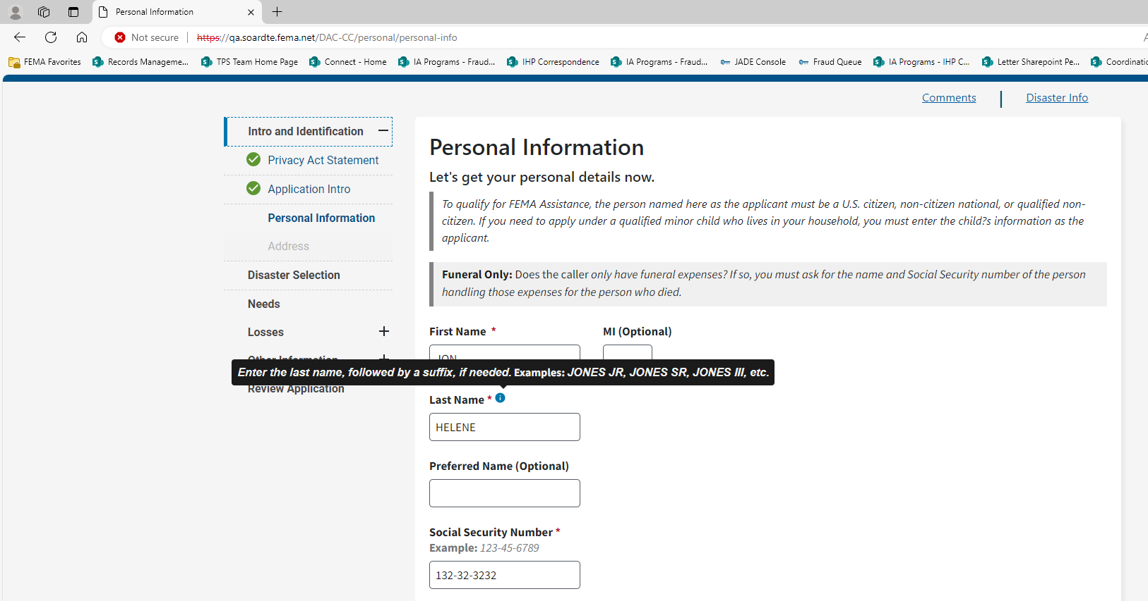

**New Version “Preferred Name (Optional)” removed, and “non-Citizen” changed to “Alien”.**

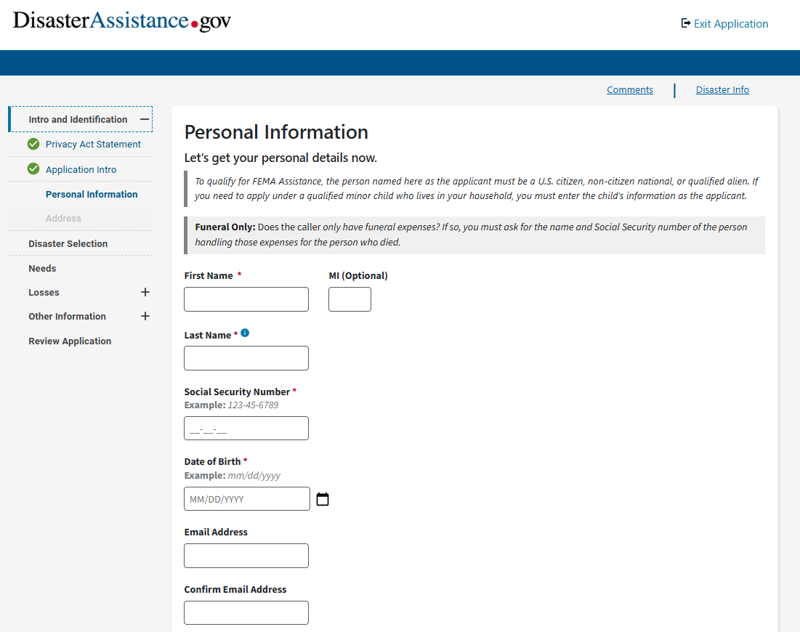

**Demographics Screen Removed**

