**1660-0002 Disaster Registration Intake “Public” Updates**

**Disaster Registration Intake “Public” Screens**

**Personal Information Screen**

**Old Version with “Preferred Name (Optional)”**

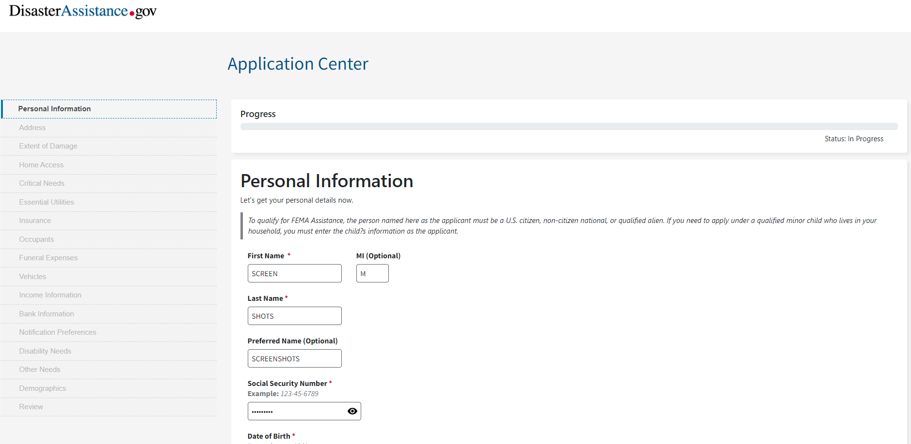

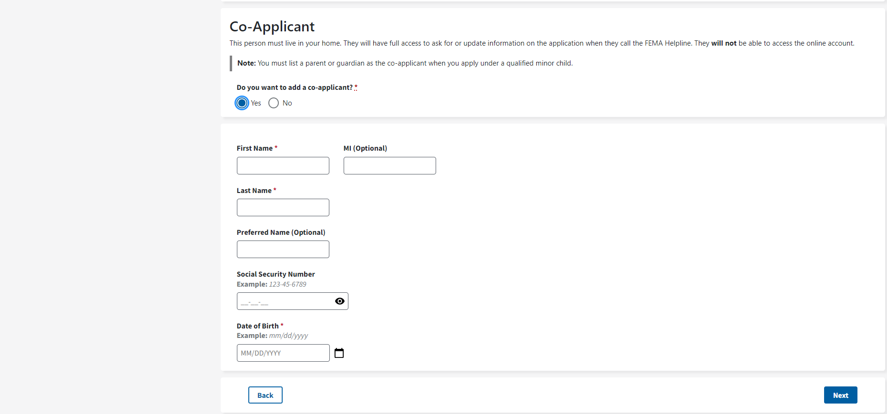

**Demographics Screen Removed**

