**Non-substantive Change Request**

**0535-0213 – Agricultural Surveys Program**

**AGRICULTURAL SURVEY - SEPTEMBER 1, 202x**

NASS will need a change to the September Agricultural Production Survey questionnaire for one State only: To add cotton acres planted and cotton acres to be harvested for Texas only.

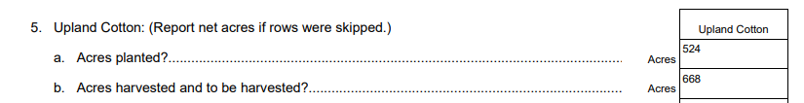

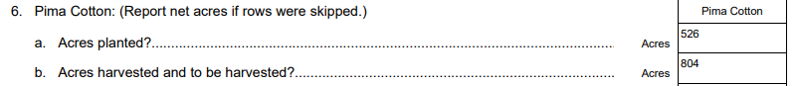

The September Agricultural Production Survey (September APS) is included with the March, June, and December Agricultural Production Surveys (APS) in OMB Control Number 0535-0213. The APS surveys provide detailed estimates of crop acreage, yields and production, and quantities of grain and oilseeds stored on farms. Specifically, the September Agricultural Survey asks questions related to production or yield of the small grains or cereal grains (all wheat varieties, barley, oats, and rye). Cotton acreage data are collected in the March, June, and December APS.

Over the last several years, Texas cotton acreage harvested has changed significantly from the August forecast to the final. For the 2023 production year, the final estimate was 46% below the August forecast. In 2020, the final estimate was 18% below August and in 2019, the final was 16% below August. NASS has been looking for options to take into account producer decisions that have changed since August to update cotton harvested acres. NASS looked into using FSA and RMA data to obtain the required information without additional respondent burden, but these data are delayed and do not give a complete picture. NASS is proposing to add cotton planted and harvested acreage questions only to Texas as this is the State that has had the most variability over the last several years. Also, Texas is the largest cotton acreage and production State. This proposed change would allow NASS to provide the agricultural and cotton industry a more timely and complete production forecast. NASS’ Methodology Division reviewed the current September Ag sample and confirmed that enough cotton samples are already in the current sample to produce a harvested acres indication, so additional burden would only be the two additional questions mentioned earlier.

These changes will not impact the current sample size or respondent burden.

The revised master questionnaire is loaded to ROCIS.

NOTE: This ICR has one survey that contains race/ethnicity questions that will be affected by SPD-15, the June Area Survey. The revised SPD-15 came too late to be implemented in the June 1, 2024 survey, but NASS will implement one of the two categories for the next iteration on June 1, 2025. It is requested that an exemption be granted committing NASS to one of two categories (for June 1, 2025) because the September 1, 2024 survey needs to be sent to the printer in July, 2024.