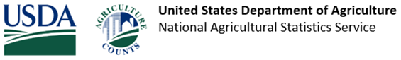
USDA NASS: Please complete the [CAMPAIGN.SHORT_SURVEY_NAME] at agcounts.usda.gov, Fax to [REGION.FAX] or mail for receipt by [CAMPAIGN.SURVEY_DUE_DATE_PARSED]. Thank you! Questions [REGION.PHONE]

