Request for Nonsubstantive Change
OMB Control Number: 0560-0237
July 14, 2025

Title of Clearance: Farm Loan Programs, Direct Loan Making

Agency Form Number affected by Change Worksheet: FSA-2028 “Security Agreement”

Other Changes: The specific changes to the Form FSA-2028 are the following:

- In part 2, language is added to include items acquired after the execution of the document as part of the overall collateral covered by the security agreement.
- In part 2(c), language is added to clarify that all equipment owned by the borrower is covered by the security agreement including any additions.

These changes are minor clarifications to the existing specific terms of the agreement. They do not require any additional data collection from the public. Due to the minor nature of these changes, they do not impact the estimated time per response or the estimated number of respondents.

FORM: FSA-2028 (Security Agreement) (2 changes)

Change 1: Language regarding collateral hereafter acquired added to Item 2 in the paragraph labeled “DEBTOR GRANTS”

CURRENT
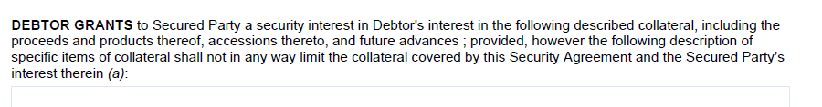
CHANGE

Change 2: Language regarding equipment collateral and additions thereto added to item 2(c)

CURRENT
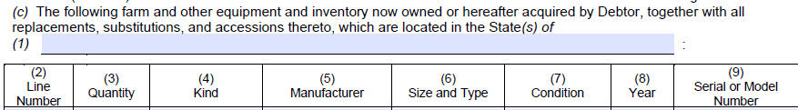

CHANGE

