**Request for Nonsubstantive Change**

**OMB Control Number: 0560-0155**

**July 14, 2025**

**Title of Clearance: Guarantee Loan Report of Loss**

**Agency Form Number affected by Change Worksheet:** FSA-2254

**Other Changes:** This form is used by FSA Guaranteed Lenders to report a loss on a FSA Guaranteed loan and provide details of the loss based on loan information. The time required to complete this information collection is estimated to average 25 hours per response, including the time for reviewing instructions, searching existing data sources, gathering and maintaining the data needed, and completing and reviewing the collection of information.

No changes are being made to the specific fields on the FSA-2254 or to the existing instructions for completing the FSA-2254. The lender completes the form and certifies to the completeness. The only changes are updates to add a certification and acknowledgement language associated with the submission of the form.

There is no change to the burden hours since the previous information collection request. The additions associated with this change do not require an additional information collection from the lender completing the form.

FSA has reviewed Form FSA-2254 and determined that the form requires the addition of a certification and acknowledgment section to the form certified by the lender when submitted. FSA requests approval for the nonsubstantive change as this change does not affect the response time or require additional information to be collected.

**Change 1: Addition of certification and acknowledgement section.**

**Current:**

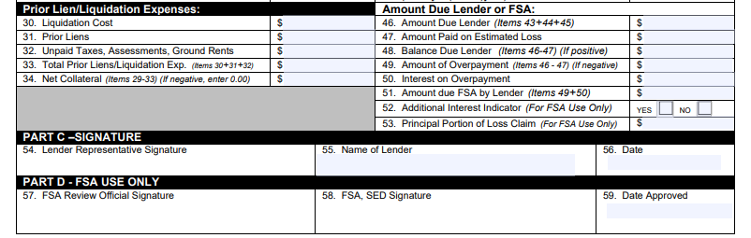

**Change:**

