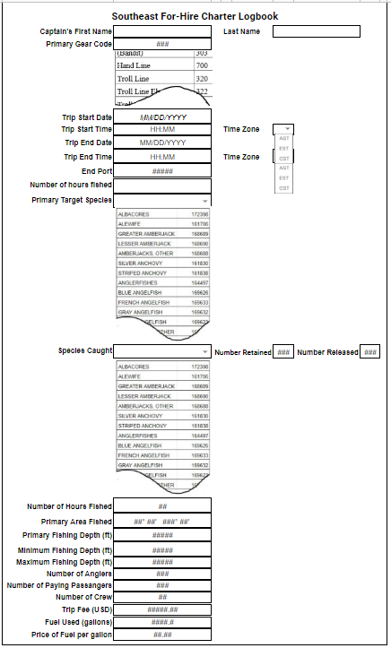

A federal agency may not conduct or sponsor, and a person is not required to respond to, nor shall a person be subject to a penalty for failure to comply with an information collection subject to the requirements of the Paperwork Reduction Act of 1995 unless the information collection has a currently valid OMB Control Number. The approved OMB Control Number for this information collection is 0648-0016. Without this approval, NMFS could not conduct this information collection. Public reporting burden for this information collection is estimated to be 10 minutes each for the fishing report, including the time for reviewing instructions, searching existing data sources, gathering and maintaining the data needed, and completing and reviewing the information collection. All responses to this information collection are mandatory pursuant to the Magnuson-Stevens Act (16 U.S.C. 1801 *et seq*). Send comments regarding this burden estimate or any other aspect of this information collection, including suggestions for reducing this burden to the NMFS, Southeast Regional Office F/SER2, Attn: PRA Officer, 263 13th Ave. South, St. Petersburg, FL 33701.

**Privacy Act Statement** –

**Authority**: This information collection is authorized under the Magnuson-Stevens Fishery Conservation and Management Act (16 U.S.C 1801 *et seq*.), the High Seas Fishing Compliance Act, the American Fisheries Act, and the Atlantic Coastal Fisheries Cooperative Management Act.

**Purpose:** To manage U.S. fisheries, permit holders must submit trip-level electronic fishing reports (logbooks) at weekly intervals, or at shorter intervals if notified by NMFS, through NMFS-approved hardware and software. Information collected includes fishing location and effort, fish harvested and discarded, as well as socio-economic and other data.

**Routine Uses**: The Commerce Department will use this information to ensure compliance with the regulations at 50 CFR part 622. Disclosure of this information is permitted under the Privacy Act of 1974 (5 U.S.C. Section 552a), to be shared among NMFS staff to coordinate monitoring and management of sustainability of fisheries and protected resources, as well as with the applicable state or regional marine fisheries commissions and international organizations. Disclosure of this information is also subject to all of the published routine uses as identified in the Privacy Act System of Records Notice COMMERCE/NOAA-6, Fishermen's Statistical Data.

**Disclosure**: Furnishing this information is mandatory. Making a false statement on these forms is punishable by law. Failure to provide complete and accurate information will prevent the determination of compliance and eligibility to obtain benefits..