***PRA Application Supporting Statement***

**OMB Control #0693-0078**

**Expiration Date: 07/31/2025**

**NIST Generic Clearance for Community Resilience Data Collections**

**NIST HURRICANE MARIA STUDY,**

**HURRICANE MARIA RECOVERY OF INFRASTRUCTURE PROJECT:**

**INFRASTRUCTURE INTERDEPENDENCY FOLLOWING HURRICANE MARIA**

**MUNICIPAL TRANSPORTATION SYSTEM INTERVIEW**

**FOUR STANDARD SURVEY QUESTIONS**

This PRA application covers the Infrastructure Interdependency Interview for the Recovery of Infrastructure component of the scientific study of Hurricane Maria (henceforth the *Recovery of Infrastructure Project*).

## 1. Explain who will be surveyed and why the group is appropriate to survey.

NIST is conducting an interview of a purposive sample of infrastructure service providers in Puerto Rico in order to learn how disruptions related to Hurricane Maria impacted their recovery. The semi-structured interviews target specific representatives of municipal transportation systems who meet certain eligibility criteria. Criteria include (1) agreeing to participate in the study, (2) working in the geographic location/NIST study area (Figure 1), (3) holding relevant position during the Hurricane Maria timeframe and having an understanding of the response and recovery efforts and (4) being an adult (18 years of age or older). By targeting suitable organizational representatives, the study will provide direct insight into transportation service before and after Hurricane Maria, disruptions in transportation service, the impact to service of disruptions in goods and services, including other infrastructure service providers, on which the transportation system relies, the recovery process from Hurricane Maria, as well as actions taken by the organization to prepare for future hurricanes.

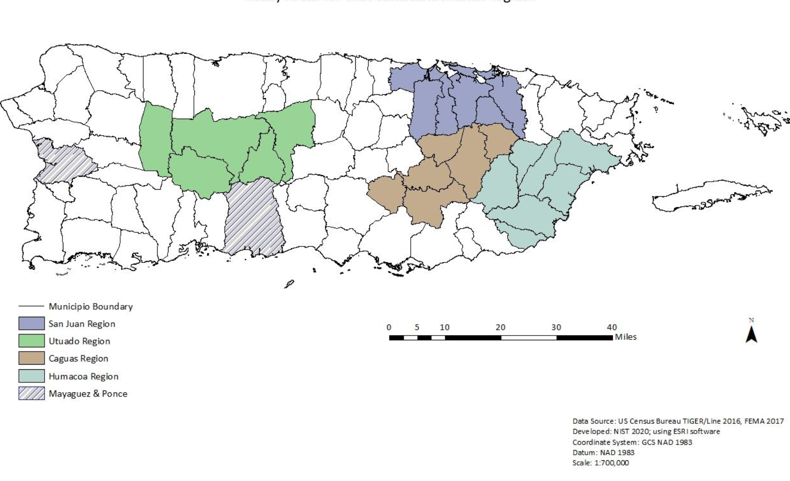

Figure 1. Study Area includes municipios in four regions plus Mayaguez and Ponce

The category *Transportation Systems* is one of 16 critical infrastructure sectors defined by the Cybersecurity and Infrastructure Security Agency (CISA)[1]. CISA defines critical infrastructure as those assets, systems, and networks that provide functions necessary for our way of life. The *Transportation Systems* sector consists of seven key sub-sectors including aviation, highway and motor carrier, maritime transportation system, mass transit and passenger rail, pipeline systems, freight rail, and postal and shipping subsectors. CISA describes that a transportation system “quickly, safely, and securely moves people and goods through the country and overseas”.

By identifying the underlying characteristics and conditions associated with recovery of the transportation system from Hurricane Maria and its dependence on the functioning of the other infrastructure service providers (e.g.s., power, water), this work will allow us to make recommendations for improving the resilience of our infrastructure systems.

**Project Background:** The research objective of the *Recovery of Infrastructure Project* is to identify the underlying characteristics and conditions associated with recovery of infrastructure from Hurricane Maria in Puerto Rico.

This study falls within a broader program of activity at NIST - the Hurricane Maria Program. Under this program, there is both a technical investigation of Hurricane Maria and its impacts on Puerto Rico and a scientific study of the impacts of and recovery from Hurricane Maria. As complementary components of the NIST Hurricane Maria Program, the NCST technical investigation and the NWIRP research study are closely coordinated. Under the National Windstorm Impact Reduction Act Reauthorization of 2015 (Public Law 114-52), NIST is conducting a scientific study of the impacts of and recovery from Hurricane Maria. The National Windstorm Impact Reduction Act Reauthorization (Public Law 114-52) designates NIST as the lead agency for the National Windstorm Impact Reduction Program (NWIRP) and gives NIST responsibility to:

* Ensure that the Program includes the necessary components to promote the implementation of windstorm risk reduction measures;
* Support the development of performance-based engineering tools, and working with appropriate groups to promote the commercial application of such tools;
* Request the assistance of Federal agencies other than the Program agencies, as necessary;
* Coordinate all Federal post-windstorm investigations to the extent practicable; and
* When warranted by research or investigative findings, issue recommendations to assist in informing the development of model codes, and provide information to Congress on the use of such recommendations.

NWIRP was established by Congress “…to achieve major measurable reductions in the losses of life and property from windstorms through a coordinated Federal effort, in cooperation with other levels of government, academia, and the private sector, aimed at improving the understanding of windstorms and their impacts and developing and encouraging the implementation of cost-effective mitigation measures to reduce those impacts.”

Under the NWIRP authority, NIST is conducting a scientific study of Hurricane Maria’s impacts on Puerto Rico and subsequent recovery processes. The three main goals of the study are to characterize the impacts to and recovery of: (1) small and medium-sized manufacturers (SMMs), as well as businesses in retail and service industries, (2) education and healthcare services, and (3) infrastructure systems, with a focus on infrastructure that supports the functioning of critical buildings (i.e., schools and hospitals) and emergency communications.

## 2. Explain how the survey was developed including consultation with interested parties, pre-testing, and responses to suggestions for improvement.

The interview guide was developed by NIST scientists and contractors with backgrounds in sociology, geography, anthropology, and engineering through a series of development and quality control activities. The interview guide was reviewed in depth by scientists and engineers with backgrounds in disaster resilience, infrastructure system modeling, and operations research. The interview guide explores the characteristics and conditions that influence infrastructure recovery and resilience in the context of disasters.

This work directly builds on a previous NIST study[2] examining the “critical path” to recovery of a community, including an infrastructure system, where critical path refers to those activities, the completion of which, determine the timing of when services are recovered. The methodology in that study entailed the assembly of a group of community stakeholders, including infrastructure service providers, to map out the critical path. In contrast, here, with individual semi-structured interviews, we are testing out an alternative, less costly approach to obtaining the needed information for a new and much larger set of geographical areas.

After a draft interview guide was developed, NIST researchers obtained feedback from subject matter experts in infrastructure systems modeling and from social scientists conducting work on disaster resilience to better assess question wording, complexity, and overall burden. This review also included members of the contractor team that is working with NIST. Administration of a small pilot involving 2 municipal transportation system interviews led to several revisions that reduced the length and cognitive burden of the interviews. Other, minor revisions were made to the interview questionnaire to enhance clarity and improve consistency in wording. These include changes to word choice, formatting, scripting for interviewers, and ordering of questions, and elimination of ineffective questions.

## 3. Explain how the survey will be conducted, how customers will be sampled if fewer than all customers will be surveyed, expected response rate, and actions your agency plans to take to improve the response rate.

NIST, in partnership with contractors who can utilize trained personnel local to Puerto Rico, will interview municipal transportation system representatives in the study area (Figure 1). Semi-structured interviews shall be administered to the representatives of a purposive sample of municipal transportation systems. The sampling strategy will identify the initial list of interviewees for municipal transportation systems to be invited for study participation. From this initial list of interviewees, the Contractor will follow a snowball sampling strategy to identify additional interview candidates. The interviews, via a combination of open-and-close-ended questions, will allow for collecting detailed and in-depth information on particular topics, such as the condition of the municipal transportation system prior to Hurricane Maria, a characterization of hurricane-related impacts to transportation service, and identification of the potential factors that lead to the loss of transportation services and/or influenced the time to recover from Hurricane Maria, and interviewee expectations for future similar hurricanes.

For those municipal transportation system representatives that are selected for the interview, NIST contractors will reach out through email or telephone. During this initial outreach, potential respondents will receive an introduction to the interview, including a description of the scope and objective of the interview, as well as a formal invitation to participate. All respondents, regardless of initial mode of contact, will have the option to specify their preferred mode for completing the interview (over the telephone, online via video conference, or in-person). If the respondent accepts the invitation to participate, an appointment for the 60-minute interview will be created. NIST contractors will contact the respondent at the predetermined time through the respondent’s preferred mode. After obtaining verbal consent, NIST Contractors will administer the interview. For the interview conducted by telephone, NIST contractors will telephone the respondent at a predetermined time and conduct the interview after obtaining verbal consent. For the interview conducted online via video conference, respondents will receive a confirmation email containing the video conference link and the interview date and time scheduled by the respondent. The confirmation email will also contain a unique ID and password. The respondent will be prompted to enter the unique ID and password to gain access to the virtual meeting space. Upon gaining access to the virtual meeting space, the respondent will be greeted by the interviewer, and the interviewer will obtain consent and proceed with the interview. In-person data collection will also depend upon successful initial contact and a prior appointment with the respondent. NIST contractors will arrive at the organization location at a predetermined time and conduct the interview in a private setting after obtaining verbal consent. It is anticipated that 50% of respondents will opt to complete the interview in person; 20% of respondents will opt to complete the interview by telephone; the remaining 30% of respondents are expected to complete the interview online via teleconference.

Interviews will be audio-recorded to help ensure the accuracy of responses, which will be transcribed for analysis. Consistent with IRB requirements, interviews will only take place once consent to be interviewed and permission to be audio-recorded has been granted by the interviewee. In-person interviews will be recorded using a digital audio recorder. Telephone interviews will be recorded using the Nuxiba audio-recording service. Video conference interviews will be recorded using the conferencing platform. At the conclusion of the interview, interviewers will thank participants for their time, and instructions will be provided on how to access online the status of the project and eventually study findings.

Given the sensitive nature of the interview topic and the lack of a sample frame data source, the study adopts a purposive sampling approach. The sample methodology seeks to capture a range of recovery experiences following Hurricane Maria and maximize representation across all infrastructure systems. However, certain criteria will be put in place to maximize representation and establish recruitment priorities. Representativeness in this study is defined as a sample that represents the perspectives of municipal transportation system representatives under study rather than matching the characteristics of the population under study. To maximize representation of all infrastructure sectors and municipal governments under study, attempts will be made to conduct 26 interviews of the municipal transportation system representatives. Based on the piloting, as well as the pilots conducted for the other infrastructure types, it is anticipated that a quarter (27% in the pilot) of potential respondents who are contacted will opt to complete the interview.

A combination of proactive measures and alternative data collection procedures are planned to achieve the expected response rate:

* Outreach efforts including the creation of the NIST Hurricane Maria webpage, introductory emails sent to municipal transportation system representatives, and a series of meetings between NIST researchers, stakeholders and representatives of the relevant governing bodies;
* Weekly monitoring of response rates over the course of data collection;
* Multiple communication attempts to individual municipal transportation system representatives as needed;
* A multi-mode approach for respondent completion (i.e., by telephone, online via video conference, in person).

No sensitive PII will be collected with this instrument, rather the contractor will link appropriate data before the information is translated to NIST, and NIST will retain no sensitive PII. Therefore, this is not a Privacy Act System and SORN and Privacy Act Notice are not applicable.

Time burden is calculated to be 26 respondents * 60 (minutes) = 26 burden hours.

## 4. Describe how the results of the survey will be analyzed and used to generalize the results to the entire customer population.

The aim of the semi-structured interview analysis is to summarize the full range of experiences of Hurricane Maria and subsequent recovery, and to identify critical recovery delays. This information will be joined with other secondary sources of data (e.g., agency damage assessment reports) to develop a more complete picture of infrastructure system recovery and resilience decision-making. Following the conclusion of data collection, the interviews will be transcribed and translated into English by the Contractor and, along with the closed-ended responses, delivered to NIST personnel for analysis. Interview transcriptions will be entered into a standard qualitative data software package (e.g., Atlas.ti, NVivo) for database construction and analysis. Descriptive coding techniques will be applied to interview content in order to identify key themes and constructs relating to infrastructure system recovery. Once formalized, the final codebook will be applied to all interview transcripts to identify overarching themes in the recovery process for municipal transportation systems, as well as to characterize the similarities and differences among the representatives’ experiences.

Ultimately, analysis of the interviews will support the description of the recovery of municipal transportation systems. The closed-ended questions will yield a variety of information: infrastructure condition prior to Hurricane Maria; the time taken to recover various attributes of transportation service (amount, safety, reliability); the identification of goods and services, including other infrastructure services, the disruptions in which most impacted service recovery; and the degree of and nature by which their organization and their system changed since Hurricane Maria with respect to resilience (e.g., parts inventories, generators, tanks, adoption of new codes and standards, changes to hazard plans, etc.). The coded responses to the open-ended questions, which typically were asked after a batch of close-ended questions, are expected to provide more specifics on the social context in which their organization’s recovery processes play out. A standard statistical approach will be applied to analyze the close-ended response data with the goal of, for example, assessing the drivers of the time required for service recovery. Analysis of the responses to the open-ended questions will provide needed context for interpreting the responses to the close-ended questions. These findings will be used to support the study’s ultimate recommendations.

1. https://www.cisa.gov/topics/critical-infrastructure-security-and-resilience/critical-infrastructure-sectors/transportation-systems-sector
2. https://www.nist.gov/publications/critical-path-method-assessment-community-recovery