AGENCY DISCLOSURE NOTICE
The public reporting burden for this collection of information, OMB Control Number: 0704-SMFP, is estimated to average one hour per response, including the time for reviewing instructions, searching existing data sources, gathering and maintaining the data needed, and completing and reviewing the collection of information. Send comments regarding the burden estimate or burden reduction suggestions to the Department of Defense, Washington Headquarters Services, at whs.mc-alex.esd.mbx.dd-dod-information-collections@mail.mil. Respondents should be aware that notwithstanding any other provision of law, no person shall be subject to any penalty for failing to comply with a collection of information if it does not display a currently valid OMB control number.

Thank you for participating in this focus group! We value your input. We would like to gather a few basic demographic and military characteristics about focus group participants to compare them to the characteristics of service members at this installation, as well as service members in each service branch. The form should take 1-2 minutes to complete.
This form is completely voluntary. You may skip any item you wish. If you do not wish to participate, please leave the questions blank. Your participation will not result in any loss of any benefit to which you are otherwise entitled. There are no significant risks or benefits associated with participation.
We will not link your identity to your responses, nor will we tell your leadership or anyone else in the military who completed or did not complete the survey. All results will be reported in the aggregate.
If you have questions about your rights as a research participant or need to report a research-related injury or concern, you can contact RAND's Human Subjects Protection Committee toll-free at (866​​) 697-5620 or by emailing hspcinfo@rand.org. When you contact the Committee, please reference Study #2022-N0421.
Q1. What is your current marital status? Please select one response.
- Married
- Living with a romantic partner (for example, a boyfriend or girlfriend)
- In a committed romantic relationship, but not living together
- Divorced and not currently in a relationship
- Widowed and not currently in a relationship
- Never married and not currently in a relationship
- Other: ________________

Q2. How old are you?

______ Years

Q3.
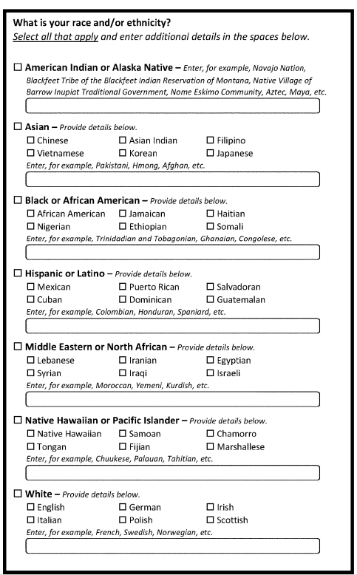

Q4. How many children under the age of 18 currently live with you? Please only include those children for whom you are legally responsible.

______ Children

Q5. What is your current military occupational specialty (MOS) or military occupational code (MOC)? This is usually a three- or four-digit number and/or letter combination.

___________

