ATTACHMENT 2a: MONTHLY IMPLEMENTATION ASSESSMENT INSTRUMENT (ENDS or Other Tobacco Product)
(VERSION 2-3-2025)

The Real Cost Campaign Monthly Implementation Assessment
(ENDS or Other Tobacco Product Ad Focus)

OMB No: [FILL NUMBER] Expiration Date: [FILL DATE]

Paperwork Reduction Act Statement: According to the Paperwork Reduction Act of 1995, an agency may not conduct or sponsor, and a person is not required to respond to a collection of information unless it displays a valid OMB control number. The public reporting burden for this collection of information has been estimated to average 25 minutes per response. Send comments regarding this burden estimate or any other aspects of this collection of information, including suggestions for reducing burden to PRAStaff@fda.hhs.gov

INTRO
This study is all about you.
Your thoughts, your opinions, your experiences.
We want to know about some of your experiences as you see [advertisements (ads)/displays/posts/gaming features/shows/etc.] on social media or streaming platforms. We also want to know about some of your beliefs and behaviors. We will ask you some questions about tobacco products. Even if you don’t use tobacco, we want to know what you think. Finally, we will also ask about your experiences with your parents and in your home.
It will take approximately 25 minutes for you to complete this survey. Please take your time and answer as honestly and thoughtfully as you can. Please take the survey in a place where no one can look over your shoulder and view your answers.
This study is sponsored by the U.S. Food and Drug Administration (FDA). Your answers may be shared with the FDA but will not be linked to any of your personally identifying information. We will not share any information you give us with your parents or anyone outside the research teams. As a reminder, your responses are only ever used for research purposes. You can choose not to answer any question. All your answers will be kept private to the fullest extent allowable by law. It is not completely safe to send data through the Internet, but we are doing everything we can to protect your data. We will code your survey data and send it over a secure connection for added protection.
Your responses will be combined with those of others who are taking this survey before the data are reported.

ASK: All respondents

INTRO_DOB. To confirm your eligibility, please enter your date of birth. Remember that your responses to this survey will not be shared with anyone outside of the study team and will remain confidential.
__________ (3 DROPDOWN BOXES WITH: (1) month (2) dd (3) yyyy)
INTRO_DOB_CONFIRM. To be sure we have the right information, please enter your date of birth again.
__________ (3 DROPDOWN BOXES WITH: (1) month (2) dd (3) yyyy)
[PROGRAMMER: INTRO_DOB AND INTRO_DOB_CONFIRM ARE SHOWN IN THE SAME SCREEN. CONFIRM THAT INTRO_DOB and INTRO_DOB_CONFIRM MATCH. IF NOT, DISPLAY: These dates do not match. Please reenter your date of birth.]
ASK: All respondents
COMPUTE RESPONDENT AGE (R_AGE)
CALCULATE AGE (R_AGE) BASED ON DATE OF INTERVIEW AND INTRO_DOB.
CHECKPOINT CHK1
IF R_AGE = 12-20, GO TO SECTION A.
IF R_AGE < 12 or > 20, GO TO END.
END. Thank you for your time. You are not eligible to participate in the survey at this time.
ASK: Youth whose calculated age (R_AGE) is < 12 or > 20.

MODULE A. Tobacco Use

The following questions are about [insert preamble such as: “vapes. You may also know them as e-cigarettes.
These products are battery-powered and produce vapor or aerosol instead of smoke. They contain nicotine liquid, sometimes called "e-liquid" or "e-juice," although the amount of nicotine can vary, and some may not contain any nicotine at all. Some can be bought as one-time, disposable products, while others can be bought as re-usable kits that are rechargeable. Some common brands include Puff Bar, Vuse, JUUL, SMOK, NJOY.

Please do not include vaping marijuana/THC/CBD/Delta 8 with these products when answering the questions in this section. “].
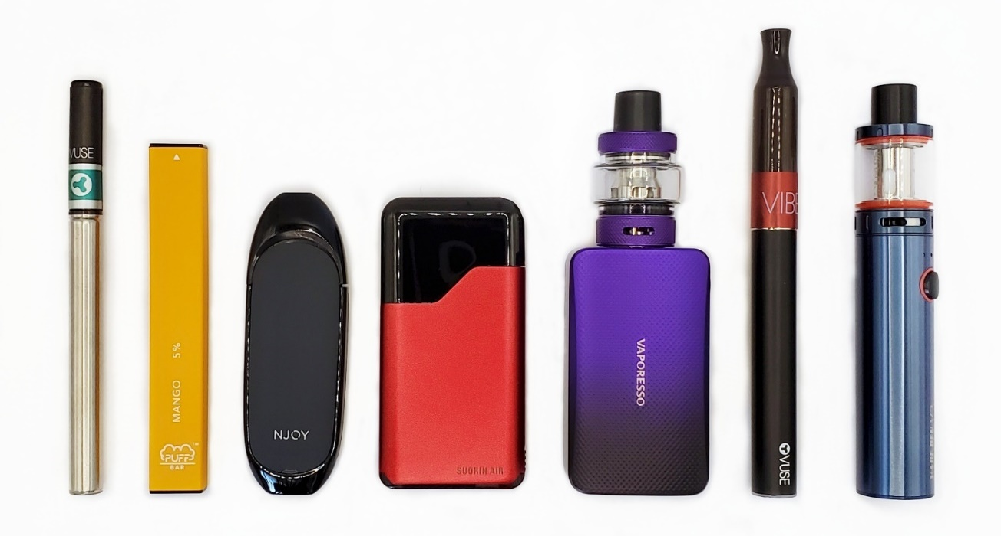

A1. Have you ever tried to [vape nicotine/other tobacco product], even one time?
- No
- Yes
ASK: All participants
A2. During the past 30 days, on how many days did you [vape nicotine/use other tobacco product]?
_____Days
ASK: Participants who answered (1) yes to A1

A3. Susceptibility Items:
 |  | Definitely Not | Probably Not | Probably Yes | Definitely Yes
A3_1 | Do you think that you might use an [e-cigarette or vape with nicotine/other tobacco product] soon? | ₁ | ₂ | ₃ | ₄
A3_2 | Do you think you will use an [e-cigarette or vape with nicotine/other tobacco product] in the next year? | ₁ | ₂ | ₃ | ₄
A3_3 | If one of your best friends were to offer you an [e-cigarette or vape with nicotine/other tobacco product], would you use it? | ₁ | ₂ | ₃ | ₄
A3_4 | Are you curious about using an [e-cigarette or vape with nicotine/other tobacco product]? | ₁ | ₂ | ₃ | ₄

ASK: Participants who answered [(0) to A1] OR [(0) to A2].
A4. Have you ever tried cigarette smoking, even one or two puffs?
- No
- Yes

ASK: All participants
A5. During the past 30 days, on how many days did you smoke cigarettes?
_____Days

ASK: Participants who answered (1) yes to A4

[PROGRAMMING INSTRUCTIONS FOR STIMULI NOT CURRENTLY IN-MARKET/ON AIR, FOR COPY TESTING]:
For assessments of TRC stimuli that are not in market (e.g., copy testing), questions in Sections B-D will not be fielded for those stimuli.

MODULE B. AWARENESS OF TRC CONTENT

[PROGRAMMING INSTRUCTIONS FOR SECTIONS B-D]:
- This section will ask participants to respond to up to 4 TRC stimuli.
- Participants will be presented with a part of the stimuli to jog their memory without re-exposing them to the entire stimuli)
- Participants will first be asked awareness about the stimuli. Then, they will be asked to provide more detailed information about all or some of the TRC stimuli. For example:
  - If participants are aware of <= 2 TRC stimuli, they may answer subsequent questions in Sections B-D about 1-2 of those stimuli.
  - If participants are aware of more than 2 pieces of TRC stimuli, participants may be randomized to answer subsequent questions in Sections B-D about 2 TRC stimuli.
  - If participants are not aware of any of the TRC stimuli, they will be directed to Section E.
- After eligible participants answer questions in Sections B-D, they will be directed to Section E.
- Awareness of in-market stimuli will be defined by B1_1.

B1. Awareness of Specific TRC content

ASK: All participants

[IF DISPLAYING VIDEO ADS]
B1_VIDEO. Please take a moment to turn on your speakers or headphones. Once you are ready, click the right-facing arrow below.

[DISPLAY SAMPLE VIDEO (A train with the whistle blowing); ADD A 5-SECOND TIMER BEFORE ALLOWING RESPONDENT TO PROCEED]
If the video loads properly, please wait 5 seconds for the right-facing arrow to appear.

What did you see and hear, if anything?
- A barking dog
- A train with the whistle blowing
- A car with the horn beeping
- A person knocking on a door
- A telephone that is ringing
- A musician playing the guitar
- I did not see or hear anything

ASK: All participants

Now we would like to show you some [ads/displays/posts/gaming features/shows/etc.] that have been shown in the U.S.

[DISPLAY VIDEO OR STATIC FILE FOR TRC STIMULI]
B1_1 Have you seen this [ad/display/post/gaming feature/show/etc.] in the past [week/30 days]?

- No
- Yes
ASK: All participants
B1_2. How certain are you that you have seen this [ad/display/post/gaming feature/show/etc.] in the past [week/30 days]?

- Not at all certain
- Somewhat certain
- Very Certain

ASK: For each TRC stimulus the participant noted seeing in the past [week/30 days].
B2. Repeated exposure

B2_1. Apart from this survey, how frequently have you seen this [ad/display/post/gaming feature/show/etc.] in the past [week, 30 days]?
- Rarely
- Sometimes
- Often
- Very Often
ASK: For each TRC stimulus the participant noted seeing in the past [week/30 days].
B2_2. Apart from this survey, approximately how many times have you seen this [ad/display/post/gaming feature/show/etc.] in the past [week, 30 days]?
___________ times [whole numbers between 1 and 100]
ASK: For each TRC stimulus the participant noted seeing in the past [week/30 days].

MODULE C. ATTENTION

Now we would like to ask you some questions based on the [ad/display/post/gaming feature/show/etc.] that you just saw. Your best guess is fine.

[DISPLAY STIMULI.]
C1. Catch Attention
Please tell us how much you disagree or agree with the following statement:

C1_1. This [ad/display/post/gaming feature/show/etc.] caught my attention when I saw it.
  - Strongly Disagree
  - Disagree
  - Neither Disagree nor Agree
  - Agree
  - Strongly Agree

ASK: For up to two TRC stimuli the participant noted seeing the past [week/30 days].
C2. Initial behavior/initial processing

C2_1.
The last time you saw this [ad/display/post/gaming feature/show/etc.], did you [skip it/scroll past it/ignore it]?
- No
- Yes
ASK: For each TRC stimulus the participant noted seeing the past [week/30 days].
C3. Reach
C3_1. Have you [watched/read/seen] this ENTIRE [ad/post/display/etc.] [without skipping/scrolling past] it at least one time?
- No
- Yes
ASK: For each TRC stimulus the participant noted seeing the past [week/30 days].
C4. Effortful Attention

Please tell us how much you disagree or agree with the following statement:

C4_1. How often do you pay attention while [watching/seeing/hearing/reading/etc.] this [ad/display/post/gaming feature/show/etc.]?

- Never
- Rarely
- Sometimes
- Most of the time
- Always
ASK: For each TRC stimulus the participant noted seeing the past [week/30 days].

MODULE D. PROCESSING
D1. Engagement with TRC Stimuli
The next few questions ask about how often you have done certain things when [watching/seeing/etc.] this [ad/post/etc.]. Your best guess is fine.

D1_1. When [watching/seeing/etc.] this [ad/post/etc.], how often have you...

[RANDOMIZE ORDER]
 |  | Never | Once | More than once
D1_1_1 | Turned the sound on, or volume up? | ¹ | ² | ³
D1_1_2 | Turned the sound off, or volume down? | ¹ | ² | ³
D1_1_3 | Made the [ad/post/etc.] full screen? | ¹ | ² | ³
D1_1_4 | Replayed the [ad/post/etc.]? | ¹ | ² | ³
D1_1_5 | Clicked on the [ad/post/etc.]? | ¹ | ² | ³
ASK: For each video TRC stimulus the participant noted seeing the past [week/30 days]
D1_2. Have you ever talked about this [ad/display/post/gaming feature/show/etc.] with a friend?

- No
- Yes
ASK: For each TRC stimulus the participant noted seeing the past [week/30 days]
D2. Dual Ad processing

[DISPLAY SCREENSHOT OF AD/DISPLAY/POST/GAMING FEATURE/SHOW/ETC.]
D2_1. The main message of the [ad/display/post/gaming feature/show/etc.] was… (multiple choice options based on the content that is airing)

[RANDOMIZE ORDER]
- Main Message 1
- Main Message 2
- Main Message 3
- Main Message 4
- Main Message 5
ASK: For each TRC stimulus the participant noted seeing the past [week/30 days]
Please tell us how much you disagree or agree with the following statements:
D2_2. There is far more information about vaping nicotine in this [ad/display/post/gaming feature/show/etc.] than I personally need.
- Strongly Disagree
- Disagree
- Neither Disagree nor Agree
- Agree
- Strongly Agree

ASK: For each TRC stimulus the participant noted seeing the past [week/30 days]
D2_3. I spent a lot of time thinking about this [ad/display/post/gaming feature/show/etc.].
- Strongly Disagree
- Disagree
- Neither Disagree nor Agree
- Agree
- Strongly Agree

ASK: For each TRC stimulus the participant noted seeing the past [week/30 days]
D3. Message processing

D3_1. When I saw this [ad/display/post/gaming feature/show/etc.] ...

... I thought about what I could do to make sure I never vape nicotine.

  - Strongly Disagree
  - Disagree
  - Neither Disagree nor Agree
  - Agree
  - Strongly Agree

ASK: For each TRC stimulus the participant noted seeing the past [week/30 days]
D3_2. When I saw this [ad/display/post/gaming feature/show/etc.] ...

… I thought I don’t have to worry about the harms of vaping nicotine at my age.

  - Strongly Disagree
  - Disagree
  - Neither Disagree nor Agree
  - Agree
  - Strongly Agree

ASK: For each TRC stimulus the participant noted seeing the past [week/30 days]
D3_3. When I saw this [ad/display/post/gaming feature/show/etc.] ...

... [TRC content-specific statement].

- Strongly Disagree
- Disagree
- Neither Disagree nor Agree
- Agree
- Strongly Agree

ASK: For each TRC stimulus the participant noted seeing the past [week/30 days]

BEFORE FIELDING SECTION E: RANDOMIZE PARTICIPANTS TO VIEW SELECTION OF TRC STIMULI
[PROGRAMMING INSTRUCTIONS]:

      - In this section, participants will be randomly assigned to view a selection of TRC stimuli. Stimuli may be TRC content that is currently in-market/on air, or new TRC content that has not yet been shown to the public.
      - After random assignment, participants will answer the questions in sections E-G about each stimulus.
      - Sections K and L will be asked if the stimulus is related to a TRC event (section K) or social media influencers (section L).

MODULE E. RECEPTIVITY

CUTEBRK1. Thank you for all of your answers so far. You’re doing great!
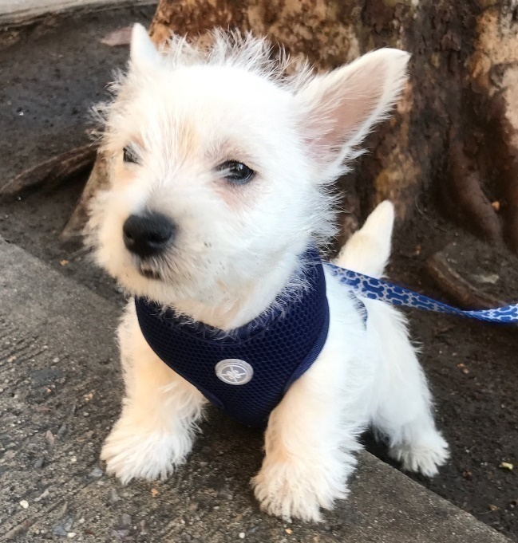

E_INTRO. We want you to show you a/an [ad/display/posts/gaming feature/show/etc.]. Please pay close attention as we will ask you several questions about it.

[SHOW STIMULI UP TO 2 TIMES IF NEEDED]

E1. Message Comprehension
Now, we would like to ask you some other questions about the [ads/displays/posts/gaming features/shows/etc.] we just showed you.

E1_1. How much do you disagree or agree with the following statement?
The main message of this [ad/display/post/gaming feature/show/etc.] was easy to understand.
- Strongly Disagree
- Disagree
- Neither Disagree nor Agree
- Agree
- Strongly Agree

ASK: For each TRC stimulus viewed
E1_2. The main message of the [ad/display/post/gaming feature/show/etc.] was… (multiple choice options based on content in the stimulus)

[RANDOMIZE ORDER]

- Main Message 1
- Main Message 2
- Main Message 3
- Main Message 4
- Main Message 5

ASK: For each TRC stimulus viewed; do not ask if respondent answered D2_1 correctly.
E1_3. How much do you disagree or agree with the following statement?

I found this [ad/display/post/gaming feature/show/etc.] to be confusing

- Strongly Disagree
- Disagree
- Neither Disagree nor Agree
- Agree
- Strongly Agree
ASK: For each TRC stimulus viewed.
E1_4. What is confusing about this [ad/display/post/gaming feature/show/etc.]? [Open-ended]
ASK: Participants who answer E1_3 = 4 or 5.
E2. Message Perceptions

E2_1. Perceived Effectiveness Scale
[RANDOMIZE ORDER]

Please tell us how much you disagree or agree with the following statements.
 |  | Strongly Disagree | Disagree | Neither Agree nor Disagree | Agree | Strongly Agree
E2_1_1 | This [ad/display/post/gaming feature/show/etc.] is worth remembering | ¹ | ² | ³ | ⁴ | ⁵
E2_1_2 | This [ad/display/post/gaming feature/show/etc.] grabbed my attention | ¹ | ² | ³ | ⁴ | ⁵
E2_1_3 | This [ad/display/post/gaming feature/show/etc.] is powerful | ¹ | ² | ³ | ⁴ | ⁵
E2_1_4 | This [ad/display/post/gaming feature/show/etc.] is informative | ¹ | ² | ³ | ⁴ | ⁵
E2_1_5 | This [ad/display/post/gaming feature/show/etc.] is meaningful | ¹ | ² | ³ | ⁴ | ⁵
E2_1_6 | This [ad/display/post/gaming feature/show/etc.] is convincing | ¹ | ² | ³ | ⁴ | ⁵
E2_1_7 | This [ad/display/post/gaming feature/show/etc.] is relevant to people my age. | ¹ | ² | ³ | ⁴ | ⁵
E2_1_8 | This [ad/display/post/gaming feature/show/etc.] feels modern and current. | ¹ | ² | ³ | ⁴ | ⁵
E2_1_9 | This [ad/display/post/gaming feature/show/etc.] is an acceptable way to talk about vaping nicotine. | ¹ | ² | ³ | ⁴ | ⁵
ASK: For each TRC stimulus viewed.
E3. Effects Perceptions
E3_1. Perceived Message Effectiveness Scale
[RANDOMIZE ORDER]
 |  | Not at all | Very little | Somewhat | Quite a bit | A Great Deal
E3_1_1 | How much does this [ad/display/post/gaming feature/show/etc.] make you worry about what [vaping nicotine/using other tobacco product] will do to you? | ¹ | ² | ³ | ⁴ | ⁵
E3_1_2 | How much does this [ad/display/post/gaming feature/show/etc.] make you think [vaping nicotine/using other tobacco product] is a bad idea? | ¹ | ² | ³ | ⁴ | ⁵
E3_1_3 | How much does this [ad/display/post/gaming feature/show/etc.] discourage you from [vaping nicotine/using other tobacco product]? | ¹ | ² | ³ | ⁴ | ⁵

ASK: For each TRC stimulus viewed.
E4. Emotional Reaction
E4_1 People sometimes have different emotional reactions when they see [ads/displays/posts/gaming features/shows/etc.]. Please indicate how much this [ad/display/post/gaming feature/show/etc.] made you feel:

[RANDOMIZE ORDER]
[LIST OF RELEVANT EMOTIONS WILL BE BASED ON THE STIMULI BEING TESTED]

 |  | Not at all | Very little | Somewhat | Quite a bit | A great deal
E4_1_1 | Sad | ¹ | ² | ³ | ⁴ | ⁵
E4_1_2 | Afraid | ¹ | ² | ³ | ⁴ | ⁵
E4_1_3 | Irritated | ¹ | ² | ³ | ⁴ | ⁵
E4_1_4 | Ashamed | ¹ | ² | ³ | ⁴ | ⁵
E4_1_5 | Curious | ¹ | ² | ³ | ⁴ | ⁵
E4_1_6 | Angry | ¹ | ² | ³ | ⁴ | ⁵
E4_1_7 | Amused | ¹ | ² | ³ | ⁴ | ⁵
E4_1_8 | Disgusted | ¹ | ² | ³ | ⁴ | ⁵
E4_1_9 | Uneasy | ¹ | ² | ³ | ⁴ | ⁵
E4_1_10 | Surprised | ¹ | ² | ³ | ⁴ | ⁵
E4_1_11 | Regretful | ¹ | ² | ³ | ⁴ | ⁵
E4_1_12 | Guilty | ¹ | ² | ³ | ⁴ | ⁵
E4_1_13 | Hopeful | ¹ | ² | ³ | ⁴ | ⁵
E4_1_14 | Motivated | ¹ | ² | ³ | ⁴ | ⁵
E4_1_15 | Understood | ¹ | ² | ³ | ⁴ | ⁵
E4_1_16 | Worried | ¹ | ² | ³ | ⁴ | ⁵
E4_1_17 | Discouraged | ¹ | ² | ³ | ⁴ | ⁵
E4_1_18 | Inspired | ¹ | ² | ³ | ⁴ | ⁵
E4_1_19 | Happy | ¹ | ² | ³ | ⁴ | ⁵
E4_1_20 | Determined | ¹ | ² | ³ | ⁴ | ⁵
E4_1_21 | Stressed | ¹ | ² | ³ | ⁴ | ⁵
E4_1_22 | Disappointed | ¹ | ² | ³ | ⁴ | ⁵
E4_1_23 | Confident | ¹ | ² | ³ | ⁴ | ⁵
E4_1_24 | [emotion] | ¹ | ² | ³ | ⁴ | ⁵
E4_1_25 | [emotion] | ¹ | ² | ³ | ⁴ | ⁵
E4_1_26 | [emotion] | ¹ | ² | ³ | ⁴ | ⁵

ASK: For each TRC stimulus viewed.
MODULE F. UNINTENDED CONSEQUENCES

F1. How much do you disagree or agree with the following statements?
[RANDOMIZE ORDER]
 |  | Strongly Disagree | Disagree | Neither Agree nor Disagree | Agree | Strongly Agree
F1_1 | This [ad/display/post/gaming feature/show/etc.] is trying to manipulate me | ¹ | ² | ³ | ⁴ | ⁵
F1_2 | The consequence of vaping in this [ad/display/post/gaming feature/show/etc.] is overblown | ¹ | ² | ³ | ⁴ | ⁵
F1_3 | This [ad/display/post/gaming feature/show/etc.] annoys me | ¹ | ² | ³ | ⁴ | ⁵

ASK: For each TRC stimulus viewed.

F2. Did this [ad/display/post/gaming feature/show/etc.] change how you thought about the harms of [vaping nicotine/using tobacco product] compared to smoking cigarettes?
  - No
  - Yes
ASK: For each TRC stimulus viewed.
F3. This [ad/display/post/gaming feature/show/etc.] made me think [vaping nicotine/using other tobacco product] is:
    - More harmful than smoking cigarettes
  - About the same amount of harm as smoking cigarettes
  - Less harmful than smoking cigarettes
ASK: For each TRC stimulus viewed. Ask if F2=1 (yes)

F4. On a scale of 1 to 5, indicate whether the [ad/display/post/gaming feature/show/etc.] made [vaping nicotine/using other tobacco product] look like something you would or would not want to do.

1  Makes me not want to [vape nicotine/use other tobacco product]. | 2 | 3 | 4 | 5  Makes me want to [vape nicotine/use other tobacco product].
ASK: For each TRC stimulus viewed.

Please indicate how much you disagree or agree with the following statement
F5. Vaping nicotine can increase your risk for developing an anxiety disorder.
- Strongly disagree
- Disagree
- Neutral
- Agree
- Strongly agree
ASK: For each anxiety related TRC stimulus viewed.
Please indicate how much you disagree or agree with the following statement
F6. [Using tobacco product] will lead to [consequence]
- Strongly disagree
- Disagree
- Neutral
- Agree
- Strongly agree
ASK: For each TRC stimuli viewed.
MODULE G. QUALITATIVE DISCUSSION GUIDE

INSTRUCTIONAL NOTE: Probes are asked for each stimuli that the participant views. The Qualitative Discussion Guide consists of questions that researchers anticipate are relevant to ask. However, this does not mean that every question listed will definitely be asked or asked in every focus group or in-depth interview. As per standard protocol for qualitative research, researchers will allow the conversation to unfold naturally. Certain questions listed may no longer be asked because they may not be relevant to a particular discussion.
Note: Moderators may swap the order of themes and tailor question prompts or probes depending on the discussion group or interview to allow the conversation to unfold naturally.

G1. Main Message
1. What do you think the [stimuli] is trying to say?
2. How would you describe the main idea/message to someone who hasn’t seen it?
3. Is there anything others might find confusing or unclear about this [stimuli]?
4. [Follow-up probes]

G2. Initial Reactions
1. Did you learn anything new from this [stimuli]?
- If yes, what did you learn?
2. What did you like about this [stimuli]?
3. What did you dislike?
4. How would you describe the tone of this [stimuli]? For example, was it funny, serious, something else? How did you feel about that?
5. [Follow-up probes]

G3. Believability/Compelling
1. Do you believe what this [stimuli] is trying to say?
- Why/why not?
- Is the fact [insert fact] believable?
- Do you feel like this [stimuli] is intended for someone like you?
- [Follow-up probes]

2. Do you feel like this [stimuli’s] main fact is intended for someone like you?
- Why/why not?
- [Follow-up probes]

  - Does this [stimuli] make you think twice about [vaping/using other tobacco product]?
- Why/why not?
- [Follow-up probes]

G4. Emotional Reaction
1. How did you feel while watching/viewing this [stimuli]?
- Alt: How did this [stimuli] make you feel?

G5. Stimuli Comparison
Facilitator: Now thinking about all the concepts that I shared with you today, please turn your attention to the poll on screen to take a couple minutes to answer the questions.
[On screen, there are screenshots of each [stimuli] shown in the group, with label below the screenshot and listed in order that they were presented.]
- Which [stimuli] does the BEST job at making you think twice about [vaping/using other tobacco product]?
- Which [stimuli] does the WORST job at making you think twice about [vaping/using other tobacco product]?
- Regardless of which [stimuli] you picked for the other questions, which of the following messages, separate from the [stimuli] themselves, does the BEST job at making you think twice about [vaping/using other tobacco product]?
- Which [stimuli] does the BEST job at grabbing your attention?
- Which [stimuli] does the WORST job at grabbing your attention?
- [Additional comparison items]
- What [stimuli] did you choose for doing the BEST job at making you think twice about [vaping/using other tobacco product], and why?
- What [stimuli] did you choose for doing the WORST job at making you think twice about [vaping/using other tobacco product], and why?
- Which message did you choose for doing the BEST job at making you think twice about [vaping/using other tobacco product]?, and why?
- Which [stimuli] does the BEST job at grabbing your attention?
- Which [stimuli] does the WORST job at grabbing your attention?
- Which [stimuli] would you show to someone to convince them
  - a) to stop [vaping/using other tobacco product]?
  - b) to prevent them from starting to [vaping/using other tobacco product]?

G6. Audience Insights
1. Describe your typical [weekday/weekend].
2. What do you do in your free time?
3. Do you have a job? Describe it.
4. Tell me about your friends – what are they like?
5. How are you similar or different from other [boys/girls] around here?
6. What is your family like?
7. Who are some of the people that are important to you?
8. Who are some people that you look up to?
9. How would your family describe you?
10. How would your closest friends describe you?
11. Describe your tobacco use
12. Describe beliefs/perceptions of tobacco use
13. [Other Audience Insight Probes]

MODULE H. PSYCHOGRAPHICS/AUDIENCE PROFILE
H_INTRO. Thanks for all your answers so far! We have just a few more questions for you.

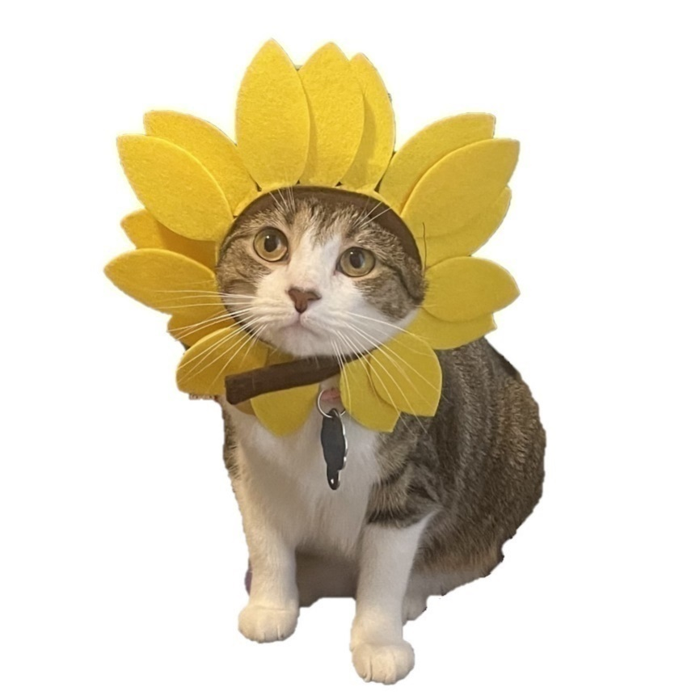

H1. Other than you, has anyone who lives with you used any of the following in the past 30 days? Select all that apply.
- Cigarettes
- Electronic vaping products or electronic cigarettes with nicotine, such as [NAME 3 TOP BRANDS]
- Cigars, cigarillos, or little cigars such as [NAME 3 TOP BRANDS]
- Any other form of tobacco (such as smokeless tobacco, tobacco out of a water pipe (“hookah”), nicotine pouches).
- No, no one who lives with me has used any form of tobacco during the past 30 days
ASK: All participants.
H2. How far do you think you will go in school?

- I don’t plan to go to school anymore
- 9th grade
- 10th grade
- 11th grade
- 12th grade or GED
- Some college or technical school but no degree
- Technical school degree
- College degree
- Graduate school, medical school, or law school

ASK: All participants.
H3. (Source: PATH)
In the past 12 months, have your parents or guardians talked with you, even once, about NOT vaping nicotine?
  - No
  - Yes
ASK: If participant age is < 18.
H4. How close do you feel to the adult or adults you live with?

- Not at all close
- Not very close
- Somewhat close
- Quite close
- Very close
ASK: If participant age is < 18.
H5. (Source: PHQ-4)
In the past 2 weeks, how often have you been bothered by the following problems?

 |  | Not at all | Several days | More than half the days | Nearly every day
H5_1. | Feeling nervous, anxious or on edge. | ₁ | ₂ | ₃ | ₄
H5_2. | Not being able to stop or control worrying. | ₁ | ₂ | ₃ | ₄
H5_3. | Little interest or pleasure in doing things. | ₁ | ₂ | ₃ | ₄
H5_4. | Feeling down, depressed, or hopeless. | ₁ | ₂ | ₃ | ₄

ASK: All respondents

MODULE I. DEMOGRAPHICS

I1. How old are you?

_____________years old

ASK: All participants.
I2. Are you: [Select one]

- Female
- Male
- ASK: All participants.
I 3. Which of the following best represents how you think of yourself? [Select one]
- Straight or heterosexual
- Gay or Lesbian
- Bisexual
- Other
ASK: All participants.
I4. What is your race and/or ethnicity? [Select all that apply and enter additional details in the spaces below]

American Indian or Alaska Native –
Enter, for example, Navajo Nation,
Blackfeet Tribe of the Blackfeet Indian Reservation of Montana, Native Village of
Barrow Inupiat Traditional Government, Nome Eskimo Community, Aztec, Maya, etc.
______________
Asian – Provide details below.
Chinese Asian Indian Filipino
Vietnamese Korean Japanese
Enter, for example, Pakistani, Hmong, Afghan, etc.
______________
Black or African American – Provide details below.
African American Jamaican Haitian
Nigerian Ethiopian Somali
Enter, for example, Trinidadian and Tobagonian, Ghanaian, Congolese, etc.
____________________
Hispanic or Latino – Provide details below.
Mexican Puerto Rican Salvadoran
Cuban Dominican Guatemalan
Enter, for example, Colombian, Honduran, Spaniard, etc.
___________________
Middle Eastern or North African – Provide details below.
Lebanese Iranian Egyptian
Syrian Iraqi Israeli
Enter, for example, Moroccan, Yemeni, Kurdish, etc.
____________________
Native Hawaiian or Pacific Islander – Provide details below.
Native Hawaiian Samoan Chamorro
Tongan Fijian Marshallese
Enter, for example, Chuukese, Palauan, Tahitian, etc.
____________ __________
White – Provide details below.
English German Irish
Italian Polish Scottish
Enter, for example, French, Swedish, Norwegian, etc.
_______________________

ASK: All participants.
I5. In general, do you usually speak...

- Only Spanish
- Spanish more than English
- Spanish and English equally
- English more than Spanish
- Only English

ASK: All participants
I6. How much money does your family have?
- Not enough to get by.
- Just enough to get by.
- Only have to worry about money for fun or extras.
- Never have to worry about money.

ASK: All participants.

MODULE J. MEDIA USE
J_INTRO. The next few questions will ask about your use of different types of media.
J1. Do you use any of the following social media platforms or sites at least once a [week/month]?

[RANDOMIZE ORDER]

 |  | No | Yes
J1_1 | Facebook | 0 | 1
J1_2 | Instagram | 0 | 1
J1_3 | Snapchat | 0 | 1
J1_4 | TikTok | 0 | 1
J1_5 | Reddit | 0 | 1
J1_6 | YouTube | 0 | 1
J1_7 | X (Formerly, Twitter) | 0 | 1
J1_8 | Twitch | 0 | 1
J1_9 | Wattpad | 0 | 1
J1_10 | Brainly | 0 | 1
J1_11 | Hudl | 0 | 1
J1_12 | Discord | 0 | 1
J1_13 | WhatsApp | 0 | 1
J1_14 | Lemon8 | 0 | 1
J1_15 | BeReal | 0 | 1
J1_16 | Threads | 0 | 1
J1_17 | [Platform] | 0 | 1
J1_18 | [Platform] | 0 | 1
J1_19 | Other platform or site | 0 | 1
ASK: All participants.

J1_19_OE. [ASK IF J1_19=1 (yes)]
What other social media platforms or sites do you use at least once a [week/month]? [Open-ended]
ASK: Participants who select “yes” to “other”
J2. How much time do you spend on each of the following social media platforms in a typical day? [Matrix format]
- Do not use in a typical day
- Less than 1 hour
- 1-3 hours
- 4 or more hours
ASK: For each platform selected in J1
J3a. Who are some of the social media influencers that you find particularly interesting? [Open-ended]
  - I don’t find any social media influencer interesting

ASK: All participants.
J3b. What type of content do you follow on social media? (e.g., cooking, gaming, fishing, fashion, dog videos, etc.) [Open-ended]
  - I don’t follow content on social media

ASK: All participants.

J4. Do you watch any of the following streaming services at least once a [week/month]?

[RANDOMIZE ORDER]

 |  | No | Yes
J4_1 | Netflix | 0 | 1
J4_2 | Hulu | 0 | 1
J4_3 | Amazon Prime | 0 | 1
J4_4 | YouTube TV | 0 | 1
J4_5 | Disney+ | 0 | 1
J4_6 | Max (HBO) | 0 | 1
J4_7 | Apple TV+ | 0 | 1
J4_8 | Peacock | 0 | 1
J4_9 | Paramount+ | 0 | 1
J4_10 | Sling TV | 0 | 1
J4_11 | Fubo | 0 | 1
J4_12 | TubiTV | 0 | 1
J4_13 | Twitch | 0 | 1
J4_14 | Crunchyroll | 0 | 1
J4_15 | The Roku Channel | 0 | 1
J4_16 | Freevee | 0 | 1
J4_17 | [Service] | 0 | 1
J4_18 | [Service] | 0 | 1
J4_19 | Other streaming service | 0 | 1

ASK: All participants.
J4_19_OE. [ASK IF J4_19=1 (yes)]
What other streaming services do you use at least once a [week/month]? [Open-ended]
ASK: Participants who select “yes” to “other” in J4
J5. When you watch each of the following streaming services, are there video advertisements during the shows/movies?
- No, there are no video ads at all
- Yes, there are video ads
ASK: For each streaming service selected in J4 where there is an ad-free option.
J6. How much time do you spend watching each of the following streaming services in a typical day? [Matrix format]
- Do not use in a typical day
- Less than 1 hour
- 1-3 hours
- 4 or more hours
ASK: For each streaming service selected in J4
J7. What shows/movies are you currently watching on [STREAMING SERVICES SELECTED IN J4]? [Open-ended]
ASK: Participants who select “yes” to at least one streaming service in J4
J8. Which device(s) do you typically use to watch streaming services? Please check all that apply.
- Smart TV/Connected TV (internet connected TV with apps)
- Cable TV (like Xfinity or Spectrum)
- Laptop
- Desktop
- Smartphone
- Tablet
- AppleTV
- Roku
- Amazon Fire
- TiVo
- Google Chromecast
- Gaming consoles (like PlayStation or Xbox)
- [Device]
- Other __________
- I do not use any devices to watch content [EXCLUSIVE]
- Prefer not to answer [EXCLUSIVE]
ASK: Participants who select “yes” to at least one streaming service in J4
J9. Do you use any of the following audio services at least once a [week/month]?

[RANDOMIZE ORDER]

 |  | No | Yes
J9_1 | Spotify | 0 | 1
J9_2 | Pandora | 0 | 1
J9_3 | Soundcloud | 0 | 1
J9_4 | YouTube Music | 0 | 1
J9_5 | Amazon Music | 0 | 1
J9_6 | Apple Music | 0 | 1
J9_7 | Tidal | 0 | 1
J9_8 | iHeart Radio | 0 | 1
J9_9 | Sirius XM | 0 | 1
J9_10 | [Service] | 0 | 1
J9_11 | [Service] | 0 | 1
J9_12 | Other audio service | 0 | 1
ASK: All participants.
J9_12_OE. [ASK IF J9_12=1 (yes)]
What other audio services do you use at least once a [week/month]? [Open-ended]
ASK: Participants who select “yes” to “other” in J9
J10. When you listen to each of the following audio services, are there advertisements?
- No, there are no ads at all
- Yes, there are ads
ASK: For each audio service selected in J9
J11. What mobile or video games do you play at least once a [week/month]? This includes games on a cellphone, console, or computer. [Open-ended]
- I don’t play any games
ASK: All participants.

J12. How often do you go to the movies at a movie theater?
- Once a week or more often
- One or two times a month
- Once every two or three months
- One or two times a year
- I do not see movies at a movie theater
- Prefer not to answer

ASK: All participants.

J13. What movies have you been to in the past [week/month]?
- Movie 1
- Movie 2
- Movie 3
- [Movie]
- Other __________
- Prefer not to answer

ASK: Respondents who indicated movie attendance in J12.

MODULE K. TRC EVENTS (include if there are TRC events occurring during or leading up to data collection)

K_INTRO. The next few questions will ask you about special events that have recently occurred in the U.S., either online or in person.

K1. Have you heard of [event]?
      - No
      - Yes
ASK: All
[IF K1=1 (yes)]
K2. Where did you hear about [event]? Select all that apply.
            - Online promotion
            - From a friend or family member
            - Placeholder source
            - Placeholder source
            - Placeholder source
ASK: For participants who heard of event.
[IF K1=1 (yes)]
K3. In the past [week/30 days/etc.] did you [attend event/follow event online]?
      - No
      - Yes
ASK: For participants who heard of event.
[IF K3=1 (yes)]
K4. When you [attended event/followed event online], did you see or hear anything from The Real Cost about the harms of [vaping nicotine/using other]?
      - No
      - Yes
ASK: For participants who attended/followed event.
[IF K3=1 (yes)]
K5. When I saw or heard The Real Cost’s messages at [event]…
… I really paid attention to it.
- Strongly Disagree
- Disagree
- Neither Disagree nor Agree
- Agree
- Strongly Agree
ASK: For participants who heard of TRC at event.
[IF K4=1 (yes) AND (A1=0 OR A2=0) OR (A4=0 OR A5=0)]
K6. When I saw or heard The Real Cost’s messages at [event]…
... I thought about what I could do to make sure I never [vape nicotine/use other tobacco product].
- Strongly Disagree
- Disagree
- Neither Disagree nor Agree
- Agree
- Strongly Agree
ASK: For participants who heard of TRC at event and are not current [vapers/users of other tobacco product]
[IF K4=1 (yes) AND (A2>=1 OR A4>=1)]
K7. When I saw or heard The Real Cost’s messages at [event]…
... I thought about what I could do to stop [vaping nicotine/use other tobacco product].
- Strongly Disagree
- Disagree
- Neither Disagree nor Agree
- Agree
- Strongly Agree
ASK: For participants who heard of TRC at event and are current [vapers/users of other tobacco product]

MODULE L. SOCIAL MEDIA INFLUENCERS (include if asking about TRC influencer content in section C)
L1. In general, how much do you trust the information about vaping nicotine from [social media influencer]?
- Not at all
- A little
- Some
- A lot

ASK: For each TRC social media influencer content the participant noted seeing the past [week/30 days].

L2. Did you take information about vaping nicotine from [social media influencer] seriously?
            - No
            - Yes
ASK: For each TRC social media influencer content the participant noted seeing the past [week/30 days].

L3. Did your opinion of vaping change after seeing [social media influencer]’s posts on vaping nicotine?
            - No
            - Yes
ASK: For each TRC social media influencer content the participant noted seeing the past [week/30 days].
L4. How did [social media influencer]’s posts on vaping nicotine change your opinion about the safety of vaping?
- I now think vaping is safer than I used to think
- I now think vaping is less safe than I used to think
- Don’t Know
ASK: If L3=1

MODULE M. BRAND EQUITY

M1.


In the past 3 months, that is since [FILL DATE], have you seen or heard the following slogan or logo?

The Real Cost
- Yes
- No
- Not sure

M2.

In the past 3 months, that is since [FILL DATE], have you seen or heard the following slogan or logo?

[Placeholder for Brand]
Placeholder for Image
- Yes
- No
- Not sure

Please tell us how much you agree or disagree with the following statements about The Real Cost.
M3a. [INSERT TRC LOGO]
The Real Cost gives me information I want.
- Strongly disagree
- Disagree
- Neutral
- Agree
- Strongly agree

M3b. [INSERT TRC LOGO]
The Real Cost helps me understand how tobacco can influence me.
- Strongly disagree
- Disagree
- Neutral
- Agree
- Strongly agree

M3c. [INSERT TRC LOGO]
The Real Cost is for people like me.
- Strongly disagree
- Disagree
- Neutral
- Agree
- Strongly agree

M3d. [INSERT TRC LOGO]
If I saw something from The Real Cost, I would check it out.
- Strongly disagree
- Disagree
- Neutral
- Agree
- Strongly agree
M4.
The Real Cost is against teen [vaping/use of other tobacco product]].
- Strongly disagree
- Disagree
- Neutral
- Agree
- Strongly agree

M5.
The Real Cost is about providing information about the harms of [vaping/use of other tobacco product] to teens.
- Strongly disagree
- Disagree
- Neutral
- Agree
- Strongly agree

M6.
When I see or hear something from The Real Cost, I feel informed about the harms of [vaping/use of other tobacco product] .
- Strongly disagree
- Disagree
- Neutral
- Agree
- Strongly agree

M7.
The Real Cost makes the harms of [vaping/use of other tobacco product] seem more immediate to me.
- Strongly disagree
- Disagree
- Neutral
- Agree
- Strongly agree
M8.
When I think of The Real Cost, I think… [vaping/use of other tobacco product] is harmful to teens.
- Strongly disagree
- Disagree
- Neutral
- Agree
- Strongly agree
M9.
When I think of The Real Cost, I think… [vaping/use of other tobacco product] harms teens’ [mental health/physical health/relationships].
- Strongly disagree
- Disagree
- Neutral
- Agree
- Strongly agree

M10.
I would share an ad from The Real Cost if I saw one on social media.
- Strongly disagree
- Disagree
- Neutral
- Agree
- Strongly agree

M11.
I would click on an ad from The Real Cost if I saw one.
- Strongly disagree
- Disagree
- Neutral
- Agree
- Strongly agree

M12.
I would watch an ad from The Real Cost all the way to the end if it came up in my social media feed.
- Strongly disagree
- Disagree
- Neutral
- Agree
- Strongly agree

M13.
I would visit TheRealCost.com to learn about the harms of [vaping /use of other tobacco product].
- Strongly disagree
- Disagree
- Neutral
- Agree
- Strongly agree

M14.
I trust The Real Cost to provide information about the harms of [vaping/use of other tobacco product] to teens.
- Strongly disagree
- Disagree
- Neutral
- Agree
- Strongly agree
M15.
The Real Cost is honest.
- Strongly disagree
- Disagree
- Neutral
- Agree
- Strongly agree
M16.
The Real Cost provides accurate information about the harms of [vaping/use of other tobacco product].
- Strongly disagree
- Disagree
- Neutral
- Agree
- Strongly agree

M17.
The Real Cost provides information in a way that respects teens’ ability to make informed choices.
- Strongly disagree
- Disagree
- Neutral
- Agree
- Strongly agree
M18.
The Real Cost does not try to shame young people into changing their behavior.
- Strongly disagree
- Disagree
- Neutral
- Agree
- Strongly agree

DEBRIEF

Thank you for your participation. This study was done for the Food and Drug Administration (FDA). FDA studies people’s beliefs about tobacco and nicotine products. This study looked at your tobacco use behaviors, as well as your beliefs around tobacco and perceptions about ads that are currently airing. The FDA does not support or encourage tobacco use.

We asked you to provide your opinions around some statements on vapes. Some statements were made up for this study and are not facts.

If you or a loved one wants to quit tobacco or learn more about its harms, you can call your state’s quitline at 1-800-QUIT-NOW (1-800-784-8669) or visit https://teen.smokefree.gov/ to learn more about Smokefree Teen, a free web, text, and app-based program for quitting tobacco run by the National Cancer Institute.

If you or a loved one needs assistance with mental health, you can call SAMHSA’s National Helpline 1-800-662-HELP (4357) or via text message 435748 (HELP4U). This is a confidential, free, 24-hour-a-day, 365-day-a-year, information service, in English and Spanish, for individuals and family members facing mental and/or substance use disorders.

If you or someone you know is suicidal or in emotional distress, contact the National Suicide Prevention Lifeline. Trained crisis workers are available to talk 24 hours a day, 7 days a week. 1-800-273-TALK (8255) or Live Online Chat

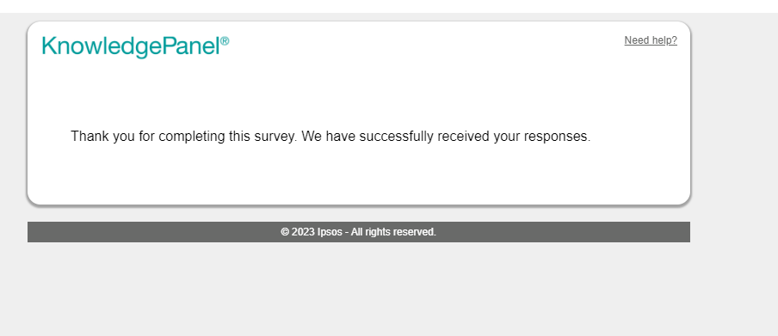

SHOW: All respondents

