**Recruitment Language (General and Post Copy)**

**Sample Recruitment Language (General)**

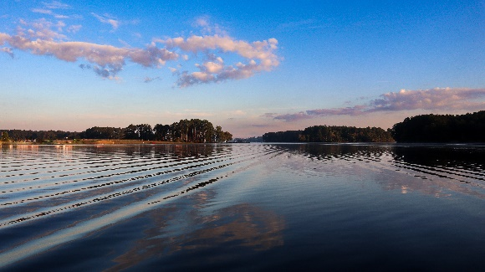 

Banyan Communications is conducting focus groups with adults to learn people’s opinions about water safety messages and to hear their preferences for getting health information. These focus groups will be about 60 minutes long and will take place online. To learn more about the focus groups and determine if you are eligible to participate, please click [ELIGIBILITY SCREENER LINK].

If you have any questions about the focus groups, please contact Banyan Communications, [insert_inbox_here@banyancom.com](mailto:insert_inbox_here@banyancom.com)

**Sample Recruitment Post (General)**

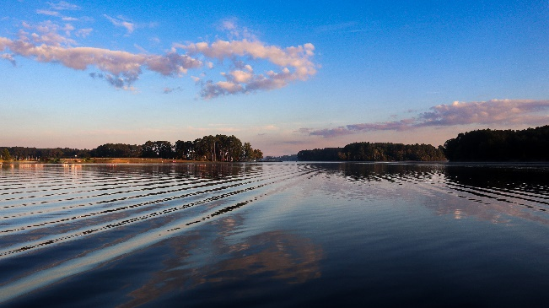

Do you visit freshwater bodies, like lakes and rivers, in the summer?

We’re looking for people 18 years and older who visit freshwater bodies to share their opinions about water safety. The conversation will be a virtual session over the internet lasting 60 minutes.

If you are interested, please click on the link below to answer some questions about yourself to see if you are qualified.

If you know someone who may be interested, please share the link with them.

Where: Online

Token of Appreciation: $75

[ELIGIBILITY SCREENER LINK]

**Sample Recruitment Post (Parents)**



Do you visit freshwater bodies, like lakes and rivers, in the summer? Do you take your children with you?

We’re looking for people 18 years and older who visit freshwater bodies with their children to share their opinions about water safety. The conversation will be a virtual session over the internet lasting 60 minutes.

If you are interested, please click on the link below to answer some questions about yourself to see if you are qualified.

If you know someone who may be interested, please share the link with them.

Where: Online

Token of Appreciation: $75

[ELIGIBILITY SCREENER LINK]

**Sample Recruitment Post (Dog Owners)**

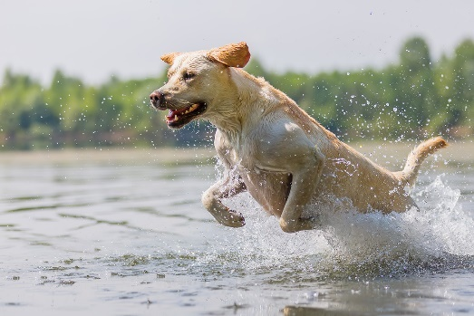

Do you visit freshwater bodies, like lakes and rivers, in the summer? Do you take your dog(s) with you?

We’re looking for people 18 years and older who visit freshwater bodies with their dogs to share their opinions about water safety. The conversation will be a virtual session over the internet lasting 60 minutes.

If you are interested, please click on the link below to answer some questions about yourself to see if you are qualified.

If you know someone who may be interested, please share the link with them.

Where: Online

Token of Appreciation: $75

[ELIGIBILITY SCREENER LINK]