## Attachment 3: Teen Consent/Assent Forms

**OMB Control No. 0920-1154**

**Exp. Date 3/31/2026**

The public reporting burden of this collection of information is estimated to average 10 minutes per response, including the time for reviewing instructions, searching existing data sources, gathering and maintaining the data needed, and completing and reviewing the collection of information. An agency may not conduct or sponsor, and a person is not required to respond to a collection of information unless it displays a currently valid OMB control number. Send comments regarding this burden estimate or any other aspect of this collection of information, including suggestions for reducing this burden to - CDC/ATSDR Reports Clearance Officer; 1600 Clifton Road NE, MS H21-8, Atlanta, Georgia 30333 ATTN: PRA (0920-1154).

**TEEN ASSENT FORM**

|  |  |
| --- | --- |
| **Sponsor / Study Title:** | CDC NCIPC Adolescent Mental Health Journey Mapping Project |
| **Principal Investigator:** | Catherine Lesesne, PhD, MPH |
| **Telephone:** | 404-270-0513 |
| **Address:** | **191 Peachtree St NE Ste 2000, Atlanta, GA 30303** |

***[PAGE 1: Assent]:***

We are asking you to take part in an interview about teen mental health. We are looking to speak with up to 206 teens ages 13 to 17 who identify as girls or nonbinary (hereafter “girls”) and live in rural areas in the US. Specifically, we want to learn more about how easy or hard it is for teens to access mental health tools and services and how to do this better. We would also like to know how teens think about mental health and how their location may change their experiences in accessing mental health care. This research is conducted on behalf of the Centers for Disease Control and Prevention (CDC).

The project offers three types of sessions:

* **Interview**: 60-minute conversation between one teen and 2-3 project team members
* **Focus Group**: 90-minute group conversation with teens, guided by the project team
* **Brainstorming Session**: 90-minute opportunity for teens to share feedback and ideas with the project team

The session questions ask about mental health topics. For some people, these topics may cause temporary discomfort or cause strong emotions. We do not anticipate any other risks in participating in the sessions. To reduce risk, we will remind participants that they do not have to answer any questions they do not want to answer, and we will provide a list of community mental health resources to all participants after the sessions.

We will record audio in the sessions. The team will use the recording to make sure our notes are correct and to summarize what we hear across all groups. Only our project team will have access to these recordings. The recordings will be deleted once our team updates the session notes. Nothing said in the sessions will be linked to you. The names of participants will never be used in reports of this research and we will not share comments from teens with parents/guardians. The sessions will not ask questions about illegal substance use. If a participant mentions illegal substance use within the sessions, the project team will not report on this. We will keep your participation in this research study confidential to the extent permitted by law. However, if you are participating in a group discussion, we cannot guarantee your participation or things you may say will remain confidential and private. This is due to the chance that other participants may disclose information about the group to unknown others. We ask all participants to use only first names or fake names in all group discussions and to keep the discussion in the group confidential to respect each other’s privacy. Even with these steps taken, we cannot guarantee confidentiality. You should keep this in mind when choosing what to share in the group setting.

This project is for research only. Participants who attend any of the above sessions will receive a $50 Visa gift card per session for their participation. Participation in these sessions is completely voluntary. You do not have to take part in any sessions. You can skip any questions they do not want to answer. You can stop or leave the session at any time by letting one of our team members know you would like to end the session. You will still receive the gift card even if you choose to end participation in a session.

If you participate in a virtual session, you must have a computer, tablet, or handheld device with a microphone and access to the Zoom app. The Zoom app is free for download and usage. If your computer does not have a microphone, you may use a phone to dial in to Zoom audio.

If you want to join a session, you need to give your assent (agreement). **Please click continue/next below to provide assent.** If we select you to join, we will contact you and your guardian. The project team will confirm participation on a rolling basis and will attempt to ensure diversity across teen participants. This means that not all eligible teens will be invited to an interview, focus group, or brainstorming session depending on the distribution of the characteristics of teens who agree to participate. For these reasons, we will not select every teen to join even if you agree to participate.

If you have any questions, concerns, or complaints about the study, please contact Dr. Catherine Lesesne at 404-270-0513 or at injuryctrengage@cdc.gov. If you have any questions about your rights as a research subject, you may contact Solutions IRB by phone, toll-free, at 855-226-4472 or by email at [participants@solutionsirb.com](mailto:participants@solutionsirb.com).

*Please click NEXT to provide your assent.*

***[PAGE 2: Formal Assent]:***

**Formal Assent:** Your response to the following question will indicate your formal agreement to participate in an interview. If you pick, “YES, I want to take part in an interview” you are agreeing to take part in an interview. Interviews will take 60 minutes. You agree to allow the project staff to collect, store, and share the combined, non-identifiable information from the sessions as outlined above. Even if you pick YES, you can decide not to join later for any reason.

If you do not want to take part in an interview, please pick “NO, I do not want to take part in an interview.”

**_________________________________________________________________________________**

1. Pleaseread the choices below and check the box that applies:
   * YES, I want to take part in an interview. [Continue to Q2]
   * NO, I do not want to take part in an interview. [Screen out and message shows: *Thank you for your time and for considering this research study.*]
2. Do you allow to the project team to record the audio of the session you want to participate in? As a reminder, the recording will only be used to make sure our notes are correct and to summarize what we hear across all groups. Nothing said in the sessions will be linked to a specific individual.:
   * YES, I allow the project team to record the audio of the session.
   * NO, I do not want the project team to record the audio of the session. [Screen out and message shows: *Thank you for your time and for considering this research study.*]

*Please click NEXT to provide your availability.*

*[****PAGE 3, Availability Selection****]:*

Please review the interview date and time options below and **select any/all of these slots that will work for your schedule**.

**Available {Interview/Focus Group/Brainstorming] Sessions:**

* [DATE] from [TIME] (in-person at [LOCATION]/virtual)
* [DATE] from [TIME] (in-person at [LOCATION]/virtual)
* [DATE] from [TIME] (in-person at [LOCATION]/virtual)
* [DATE] from [TIME] (in-person at [LOCATION]/virtual)
* Other: [Write-in]

*[****PAGE 4, Exit Page****]:*

Thank you for your responses. Your formal assent and availability are confirmed. Following this survey, we will send a confirmation of your scheduled session date(s) and time(s) to you and your parent/guardian.

**Screenshots of Web Version:**

Page 1:

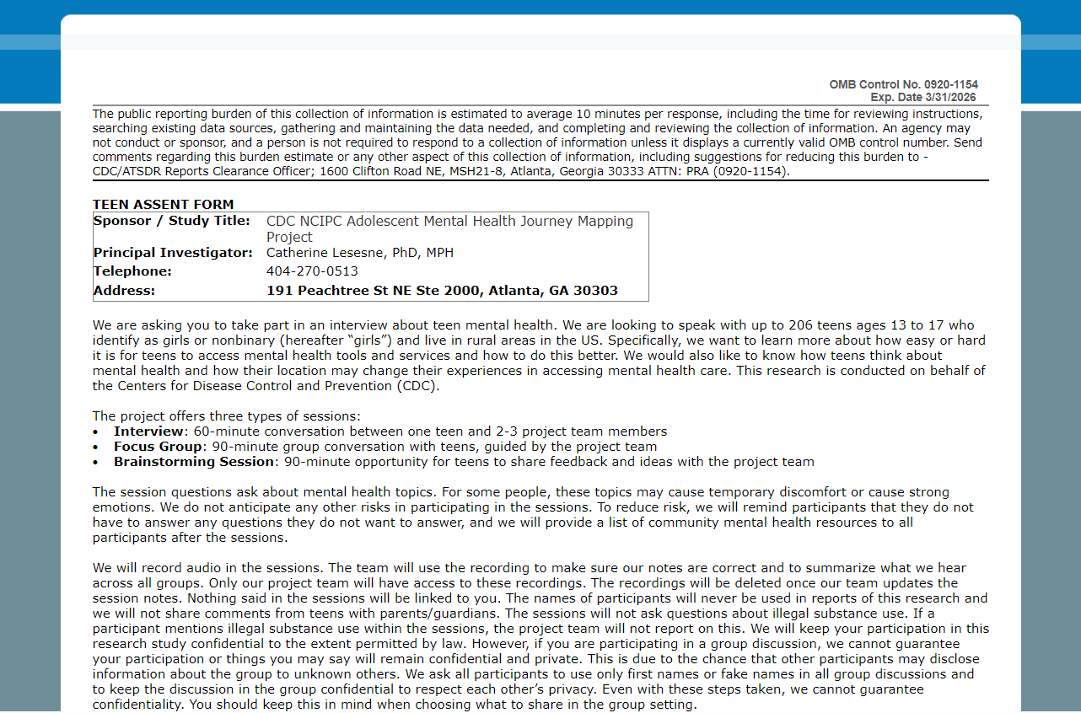

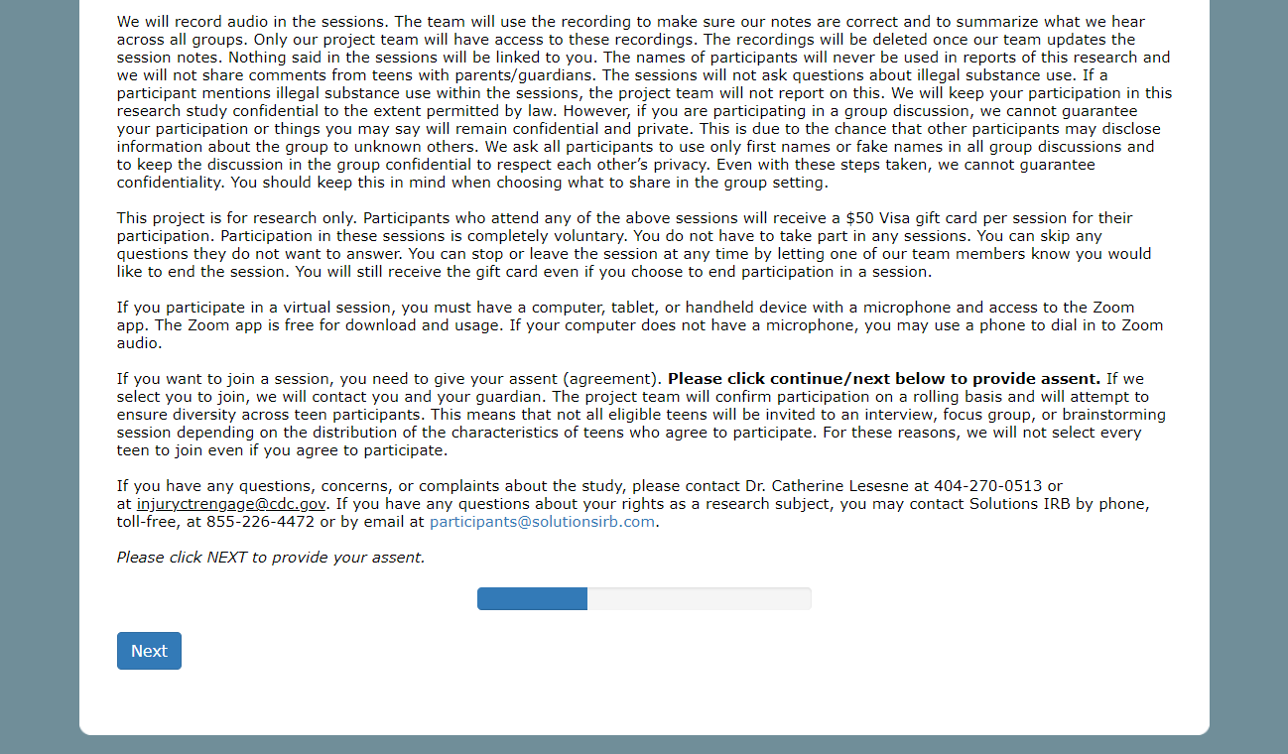

Page 2:

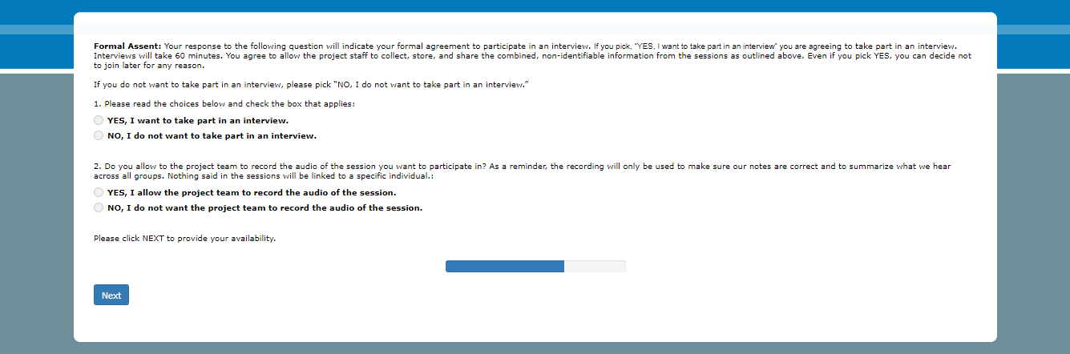

Page 3:

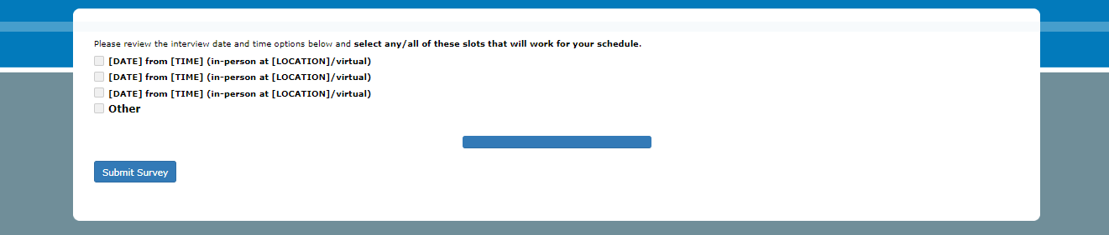

Page 4:

