Antimicrobial Resistance Message Testing Data Collection Project
Formative Evaluation Interview Guide [Focus Groups & In-Depth Interviews]
Centers for Disease Control and Prevention (CDC)
Antimicrobial Resistance Coordination & Strategy Unit (ARX)

Prepared by CATMEDIA

INTRODUCTION (Focus Group 4 min / IDI 2 min)
[Best practices for moderator: strong internet and your mobile phone or another laptop on hand as backup. Use lots of positive nonverbal cues including nods and hand gestures. Moderator introduces project to participant(s) once everyone has joined the session.]

Moderator:
Hi! Thanks for running through that technology check and confirming you can see and hear me.

My name is [INSERT NAME], and I’m a moderator with C.E.K. & Partners, a research firm in Atlanta, GA. Our team is working with another firm in Tucker, Georgia, CATMEDIA. Together, we’re working with Centers for Disease Control and Prevention (CDC) to better understand people’s knowledge of antimicrobial resistance. The feedback we receive from you and others will assist in the development of new public health communication materials.

We will have a total of [moderator to select one of below]

- 60 minutes for today’s focus group discussion.
- 30 minutes for today’s one-on-one discussion.

I really look forward to hearing your thoughts and opinions.

Sound good so far? Great.

Before we begin, I would like to remind you that your participation in this discussion is completely voluntary, and you may choose to leave the interview at any time.

I would also like to mention a few things:

- There are no right or wrong answers.
- All comments, positive or negative, what you know or do not know, are important.
- I am not an expert on this topic, so you may have questions that I’m unable to answer.
- While we want to hear from you, you don’t need to answer every question.
- Following the completion of our discussion, you will receive a prepaid digital gift card as a token of our appreciation for participating.

Everything we discuss today should be kept confidential. Everything you say today will be kept completely private and will not be shared with others outside of the project team. Any summary reports will not directly link anything you say with your name or any other personal identifiers.

I would like to confirm that you are okay with this interview being recorded; it’s just so I can draft an accurate report. Any information that could identify you, like your name or place of employment, if you mention it, will not be used in the summary report or any materials resulting from these interviews. However, we suggest you avoid mentioning this type of personal information.

Are you okay with the interview being recorded?

INTERVIEWER: If respondent does not agree to be recorded, they will be excluded and told,
“Thank you for taking the time to speak with me today but we need to be able to record so that we can accurately transcribe the interviews for reporting purposes so you will not be able to participate. Have a wonderful day.”

[START RECORDING]

Great. We are now recording, and you should see a notification pop up.

So, for today’s discussion, there are just a few quick guidelines:

- First, please be open, honest, and tell me what you are thinking.

- Second, please make sure you are in a quiet and private space where you can participate without any distractions. We’re potentially discussing sensitive topics, and I want you to be able to answer honestly. If you need to move to a quiet and private spot, please go ahead and do that now.

Do you have any questions before we get started?

GENERAL DISCUSSION (Focus Group 8 min / IDI 4 min)

Note: This discussion guide is intended as a guide and not a questionnaire. This means for a variety of reasons – whether due to time constraints or a participant not wanting to answer one - every question might not be asked / answered. Questions that may be deemed a lower priority should be identified before use of the guide.

Knowledge and understanding of antimicrobial resistance

- Today we’re talking about antimicrobial resistance. What do you know about it?

  - Potential (optional) probes:
    - Have you heard of superbugs? Tell me what you know about them?

    - Are you familiar with drug resistant infections? Could you tell me what you know?

  - Do you consider antimicrobial resistance a concern for your community, family, or yourself? Why or why not?

- Do you believe there is a connection between the development of resistant bacteria and taking antibiotics or antifungal drugs?

- Does the threat of getting an antimicrobial-resistant infection motivate you to take any actions to protect yourself, your family and friends, or your community? If so, what?

If limited or no response – probe with suggestions:

  - Practice good hygiene like hand washing
  - Talk to your doctor
  - Get vaccines
  - Do further research

- Do you know anyone who has had an antimicrobial-resistant infection?
[Seeking: Yes or No answer]

- Have you seen any communication about antimicrobial resistance in the last month or so?

  - If yes,
    - What was the primary message?
    - Where did you see it?
    - What did you think about it?

MESSAGES & MATERIALS ASSESSMENT (Focus Group 45 min / IDI 21 min)

Now we are going to look at a few different communication materials that focus on antimicrobial resistance. First, I did not create these, so please be honest, you will not hurt my feelings.

Please think about the different images and messages, along with what you like or don’t like.

I’ll guide our discussion by asking a series of questions.

MODERATOR: Randomize order of the concepts. Refer to by concept name.

Concept 1 - Germs: [Medical Illustration] – Focus Group 15 min / IDI 7 min

Now I’m going to share my screen and show you a social media post.

MODERATOR: Here’s the social media post that will be shared on screen.

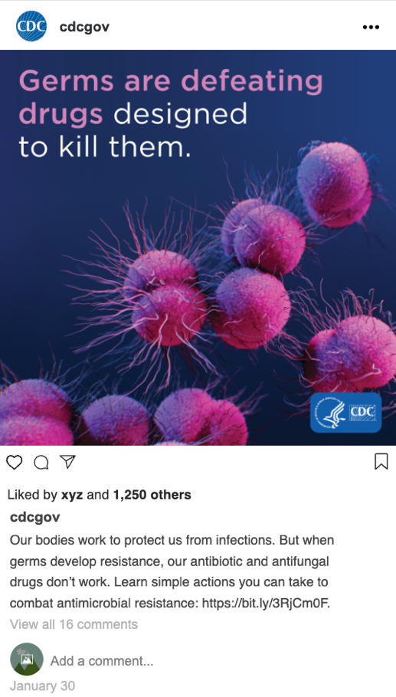

Can you see my screen?

Great, now I will read the social media post to you starting with a description of the image.

After I read it, I will allow you a minute or two to read it before we discuss it. I’ll lead the discussion by prompting you with questions.

Image descriptor: A grouping of fuchsia-colored bacteria float on a solid blue background, enhanced as though viewed through a microscope. CDC logo in the bottom right corner.

Headline: Germs are defeating drugs designed to kill them.

Copy below image: Our bodies work to protect us from infections. But when germs develop resistance, our antibiotic and antifungal drugs don’t work. Learn simple actions you can take to combat antimicrobial resistance: [There’s a link for more information].

- What is the primary message you think this social media post communicates?

- Is the message clear and easily understood or does it need to be simpler or include more details? Why/why not?

  - Probe: Are there any words that are unclear or confusing to you?
  - Probe: Would you click on the link? Why/why not?

- How does this social media post make you feel?

  - How would you describe that overall feeling?

- Could you tell me more about your reaction to this social media post?

  - What do you like about it? Why?
  - What do you dislike? Why?

- What do you think about the headline – Germs are defeating drugs designed to kill them?

  - What does that mean to you?

  - Does the description below the image help you understand the message? Why/why not?

  - Which organization would you most trust this message coming from?

- Based on what you know about antimicrobial resistance, does this social media post help you better understand it? Why/why not?

  - Does it make antimicrobial resistance seem like a problem we can solve?

  - What information does this give you that you didn’t have before?

- The social post includes the logo for Centers for Disease Control and Prevention (CDC), does that matter to you? Why/why not?

  - What if the message wasn’t from CDC and instead it was from another organization, would that change your perceptions or the actions you take?

- What do you think about the visual aspects of the social post?

  - Do you like the image? Why/why not?

  - Does the image match or support the message – Germs are defeating drugs designed to kill them?

- Do you think this social media post is relevant for you personally? Why/why not?

- What changes, if any, would you make to this social media post to make it more effective or helpful in understanding the issue of antimicrobial resistance?

We’re now going to use the Zoom poll feature. A question will appear on the screen. You will each select an answer. Your individual answers will not be seen by others in the group.

- POLL QUESTION: Please rate on a scale of 1-5 with 1 = not motivating and 5 = very motivating.

Does this social media post motivate you to change any of your behaviors to help reduce antimicrobial-resistant infection?

Moderator to read poll response out loud and follow up with these probes:

  - If you found it motivating and rated it a 4 or 5, why? If you found it not motivating and rated it a 1, 2, or 3, why?
  - What types of changes would it motivate?
  - Would it be motivating to your friends or family?

- If you saw this message – Germs are defeating drugs designed to kill them. – on a billboard, the side of a bus or on a website would it have the same impact as a social media post? Why/why not?

Concept 2 – Kids: [Human Image] – Focus Group 15 min / IDI 7 min

Now we’re going to look at another social media post. I will read the post to you starting with a description of the image.

After I read it, I will allow you a minute or two to read it before we discuss it. I’ll lead the discussion by prompting you with questions.

MODERATOR: Here’s the social media post that will be shared on screen.
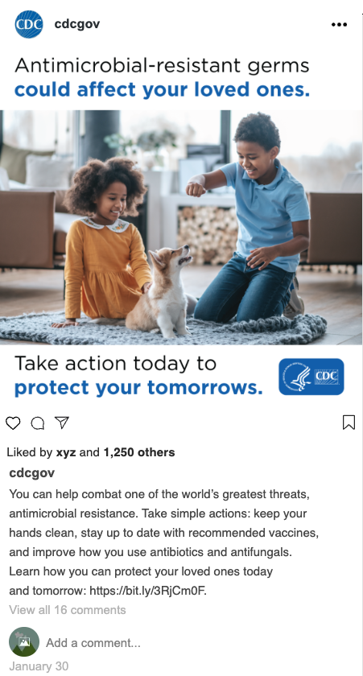

Image descriptor: Image of two young school-aged children, who appear to be siblings, playing with a small dog on a rug in a living room. CDC logo in the bottom right corner.

Headline: Antimicrobial-resistance germs could affect your loved ones.

Copy below image: You can help combat one of the world’s greatest threats, antimicrobial resistance. Take simple actions: keep your hands clean, stay up to date with recommended vaccines, and improve how you use antibiotics and antifungals. Learn how you can protect your loved ones today and tomorrow: [There’s a link for more information].

- What is the primary message you think this social media post communicates?

- Is the message clear and easily understood or does it need to be simpler or include more details? Why/why not?

  - Probe: Are there any words that are unclear or confusing to you?
  - Probe: Would you click on the link? Why/why not?

- How does this social media post make you feel?

  - How would you describe that overall feeling?

- Could you tell me more about your reaction to this social media post?

  - What do you like about it? Why?
  - What do you dislike? Why?

- What do you think about the headline – Antimicrobial-resistant germs could affect your loved ones?

  - What does that mean to you?

  - Does the description below the image help you understand the message? Why/why not?

  - Which organization would you most trust this message coming from?

- Based on what you know about antimicrobial resistance, does this social media post help you better understand it? Why/why not?

  - Does it make antimicrobial resistance seem like a problem we can solve?

  - What information does this give you that you didn’t have before?

- The social post includes the logo for Centers for Disease Control and Prevention (CDC), does that matter to you? Why/why not?

  - What if the message wasn’t from CDC and instead it was from another organization, would that change your perceptions or the actions you take?

- What do you think about the visual aspects of the social post?

  - Do you like the image? Why/why not?

  - Does the image match or support the message – Antimicrobial-resistant germs could affect your loved ones?

- Do you think this social media post is relevant for you personally? Why/why not?

- What changes, if any, would you make to this social media post to make it more effective or helpful in understanding the issue of antimicrobial resistance?

We’re now going to use the Zoom poll feature. A question will appear on the screen. You will each select an answer. Your individual answers will not be seen by others in the group.

- POLL QUESTION: Please rate on a scale of 1-5 with 1 = not motivating and 5 = very motivating.

Does this social media post motivate you to change any of your behaviors to help reduce antimicrobial-resistant infection?

Moderator to read poll response out loud and follow up with these probes:

  - If you found it motivating and rated it a 4 or 5, why? If you found it not motivating and rated it a 1, 2, or 3, why?
  - What types of changes would it motivate?
  - Would it be motivating to your friends or family?

- If you saw this message – Antimicrobial-resistant germs could affect your loved ones. – on a billboard, the side of a bus or on a website would it have the same impact as a social media post? Why/why not?

Concept 3 - Game: [The Next Wave Has Arrived] – Focus Group 15 min / IDI 7 min

Now we’re going to look at our final social media post. I will read the post to you starting with a description of the image.

After I read it, I will allow you a minute or two to read it before we discuss it. I’ll lead the discussion by prompting you with questions.

MODERATOR: Here’s the social media post that will be shared on screen.

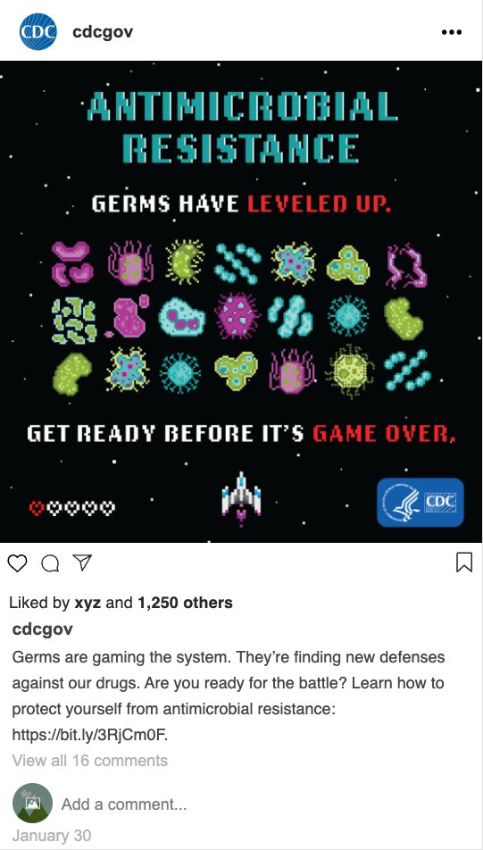

Image descriptor: Graphic of circa 1980's space-themed arcade game featuring three rows of germs facing off against a small fighter jet. Five hearts at the bottom left with only one heart filled in, indicative of one "life" left. CDC logo in the bottom right corner.

Headline: Antimicrobial-resistance. Germs have leveled up. Get ready before it’s game over.

Copy below image: Germs are gaming the system. They’re finding new defenses against our drugs. Are you ready for the battle? Learn how to protect yourself from antimicrobial resistance: [There’s a link for more information].

- What is the primary message you think this social media post communicates?

- Is the message clear and easily understood or does it need to be simpler or include more details? Why/why not?

  - Probe: Are there any words that are unclear or confusing to you?
  - Probe: Would you click on the link? Why/why not?

- How does this social media post make you feel?

  - How would you describe that overall feeling?

- Could you tell me more about your reaction to this social media post?

  - What do you like about it? Why?
  - What do you dislike? Why?

- What do you think about the headline – Antimicrobial-resistance. Germs have leveled up. Get ready before it’s game over?

  - What does that mean to you?

  - Does the description below the image help you understand the message? Why/why not?

  - Which organization would you most trust this message coming from?

- Based on what you know about antimicrobial resistance, does this social media post help you better understand it? Why/why not?

  - Does it make antimicrobial resistance seem like a problem we can solve?

  - What information does this give you that you didn’t have before?

- The social post includes the logo for Centers for Disease Control and Prevention (CDC), does that matter to you? Why/why not?

  - What if the message wasn’t from CDC and instead it was from another organization, would that change your perceptions or the actions you take?

- What do you think about the visual aspects of the social post?

  - Do you like the image? Why/why not?

  - Does the image match or support the message – Antimicrobial-resistance. Germs have leveled up. Get ready before it’s game over?

- Do you think this social media post is relevant for you personally? Why/why not?

- What changes, if any, would you make to this social media post to make it more effective or helpful in understanding the issue of antimicrobial resistance?

We’re now going to use the Zoom poll feature. A question will appear on the screen. You will each select an answer. Your individual answers will not be seen by others in the group.

- POLL QUESTION: Please rate on a scale of 1-5 with 1 = not motivating and 5 = very motivating.

Does this social media post motivate you to change any of your behaviors to help reduce antimicrobial-resistant infection?

Moderator to read poll response out loud and follow up with these probes:

  - If you found it motivating and rated it a 4 or 5, why? If you found it not motivating and rated it a 1, 2, or 3, why?
  - What types of changes would it motivate?
  - Would it be motivating to your friends or family?

- If you saw this message – Antimicrobial-resistance. Germs have leveled up. Get ready before it’s game over. – on a billboard, the side of a bus or on a website would it have the same impact as a social media post? Why/why not?

CONCLUDING REMARKS (5 min / IDI 2 min)

We’re now going to again use the Zoom polling feature.

MODERATOR: Share screen with all three social media concepts viewable at the same time.

- POLL QUESTION: Which one social media post helps you best understand antimicrobial resistance?
      - Concept Germ
      - Concept Game
      - Concept Kid

- POLL QUESTION: Which one social media post motivates you to change your behaviors?
      - Concept Game
      - Concept Kid
      - Concept Germ

- POLL QUESTION: Which one social media post do you prefer the most? Why?
      - Concept Kid
      - Concept Germ
      - Concept Game

- Based on our time together today, how would you explain antimicrobial resistance to your friends or family?

If time permits:

Any other thoughts before concluding this interview?

____________________________________________________________________________
Thank you for your time. I appreciate you sharing your thoughts with me, and I really enjoyed our time here today. If you'd like to learn more about antimicrobial resistance, you can visit the CDC website link – https://www.cdc.gov/drugresistance/index.html – I’m putting into the chat.

