Attachment #15 - Messages to be Tested

Population | Number of Focus Groups | Number of Participants
Pregnant Individuals (18+) (general population) | 1 | 6-8
Older Adults (65+) | 1 | 6-8
Caregivers of children <5 | 1 | 6-8
Immunocompromised | 1 | 6-8
Hispanic individuals | 1 | 6-8
Hispanic pregnant individuals | 1 | 6-8
Individuals who are interested in health and wellness | 2 | 6-8
Total | 8 | 48-64

Messages/Materials for Testing
POC/  Branch | Audience (pick 1-2 per content) | Message/Content (Please specify content type: social media graphic, social media text copy, video, etc.) | Testing Presentation (ex. Side-by-side, scroll through) | Probes (Why are you asking this?)
Amy/WDPB | Older Adults  Immunocompromised individuals | Germs can grow inside your pipes when there is no running water.  If you’ve been away from home, flush your faucets before using them by running the cold water for 2 minutes and then running the hot water another 2 minutes. Learn more: https://bit.ly/42ieJcO  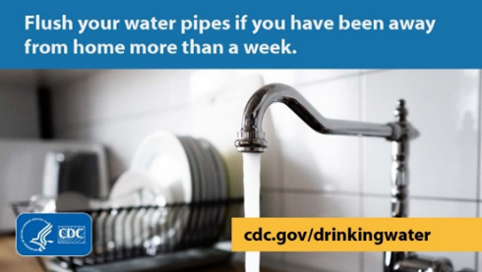Faucet-graphic-English.jpg (1200×675) (cdc.gov) | Side-by-side (message next to the graphic) | - Are the message and graphic clear?  - Would people follow the recommendations (why/why not)?  - Overall, what do people like or dislike about the message and graphic?
Amy/WDPB | Older Adults  Immunocompromised individuals | Help prevent germs from growing & extend your hot water heater’s life by flushing it:  - Annually  - If the water is discolored  - Before you move into a home  - After plumbing work  Follow the manufacturer’s instructions or use a professional.  More: https://bit.ly/42ieJcO  Water-Heater-graphic-English.jpg (1200×675) (cdc.gov) | Side-by-side (message next to the graphic) | - Are the message and graphic clear?  - Would people follow the recommendations (why/why not)?  - Overall, what do people like or dislike about the message and graphic?
Amy/WDPB | Older Adults  Immunocompromised individuals | Some germs that grow in water pipes can make you sick if they go up your nose. To avoid getting sick, never use water straight from the tap to rinse your sinuses. Learn more: https://bit.ly/42ieJcO  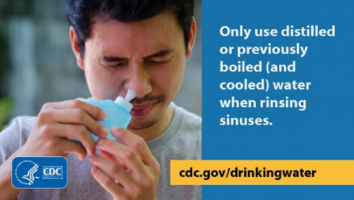Neti-Pot-graphic-English.jpg (1200×675) (cdc.gov) | Side-by-side (message next to the graphic) | - Are the message and graphic clear?  - Would people follow the recommendations (why/why not)?  - Overall, what do people like or dislike about the message and graphic?
Amy/WDPB | Older Adults  Immunocompromised individuals | Germs can live in humidifiers and spread through the air when you turn them on. Some of these germs can make people sick when the water is inhaled as a mist. You can prevent germs from growing in your humidifier by emptying the water daily, allowing it to air dry, and disinfecting your device according to the manufacturer’s instructions.  Learn more: https://bit.ly/42ieJcO  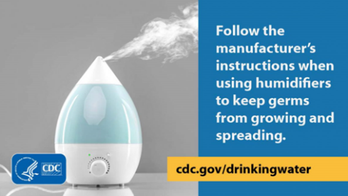Humidifier-graphic-English.jpg (1200×675) (cdc.gov) | Side-by-side (message next to the graphic) | - Are the message and graphic clear?  - Would people follow the recommendations (why/why not)?  - Overall, what do people like or dislike about the message and graphic?
Catherine/WDPB | Caregivers of children under 5 | 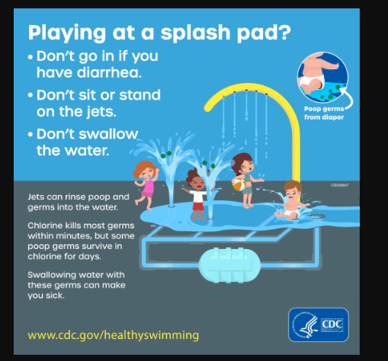  328546_waterPad_1080_5.gif (1080×1080) (cdc.gov) | It’s a GIF so I’m not sure what the best would be. If they could look it as a GIF, that would be best. | - Are the message and graphic clear?  - Would people follow the recommendations (why/why not)?  - Overall, what do people like or dislike about the message and graphic?
Catherine/WDPB | Caregivers of children under 5 | 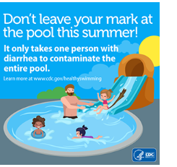 | Side-by-side (message next to the graphic) | - Are the message and graphic clear?  - Would people follow the recommendations (why/why not)?  - Overall, what do people like or dislike about the message and graphic?
OD | Immunocompromised individuals | If you have a weakened immune system and you get food poisoning, you could get severely ill because it is harder for your body to fight germs. Take extra care to protect yourself from food poisoning by choosing safer foods: https://www.cdc.gov/food-safety/foods/weakened-immune-systems.html  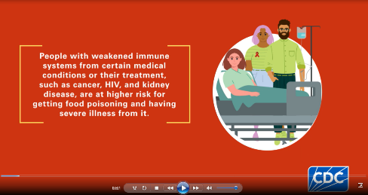 | Side by side of SM message and graphic | - Are the message and graphic clear?  - Does the information and graphic capture your attention?  - Does the information help you understand your risk for food poisoning?  - Would you change any behaviors after reading this?/Follow the recommendations of foods to avoid?  - Overall, what do like and dislike about the message and graphic?
OD | Pregnant individuals | Listeria infection can cause miscarriages, stillbirths, and preterm labor. Choose safer foods to protect your pregnancy. https://www.cdc.gov/food-safety/foods/pregnant-people.html  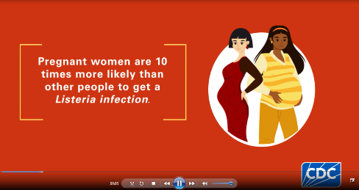 | Side by side of SM message and graphic | - Are the message and graphic clear?  - Does the information and graphic capture your attention?  - Does the information help you understand your risk for food poisoning?  - Would you change any behaviors after reading this?/Follow the recommendations of foods to avoid?  - Overall, what do like and dislike about the message and graphic?
OD | Immunocompromised individuals (condition-specific) | If you have a condition that weakens your immune system, like kidney disease, you could get severely ill from food poisoning because it is harder for your body to fight germs. Take extra care to protect yourself from food poisoning by choosing safer foods: https://www.cdc.gov/food-safety/foods/weakened-immune-systems.html  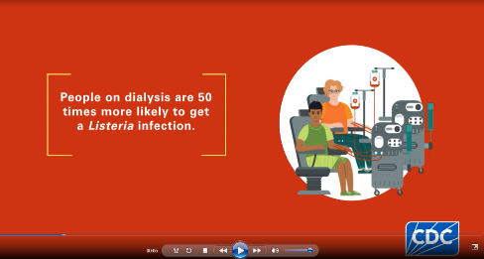 | Side by side of SM message and graphic | - Are the message and graphic clear?  - Does the information and graphic capture your attention?  - Does the information help you understand your risk for food poisoning?  - Would you change any behaviors after reading this?/Follow the recommendations of foods to avoid?  - Overall, what do like and dislike about the message and graphic?
OD | Caregivers of children under 5 | Some E. coli infections can lead to a serious health conditions like kidney failure, permanent health problems, and even death. Follow prevention tips to keep your child safe. https://www.cdc.gov/food-safety/foods/children-under-5.html  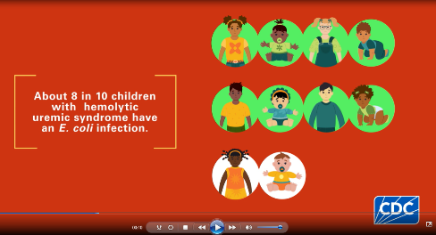 | Side by side of SM message and graphic | - Are the message and graphic clear?  - Does the information and graphic capture your attention?  - Does the information help you understand your child’s risk for food poisoning?  - Would you change any behaviors after reading this?/Follow the recommendations of foods to avoid?  - Overall, what do like and dislike about the message and graphic?
ORPB | Older adults | Listeria / deli outbreak - social media video:  https://www.facebook.com/watch/?v=1086455155375792 | Video as shown on Facebook, with post description expanded | - Initial thoughts or feelings?  - What did you like about it?  - What did you dislike about it?  - What would you do after watching this video?
ORPB | Pregnant individuals | Listeria / brie outbreak - social media video: https://www.instagram.com/reel/CjlggSvsDzE/ | Video as shown on Instagram | - Initial thoughts or feelings?  - What did you like about it?  - What did you dislike about it?  - What would you do after watching this video?
ORPB | Immunocompromised individuals | Listeria / deli outbreak - social media video: https://www.instagram.com/p/Cl4h1bdg2uw/ | Video as shown on Instagram | - Initial thoughts or feelings?  - What did you like about it?  - What did you dislike about it?  - What would you do after watching this video?
ORPB | Caregivers of children under 5 | New backyard poultry graphic and message on social media:  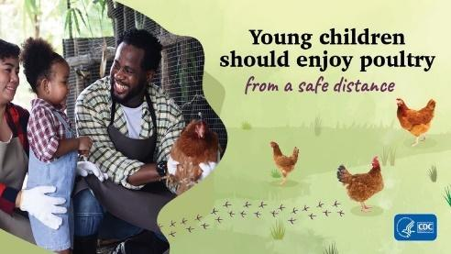  Chickens, ducks, chicks and ducklings can carry harmful germs like Salmonella. Do not let children younger than 5 years touch any poultry. Always supervise young children to enjoy poultry from a safe distance. Learn more at: https://www.cdc.gov/healthypets/pets/farm-animals/backyard-poultry.html | Side by side of message and graphic | - Initial thoughts or feelings?  - What did you like about it?  - What did you dislike about it?  - Is there any information missing?  - Would you change the way you let your child interact with backyard poultry after seeing this social media post? Why/why not?
ORPB | Hispanic pregnant women;  Hispanic population | Preventing Listeria infection webpage with new guidance table below:  https://www.cdc.gov/listeria/prevention/index.html  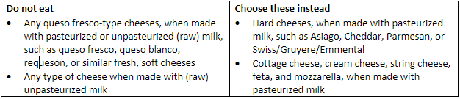 | Webpage | - Initial thoughts or feelings?  - What did you like about it?  - What did you dislike about it?  - Is there any information missing?  - What would you do after viewing this message?
ORPB | Hispanic pregnant women;  Hispanic population | CDC now advises people at high risk for Listeria to avoid eating queso fresco-type cheeses, whether made from pasteurized or unpasteurized (raw) milk. This update is based on a review of recent outbreak data.  You are at high risk for Listeria if you  P are pregnant  P are 65 or older  P have a weakened immune system  For people who are pregnant, Listeria can cause pregnancy loss, premature birth, or a life-threatening infection in their newborn.  For people who are 65 years or older or who have a weakened immune system, Listeria often results in hospitalization and sometimes death.  Learn more: https://www.cdc.gov/listeria/prevention.html  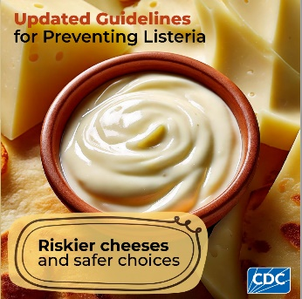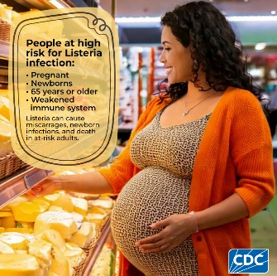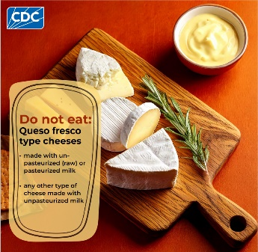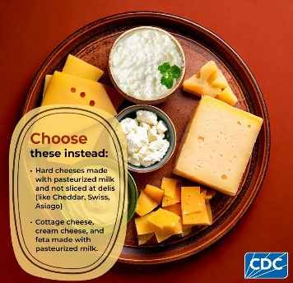  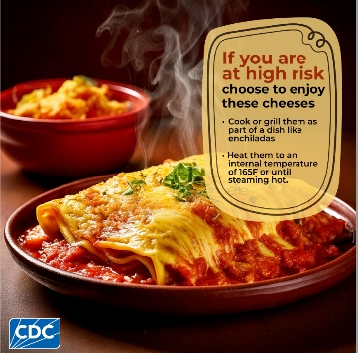 | Side by side of message and carousel graphics | - In your own words, what does this message tell you?  - Initial thoughts or feelings?  - Would you follow the recommendations (why/why not)?  - Overall, what do you like or dislike about the message and graphic?
Cait Lutfy, Samantha Williams, Mitsuru Toda/ MDB | Pregnant individuals  Immunocompromised individuals | Blastomycosis is a fungal infection that anyone can get from the environment in certain parts of the United States. Although most people who breathe in the spores do not get sick, some people will develop symptoms like fever and cough, and the infection can sometimes become serious if it is not treated. Certain groups of people may be at greater risk for developing severe blastomycosis, such as people who have weakened immune systems and pregnant people.  It may not be possible to completely avoid being exposed to the fungus that causes blastomycosis in areas where it is common in the environment. People at higher risk of infection can avoid activities that disrupt soil, like yardwork, to help protect themselves. | 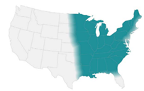 | - How do you feel after hearing this?  - Is there any information that you feel is missing or that you’d like to know more?  - After hearing this message is there anything you would change in your activities or behaviors?
Samantha Williams, Mitsuru Toda/ MDB | Pregnant individuals Older adults  Immunocompromised individuals | Coccidioidomycosis or Valley fever is a fungal infection that anyone can get from the environment in parts of the southwestern United States. Although most people who breathe in the spores do not get sick, some people will develop symptoms like fever and cough, and the infection can sometimes become serious if it is not treated. Certain groups of people may be at greater risk for developing severe Valley fever, such as adults aged 60 and older, who have weakened immune systems and pregnant people.  It may not be possible to completely avoid being exposed to the fungus that causes coccidioidomycosis in areas where it is common in the environment. There are some ways to help reduce your risk of getting sick, like avoiding construction sites and yardwork, staying inside during dust storms, and carefully cleaning any skin injuries. | 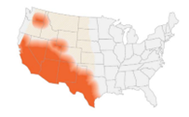 | - How do you feel after hearing this?  - Is there any information that you feel is missing or that you’d like to know more?  - After hearing this message is there anything you would change in your activities or behaviors? Why/why not?
Samantha Williams, Mitsuru Toda/ MDB | Caregivers of children under 5, Immunocompromised individuals  Older adults | Histoplasmosis is a fungal infection that anyone can get from the environment in certain parts of the United States. Although most people who breathe in the spores do not get sick, some people will develop symptoms like fever and cough, and the infection can sometimes become serious if it is not treated. Certain groups of people may be at greater risk for developing severe histoplasmosis, such as people who have weakened immune systems, infants, and adults aged 55 and older.  It can be difficult to completely avoid the fungus that causes histoplasmosis. To help reduce your risk of getting sick, avoid any exposures to bat or bird droppings, cleaning chicken coops, exploring caves, and cleaning, remodeling, or tearing down old buildings. | 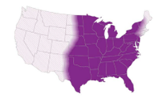 | - How do you feel after hearing this?  - Is there any information that you feel is missing or that you’d like to know more?  - After hearing this message is there anything you would change in your activities or behaviors? Why/why not?
Cait Lutfy/MDB | Older adults  Immunocompromised | In recent years some there have been outbreaks of Candida auris (C. auris) in healthcare settings (hospitals, skilled nursing facilities, long-term acute care settings, etc.).  C. auris can cause severe even deadly, infections in some patients. Other patients can get Candida auris (C. auris) on their skin or body without getting sick or having symptoms, which is called “colonization.”  Both people who are sick and people who are colonized can spread C. auris from their bodies on to surfaces and objects around them. C auris can live on surfaces and objects for a long time and make other patients sick.  Some healthcare facilities screen patients for C. auris even if they do not have symptoms. C. auris screening helps protect all patients and prevent outbreaks. |  | - In your own words, what does this message tell you?  - Initial thoughts or feelings?  - Is there more information you would want to know after hearing this message?  - Can you explain why someone without any symptoms who is not sick be tested for C. auris?
Mmesoma/OD | Individuals interested in health and wellness | Pasteurization is crucial for milk safety because it kills harmful germs. Enjoy the nutritional benefits of milk without taking unnecessary risk – choose pasteurized milk. https://www.cdc.gov/food-safety/foods/raw-milk.html |   Video: 350800-C_NCEZID_WEB_Raw-Milk_Social-Post-Reels.mp4 | - In your own words, what does this message tell you?  - Initial thoughts or feelings?  - Would you follow the recommendations (why/why not)?  - Overall, what do you like or dislike about the message and graphic?
Mmesoma/OD | Individuals interested in health and wellness | Did you know drinking raw milk may result in illnesses, hospitalization and even death? Pasteurization removes disease-causing germs by heating milk to a high enough temp for a certain length of time. Enjoy the nutritional benefits of milk without taking unnecessary risk – choose pasteurized milk and dairy products. https://www.cdc.gov/food-safety/foods/raw-milk.html | 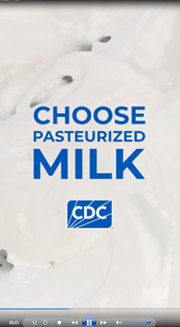  Video: 350800-D_NCEZID_WEB_Choose-Milk_Social-Post-Reels.mp4 | - In your own words, what does this message tell you?  - Initial thoughts or feelings?  - Would you follow the recommendations (why/why not)?  - Overall, what do you like or dislike about the message and graphic?
Mmesoma/OD | Individuals interested in health and wellness | Pasteurization kills harmful germs like Campylobacter, Cryptosporidium, E. coli, Listeria, Brucella, and Salmonella. It does not meaningfully affect the nutritional quality of milk. Stay healthy by choosing pasteurized milk and dairy products. https://www.cdc.gov/food-safety/foods/raw-milk.html | 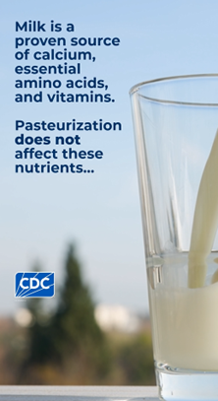  Video: 350800-B_NCEZID_WEB_Milk-Source_Social-Post-Reels.mp4 | - In your own words, what does this message tell you?  - Initial thoughts or feelings?  - Would you follow the recommendations (why/why not)?  - Overall, what do you like or dislike about the message and graphic?
OD | Individuals interested in health and wellness | 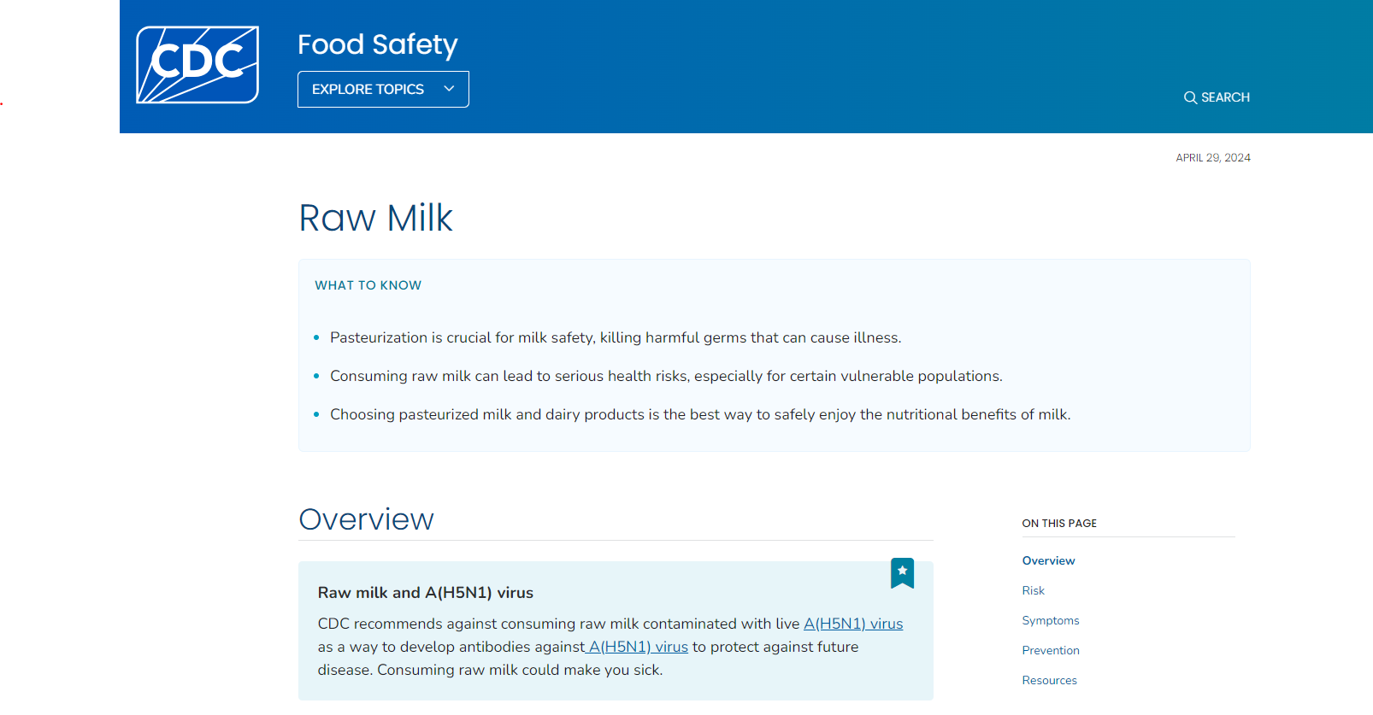Raw Milk | Food Safety | CDC | Scroll through webpage | - In your own words, what does this message tell you?  - Initial thoughts or feelings?  - Would you follow the recommendations (why/why not)?  - Overall, what do you like or dislike about the message?

