# 

# **Attachment 5. OneLab P.A.C.E.® and non-P.A.C.E.® Evaluation Survey**

Contents

**OneLab P.A.C.E.® and non-P.A.C.E.® Evaluation Survey** 1

***P.A.C.E.® Network Event*** 2

***Non-P.A.C.E.® TEST Event*** 8

***Non-P.A.C.E.® OneLab VR Course*** 13

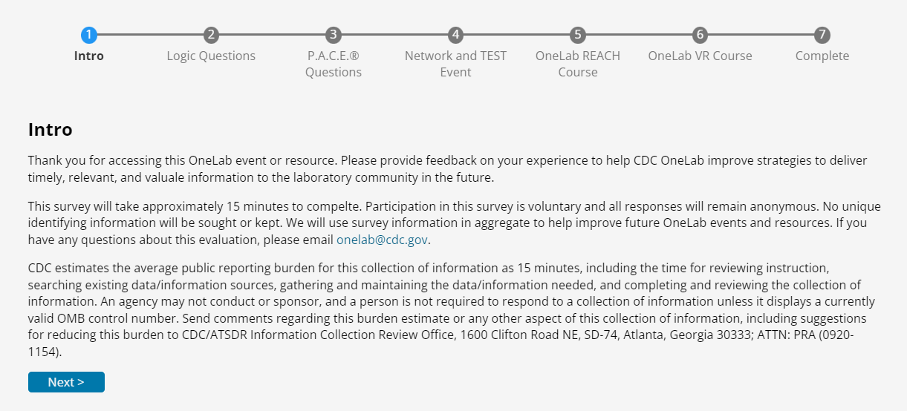

## ***P.A.C.E.® Network Event***

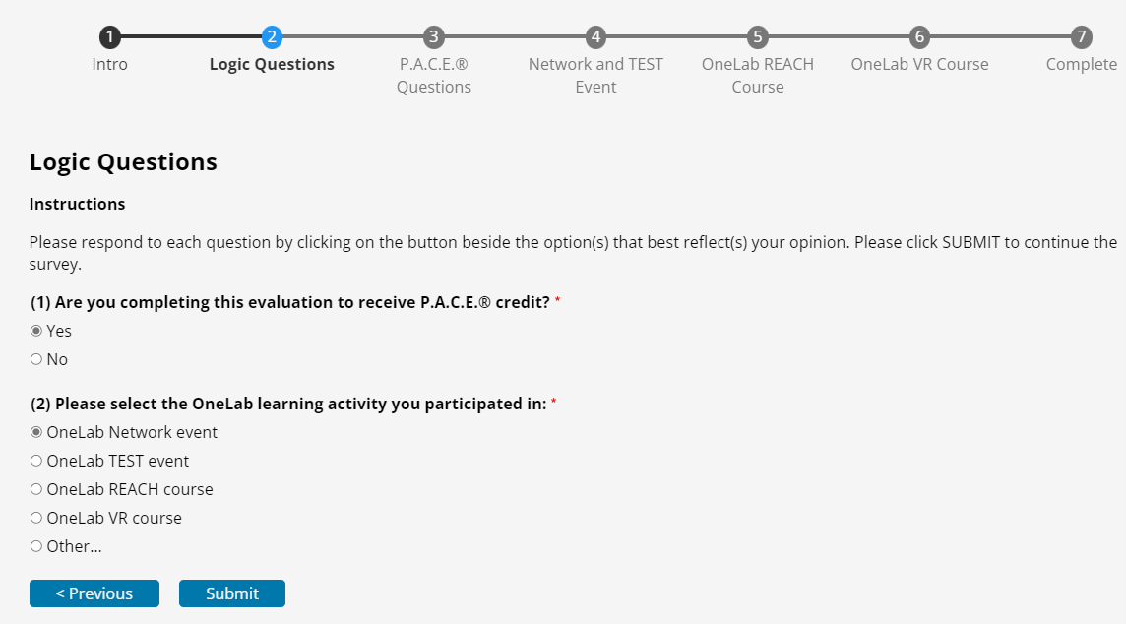

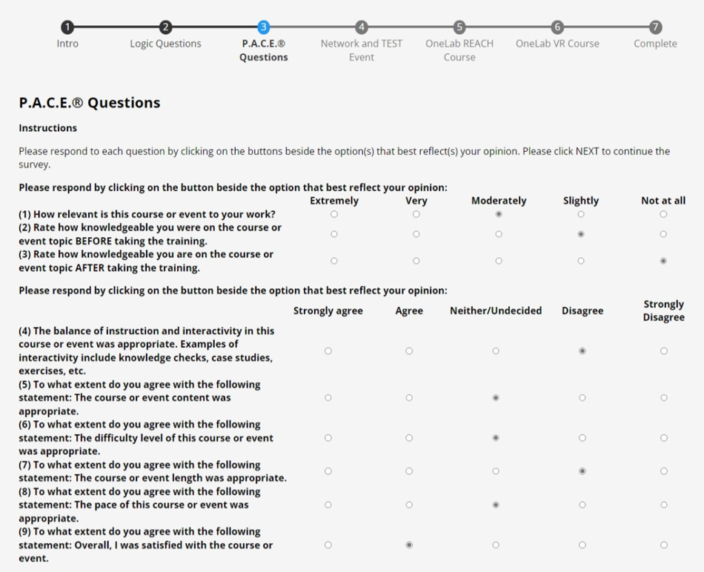

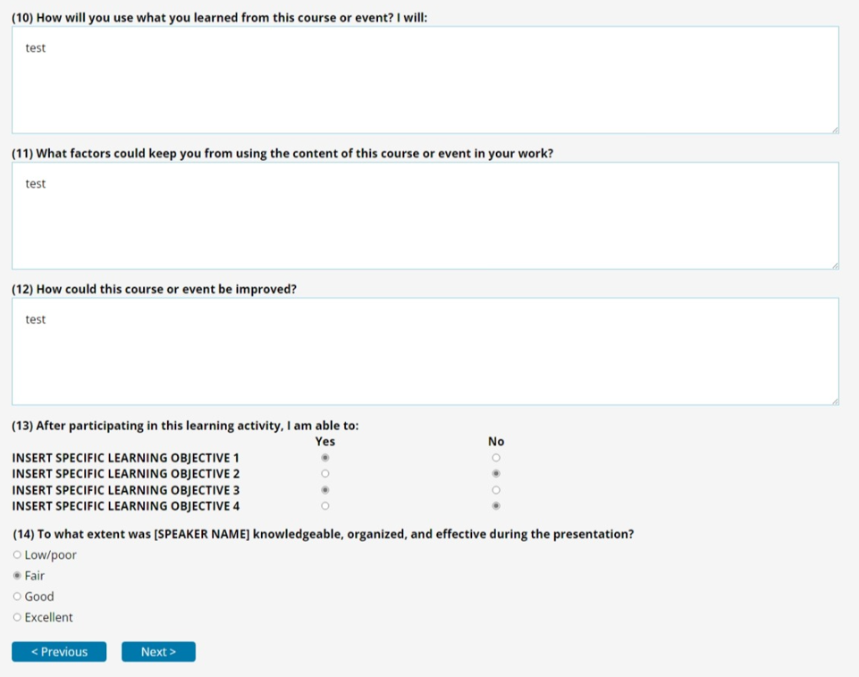

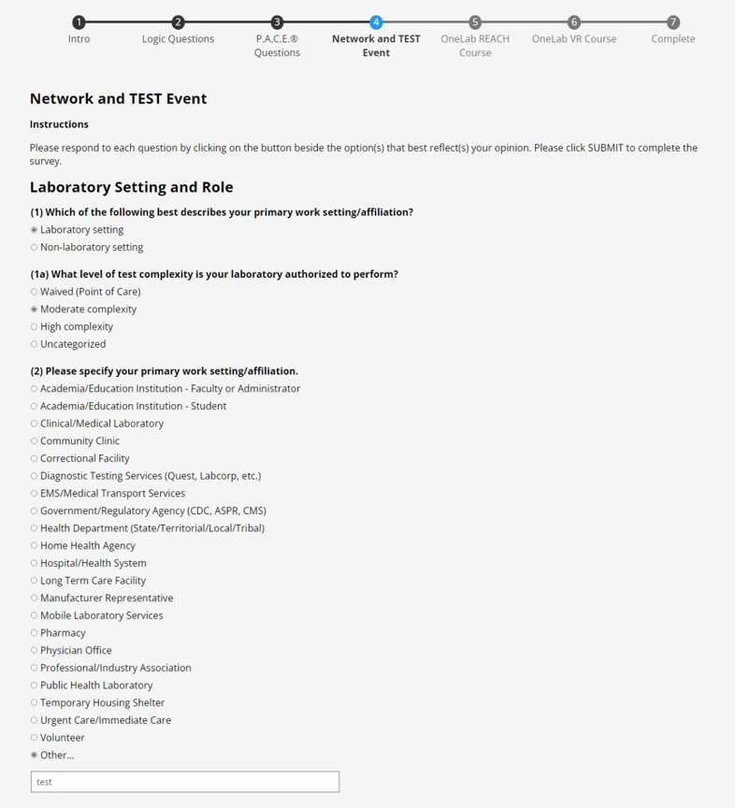

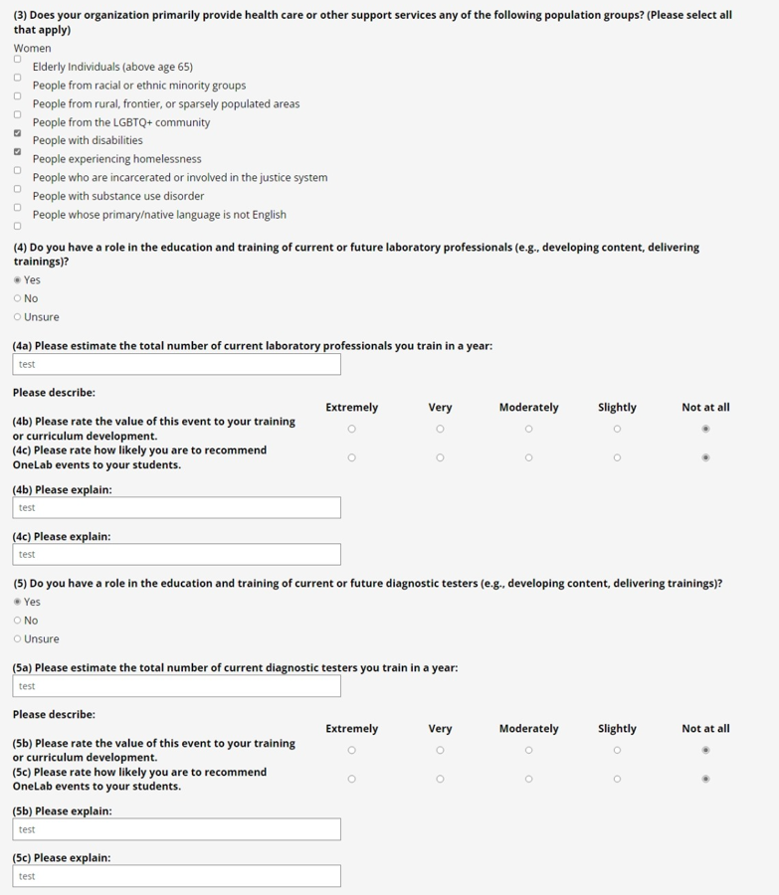

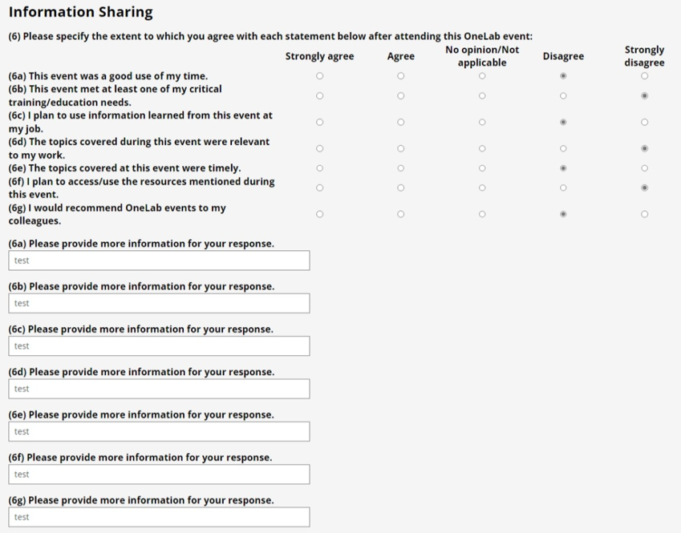

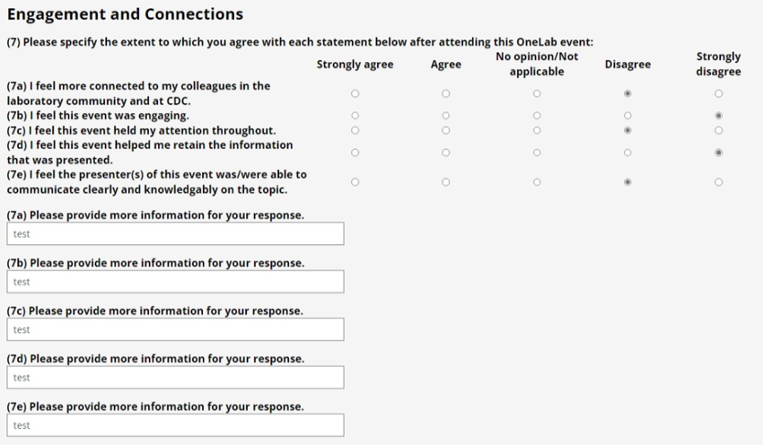

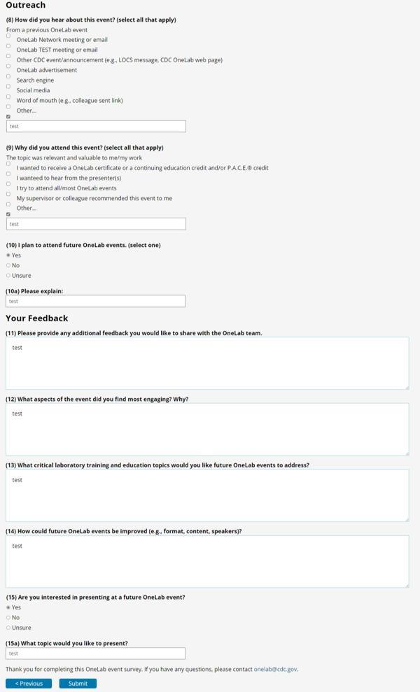

## ***Non-P.A.C.E.® TEST Event***

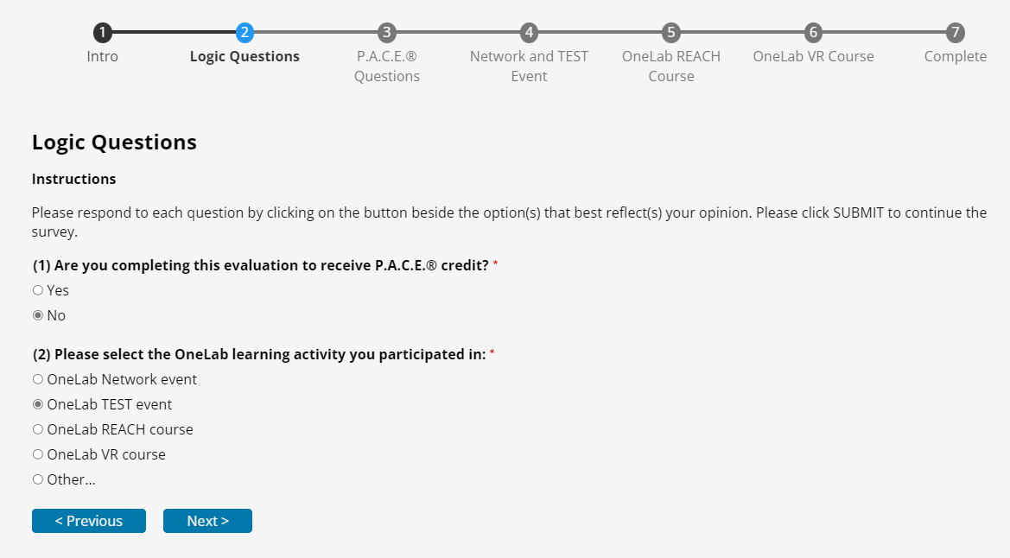

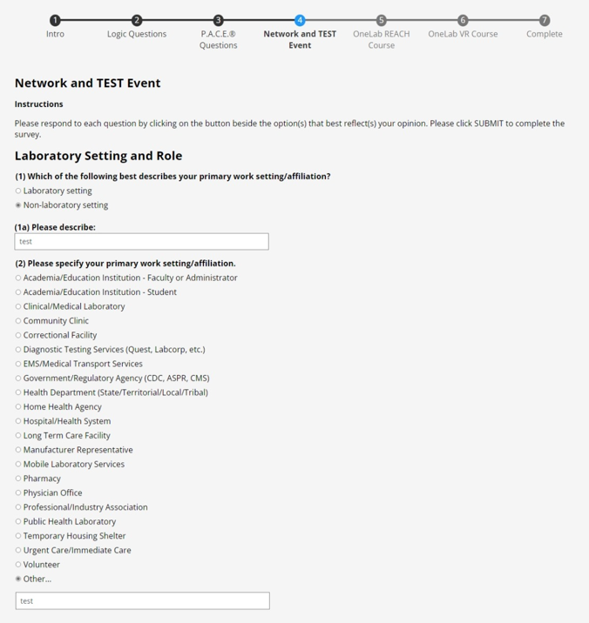









## ***Non-P.A.C.E.® OneLab VR Course***

