**Attachment 1: CAN Survey and Consent**

**OMB No. 0920-1154**

**Exp. Date 3/31/2026**

CDC estimates the average public reporting burden for this collection of information as 15 minutes per response, including the time for reviewing instructions, searching existing data/information sources, gathering and maintaining the data/information needed, and completing and reviewing the collection of information. An agency may not conduct or sponsor, and a person is not required to respond to a collection of information unless it displays a currently valid OMB control number. Send comments regarding this burden estimate or any other aspect of this collection of information, including suggestions for reducing this burden to CDC/ATSDR CDC/ATSDR Information Collection Review Office, 1600 Clifton Road NE, MS H21-8, Atlanta, Georgia 30333; ATTN: PRA (0920-1154).

Thank you for your interest in participating in this survey! This survey is related to communications about child abuse and neglect (what we refer to as “CAN”) and CAN prevention strategies. The following survey should take no longer than 15 minutes to complete. The results will inform future communications developed by the Centers for Disease Control and Prevention (CDC) related to preventing CAN. Your participation is completely voluntary. All survey questions are optional. You may choose to skip survey questions that you do not wish to answer or discontinue the survey at any point. There are no foreseeable risks associated with participating in this survey. We will not ask you for any personal identifiable information (PII), such as your name or email address, that could link your responses to you. There are no direct benefits to participating in the survey. However, you may benefit from knowing your participation will help improve future communication materials related to CAN as well as CDC’s ability to support CAN prevention work.

If you have any questions or concerns about this survey, you may contact [PI NAME] by phone at [PHONE NUMBER] or by email at [EMAIL ADDRESS].

If you understand the information above and would like to participate in the survey, please select “Yes” below. By selecting “Yes” you are electronically signing the statement of consent.

□ Yes *(CONTINUE)*

□ No. Okay, thank you for your time today. *(STOP HERE)*

General Questions

1. **What position best describes you and your relation to children in your life? Select all that apply.** 
   * I am a primary caregiver to one or more children (like parent, caregiver, guardian).
   * I am a direct service provider that works with children in a formal way through my job (like child care provider, teacher, community-based organization, housing organizations, child welfare, substance abuse and mental health provider)
   * I work with children in an informal way (like mentors, youth sports coaches).
   * I interact with children but do not directly care for or work with children (like neighbors, family members).
   * Other [open-ended]
2. **How familiar are you with the topic of child abuse and neglect (CAN)?** With 1 being the lowest (no knowledge or familiarity) and 7 being the highest (extremely knowledgeable or familiar). [scale 1-7]

A/B Message Testing

*The following five questions are intended to compare two messages. Questions 5-10 will be asked for every pair of messages that are compared.*

*Respondents would be presented with two different messages and/or concepts for comparative reaction*

*[Message Comparison #1]*

* + Message A: ACEs can negatively impact a child’s physical, mental, emotional, and behavioral development in the immediate future and for years to come.
  + Message B: When a child experiences abuse and neglect, they are less likely to thrive now and well into adulthood—their physical injuries may go without care now, and they may struggle to feel safe and form bonds with others for years to come.

*[Message Comparison #2]*

* + Message A: You can create spaces where kids form the relationships they need to thrive and where parents or caregivers feel comfortable asking for help when they need it.
  + Message B: When you create spaces for kids to learn, play, and live, you are also creating opportunities for positive relationships and supportive communities where families can get help if they need it.

*[Message Comparison #3]*

* + Message A: Even if you experienced abuse or neglect in childhood, you have the power to create better outcomes now and in the future for the children in your life.
  + Message B: Even if you endured abuse or neglect in childhood, you can be a critical source of support, understanding, and stability to the kids in your life.

1. **Please select the message that you understand best. [one option]**
   * + Message A
     + Message B
     + Neither message
2. **Please select the message that you feel is most motivating. [one option]**
   * + Message A
     + Message B
     + Neither message
3. **Please select the message that you feel is most encouraging. [one option]**
   * + Message A
     + Message B
     + Neither message
4. **Please select the message that you agree with most. [one option]**
   * + Message A
     + Message B
     + Neither message
5. **Please select the message that you will remember best. [one option]**
   * + Message A
     + Message B
     + Neither message
6. **Please select the message that you feel is most important. [one option]**
   * + Message A
     + Message B
     + Neither message
7. **Is there anything else about either message that you’d like to share?** [open text box]

# 

# Message Sets

*This is where we will present message sets to get audience feedback. We will ask the questions below for each message set (i.e., each main message and its supporting messages).*

*[Message Set #1]*

1. **Main Message:** By identifying and celebrating the positive experiences you had as a child (moments of love, support, encouragement, or resilience that helped shape who you are today), you can recognize the power these sorts of experiences have and work to provide them for the children in your life.
   1. **Supporting Message:** You can foster positive relationships with kids, listen to and appreciate their feelings without judgment, be a stable presence in their lives, and offer support and encouragement to help them thrive.

*[Message Set #2]*

1. **Main Message:** Be a consistent and reliable adult who encourages kids to share their feelings without judgment so they can feel emotionally safe and secure.
   1. **Supporting Message:** When parents reach out for help, show up, listen up, and build them up—supporting parents supports kids and helps prevent child abuse and neglect.
2. **How easy is it to understand this message set?** With 1 being the lowest ("I do not understand the messaging") and 7 being the highest ("I understand all of the messaging completely"). (scale 1-7)
3. **To what level do you agree with this message set?** With 1 being the lowest ("I do not agree with this message set") and 7 being the highest ("I completely agree with this message set"). (scale 1-7)
4. **How believable is this message set?** With 1 being the lowest ("I do not believe this message set at all") and 7 being the highest ("I completely believe this message set"). (scale 1-7)
5. **How well do you think you would remember this message set?** With 1 being the lowest ("I am unlikely to remember any of these messages") and 7 being the highest ("I will remember all of the messages"). (scale 1-7)
6. **How important is the information in this message set?** With 1 being the lowest ("not important at all") and 7 being the highest ("extremely important"). (scale 1-7)
7. **Does this message set provide too much information, not enough information, or the right amount?**
   * too much information
   * not enough information
   * the right amount of information
8. **Do you think this message set would motivate you or someone else to [listen to children and offer support]?**
   * Yes
   * No
   * Don’t know

**17. Is there anything else about the message set that you'd like to share?**

Images with Messages

*Respondents will be presented with one message and several corresponding images or graphics to gauge audience reactions to visuals.*

**Message:** Child abuse, neglect, and other adverse childhood experiences have wide-reaching consequences that extend far beyond individual lives.

* Image A:



* Image B:



* Image C:

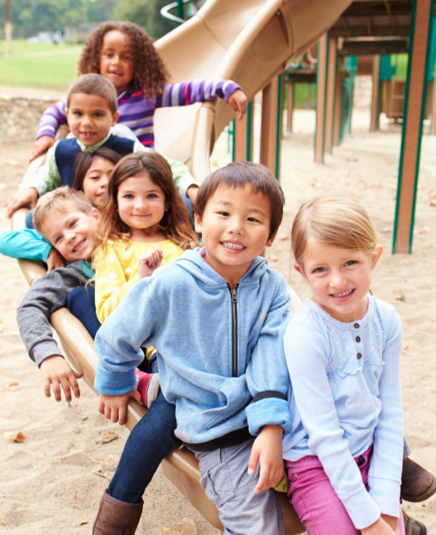

* Image D:



1. **Which of these images do you think is most appropriate for this message?** 
   * + Image A
     + Image B
     + Image C
     + Image D
     + None of the images
2. **Why did you select the image that you did?**

Demographic Questions

1. **How old are you?**
   * under 18 years of age
   * 18-24 years of age
   * 25-34 years of age
   * 35-44 years of age
   * 45-54 years of age
   * 55-64 years of age
   * 65-74 years of age
   * 75 years of age or older
2. **What is your preferred language?**
   * English
   * Spanish
   * American Sign Language
   * Other [open-ended]
3. **What is your Ethnicity?**
   * Hispanic or Latino
   * Not Hispanic or Latino
   * Prefer not to answer/Decline
4. **What is your race? Select all that apply.** 
   * American Indian or Alaska Native
   * Asian
   * Black or African American
   * Native Hawaiian or Other Pacific Islander
   * White
   * Prefer not to answer/Decline
5. **Are you:** *Mark all that apply.*
   * Female
   * Male
   * Transgender, non-binary, or another gender
   * Prefer not to answer/Decline
6. **What is the highest grade or year of school that you completed?**
   * Never attended school
   * Attended kindergarten
   * Grades 1 through 8 (Elementary)
   * Grades 9 through 11 (Some high school)
   * Grade 12 or GED (High school graduate)
   * College 1 year to 3 years (Some college or technical school)
   * College 4 years or more (College graduate)
   * Graduate school
   * I don’t know
7. **Last year, (2022), what was your total household income from all sources, before taxes?**
   * Less than $15,000
   * $15,000 to $24,999
   * $25,000 to $34,999
   * $35,000 to $49,999
   * $50,000 to $74,999
   * $75,000 to $99,999
   * $100,000 to $149,999
   * $150,000+
   * I don’t know
8. **Do you currently have or are the primary caregiver for children under the age of 18?**
   * Yes
   * No

Additional Information

1. **Is there any additional information that you would like to share about this topic or this survey?** [Open-ended]