## Attachment 2: Screening Survey

**PARENTAL CONSENT FORM**

**OMB Control No. 0920-1154**

**Exp. Date 3/31/2026**

The public reporting burden of this collection of information is estimated to average 10 minutes per response, including the time for reviewing instructions, searching existing data sources, gathering and maintaining the data needed, and completing and reviewing the collection of information. An agency may not conduct or sponsor, and a person is not required to respond to a collection of information unless it displays a currently valid OMB control number. Send comments regarding this burden estimate or any other aspect of this collection of information, including suggestions for reducing this burden to - CDC/ATSDR Reports Clearance Officer; 1600 Clifton Road NE, MS H21-8, Atlanta, Georgia 30333 ATTN: PRA (0920-1154).

|  |  |
| --- | --- |
| **Sponsor / Study Title:** | CDC NCIPC Adolescent Mental Health Journey Mapping Project |
| **Principal Investigator:** | Catherine Lesesne, PhD, MPH |
| **Telephone:** | 404-270-0513 |
| **Address:** | **191 Peachtree St NE Ste 2000, Atlanta, GA 30303** |

***[PAGE 1: Consent]:***

We are asking your permission for your adolescent (teen) to take part in an interview, focus group, or brainstorming session about teen mental health.  We are looking to speak with up to 206 teens ages 13 to 17 who identify as girls or nonbinary (hereafter “girls”) and live in rural areas in the US. Specifically, we want to learn more about how easy or hard it is for teens to access mental health tools and services and how to do this better. We would also like to know how teens think about mental health and how their location may change their experiences in accessing mental health care. This research is conducted on behalf of the Centers for Disease Control and Prevention (CDC).

The project offers three types of sessions:

* **Interview**: 60-minute conversation between one teen and 2-3 project team members
* **Focus Group**: 90-minute group conversation with teens, guided by the project team
* **Brainstorming Session**: 90-minute opportunity for teens to share feedback and ideas with the project team

The session questions ask about mental health topics. For some people, these topics may cause temporary discomfort or cause strong emotions. We do not anticipate any other risks in participating in the sessions. To reduce risk, we will remind participants that they do not have to answer any questions they do not want to answer. If any participant is showing signs of distress during our session our trained team or the onsite partner team will speak with the individual privately, assess the level of distress and respond appropriately. Response will include asking if they currently receive mental health support and if so encourage them to follow up with their provider and offering a Mental Health Resources sheet or, if the level of distress necessitates it, follow the Mental Health First Aid Protocol.[1] If a participant exhibits distress, the project team will work with the recruitment partner organization to follow up with the participant.

We will record audio in the sessions. The team will use the recording to make sure our notes are correct and to summarize what we hear across all groups. Only our project team will have access to these recordings. The recordings will be deleted once our team updates the session notes. Nothing said in the sessions will be linked to your teen. The names of participants will never be used in reports of this research, and we will not share comments from teens with parents/guardians. The sessions will not ask questions about illegal activities. If a participant mentions illegal activities within the sessions, the project team will not report on these activities. We will keep your child’s participation in this research study confidential to the extent permitted by law. However, if your child is participating in a group discussion, we cannot guarantee their participation or things they may say will remain confidential and private. This is due to the chance that other participants may disclose information about the group to unknown others. We ask all participants to use only first names or fake names in all group discussions and to keep the discussion in the group confidential to respect each other’s privacy. Even with these steps taken, we cannot guarantee confidentiality. Your child should keep this in mind when choosing what to share in the group setting.

This project is for research only. Participants who attend any of the above sessions will receive a $50 Visa gift card per session for their participation. Participation in these sessions is completely voluntary. You do not have to allow your child to take part in any sessions, and your child does not have to take part in a session even if you allow them to. Your child can skip any questions they do not want to answer. Your child can stop or leave the session at any time by letting one of our team members know they would like to end the session. They will still receive the gift card even if they choose to end participation in a session.

If your teen participates in a virtual session, they must have a computer, tablet, or handheld device with a microphone and access to the Zoom app. The Zoom app is free for download and usage. If your teen’s computer does not have a microphone, they may use a phone to dial in to Zoom audio.

If you want to allow your teen to join a session, you need to give your consent (permission) as their parent/guardian. **Please click continue/next below to provide consent by [INSERT DATE] and share information about your teen.** If we select your teen to join, we will contact you both. We will also ask your teen to assent (agree) to participate. There are limited spaces to join. The project team will confirm participation on a rolling basis and will attempt to ensure diversity across teen participants. This means that not all eligible teens will be invited to an interview, focus group, or brainstorming session depending on the distribution of the characteristics of teens who agree to participate. For these reasons, we will not select every teen to join even if you consent to their participation.

If you have any questions, concerns, or complaints about the study, please contact Dr. Catherine Lesesne at 404-270-0513 or at injuryctrengage@cdc.gov. If you have any questions about you or your teen’s rights as a research subject, you may contact Solutions IRB by phone, toll-free, at 855-226-4472 or by email at [participants@solutionsirb.com](mailto:participants@solutionsirb.com).

*Please click NEXT to review the consent form.*

***[PAGE 2: Formal Consent]:***

**Formal Consent:** Your response to the following question will indicate your formal consent. By choosing “Yes” below, you agree that you understand the goals of the sessions. You agree to allow your teen to take part in the session types (i.e., interview, focus group, or brainstorming session) you select below. You agree to allow the project staff to collect, store, and share the combined, non-identifiable information from the sessions as outlined above. You will be asked to share your teen’s name and email address. If your profile meets the needs of our sessions, you and your teen will be contacted in the next 1-2 weeks to ask for your teen’s agreement to participate, session type preferences, and their availability.

1. As the parent or guardian, do you allow your teen to take part in an interview, focus group, or brainstorming session about mental health? Please select all that apply.
   * YES my teen can participate in an interview [Continue to Q2]
   * YES my teen can participate in a focus group [Continue to Q2]
   * YES my teen can participate in a brainstorming session [Continue to Q2]
   * NO my teen may not participate in this study [Screen out and message shows: *Thank you for considering this research study.*]
2. Do you allow to the project team to record the audio of the session you want to participate in? As a reminder, the recording will only be used to make sure our notes are correct and to summarize what we hear across all groups. Nothing said in the sessions will be linked to a specific individual.:
   * YES, I allow the project team to record the audio of the session. [Continue to Q3]
   * NO, I do not want the project team to record the audio of the session. [Screen out and message shows: *Thank you for your time and for considering this research study.*]

***[PAGE 3: Additional Screening Questions]:***

Based on your answers to the following questions, the team may ask your adolescent (teen) to take part in an interview, focus group, and/or brainstorming session to learn about the mental health experiences of teen girls living in rural areas.

1. Does your teen identify as a male? (*Optional*)
   * Yes [Screen out and message shows: *Unfortunately, your teen is not a match for this project. Thank you for your time.*]
   * No [Continue to Q4]
2. Which of the following best describes the community you and your teen live in?
   * Urban [Screen out and message shows: *Unfortunately, your teen is not a match for this project. Thank you for your time.*]
   * Suburban [Continue to Q5]
   * Rural [Continue to Q5]
   * Frontier [Continue to Q5]
   * Tribal [Continue to Q5]
   * Other: __________ [Continue to Q5]
3. What state do you and your teen live in?
   * Montana [Continue to Q6]
   * New Mexico [Continue to Q6]
   * North Carolina [Continue to Q6]
   * Other [Screen out and message shows: *Unfortunately, your teen is not a match for this project. Thank you for your time.*]
4. What is your zip code?
   * [Open-Ended] ________________
5. How old is your teen (in years)?
   * _ _ _ (whole number)
     + If less than 13 [Screen out and message shows: *Unfortunately, your teen is not a match for this project. Thank you for your time.]*
     + If between 13 and 17 [Continue to Q8]
     + If greater than 18 [Screen out and message shows: *Unfortunately, your teen is not a match for this project. Thank you for your time.]*
6. Is your teen comfortable speaking English in a group setting with peers?
   * Yes [Continue to Q9]
   * No [Screen out and message shows: *Unfortunately, your teen is not a match for this project. Thank you for your time.]*
   * I am not sure [Continue to Q9]
7. What is your teen’s race or ethnicity? (Choose all that apply.)
   * American Indian or Alaska Native
   * Asian
   * Black or African American
   * Hispanic or Latino
   * Middle Eastern or North African
   * Native Hawaiian or Pacific Islander
   * White

*[****PAGE 4, Appears if Teen is Eligible for Participation****]:*

Thank you for your responses! If your teen is selected to take part in a session, their time and efforts will help the CDC make better programs and services for teen mental health in the future. In order to contact your teen for a brief survey and assent (agreement) form, similar to this survey you just completed, please confirm **your teen’s** contact information:

**Write-in:** <Capture name>

**Write-in:** <Capture email address>

Please confirm **your** contact information for our team to share session scheduling updates:

**Write-in:** <Capture name>

**Write-in:** <Capture email address>

**Screenshots of Web Version:**

Page 1:

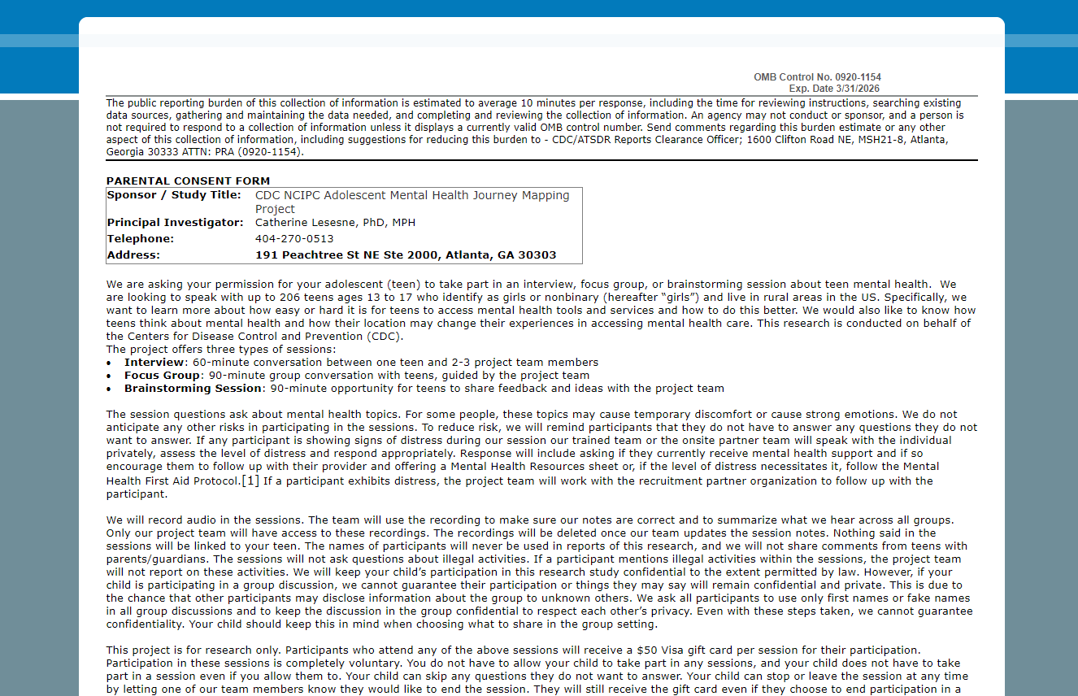

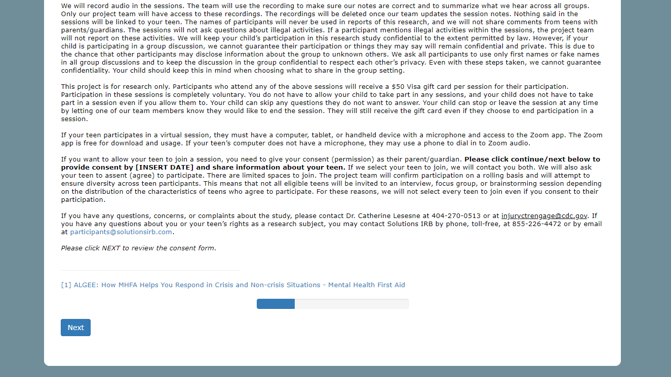

Page 2:

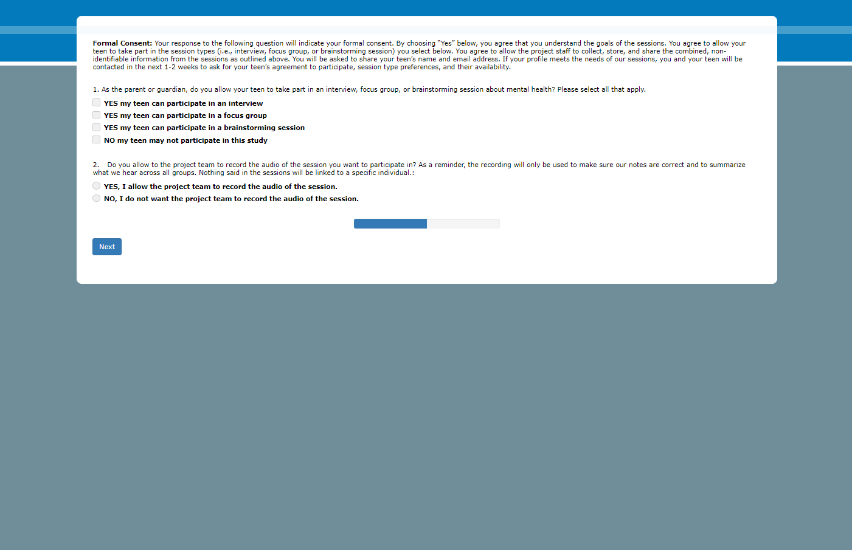

Page 3:

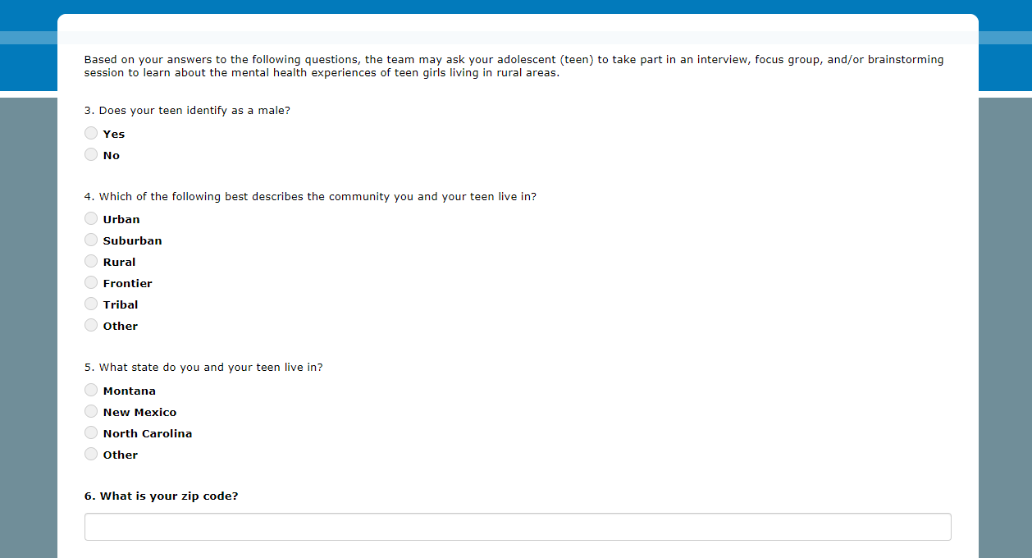

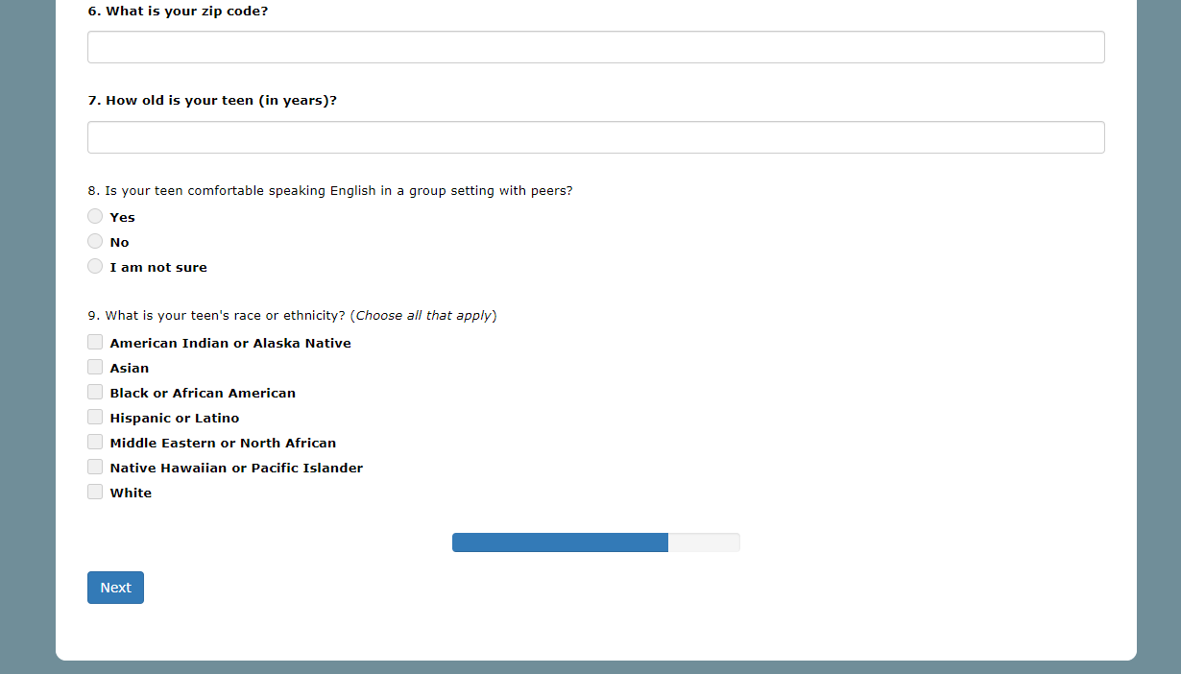

Page 4:

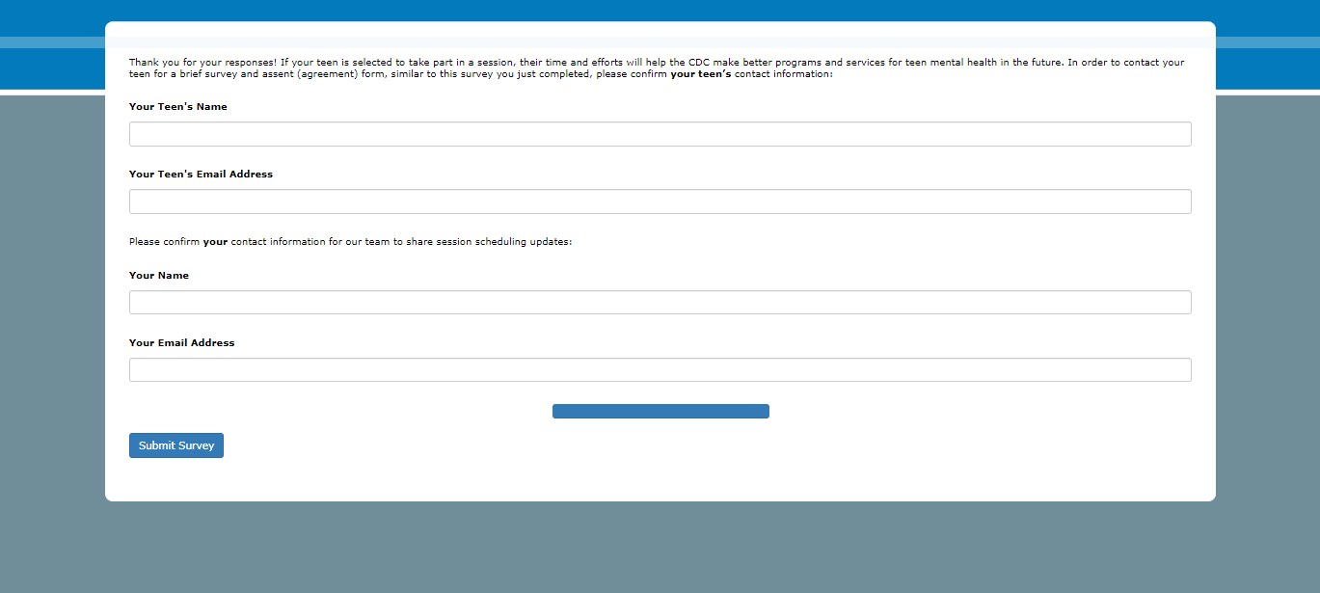

1. [ALGEE: How MHFA Helps You Respond in Crisis and Non-crisis Situations - Mental Health First Aid](https://www.mentalhealthfirstaid.org/2021/04/algee-how-mhfa-helps-you-respond-in-crisis-and-non-crisis-situations/)