**Attachment 3: ACEs Focus Group Participant Screener**

**OMB Control No. 0920-1154**

**Exp. Date 3/31/2026**

The public reporting burden of this collection of information is estimated to average 5 minutes per response, including the time for reviewing instructions, searching existing data sources, gathering and maintaining the data needed, and completing and reviewing the collection of information. An agency may not conduct or sponsor, and a person is not required to respond to a collection of information unless it displays a currently valid OMB control number. Send comments regarding this burden estimate or any other aspect of this collection of information, including suggestions for reducing this burden to - CDC/ATSDR Reports Clearance Officer; 1600 Clifton Road NE, MS D-74, Atlanta, Georgia 30333 ATTN: PRA (0920-1154).

[For recruiter to use when recruiting focus group participants who are general consumers and/or parents]

1. Are you comfortable speaking and reading in English?
   1. Yes [ELIGIBLE; CONTINUE]
   2. No [INELIGIBLE; STOP]
   3. Don’t Know [INELIGIBLE; STOP]
2. Are you an adult (age 18+ years old)?
   1. Yes (18+ years) [ELIGIBLE; CONTINUE]
   2. No (<18 years) [INELIGIBLE; STOP]
   3. Refused [INELIGIBLE; STOP]
3. Have you participated in any focus group, interview, telephone survey, or online survey in which you were asked your opinions about a product, a service, or advertising within the past six months?
   1. No [ELIGIBLE; CONTINUE]
   2. Yes [INELIGIBLE; STOP]

The discussion we would like you to participate in will take place on the computer.  The next few questions will involve technology – please answer these questions considering the computer you will be using to join the focus group.

1. Do you currently have access to high-speed (at least 1.5Mbps) internet – again considering the location and computer you will be joining the discussion from?

[    ] Yes

[    ] No TERMINATE

1. What type of computer will you be using?

[ ] Laptop

[ ] Desktop

[ ] I do not have access to a laptop or desktop -TERMINATE

1. Do you currently have a working webcam on your computer (whether built in or plug in)?

[ ] Yes – Built In

[ ] Yes – External

[  ] No- TERMINATE

1. Do you have access to an active email account?

[    ] Yes – RECORD CAREFULLY ________________________________________

[    ] No TERMINATE

This account is where we will send your confirmation email with important instructions on how to join the session.

|  |  |  |
| --- | --- | --- |
| ELIGIBILITY CHECK: | □ Yes  □ No | Date:  Initials: |

[If participant is ineligible based on questions above, TERMINATE]

Unfortunately, you do not meet the qualifications to participate in this study. Thank you for your time and interest.

[If participant is eligible based on questions above, CONTINUE]

Good news. You are eligible to participate in this study.

I have a few additional questions to ensure we get a balanced mix of participants in this study.

1. How old are you?
   1. 18-24 years of age
   2. 25-34 years of age
   3. 35-44 years of age
   4. 45-54 years of age
   5. 55-64 years of age
   6. 65-74 years of age
   7. 75 years of age or older
2. 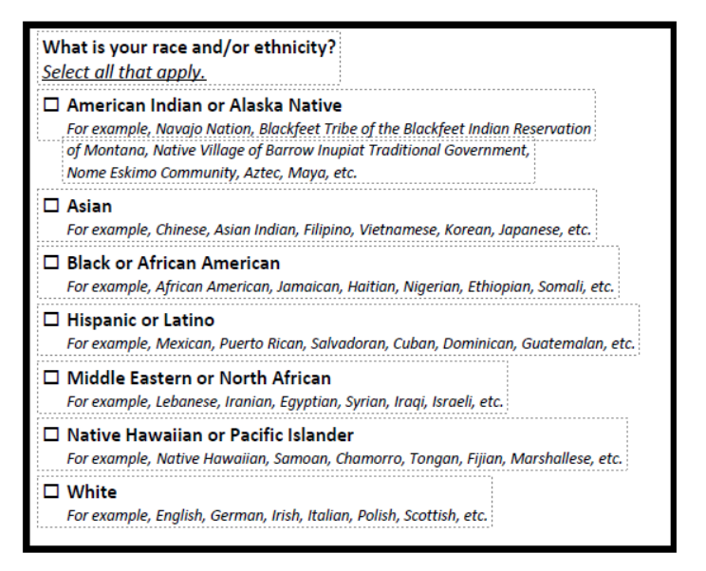
3. How do you currently describe yourself (mark all that apply)?
   1. _ Female
   2. _ Male
   3. _ Transgender
   4. _ Prefer not to answer/Decline
4. What is the highest grade or year of school that you completed?
   1. Never attended school
   2. Attended kindergarten
   3. Grades 1 through 8 (Elementary)
   4. Grades 9 through 11 (Some high school)
   5. Grade 12 or GED (High school graduate)
   6. College 1 year to 3 years (Some college or technical school)
   7. College 4 years or more (College graduate)
   8. Graduate school
   9. I don’t know
5. Last year, (2023), what was your total household income from all sources, before taxes?
   1. Less than $15,000
   2. $15,000 to $24,999
   3. $25,000 to $34,999
   4. $35,000 to $49,999
   5. $50,000 to $74,999
   6. $75,000 to $99,999
   7. $100,000 to $149,999
   8. $150,000+
   9. I don’t know
6. Do you currently have children or are the primary caregiver for children under 18 years of age?
   1. Yes
   2. No
7. If you are interested in participating in a discussion about messages related to adverse childhood experiences, please give us your contact information (*recruiter will fill out contact information card*) below. If you are chosen for the study, a team member will contact you to arrange a convenient time for the focus group discussion.

|  |  |
| --- | --- |
| **PARTICIPANT PREFERRED CONTACT INFORMATION** | |
| **PARTICIPANT NAME:** | |
| **Cell:** | **Home (other phone):** |
| **EMAIL (*must be an email address that is used frequently*):** | |
| **Best time and way to reach:** | |