Fungal and Waterborne Disease images (Switch out with lettuce image):

* Fungal
  + 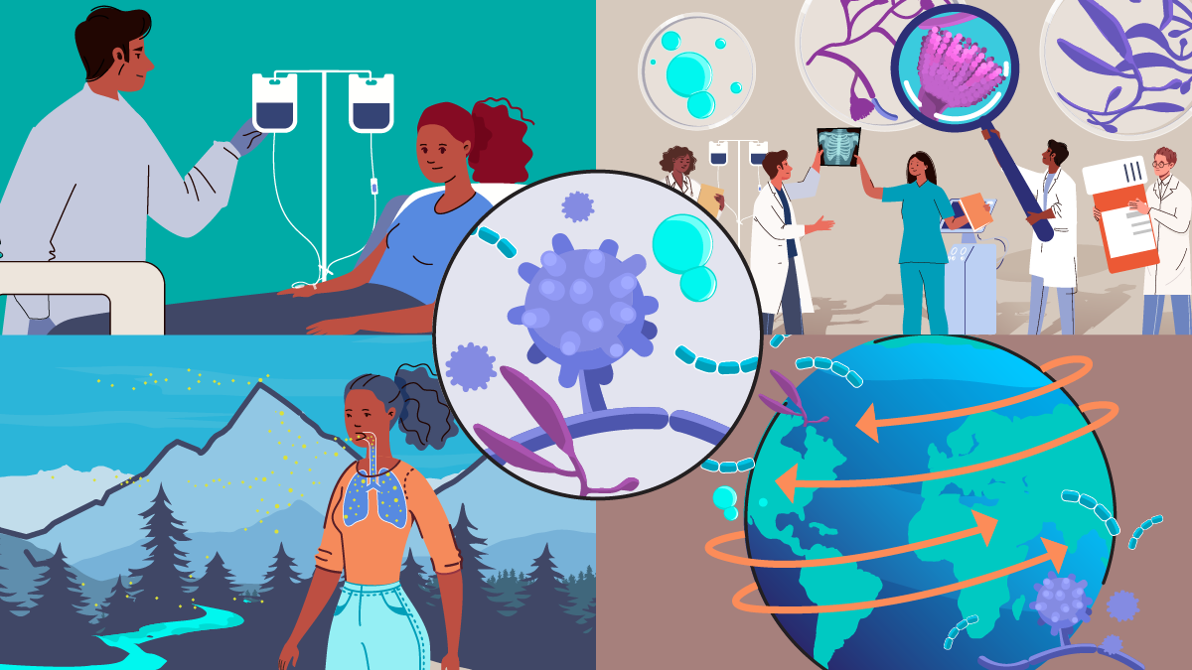
  + 
* Waterborne
  +  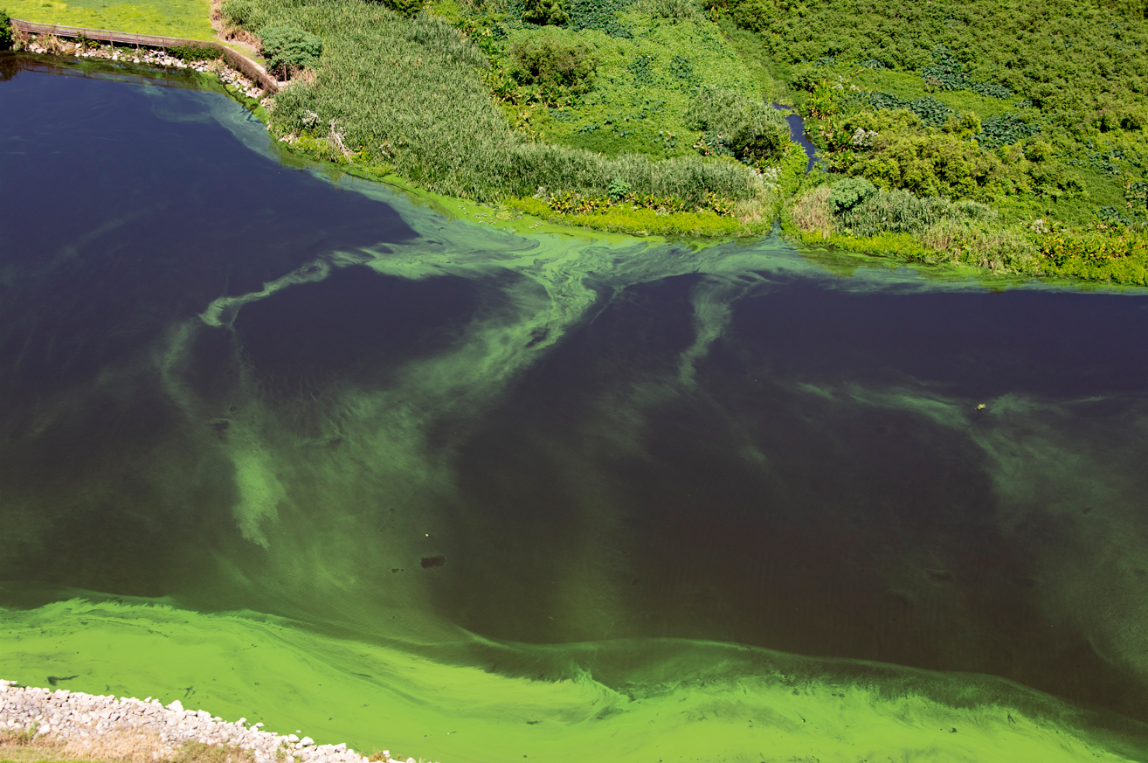
  + 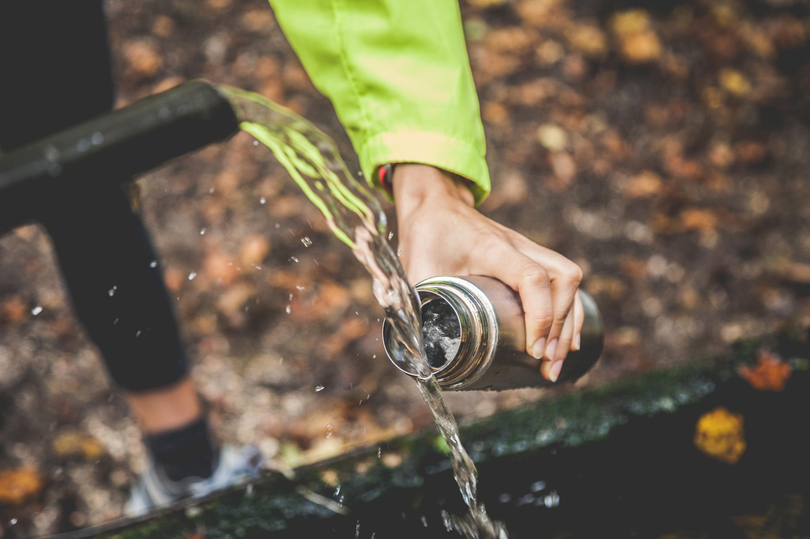

**Recruitment Language (General and Post Copy)**

**Sample Recruitment Language (General)**



Banyan Communications is conducting focus groups with adults to learn people’s opinions about health-related messages and to hear their preferences for getting health information. These focus groups will be about 60 minutes long and will take place online. To learn more about the focus groups and determine if you are eligible to participate, please click [link to online screening form].

If you have any questions about the focus groups, please contact Banyan Communications, [insert_inbox_here@banyancom.com](mailto:insert_inbox_here@banyancom.com)

**Sample Recruitment Post (Immunocompromised)**



Do you take medication or have a disease or condition that affects your immune system’s ability to fight off infections?

We’re looking for people 18 years and older to share their opinions about foodborne, waterborne, and fungal disease safety. The conversation will be a virtual session over the internet lasting 60 minutes.

If you are interested, please click on the link below to answer some questions about yourself to see if you are qualified.

If you know someone who may be interested, please share the link with them.

When: [DATE]

Where: Online

Token of Appreciation: $75

[ELIGIBILITY AND DEMOGRAPHIC SCREENER LINK]

**Sample Recruitment Post (Caregivers)**



Do you have a child living in your home who is under 5 years old?

We’re looking for people 18 years and older who have at least one child under 5 years old living in their home to share their opinions about foodborne, waterborne, and fungal disease safety. The conversation will be a virtual session over the internet lasting 60 minutes.

If you are interested, please click on the link below to answer some questions to see if you are qualified to

If you know someone who may be interested, please share the link with them.

When: [DATE]

Where: Online

Token of Appreciation: $75

[ELIGIBILITY AND DEMOGRAPHIC SCREENER LINK]

**Sample Recruitment Post (Older Adults)**



We’re looking for people 65 to 75 to share their opinions about foodborne, waterborne, and fungal disease safety. The conversation will be a virtual session over the internet lasting 60 minutes.

If you are interested, please click on the link below to answer some questions about yourself. If you are qualified, you will see a link to the survey.

If you know someone who may be interested, please share the link with them.

When: [DATE]

Where: Online

Token of Appreciation: $75

[ELIGIBILITY AND DEMOGRAPHIC SCREENER LINK]

**Sample Recruitment Post (Pregnant)**



Are you currently pregnant or have you recently been pregnant?

We’re looking for people 18 years and older who are currently or were recently pregnant to share their opinions about foodborne, waterborne, and fungal disease safety. The conversation will be a virtual session over the internet lasting 60 minutes.

If you are interested, please click on the link below to answer some questions about yourself. If you are qualified, you will see a link to the survey.

If you know someone who may be interested, please share the link with them.

When: [DATE]

Where: Online

Token of Appreciation: $75

[ELIGIBILITY AND DEMOGRAPHIC SCREENER LINK]

**Sample Recruitment Post (Wellness and Healthy Eaters)**

 

Are you someone that is interested in wellness and healthy eating?

We’re looking for people 18 years and older to learn more about wellness share their opinions about it. The conversation will be a virtual session over the internet lasting 60 minutes.

If you are interested, please click on the link below to answer some questions about yourself to see if you are qualified.

If you know someone who may be interested, please share the link with them.

When: [DATE]

Where: Online

Token of Appreciation: $75

[ELIGIBILITY AND DEMOGRAPHIC SCREENER LINK]