GenIC Clearance for CDC/ATSDR
Formative Research and Tool Development

Food Safety Communication Evaluation: Assessing Food Safety Messages, Knowledge, and Attitudes

Attachment 12 – Messages for testing

Contact: Sara Bresee, MPH
Office of the Director
Division of Foodborne, Waterborne, and Environmental Diseases
Centers for Disease Control and Prevention
1600 Clifton Road, NE
Atlanta, Georgia 30333
Phone: (404) 639.3371
Email: yla4@cdc.gov

Messages for testing
Message/content (also add in if there is anything specific you would like to test—like focus on the colors etc). | What | Audience | POC/Branch
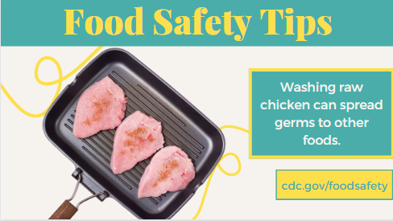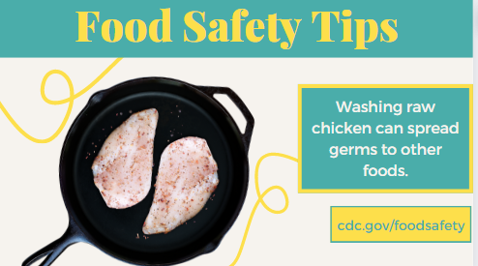  Compare these messages:  - Washing raw chicken does not prevent illness, and can actually spread bacteria to other foods, utensils, and surfaces through splashing. To kill germs, cook chicken and other poultry to 165°F.  - Washing raw chicken can spread germs and make you sick. If you wash it, immediately clean and thoroughly sanitize sink and surrounding area. USDA study: 1 in 7 people who cleaned sink after washing chicken still had germs in the sink.  - Washing chicken can spread germs and make you sick. Instead of washing, you could pat chicken dry with a paper towel and throw towel away. Immediately wash hands and sanitize surfaces the chicken touched.  - Raw chicken is ready to cook. It doesn't need to be washed first. According to a USDA study, 1 in 7 people who cleaned their sink after washing chicken still had germs in the sink. If you choose to wash chicken, do so as safely as possible:  1. Run the water gently over the chicken to reduce splashing.  2. Then immediately clean the sink & area around the sink with hot soapy water & sanitize thoroughly.  3. Wash your hands for 20 seconds.  Wash chicken vs rinse chicken | SM post and potential website content – want to see which people prefer and which is most likely to cause behavior change, 1) cook to kill germs, 2) washing spreads germs, 3) paper towel alternative, 4) safe way to wash chicken | Maybe target:  AA/Black individuals  H/L  Older adults | Kelsey/Cara
Refrigerate perishable food within 2 hours. If the food is exposed to temperatures above 90°F (like a hot car or picnic), refrigerate it within 1 hour.  Refrigerate perishable food (including meat, chicken, turkey, seafood, eggs, cut fruit, cooked rice, and leftovers) within 2 hours. If the food is exposed to temperatures above 90°F (like a hot car or picnic), refrigerate it within 1 hour. | Message, specifically interested in people’s understanding of (1) “perishable”, (2) the 1 hour exception and (3) the examples of perishable |  | Kelsey
Use a food thermometer to ensure foods are cooked to a safe internal temperature:  - Fish with fins: 145°F or cook until flesh is opaque  - Fish with fins: 145°F or cook until flesh separates easily with a fork | Message, want to know what description of “done” is easier to understand or if they have suggestions |  | Kelsey
- Keep raw chicken and its juices away from ready-to-eat foods.  OR  - Keep raw chicken and its juices away from ready-to-eat foods, like salads or food that is already cooked. | Message, want to know if they understand ready-to-eat or need the examples |  | Kelsey
- Always wash hands after handling uncooked meat, poultry, seafood, flour, or eggs.  OR  - Always wash hands after handling uncooked meat, chicken and other poultry, seafood, flour, or eggs. | Message, want to know if they understand “poultry” or need the chicken example |  | Kelsey
Use a food thermometer to ensure foods are cooked to a safe internal temperature:  - Whole cuts of beef, veal, lamb, and pork, including fresh ham (raw): 145°F (then allow the meat to rest for 3 minutes before carving or eating)  - Whole cuts of beef, veal, lamb, and pork, including fresh ham (raw): 145°F (then allow the meat to sit untouched for 3 minutes before carving or eating) | Message, want to see what is easier to understand (rest or sit, untouched) |  | Kelsey
FSEM infographic with all steps  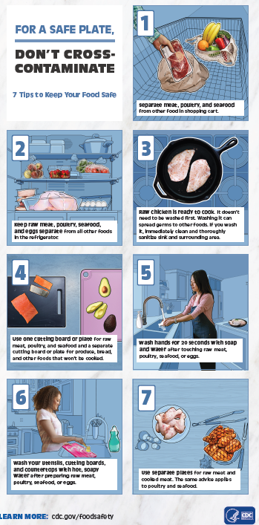 | Full infographic with messages and images (more realistic than those tested in the past) |  | Kelsey/Cara
Updated food poisoning symptoms searchable table  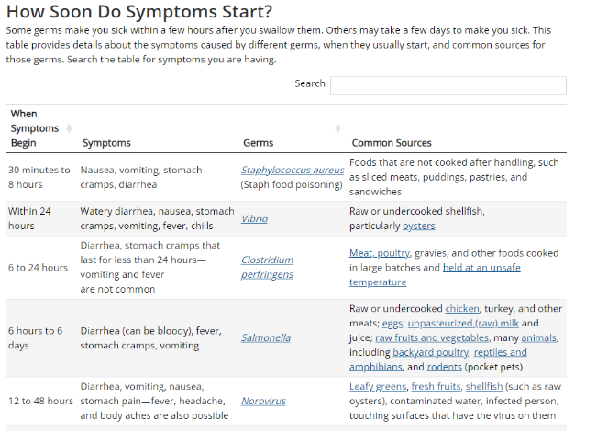  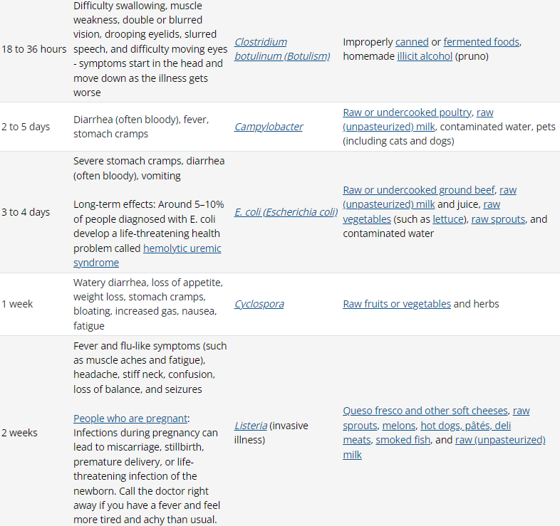  Food Poisoning Symptoms | CDC | Web page – test desktop and mobile version of table |  | Kelsey
Riskier/safer foods table for high-risk groups  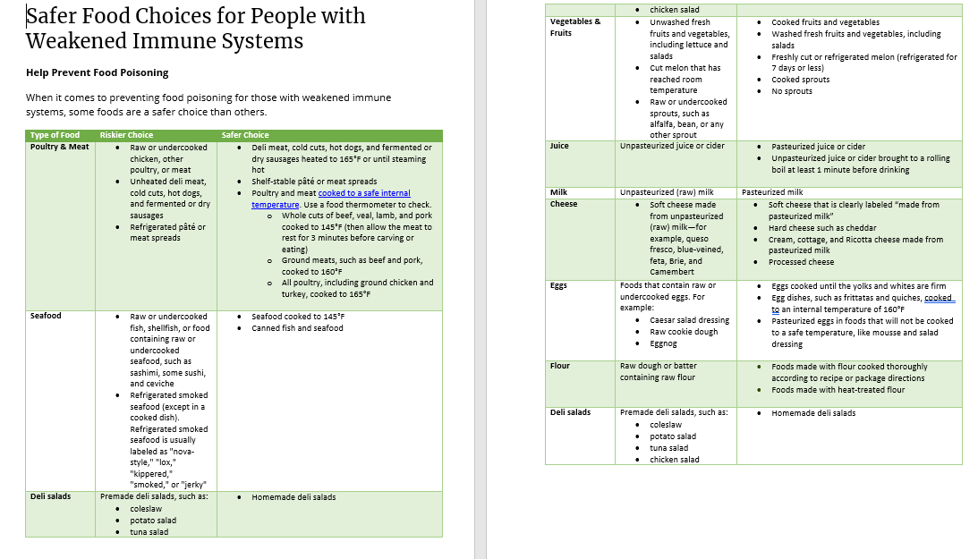 | Web page – the content is still under review and then we will build out the table (there is a different table for each group) and an infographic based on this content | All high-risk groups | Kelsey
cooking meat graphics: thanksgiving mom, turkey bear, superhero post, rules of the game, grilling, holiday, and winter holiday meat video | Messages, pick a few for participants to see side-by-side and state preference and why and which are most likely to impact behavior change |  | Kelsey
New winter 2022 graphics with food thermometer placement in meat  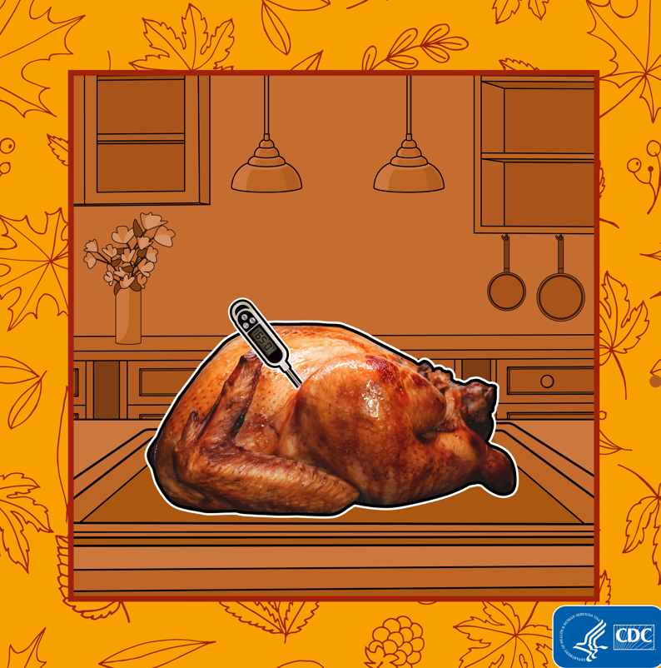 | Graphic, want to know if they find it helpful to be shown and told where to place the thermometer and if that will impact behavior change. This version will be updated soon to be a GIF that shows the different places that need to be checked. |  | Kelsey
People who have 1 cutting board message- write message that explains to wash it in between uses, or just cut meat last  - cut fruits and veggies first then wash cutting board with soap and hot water before cutting raw meat on it | Health equity related message, since kitchen tools may be expensive.
Show video of a physician giving advice | Healthcare provider was most popular choice for people to pick where they want Food safety info from (PN styles): can we explore web or social messages from a doctor? (ie. Create a new video)
Behavior/perception question: Explore what makes certain races (from our research, non- white) more worried about getting sick from salmonella in chicken
Soft cheeses recommendation |  | Pregnant people
food safety in an emergency messages and graphics  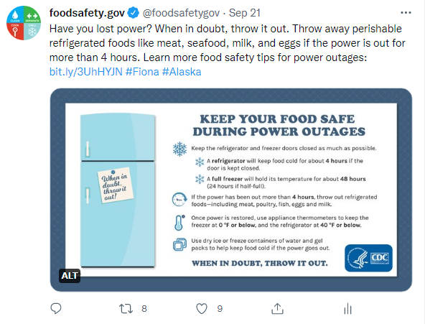  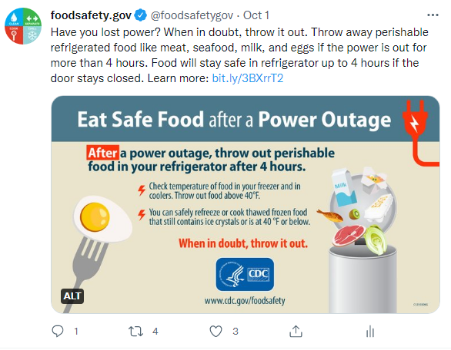 | SM | General public | Kelsey/Cara
Different kinds of chicken images
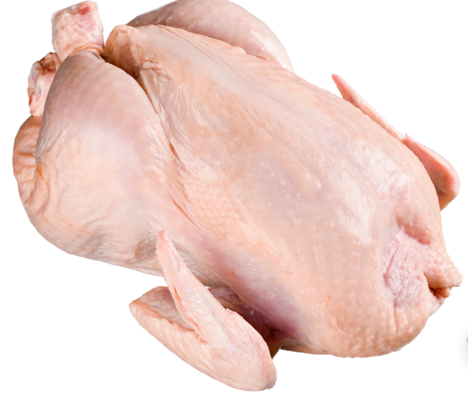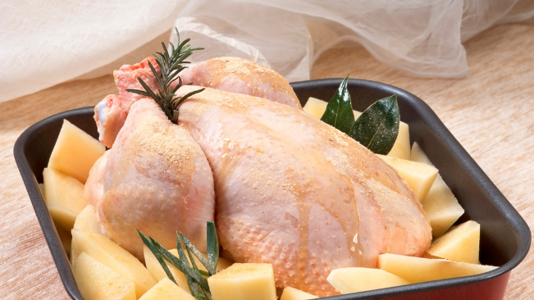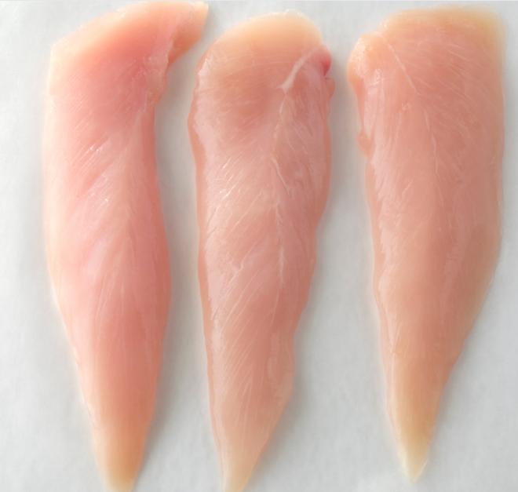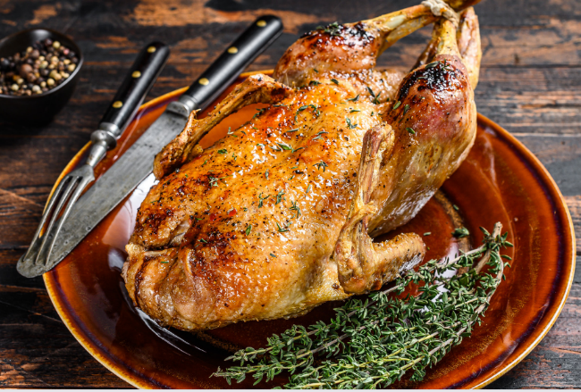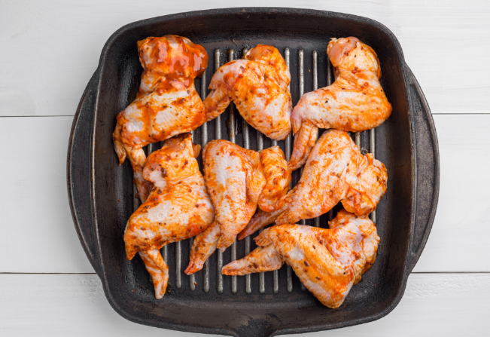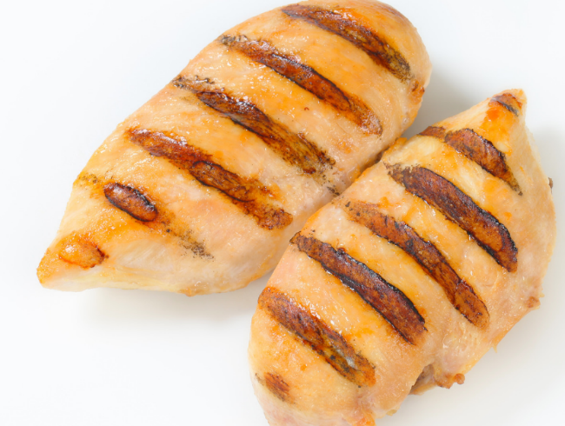
LOWER PRIORITY for OD comms
Compare raw flour: stock image post, family post, and cartoon post |  |  | Sarah D
test this page: https://www.cdc.gov/foodsafety/communication/no-raw-dough.html |  |  | Sarah D
Raw Milk messaging (Raw Milk Questions and Answers | Raw Milk | Food Safety | CDC) | Explore how people feel about messaging including special focus on more “fear based messaging” and what is most likely to impact behavior change | “moveable middle” of raw milk drinkers | SD
Food waste prevention messages pulled from Tips to Reduce Food Waste | FDA  “Ugly” fruits and vegetables are still food safe! “Ugly” produce has physical imperfections but are not damaged or rotten. “Ugly” fruits and vegetables are safe and nutritious and can sometimes be found at discounted prices.  Do you have any fruit or vegetables that are bruised or damaged? Before you eat them, you can cut away any damaged or bruised areas to prevent food waste.  Pulled from Fruit and Vegetable Safety | CDC | Health equity issue- need to talk to SMEs about this, but we are not conscious of some of our wording on our pages (ie don't buy ugly vegetables/fruits)  If we could get SMEs to agree on any of these messages, it would be great to test graphics

WDPB
Message/content (also add in if there is anything specific you would like to test—like focus on the colors etc). | What (SM/inforgraphic/message) | Audience (see audience list above) | POC/Branch
Cronobacter prevention infographic (cdc.gov) | Infographic | Mothers and caretakers of infants | Ashley Andujar/WDPBBrittany Robinson, WDPB

ORPB
Message/content (also add in if there is anything specific you would like to test—like focus on the colors etc). | What (SM/inforgraphic/message) | Audience (see audience list above) | POC/Branch
Do not eat recalled ground beef. Throw it away.  Context: Looking to find out what people in these groups would do if they read this message. Would they follow the advice, or would they consider cooking it rather than wasting the food? | Message | Lower income people/ People who use food banks  AI/AN people, people living in non-metro areas, people with no access to cars  -people who cook/eat ground beef at home | ORPB Comms
Do not eat recalled ground beef. Throw it away or return it to the store.  Context: Looking to find out what people in these groups would do if they read this message. In comparison to the message above, would they follow this advice given the option to return for a refund or would they still consider cooking it rather than wasting the food? | Message | Lower income people/ People who use food banks  AI/AN people, people living in non-metro areas, people with no access to cars  -people who cook/eat ground beef at home | ORPB Comms
What People at Higher Risk Should Do  You are at higher risk for severe Listeria illness if you are pregnant, aged 65 or older, or have a weakened immune system due to certain medical conditions or treatments. If you are not in these groups, you are unlikely to get very sick from Listeria.  Listeria is especially harmful if you are pregnant, aged 65 or older, or have a weakened immune system due to certain medical conditions or treatments. If you are pregnant, it can cause pregnancy loss, premature birth, or a life-threatening infection in your newborn. Other people can be infected with Listeria, but they rarely become seriously ill. | Web screenshot? | -older adults 65+  -Pregnant people  -Immuno-compromised  -People who are not in the high risk groups  -parents to children under 5 | ORPB Comms
Listeria – new infographic for pregnant people in English and Spanish (draft) | Factsheet | Pregnant people | ORPB Comms
Listeria – existing fotonovela (English PDF, Español PDF) |  | Hispanic/L pregenant people
Listeria factsheet for older adults  Listeria – new infographic for older adults and people with weakened immune system (draft) | Factsheet | Older adults 65+ | ORPB Comms
E. coli/Salmonella/Listeria symptoms module in outbreak postings  Context: These symptoms modules have been used for many years with few changes. We’re looking for feedback on the understandability or usefulness of their content from a variety of audiences.  Symptom language from here  - Questions and Answers | Salmonella | CDC  - Salmonella Outbreak Linked to Pet Bearded Dragons | CDC  Symptom language from: Listeria Outbreak Linked to Enoki Mushrooms | CDC  sytmptoms from this page CDC Issues Update on Search for Source of Midwestern E. coli Outbreak | CDC Online Newsroom | CDC  E.coli on outbreak pages  About E. coli:  - Symptoms of Shiga toxin-producing coli (STEC) infection vary for each person, but often include severe stomach cramps, diarrhea (often bloody), and vomiting. Some people may have a fever, which usually is not very high (less than 101˚F/38.5˚C).  - Most people get better within 5 to 7 days. Some infections are very mild, but others are severe or even life-threatening.  - Most people with a STEC infection start feeling sick 3 to 4 days after eating or drinking something that contains the bacteria. However, illnesses can start anywhere from 1 to 10 days after exposure.  E.coli  Symptoms of Shiga toxin-producing E. coli (STEC) infection vary for each person, but often include severe stomach cramps, diarrhea (often bloody), and vomiting. Some people may have a fever, which usually is not very high (less than 101˚F/38.5˚C). Most people get better within 5 to 7 days. Some infections are very mild, but others are severe or even life-threatening.  Most people with a STEC infection start feeling sick 3 to 4 days after eating or drinking something that contains the bacteria. However, illnesses can start anywhere from 1 to 10 days after exposure. Contact your healthcare provider if you have diarrhea that lasts for more than 3 days or diarrhea that is accompanied by a fever higher than 102˚F, bloody diarrhea, or so much vomiting that you cannot keep liquids down and you pass very little urine. | Message/web text | -H/L individuals  -AA/Black individuals  -Parents to children under 5  -Older adults 65+  -Pregnant people (one H/L pregnant one?)  -Immuno-compromised | ORPB Comms
Many groceries stores have shopper card or store loyalty programs. Enroll in these programs to track your grocery purchases. Shopper records can provide important information on foods, brands, and other details that can help outbreak investigators. Outbreak investigators only use your shopper records with your permission.  Context: We hear in outbreaks that people are often reluctant to give out shopper card info. This info helps tremendously during outbreaks, and we’re looking to find a message that may convince people we won’t/don’t share their private info. | Web message | -White, under 65 year olds...  -H/L individuals  -AA/Black individuals  -Older adults 65+ | ORPB PEA
Always take steps to prevent getting sick from raw frozen breaded stuffed chicken products. Some frozen breaded stuffed chicken products may look browned and cooked but are, in fact, raw. They have been linked to several outbreaks, including a 2015 Salmonella outbreak.  - Follow cooking instructions exactly as written on the label. Do not cook them using a microwave, air fryer, or other methods not stated on the label; these methods do not always cook raw chicken products fully.  - Use a food thermometer to check that the center of the chicken has reached 165°F, a temperature high enough to kill harmful bacteria. Color is not a reliable way to tell if the chicken is safe to eat.  - Wash your hands before and after handling raw chicken products. Wash surfaces and containers that have touched raw chicken using hot soapy water or a dishwasher.  Context: Looking to find what people would do if they read this message. Survey data indicates certain groups of people more likely to not use ovens or use microwaves to prepare | Message | -Lower income people  -People who live in mobile-types of homes  -Younger adults (18-29 years) | ORPB PEA
Irradiation webpage | Web message/Infographic? |  | ORPB PEA

EDEB
Message/content(also add in if there is anything specific you would like to test—like focus on the colors etc). | What (SM/inforgraphic/message) | Audience (see audience list above) | POC/Branch
Making Chitlins? (cdc.gov)
https://www.cdc.gov/yersinia/chitlins.html
Behavioral questions about:  Asking people their behaviors about “pre-prepared”  - Frozen breaded stuffed chicken  - Frozen breaded not stuffed chicken  - Chicken nuggets  - What do they know about this?  - Is this something they are aware of being an issue? |  |  | Staci
Cronobacter and the preparation of infant formula  - What is the usual amount of time an infant can get a bottle of the formula after it’s prepared?  - Do people typically go beyond the time limit?  - What are best practices?  - How do people get this info? |  | Pregnant people | Staci

