Attachment #9- Messages to be Tested (NWSS Focus Groups)
Population | Segmentation | Number of Focus groups | Number of Participants
Caregivers (of children and elderly individuals) | Caregivers of children under 5 years old | 1 | 8-10
 | Caregivers of elderly individuals | 1 | 8-10
Business Leaders | General population (not including low education individuals) | 1 | 8-10
 | Low education (less than high school diploma) | 1 | 8-10
Individuals at high risk of viral diseases | N/A | 1 | 8-10
Rural populations | N/A | 1 | 8-10
Total |  | 6 | 48-60

Messages/Materials for Testing
Audience | Message/Content (Please specify content type: webpage, social media graphic, social media text copy, video, etc.) | Testing Presentation
Caregivers of children, caregivers of elderly, business leaders (high and low education), high-risk individuals, rural populations | 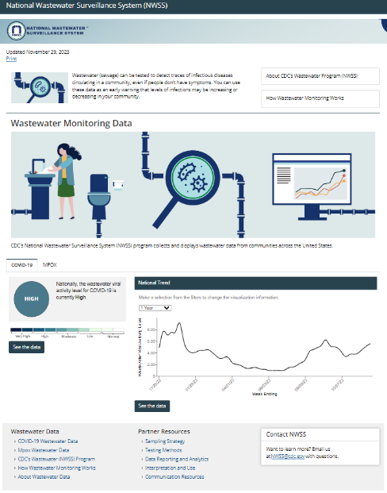  NWSS Website Homepage: https://www.cdc.gov/nwss/index.html | Scroll through
Caregivers of children, caregivers of elderly, business leaders (high and low education), high-risk individuals, rural populations | 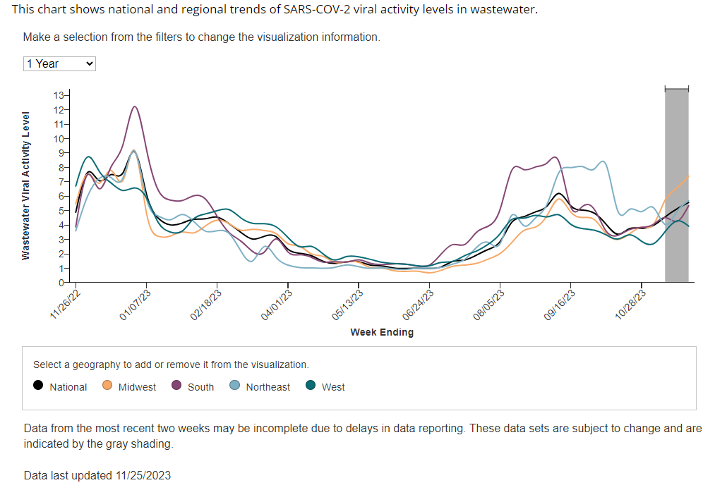  COVID-19 National/regional trend graph: https://www.cdc.gov/nwss/rv/COVID19-nationaltrend.html
Caregivers of children, caregivers of elderly, business leaders (high and low education), high-risk individuals, rural populations | 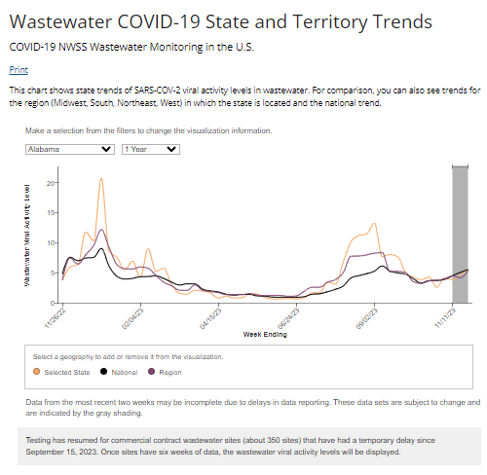  COVID-19 State-level trend graph: https://www.cdc.gov/nwss/rv/COVID19-statetrend.html
Caregivers of children, caregivers of elderly, business leaders (high and low education), high-risk individuals, rural populations | 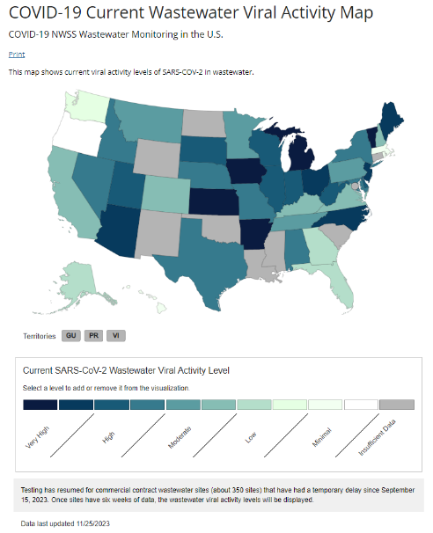  COVID-19 viral activity map: https://www.cdc.gov/nwss/rv/COVID19-currentlevels.html
Caregivers of children, caregivers of elderly, business leaders (high and low education), high-risk individuals, rural populations | 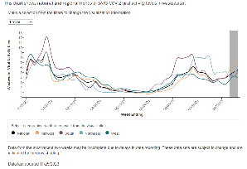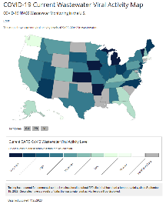  National/regional trend graph vs. Viral activity map | Side-by-side
Low-education business leaders | 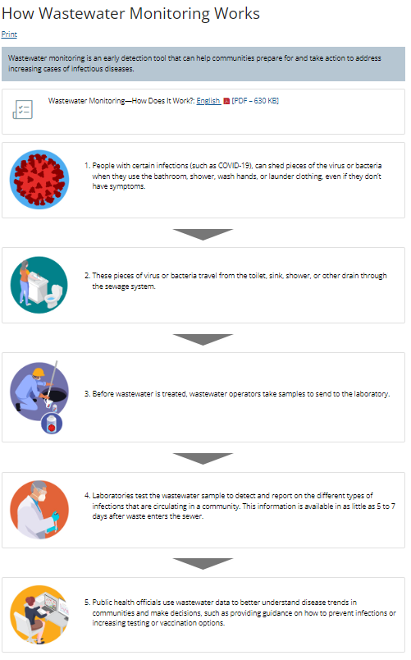  NWSS Website Page- How wastewater monitoring works:  https://www.cdc.gov/nwss/how-wws-works.html | Scroll through

