Attachment #9- Messages to be Tested
Population | Number of Participants
Primary Care Physicians or Family/Internal Medicine Physicians | 5
Obstetricians/Gynecologists (OB/GYNs) | 5
Pediatricians | 5
Oncologists | 5
Nurse practitioners (NP) or physician assistants (PAs) | 5
Healthcare providers (of any type) who work at federally qualified health centers (FQHCs) or community health centers | 8
Total | 33

- Please submit fewer messages if you think your content will take a longer time (> 5 minutes) to present. An example of a longer piece is a two-page infographic, a video, or a webpage.
- Please specify 1-2 audiences for each message from the list above.
- Add drafts/concepts of messages that have yet to be developed if needed.
- See the example line below.
Messages/Materials for Testing
POC/  Branch | Audience (pick 1-2 per content) | Message/Content (Please specify content type: social media graphic, social media text copy, video, etc.) | Testing Presentation (ex. Side-by-side, scroll through) | Probes (Why are you asking this?)
Deanna/OD example | Older Adults (65+) | 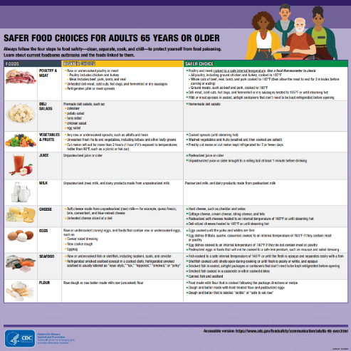  Flyer:cdc.gov/foodsafety/communication/pdf/341844-Series_NCEZID_SafeFoodTables_B.pdf | Scroll through | - How do you feel after reading this table?  - Is there any information that you feel is missing/that you’d like to see here?
Sara/OD | All audiences | Information for Healthcare Professionals (cdc.gov) | Scroll through and look at the high level topics and information | - Will these topics help you in your job?  - What additional information is missing that you’d like to see?
Mabel/ORPB | OB/GYN and PCPs | Protect your pregnant from Listeria webpage and factsheet | Show the webpage and get participant’s feedback. Then click on the “Download factsheet” button at the bottom of the page to show the factsheet (to show participants where the factsheet can be downloaded), and get feedback as well | Webpage  - First impression/ thoughts?  - How familiar are you with Listeria? Have you spoken to your patients about Listeria before? (if not mentioned earlier in the interview/FGD)  - What do you think would be helpful or not helpful for your patients (who are pregnant)?  - Is there any information missing?  - How likely would you use this page/information as a resource when talking to your patients?  - How likely would you share this link with your patients? Which patients would you share it with?  Factsheet  - First impression/ thoughts?  - (Second page of factsheet) Are there any food on this table that you disagree with, or won’t necessarily ask your patients to avoid? Are there any food not listed here that you have told patients to avoid?  - (Second page) How helpful would this be for your patients? Why?  - Would you prefer sharing a printout of this factsheet or a link to the webpage?
Mabel/ORPB | PCP and FQHCs (NP/PAs too if possible) | Listeria and Older Adults webpage and factsheet | Same as above | Same as above, for patients who are 65 years or older
Mabel/ORPB | Oncologists and PCPs (NP/PA and FQHCs too if possible) | Listeria and People with Weakened Immune Systems webpage and factsheet | Same as above | Same as above, for patients who have a weakened immune system
Kelsey/OD | PCP and FQHCs (Oncologists, NP/PA if possible too) | 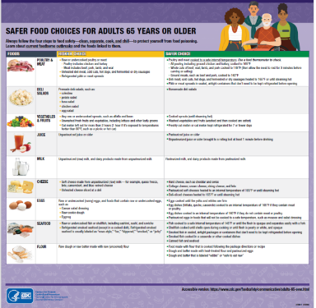  Safer/riskier food table for older adults (printable PDF) | Scroll through focusing on each food type for ~30 seconds | - How likely are you to share this resource with your older patients? (follow-up question: If not you, what HCP will likely discuss this with patient?)  - Are there any of your patients you are more likely to share this with (older and immunocompromised, older with chronic conditions, only those that ask about safe food, etc.)?  - Do you agree with the foods that are listed as safer and riskier?  - Do you have time to explain to your patients why foodborne illness is of concern for them at their age?  - What information do you feel is missing/you’d like to see here?  - Would you prefer this resource be available for your patients in another form (is a printable version or online link more helpful, something else)?
Kelsey/OD | Pediatricians and PCPs | 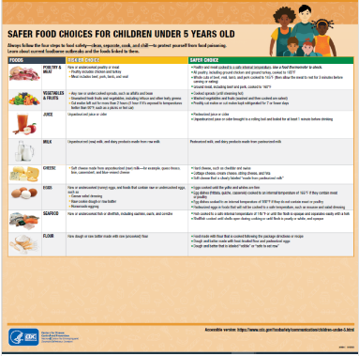  Safer/riskier food table for young children (printable PDF) | Scroll through focusing on each food type for ~30 seconds | - How likely are you to share this resource with parents/caregivers of your patients that are under age 5? (follow-up question: If not you, what HCP will likely discuss this with patient?)  - Are there any of your patients’ parents you are more likely to share this with (under 5 and immunocompromised, under 5 with chronic conditions, only those that ask about safe food, etc.)?  - Do you agree with the foods that are listed as safer and riskier?  - Do you have time to explain to your patients’ parents why foodborne illness is of concern for their child at their age?  - What information do you feel is missing/you’d like to see here?  - Would you prefer this resource be available for your patients’ parents in another form (is a printable version or online link more helpful, something else)?
Kelsey/OD | PCP and Oncologists  (FQHCs and NP/PAs too if possible) | 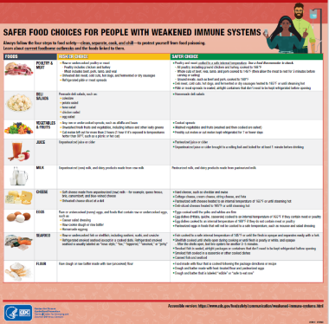  Safer/riskier food table for people with weakened immune systems (printable PDF) | Scroll through focusing on each food type for ~30 seconds | - How likely are you to share this resource with your immunocompromised patients? (follow-up question: If not you, what HCP will likely discuss this with patient?)  - Are there any of your patients you are more likely to share this with (specific type(s) of immunocompromising conditions, older and immunocompromised, very young and immunocompromised, only those that ask about safe food, etc.)?  - Do you agree with the foods that are listed as safer and riskier?  - Do you have time to explain to your patients why foodborne illness is of concern for them due to their health condition?  - What information do you feel is missing/you’d like to see here?  - Would you prefer this resource be available for your patients in another form (is a printable version or online link more helpful, something else)?
Kelsey/OD | OB/GYNs and PCP (FQHCs and NP/PAs too if possible) | 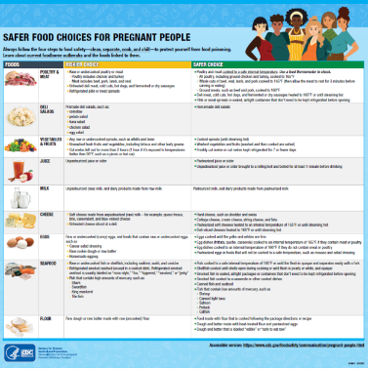  Safer/riskier food table for pregnant people (printable PDF) | Scroll through focusing on each food type for ~30 seconds | - How likely are you to share this resource with your pregnant patients? (follow-up question: If not you, what HCP will likely discuss this with patient?)  - Are there any of your patients you are more likely to share this with (pregnant and immunocompromised, high-risk pregnancy, pregnant with chronic conditions, only those that ask about safe food, etc.)?  - Do you agree with the foods that are listed as safer and riskier?  - Do you have time to explain to your patients why foodborne illness is of concern for them due to pregnancy?  - What information do you feel is missing/you’d like to see here?  - Would you prefer this resource be available for your patients in another form (is a printable version or online link more helpful, something else)?

