## Attachment 2: Screening Survey

**OMB Control No. 0920-1154**

**Exp. Date 3/31/2026**

The public reporting burden of this collection of information is estimated to average 10 minutes per response, including the time for reviewing instructions, searching existing data sources, gathering and maintaining the data needed, and completing and reviewing the collection of information. An agency may not conduct or sponsor, and a person is not required to respond to a collection of information unless it displays a currently valid OMB control number. Send comments regarding this burden estimate or any other aspect of this collection of information, including suggestions for reducing this burden to - CDC/ATSDR Reports Clearance Officer; 1600 Clifton Road NE, MS H21-8, Atlanta, Georgia 30333 ATTN: PRA (0920-1154).

**ADULT MENTOR SCREENING SURVEY**

|  |  |
| --- | --- |
| **Sponsor / Study Title:** | CDC NCIPC Caring Adults Perceptions on Teen Mental Health |
| **Principal Investigator:** | Catherine Lesesne, PhD, MPH |
| **Telephone:** | 404-270-0513 |
| **Address:** | **191 Peachtree St NE Ste 2000, Atlanta, GA 30303** |

***[PAGE 1: Project Background]:***

We are asking your permission to take part in an adult mentor interview or focus group about teen mental health. We are looking to speak with mentors who work with girls and/or nonbinary adolescents (ages 13-17) (hereafter “girls”) in rural communities of the US. Specifically, we want to learn more about how easy or hard it is for teens to access mental health tools and services and how to do this better. We would also like to know how teens think about mental health and how their location may change their experiences in accessing mental health care. This research is conducted on behalf of the Centers for Disease Control and Prevention (CDC).

The project offers two types of sessions for adult mentors:

* **Interview**: 60-minute conversation between one adult mentor and 2-3 project team members
* **Focus Group**: 90-minute group conversation with adult mentors, guided by the project team

The session questions ask about mental health topics. For some people, these topics may cause temporary discomfort or cause strong emotions. We do not anticipate any other risks in participating in the sessions. To reduce risk, we will remind participants that they do not have to answer any questions they do not want to answer, and we will provide a list of community mental health resources to all participants after the sessions. If any participant is showing signs of distress during our session our trained team or the onsite partner team will speak with the individual privately, assess the level of distress and respond appropriately. Response will include asking if they currently receive mental health support and if so encourage them to follow up with their provider and offering a Mental Health Resources sheet or, if the level of distress necessitates it, follow the Mental Health First Aid Protocol.[1] If a participant exhibits distress, the project team will work with the recruitment partner organization to follow up with the participant.

We will record audio in the sessions. The team will use the recording to make sure our notes are correct and to summarize what we hear across all groups. Only our project team will have access to these recordings. The recordings will be deleted once our team updates the session notes. Nothing said in the sessions will be linked to you. The names of participants will never be used in reports of this research and we will not share comments from teens with parents/guardians. The sessions will not ask questions about illegal substance use. If a participant mentions illegal substance use within the sessions, the project team will not report on this. We will keep your participation in this research study confidential to the extent permitted by law. However, if you are participating in a group discussion, we cannot guarantee your participation or things you may say will remain confidential and private. This is due to the chance that other participants may disclose information about the group to unknown others. We ask all participants to use only first names or fake names in all group discussions and to keep the discussion in the group confidential to respect each other’s privacy. Even with these steps taken, we cannot guarantee confidentiality. You should keep this in mind when choosing what to share in the group setting.

This project is for research only. Participants who attend any of the above sessions will receive a $50 Visa gift card per session for their participation. Participation in these sessions is completely voluntary. You do not have to take part in any sessions. You can skip any questions you do not want to answer. You can stop or leave the session at any time by letting one of our team members know you would like to end the session. You will still receive a gift card even if you choose to end participation in a session.

If you participate in a virtual session, you must have a computer, tablet, or handheld device with a microphone and access to the Zoom app. The Zoom app is free for download and usage. If your computer does not have a microphone, you may use a phone to dial in to Zoom audio.

**Please click continue/next below to share some information about you by [INSERT DATE].** If we select you to join, we will contact you via email. The project team will confirm participation on a rolling basis.

If you have any questions, concerns, or complaints about the study, please contact Dr. Catherine Lesesne at 404-270-0513 or at injuryctrengage@cdc.gov. If you have any questions about your rights as a research subject, you may contact Solutions IRB by phone, toll-free, at 855-226-4472 or by email at [participants@solutionsirb.com](mailto:participants@solutionsirb.com).

*Please click NEXT to complete a short survey to share some more information about you.*

***[PAGE 2: Screening Survey]:***

Based on your answers to the following questions, the team may ask you to take part in an adult mentor interview or focus group to share your perspective on the mental health experiences of teen girls living in rural areas.

1. Which of the following best describes the community you work with teens in? Select all that apply.
   * Urban [Continue to Q2]
   * Suburban [Continue to Q2]
   * Rural [Continue to Q2]
   * Frontier [Continue to Q2]
   * Tribal [Continue to Q2]
   * Other: __________ [Continue to Q2]
2. What is your zip code? [Open-Ended] ________________
3. Are you 18 years of age or older?
   * Yes, I am 18 years of age or older.
     + If greater than or equal to 18 [Continue to Q5]
   * No, I am under the age of 18.
     + If less than 18 [Screen out and message shows: *Unfortunately, you are not a match for this project. Thank you for your time.*]
4. How often do you work with teen girls (ages 13-17)?
   * Never
   * Rarely
   * Monthly
   * Weekly
   * Almost every day
5. In what organization and/or role do you mentor teen girls? [Open-Ended] ________________
6. Are you comfortable speaking English in a group setting?
   * Yes
   * No
   * I am not sure
7. The project offers two types of sessions:
   * **Interview**: 60-minute conversation between one adult mentor and 2-3 project team members
   * **Focus Group**: 90-minute group conversation with adult mentors, guided by the project team

Which session type are you interested in participating in? (Select as many as you’re interested in.)

* Interview
* Focus Group

*[****PAGE 3, Appears if Adult Mentor is Eligible for Participation****]:*

Thank you for your responses! If you are selected to take part in a session, your time and efforts will help the CDC make better programs and services for teen mental health in the future. In order to contact you to confirm your availability, please provide **your** contact information:

**Write-in:** <Capture name>

**Write-in:** <Capture email address>

**Screenshots of Web Version:**

Page 1:

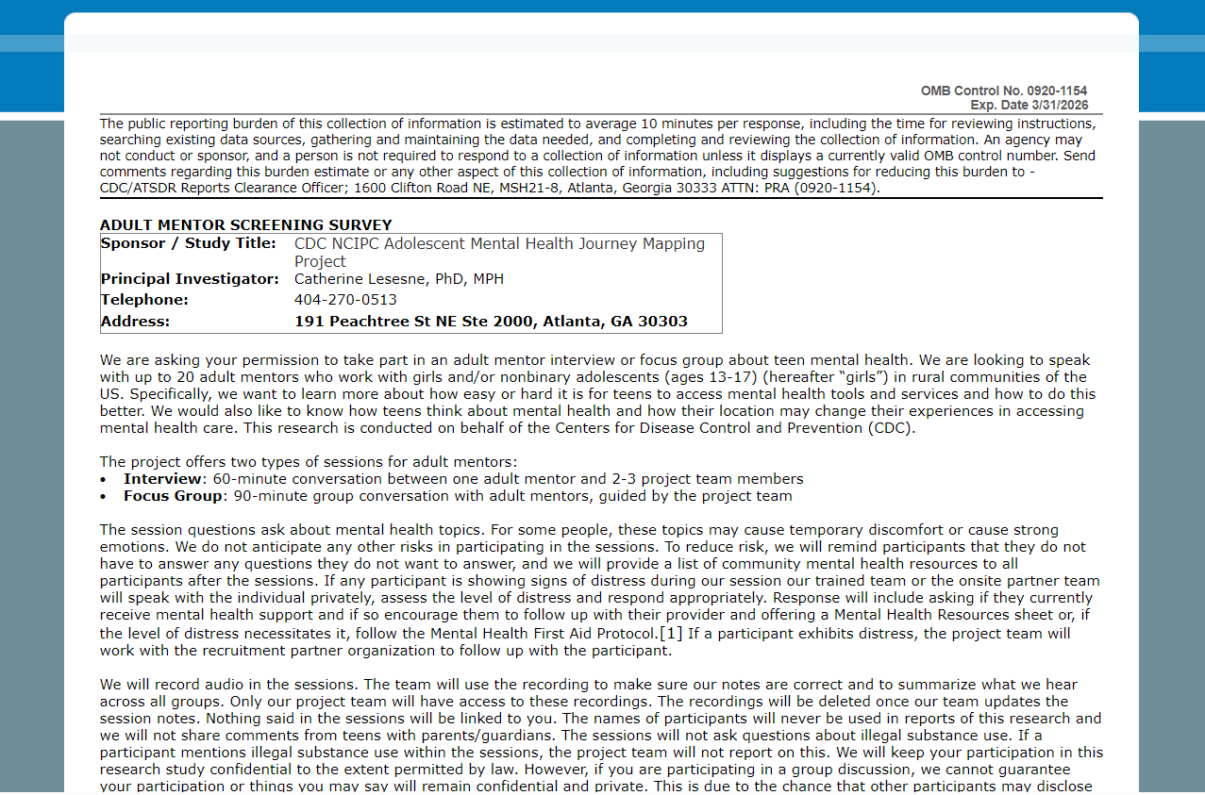

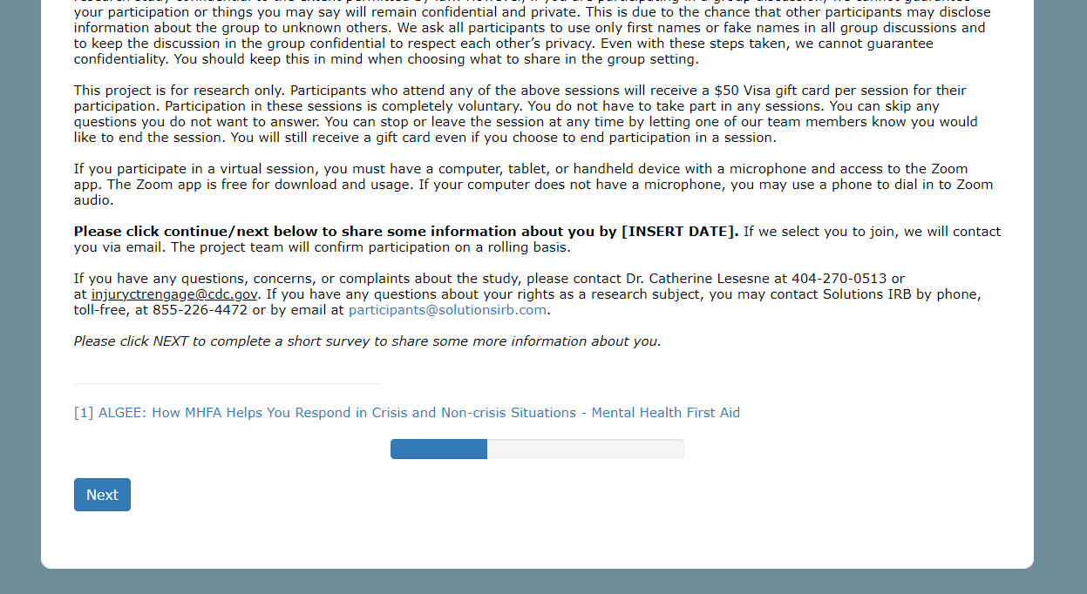

Page 2:

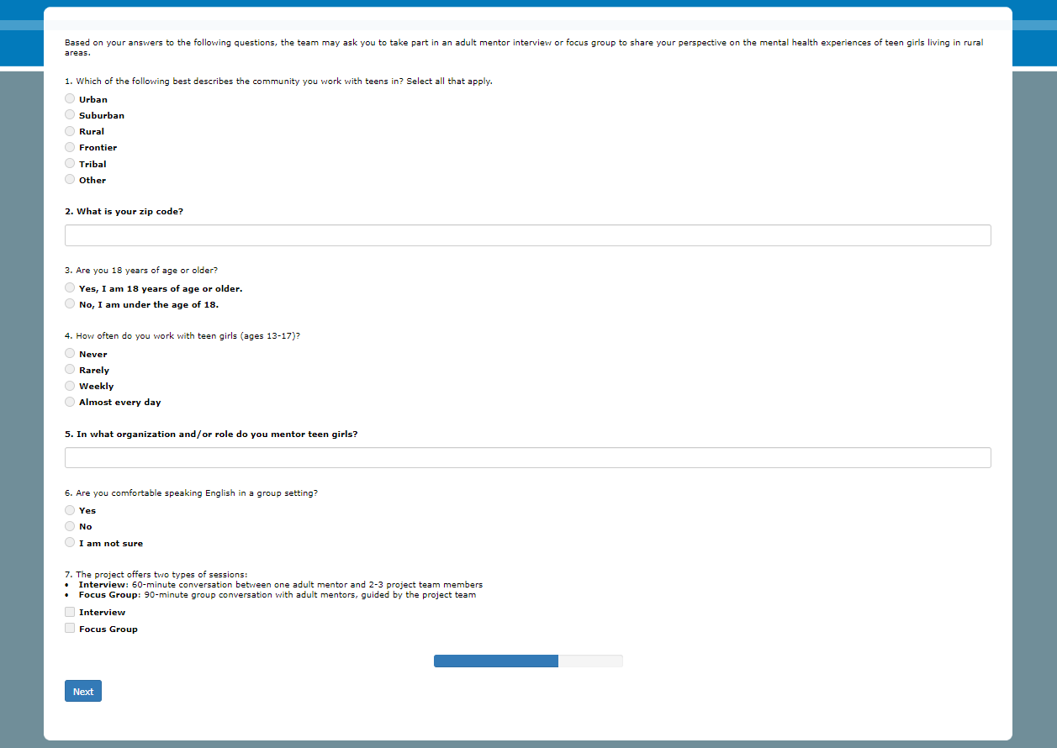

Page 3:

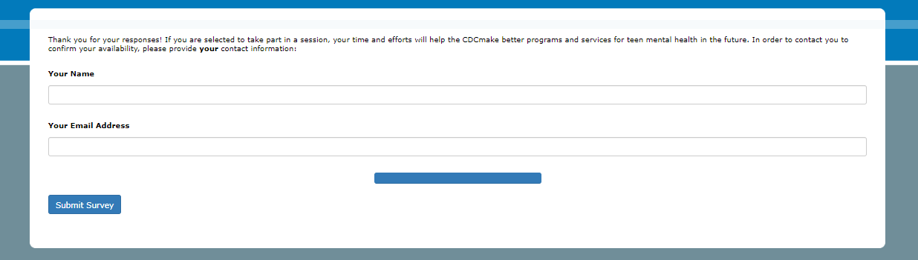

1. [ALGEE: How MHFA Helps You Respond in Crisis and Non-crisis Situations - Mental Health First Aid](https://www.mentalhealthfirstaid.org/2021/04/algee-how-mhfa-helps-you-respond-in-crisis-and-non-crisis-situations/)