**Attachment 1: ACEs Survey and Consent**

**OMB No. 0920-1154**

**Exp. Date 3/31/2026**

CDC estimates the average public reporting burden for this collection of information as 15 minutes per response, including the time for reviewing instructions, searching existing data/information sources, gathering and maintaining the data/information needed, and completing and reviewing the collection of information. An agency may not conduct or sponsor, and a person is not required to respond to a collection of information unless it displays a currently valid OMB control number. Send comments regarding this burden estimate or any other aspect of this collection of information, including suggestions for reducing this burden to CDC/ATSDR CDC/ATSDR Information Collection Review Office, 1600 Clifton Road NE, MS D-74, Atlanta, Georgia 30333; ATTN: PRA (0920-1154).

Thank you for your interest in participating in this survey. This survey is related to communications about adverse childhood experiences (what we refer to as “ACEs”) and ACEs prevention strategies. The following survey should take no longer than 15 minutes to complete. The results will inform future communications developed by the Centers for Disease Control and Prevention (CDC) related to preventing ACEs. Your participation is completely voluntary. All survey questions are optional. You may choose to skip survey questions that you do not wish to answer or discontinue the survey at any point. There are no foreseeable risks associated with participating in this survey. We will not ask you for any personal identifiable information (PII), such as your name or email address, that could link your responses to you. There are no direct benefits to participating in the survey. However, you may benefit from knowing your participation will help improve future communication materials related to ACEs as well as CDC’s ability to support ACEs prevention work.

If you have any questions or concerns about this survey, you may contact [PI NAME] by phone at [PHONE NUMBER] or by email at [EMAIL ADDRESS].

**If you understand the information above and would like to participate in the survey, please proceed to the next page.**

General Questions

1. **What position best describes you and your relation to children in your life? Select all that apply.** 
   * I am a primary caregiver to one or more children (like parent, caregiver, guardian).
   * I am a direct service provider that works with children in a formal way through my job (like child care provider, teacher, community-based organization, housing organizations, child welfare, substance abuse and mental health provider).
   * I work with children in an informal way (like mentors, youth sports coaches).
   * I interact with children but do not directly care for or work with children (like neighbors, family members).
   * Other [open-ended].
2. **How familiar are you with the topic of adverse childhood experiences (ACEs)?** With 1 being the lowest (no knowledge or familiarity) and 5 being the highest (extremely knowledgeable or familiar). [scale 1-5]
   * 1- No knowledge or familiarity
   * 5- Extremely knowledgeable or familiar

Reaction Questions

We will present messages to get audience reactions. We will ask the questions below for each of 5 messages, one message for each Construct listed below. All messages can be seen in **Att 8 ACEs Messages for Testing**.

Please read the bolded message below and then respond to the questions.

Construct 1: Adversity is harmful, but we can prevent and mitigate it.

[Example Message for Construct 1:]

***When adversity happens, it can derail children’s healthy development. To keep kids on track, we need to prevent harm when we can, and respond quickly if we can’t.***

Construct 2: We can prevent adversity from harming children.

Construct 3: Safe, stable, and nurturing relationships and environments

Construct 4: Prevention Strategies

Construct 5: Positive childhood experiences

1. **How easy is it to understand this message?** With 1 being the lowest ("not easy at all") and 5 being the highest ("extremely easy"). (scale 1-5)
2. **To what level do you agree with this message?** With 1 being the lowest ("don’t agree at all") and 5 being the highest ("completely agree"). (scale 1-5)
3. **How well do you think you would remember this message?** With 1 being the lowest ("not well at all") and 5 being the highest ("extremely well"). (scale 1-5)
4. **Do you think this message set would motivate you or someone else to [INSERT message-specific action, such as “prevent harm of children or respond quickly”]?**
   * Yes
   * No
   * Don’t know

A/B Questions

The following question is intended to compare two messages and will be asked for every pair of messages that are compared. Eight (8) message pairs will be displayed.

[Display two messages from messages document (**Att 8 ACEs Messages for Testing**). An example message pair is provided below.]

* ***Message A:*** *When adversity happens, it can derail children’s healthy development. To keep kids on track, we need to prevent harm when we can, and respond quickly if we can’t.*
* ***Message B:*** *Serious adversity is harmful to children. As a society, we can prevent most adverse childhood experiences. When adversity happens, we can reduce its negative impact.*

1. **Which message do you prefer?** 
   * Message A
   * Message B
   * Neither message

Additional Information

1. **Is there anything else you’d like to share about the messages or this topic?** [Open-ended]

Demographic Questions

1. **How old are you?**
   * 18-24 years of age
   * 25-34 years of age
   * 35-44 years of age
   * 45-54 years of age
   * 55-64 years of age
   * 65-74 years of age
   * 75 years of age or older
2. 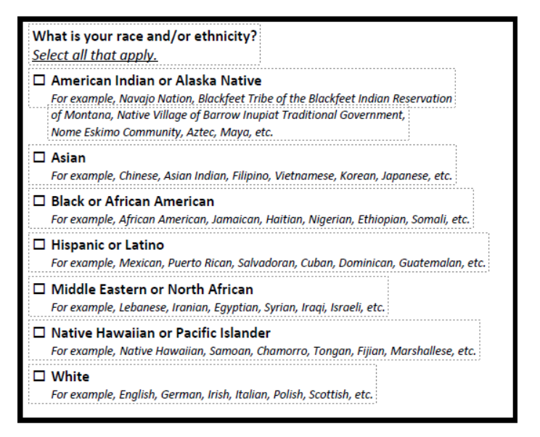
3. **How do you currently describe yourself (mark all that apply)?**
   * **_** Female
   * _ Male
   * _ Transgender
   * _ Prefer not to answer/Decline
4. **What is the highest grade or year of school that you completed?**
   * Never attended school
   * Attended kindergarten
   * Grades 1 through 8 (Elementary)
   * Grades 9 through 11 (Some high school)
   * Grade 12 or GED (High school graduate)
   * College 1 year to 3 years (Some college or technical school)
   * College 4 years or more (College graduate)
   * Graduate school
   * I don’t know
5. **Last year, (2023), what was your total household income from all sources, before taxes?**
   * Less than $15,000
   * $15,000 to $24,999
   * $25,000 to $34,999
   * $35,000 to $49,999
   * $50,000 to $74,999
   * $75,000 to $99,999
   * $100,000 to $149,999
   * $150,000+
   * I don’t know