**Recruitment Content (General and Post Copy)**

**Sample Recruitment Images**

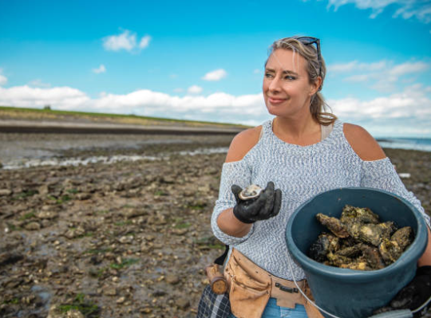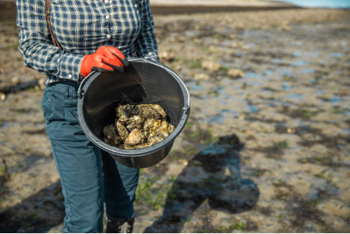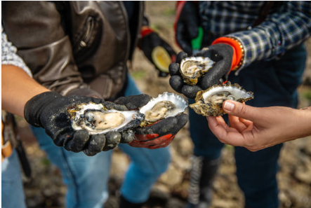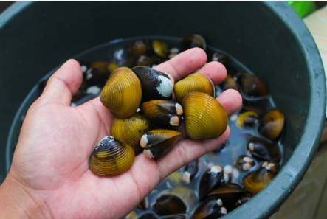

**Sample Recruitment Language (General)**

Banyan Communications is conducting focus groups with adults to learn people’s opinions about shellfish safety messages and to hear their preferences for getting health information. These focus groups will be about 60 minutes long and will take place online. You will receive $75 as a thank you for your time. To learn more about the focus groups and determine if you are eligible to participate, please click [ELIGIBILITY SCREENER LINK].

If you have any questions about the focus groups, please contact Banyan Communications, [insert_inbox_here@banyancom.com](mailto:insert_inbox_here@banyancom.com)

**Sample Recruitment Post (General)**

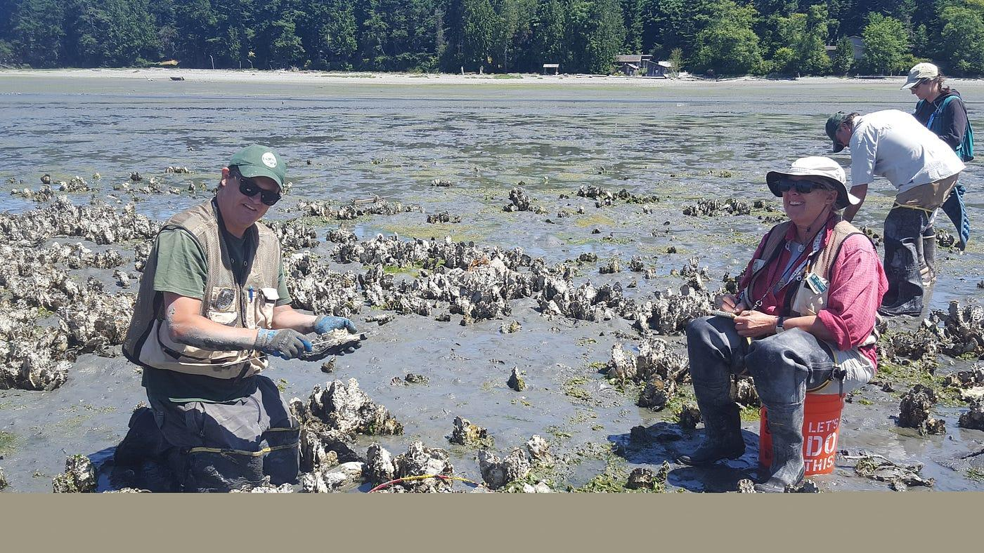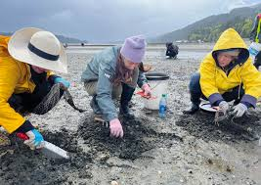

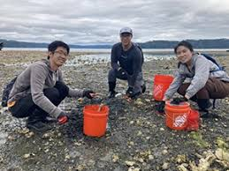 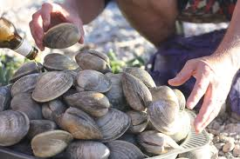

Do you live along the West Coast, East Coast, or Gulf Coast, or Alaskan Coast?

Do you collect or harvest shellfish for yourself, your family, or friends?

We’re looking for people 18 years and older who collect/harvest shellfish to share their opinions. The conversation will be a virtual session over the internet lasting 60 minutes.

If you are interested, please click on the link below to answer some questions about yourself to see if you are qualified.

If you know someone who may be interested, please share the link with them.

Where: Online

Token of Appreciation: $75

[ELIGIBILITY SCREENER LINK]