**Non-substantive Change Request**

**OMB Control Number** 0920-1406

Traveler-based Genomic Surveillance

**Date Submitted: 03/04/2025**

**Summary of request:** CDC/NCEZID/DGMH is requesting to revise questions to align with Executive Order (EO) 14168 *Defending Women From Gender Ideology Extremism and Restoring Biological Truth to the Federal Government.*

**Description of Changes Requested:** This request revises a question that references respondent sex, and available response options used in this Traveler-based Genomic Surveillance Questionnaire (OMB Control Number 0920-1406) to align with EO 14168.

✓□ Revision of an existing question(s)

□ Deletion of an existing question(s)

Question 3 in the “Background Information” section previously read:

*What sex were you assigned at birth, on your original birth certificate?*

* *Male*
* *Female*
* *Prefer not to answer*

It now reads:

*Sex:*

* *Male*
* *Female*
* *Skip question*

Language referencing sex assigned at birth has been removed for compliance with Executive Order 14168.

Additionally, the “prefer not to answer” button was removed. A “skip question” button was added so the respondent can proceed to the next question on the digital form without answering the question. The “skip to end” navigational button is unchanged.

Screenshot of previous version of Question 3 below:

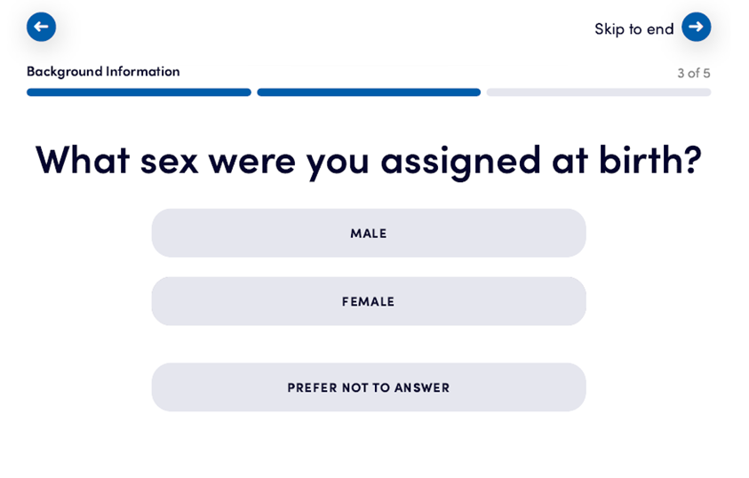

Screenshot of updated version of Question 3 below:

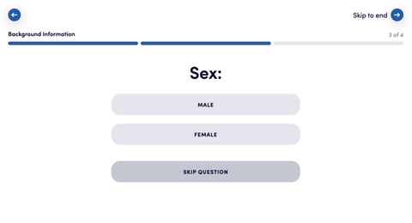

**Description of Changes to Burden (if applicable):** There is no change in Burden Hours associated with the modifications made to comply with EO 14168.