**ATTACHMENT 7**

**PROGRAM COMMUNICATIONS**

**Examples of Million Hearts® Hospital / Health System Communications**

Post on the [Million Hearts: Posts | LinkedIn](https://www.linkedin.com/showcase/million-hearts/posts/?feedView=all)

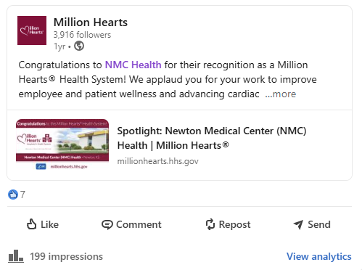

Notice in the “Million Hearts® in the Community®” section of the “Million Hearts® Minute” newsletter (clicking on “Congratulations, NMC Health” goes to [Spotlight: NMC Health](https://millionhearts.hhs.gov/partners-progress/hospitals-health-systems/nmc-health.html?ACSTrackingID=DM127950&ACSTrackingLabel=New%20Resources%20for%20Addressing%20Hypertension%20in%20Pregnancy&deliveryName=DM127950))

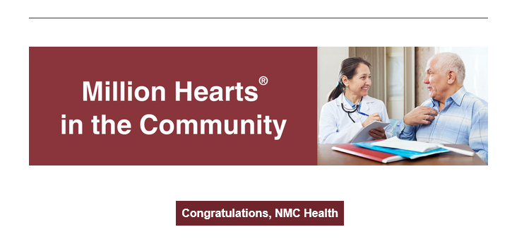

Full [Spotlight: NMC Health](https://millionhearts.hhs.gov/partners-progress/hospitals-health-systems/nmc-health.html?ACSTrackingID=DM127950&ACSTrackingLabel=New%20Resources%20for%20Addressing%20Hypertension%20in%20Pregnancy&deliveryName=DM127950) announcement on the Million Hearts® website:

