1. **CoC Screens**
   1. 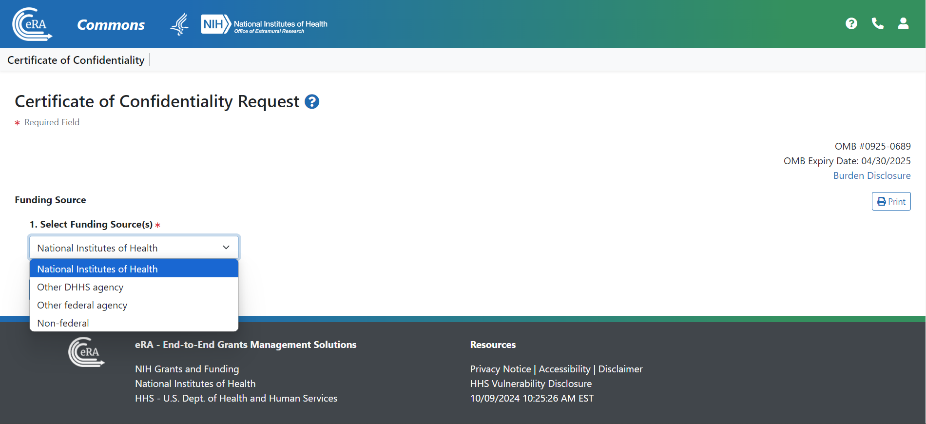**CoC User Interface, Question 1**
   2. **Burden Statement**

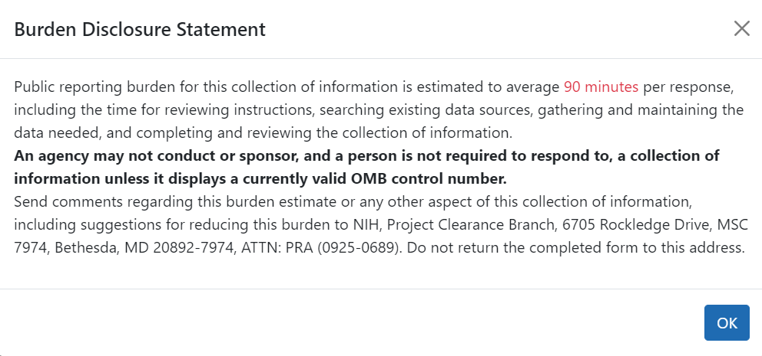

* 1. **User Interface: Certification, Questions 2-6**

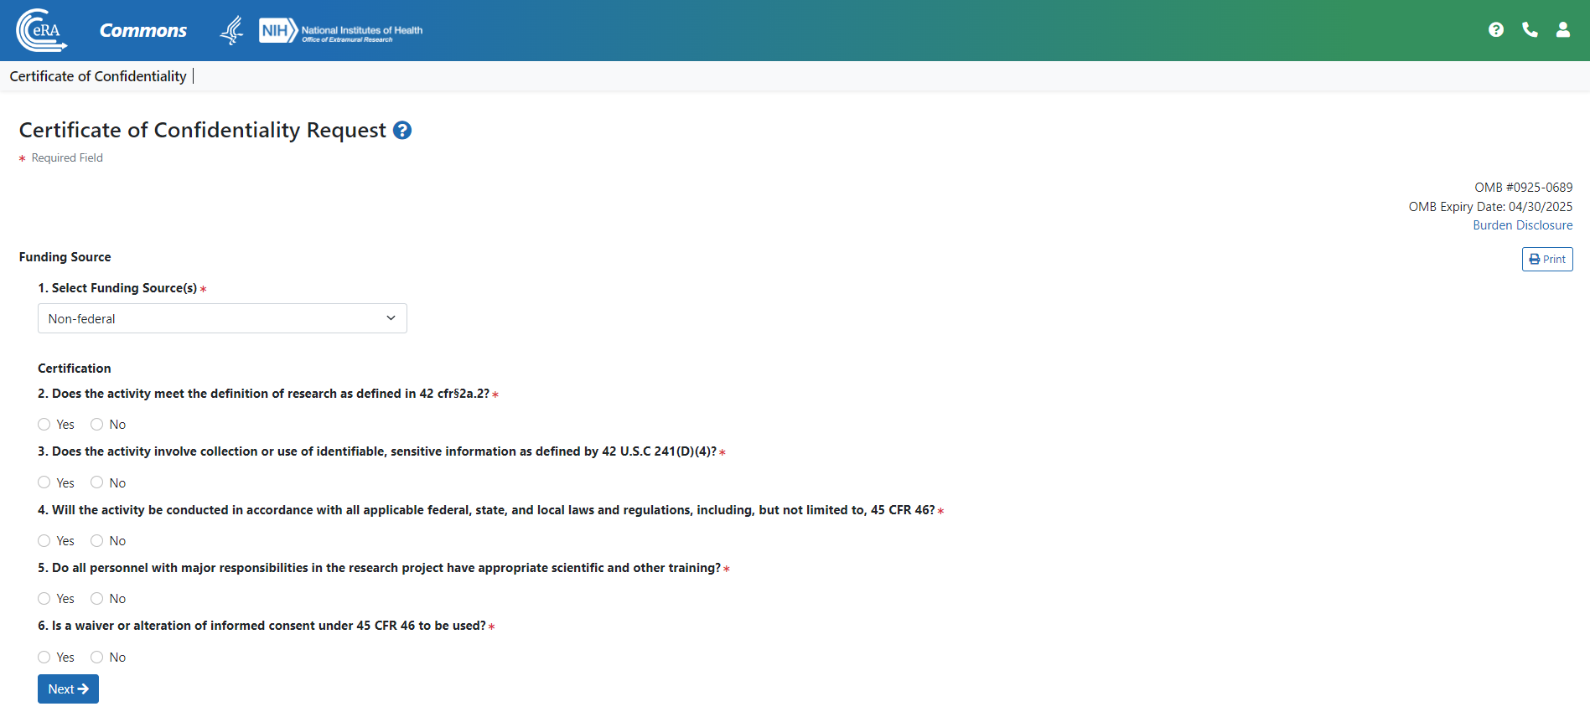

* 1. **User Interface: Certification, Questions 7-10, Project Details**

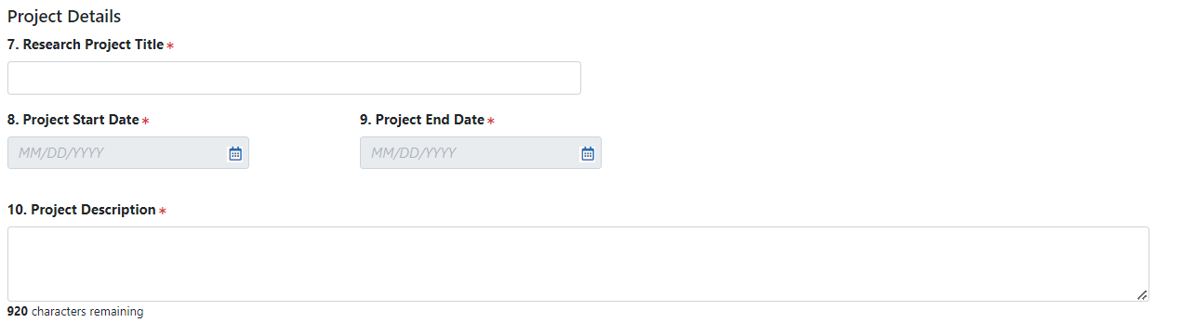

* 1. **User Interface: Certification, Questions 11-15, Institution and performance Site Details**

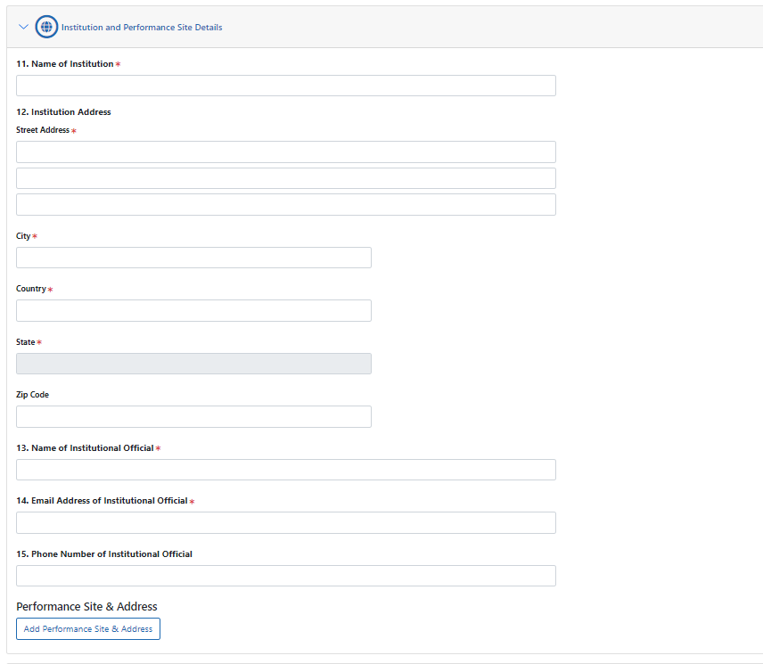

* 1. **User Interface: Certification, Questions 18-24, Principal Investigator and Other Key Personnel**

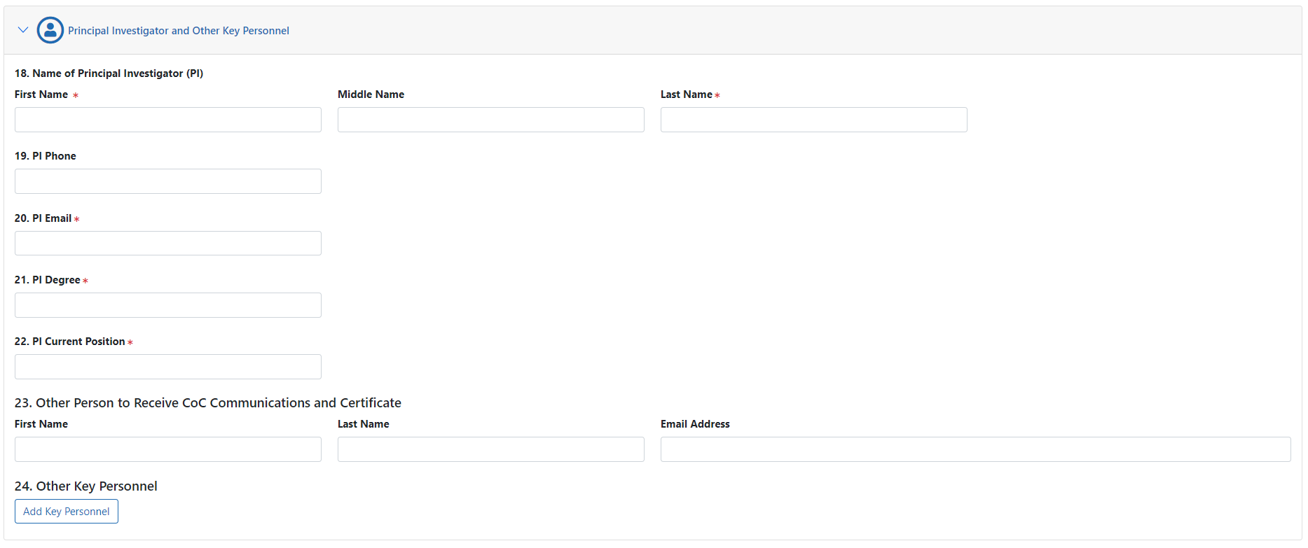

* 1. **User Interface: Certification, Question 25-27, Administration of Drugs and Submit Button**

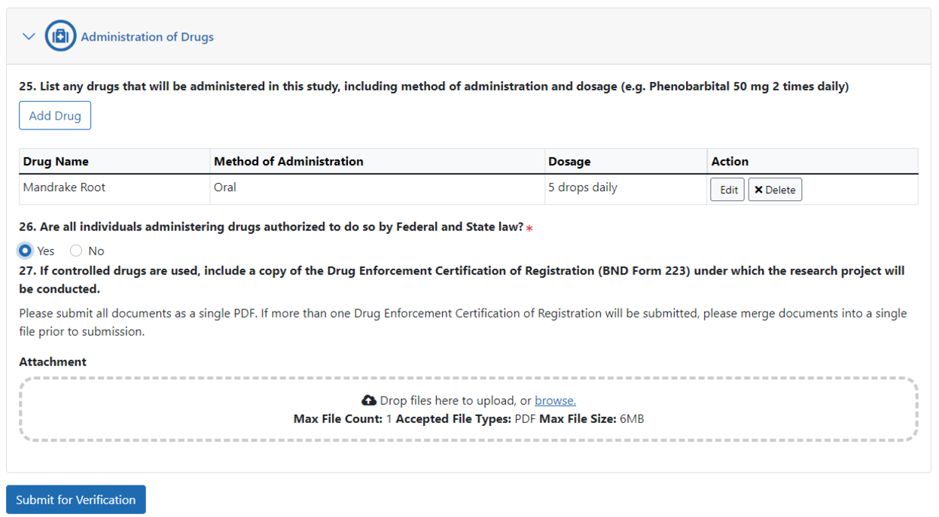

* 1. **For Instructional Purposes Only: User Interface**

After the user completes questions 1-25 and clicks the Submit for Verification button, the Confirmation Needed dialog pops up. The user will click Yes.

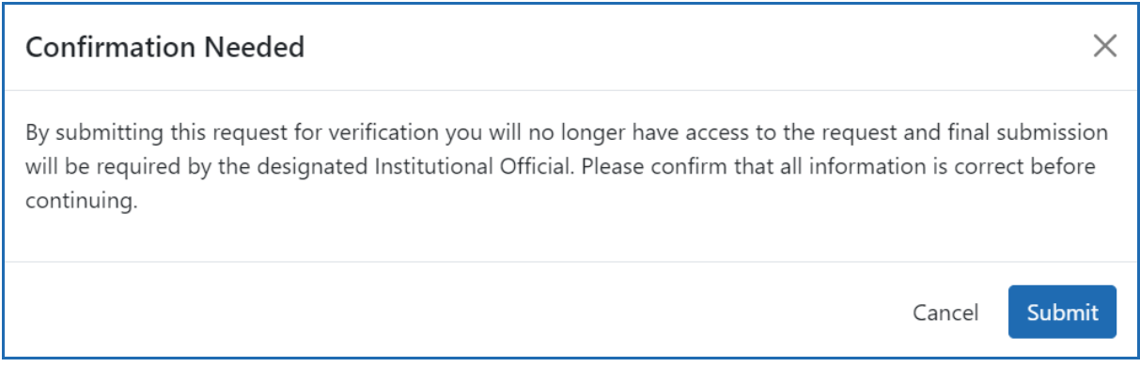

The browser will display a success message.



If there are errors on the form, the form is not submitted and the user can scroll through the form to see the errors in red and correct:

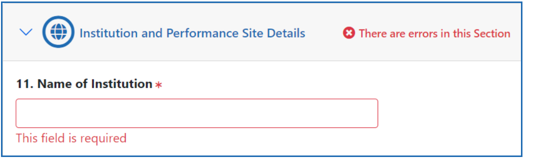

Once corrected, the user will repeat the steps above to submit the CoC request. Once the request to apply for a CoC has been completed and submitted, it will trigger the system to send an automated email to the email address entered for the Institutional Official (IO).

The IO will need to click the link in the Verification and Submission email, and the browser will open to a page that contains the original CoC request. The IO needs to review the information in the request and verify it is correct. At the bottom of the request, a section titled Assurance Statement appears. The IO needs to review and select all checkboxes and click the Submit button.

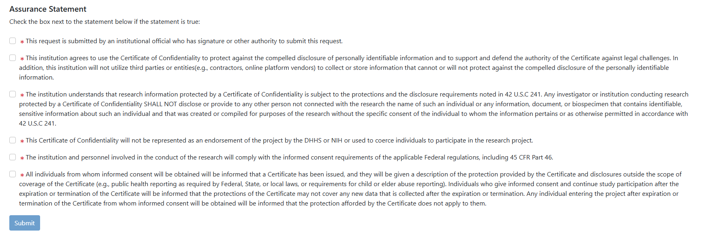

A pop-up confirmation message appears. The IO needs to click the I Certify button to verify that the statements are true and complete the submission. Once it is fully submitted, both the IO and the PI and other persons listed in the application will receive a confirmation email.

