**Security Authentication PIN (SAP) Code Generation Steps – Screenshots**

**Public-Facing SAP Code Generation via Vanity URL (ssa.gov/pin):**

1. **User leverages the Vanity URL and signs in to their mySocialSecurity account using their Login.Gov or ID.me credential**

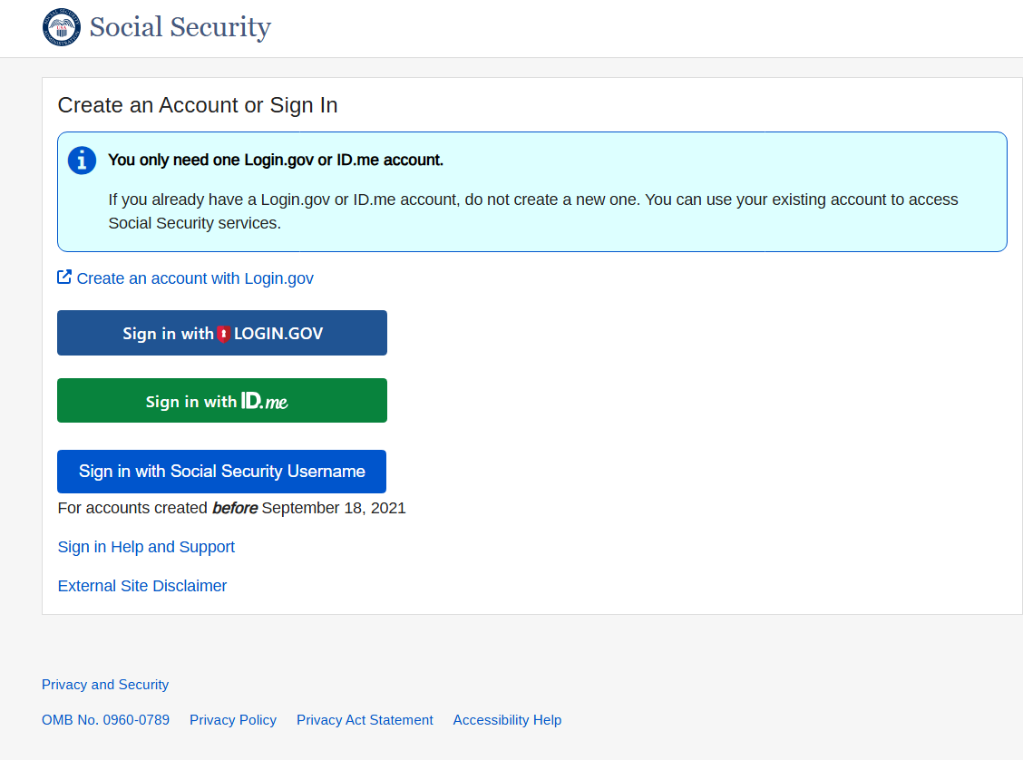

1. **After completing login, user is navigated directly to screen where they can generate the SAP code**

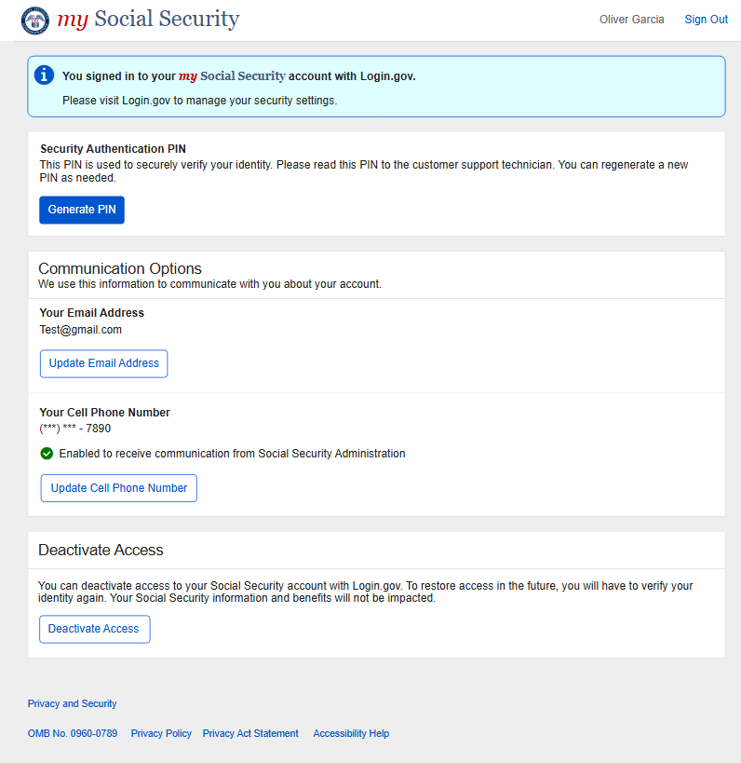

1. **User generates PIN and shares PIN with SSA Technician**

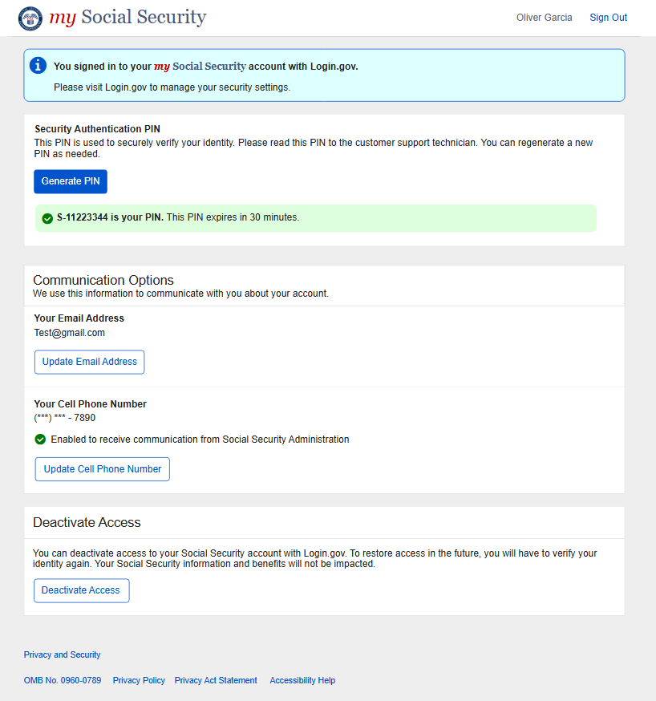

**Public-Facing SAP Code Generation via Traditional URL (ssa.gov)**

1. **User signs in to their mySocialSecurity account via traditional URL using their Login.Gov or ID.me credential**



1. **User selects ‘My Profile’ in the MySSA Home page**

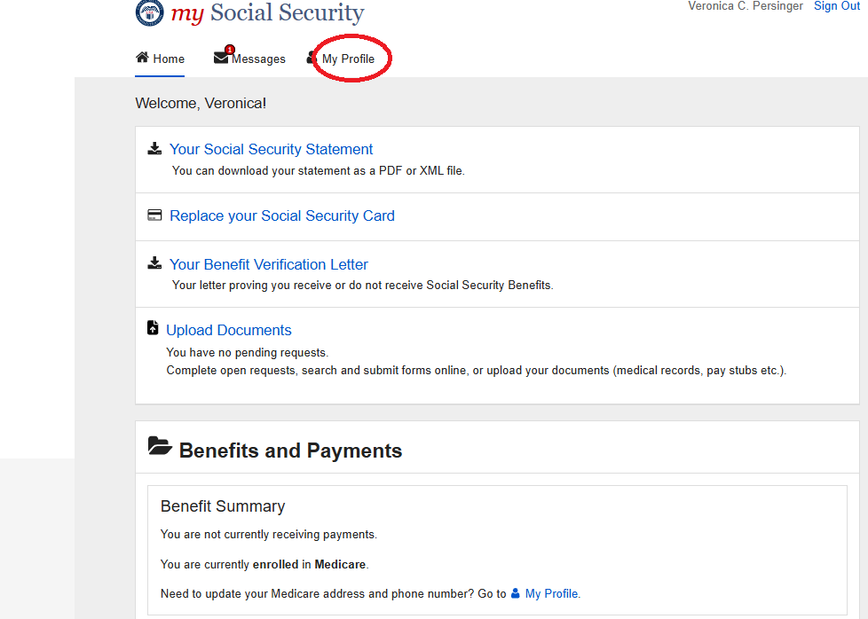

1. **User selects ‘Security’ from the mySSA ‘My Profile’ page to navigate to SAP screen.**

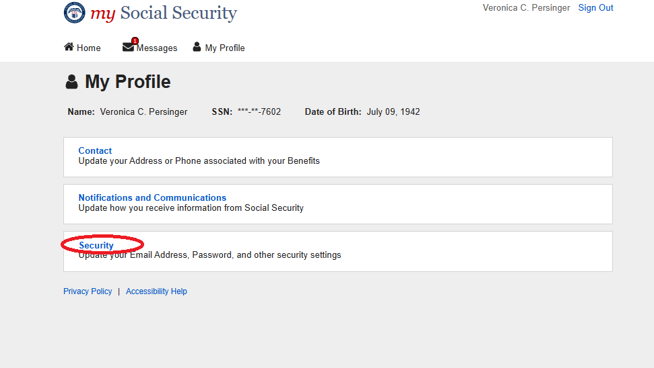

1. **User arrives at screen where they can generate the SAP code**

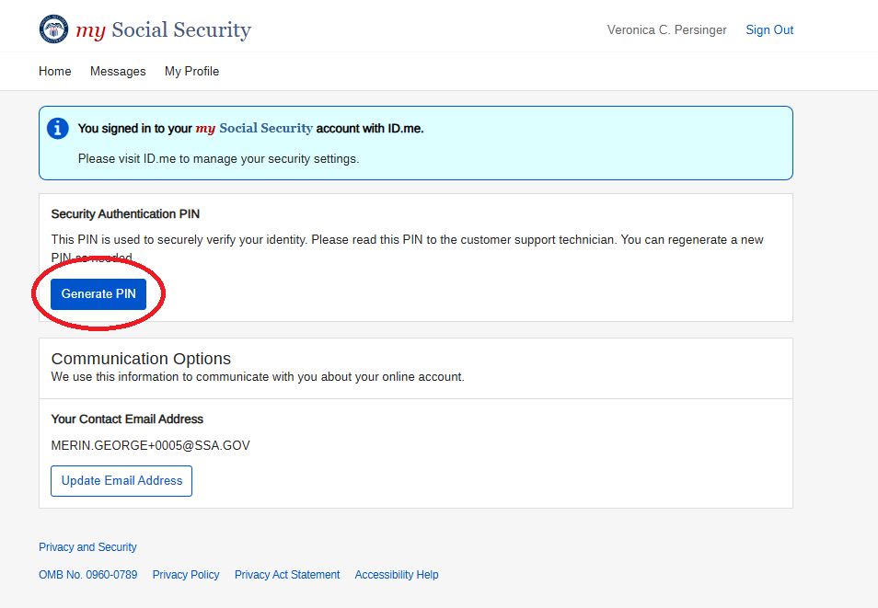

1. **User generates PIN and shares PIN with SSA Technician**

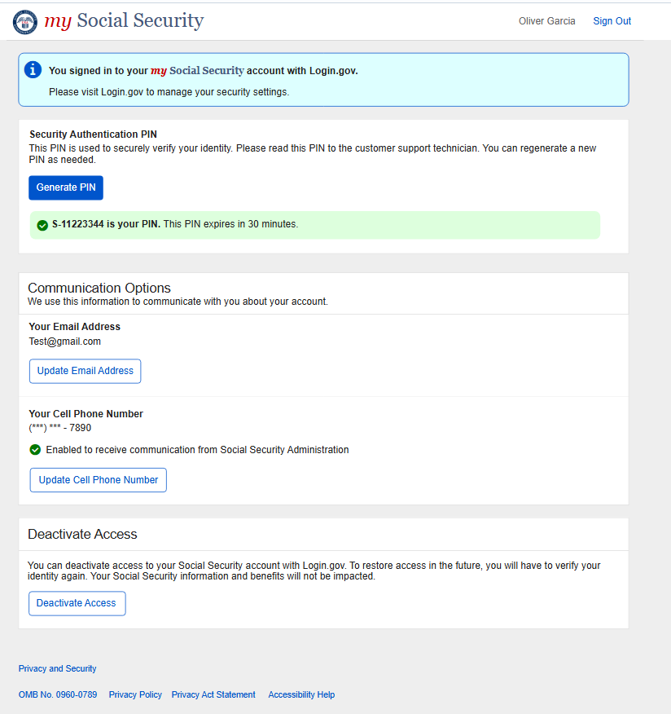

**Technician Experience Dashboard – SAP Validation Screen**

1. **Technician enters SAP code provided by customer and validates code.**

