OMB Control No: 0970-0427
Expiration date: X/XX/XXXX
Center Locations and Contacts
Edit Center Name and Information: 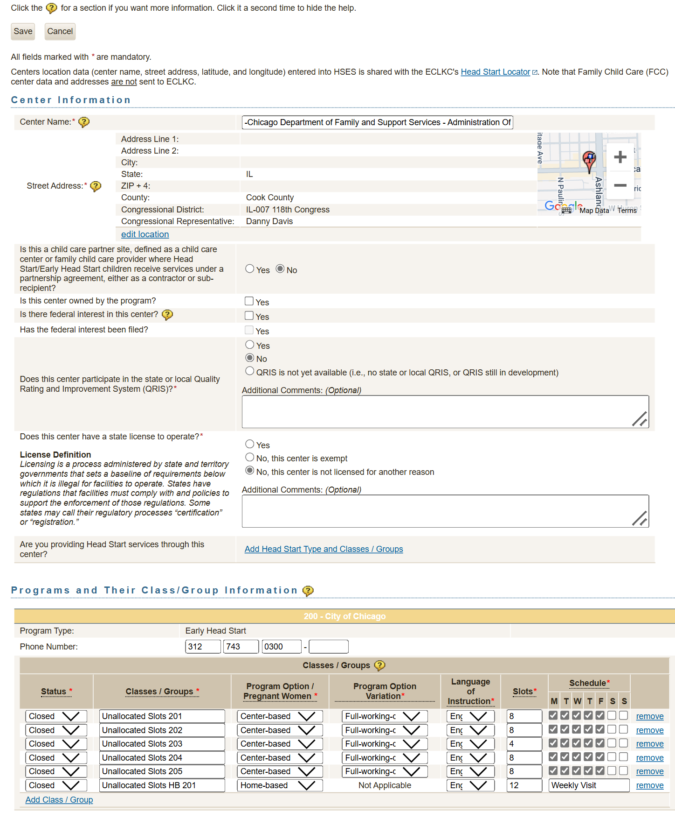

THE PAPERWORK REDUCTION ACT OF 1995 (Pub. L. 104-13)
Public reporting burden for this collection of information is estimated to average 0.25 hours per response, including the time for reviewing instructions, gathering and maintaining the data needed, and reviewing the collection of information. An agency may not conduct or sponsor, and a person is not required to respond to, a collection of information unless it displays a currently valid OMB control number.

Edit Location: 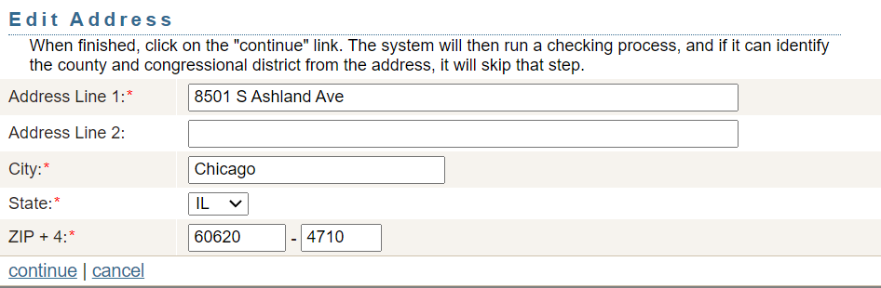
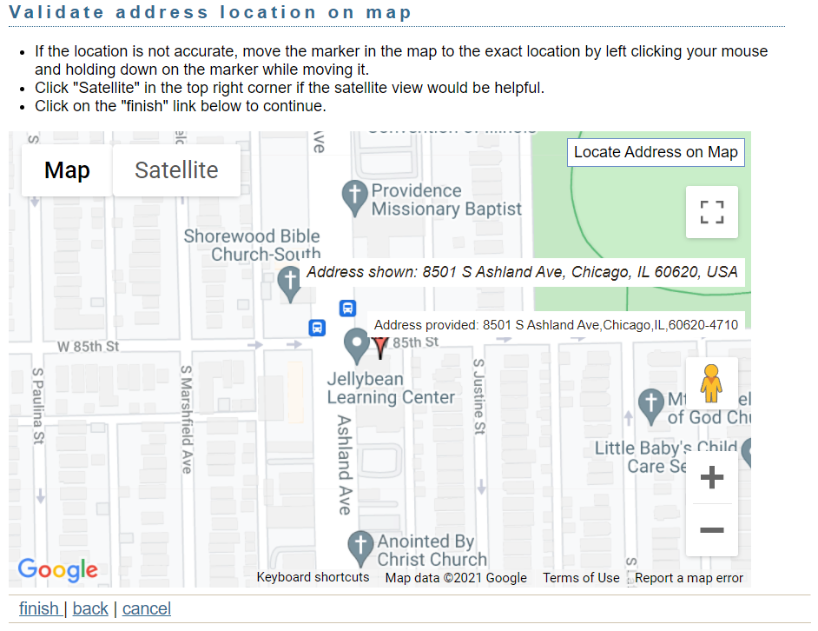

Edit Programs and Their Class/Group Information:
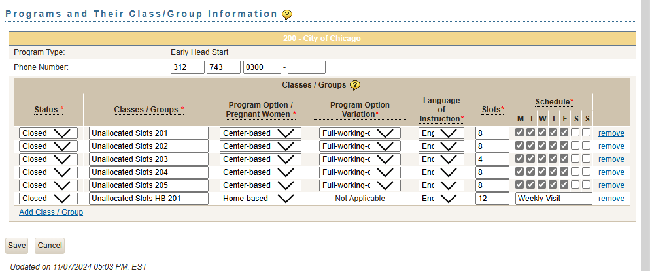

Edit Contacts:
